Git Configuration and Basic Git Commands
[Submitted by: 231fa04341@gmail.com]

Objective
- To configure Git on the local machine.
- To set Notepad++ as the default Git editor.
- To create a local Git repository.
- To add, commit, and push files to a GitHub repository.
- To learn basic Git commands such as git init, git status, git add, git commit, git push

Steps:
Step 1: Verify Git Installation
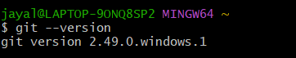
Step 2: Configure Git
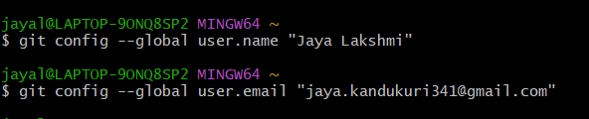
Step 3: Configure Notepad++
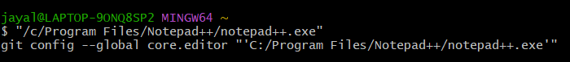
Step 4: Create a Local Repository
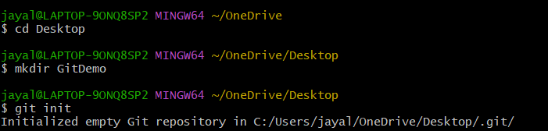

Step 5: Create a File
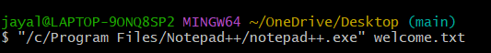
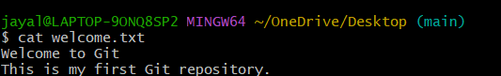
Step 6: Add the File
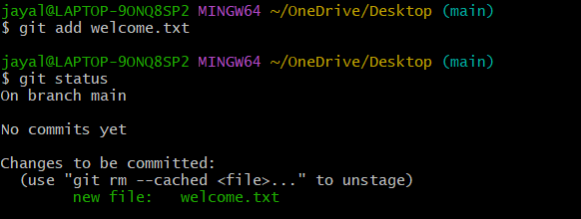
Step 7: Commit Changes
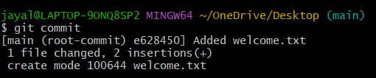
Step 8: Create a Remote Repository
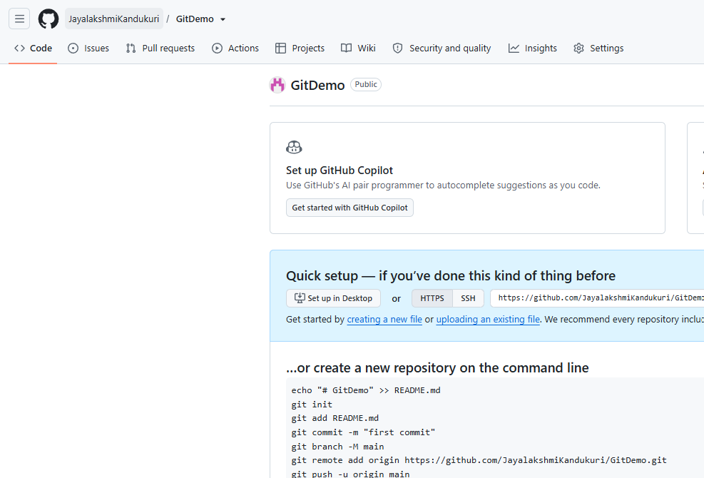

Step 9: Connect Local and Remote Repository
Step 10: Push the Repository
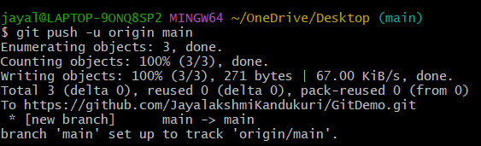

Result: 