Implementing Git Ignore to Exclude Unwanted Files and Folders
[Submitted by: 231fa04341@gmail.com]
Objective
- To understand the purpose of .gitignore.
- To ignore unwanted files and folders from being tracked by Git
Steps
1.Open Git Bash and navigate to the Git repository folder.
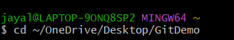
2. Create a .log file and a log folder.
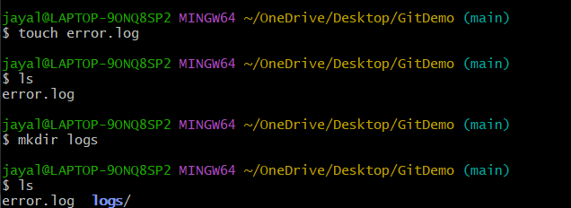
3. Create and edit the .gitignore file.
4. Add the following lines in .gitignore
*.log
logs/
5. Add and commit the .gitignore file.
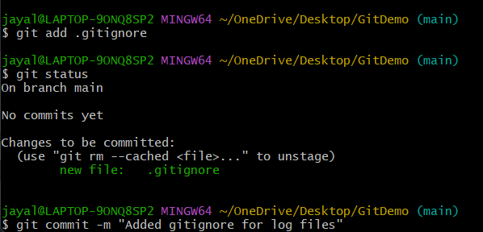

6.Verify ignored files.
