ReactJS – Task12
[Submitted by: 231fa04341@gmail.com]
Objective
Implement conditional rendering in React so that:
- Guest users can only view flight details.
- Logged-in users can book tickets.
- Clicking Login shows the User page.
- Clicking Logout shows the Guest page.
Steps
Create React Project
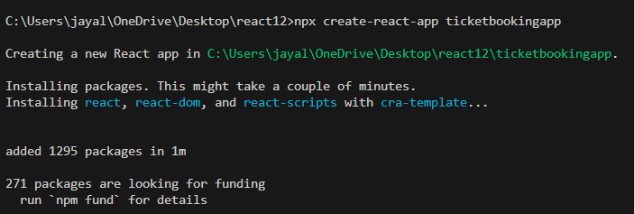
Code:
UserGreeting.js code
import React from "react";
function UserGreeting() {
return (
<div>
<h2>Welcome User!</h2>
<h3>Available Flights</h3>
<table border="1">
<thead>
<tr>
<th>Flight</th>
<th>From</th>
<th>To</th>
<th>Price</th>
</tr>
</thead>
<tbody>
<tr>
<td>AI101</td>
<td>Hyderabad</td>
<td>Delhi</td>
<td>₹5000</td>
</tr>
<tr>
<td>AI202</td>
<td>Chennai</td>
<td>Mumbai</td>
<td>₹4500</td>
</tr>
</tbody>
</table>
<br />
<button>Book Ticket</button>
</div>
);
}
export default UserGreeting;

GuestGreeting.js code:
import React from "react";
function GuestGreeting() {
return (
<div>
<h2>Welcome Guest!</h2>
<h3>Available Flights</h3>
<table border="1">
<thead>
<tr>
<th>Flight</th>
<th>From</th>
<th>To</th>
<th>Price</th>
</tr>
</thead>
<tbody>
<tr>
<td>AI101</td>
<td>Hyderabad</td>
<td>Delhi</td>
<td>₹5000</td>
</tr>
<tr>
<td>AI202</td>
<td>Chennai</td>
<td>Mumbai</td>
<td>₹4500</td>
</tr>
</tbody>
</table>
<p>Please login to book tickets.</p>
</div>
);
}
export default GuestGreeting;
LoginButton.js code:
import React from "react";
function LoginButton(props) {
return (
<button onClick={props.onClick}>
Login
</button>
);
}
export default LoginButton;

LogoutButton.js code:
import React from "react";
function LogoutButton(props) {
return (
<button onClick={props.onClick}>
Logout
</button>
);
}
export default LogoutButton;
App.js code:
import React, { Component } from "react";
import LoginButton from "./LoginButton";
import LogoutButton from "./LogoutButton";
import UserGreeting from "./UserGreeting";
import GuestGreeting from "./GuestGreeting";
class App extends Component {
constructor(props) {
super(props);

this.state = {
isLoggedIn: false
};
this.handleLoginClick = this.handleLoginClick.bind(this);
this.handleLogoutClick = this.handleLogoutClick.bind(this);
}
handleLoginClick() {
this.setState({
isLoggedIn: true
});
}
handleLogoutClick() {
this.setState({
isLoggedIn: false
});
}
render() {
const isLoggedIn = this.state.isLoggedIn;
let button;
if (isLoggedIn) {
button = (
<LogoutButton onClick={this.handleLogoutClick} />
);
} else {
button = (
<LoginButton onClick={this.handleLoginClick} />
);
}
return (
<div style={{ textAlign: "center" }}>
<h1>Flight Ticket Booking</h1>
{button}
<hr />
{isLoggedIn ? (
<UserGreeting />
) : (
<GuestGreeting />
)}
</div>
);
}
}
export default App;
Output:
