ReactJS – Task1
[Submitted by: 231fa04341@gmail.com]

Objective
To create and run a basic React application using Create React App and display a welcome message as a heading in the browser.
Steps
1.To create a React Application with the name of “myfirstreact”
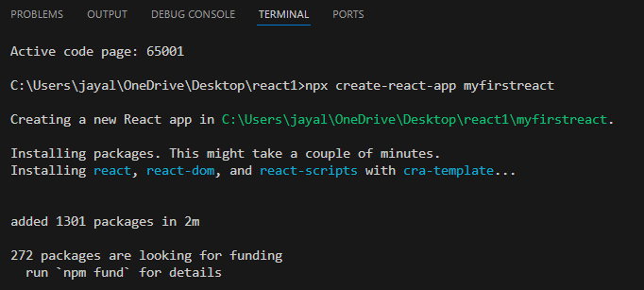

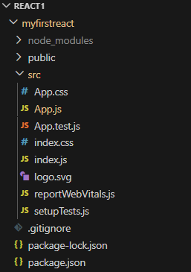

2. Navigate into the folder of myfirstreact
3. Replace App.js code with the following:
function App() {
return (
<h1>Welcome to the first session of React</h1>
);
}
export default App;

4. Executing the React application:
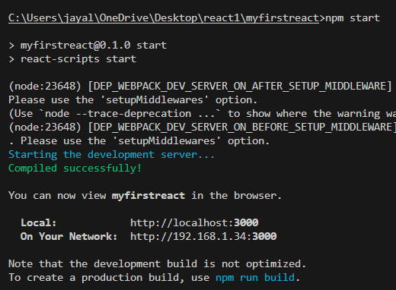

Output:
