ReactJS – Task2
[Submitted by: 231fa04341@gmail.com]

Objective:
To create a React-based Student Management Portal by creating and using multiple reusable components Home, About, and Contact and displaying their respective messages on the application page.
Steps:
1.Create a React project named “StudentApp”
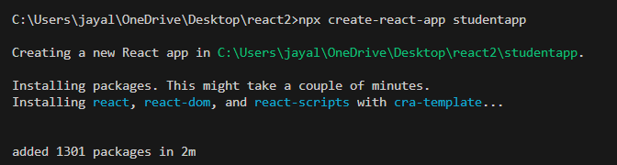

2.Create a new folder under Src folder with the name “Components”.Add a new file named Home.js, About.js, Contact.js:
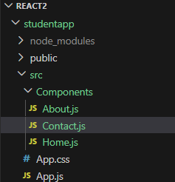
Home.js code:
import React, { Component } from 'react';
class Home extends Component {
render() {
return (
<div>
<h3>Welcome to the Home page of Student Management Portal</h3>
</div>
);
}
}
export default Home;
About.js code:
import React, { Component } from 'react';
class About extends Component {
render() {
return (
<div>
<h3>Welcome to the About page of the Student Management Portal</h3>
</div>
);
}
}
export default About;

Contact.js code:
import React, { Component } from 'react';
class Contact extends Component {
render() {
return (
<div>
<h3>Welcome to the Contact page of the Student Management Portal</h3>
</div>
);
}
}
export default Contact;

App.js code:
import './App.css';
import Home from './Components/Home';
import About from './Components/About';
import Contact from './Components/Contact';

function App() {
return (
<div>
<Home />
<About />
<Contact />
</div>
);
}

export default App;

3.Run the React Application

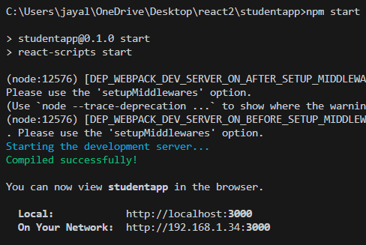

Output:
