ReactJS – Task3
[Submitted by: 231fa04341@gmail.com]
Objective
To create a React functional component that accepts student details and calculates and displays the student's average score with styling.
Steps:
1.Create a React project named “scorecalculatorapp”
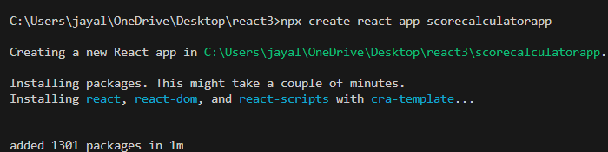
2.Create a new folder under Src folder with the name “Components”. Add a new file named “CalculateScore.js”
CalculateScore.js code:
import '../Stylesheets/mystyle.css';
const percentToDecimal = (decimal) => {
return (decimal.toFixed(2) + '%');
};

const calcScore = (total, goal) => {
return percentToDecimal(total / goal);
};

export const CalculateScore = ({ Name, School, total, goal }) => (
<div className="formatstyle">
<h1>Student Details:</h1>

<div className="Name">
<b>Name: </b>
<span>{Name}</span>
</div>

<div className="School">
<b>School: </b>
<span>{School}</span>
</div>

<div className="Total">
<b>Total: </b>
<span>{total} Marks</span>
</div>

<div className="Score">
<b>Score: </b>
<span>{calcScore(total, goal)}</span>
</div>
</div>
);

3.Create a new folder under Src folder with the name “Stylesheets”. Add a new file named “mystyle.css”
Mystyle.css code:
.Name {
font-weight: 300;
color: blue;
}

.School {
color: crimson;
}

.Total {
color: darkmagenta;
}

.formatstyle {
text-align: center;
font-size: large;
}

.Score {
color: forestgreen;
}

App.js code:
import { CalculateScore } from './Components/CalculateScore';
function App() {
return (
<div>
<CalculateScore
Name="Steeve"
School="DNV Public School"
total={284}
goal={3}
/>
</div>
);
}
export default App;

4.Executing the React Application
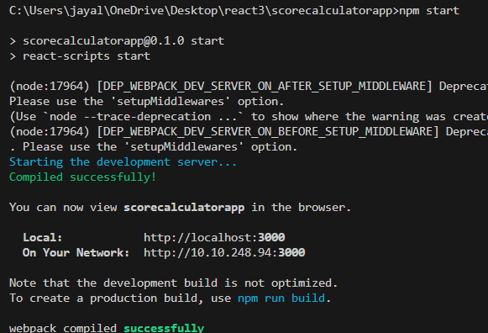

Output:
