ReactJS – Task4
[Submitted by: 231fa04341@gmail.com]
Objective
To understand the React component life cycle and implement the componentDidMount() and componentDidCatch() life cycle methods to fetch and display blog posts using the Fetch API.
Steps:
1.Create a new react application using create-react-app tool with the name as “blogapp”
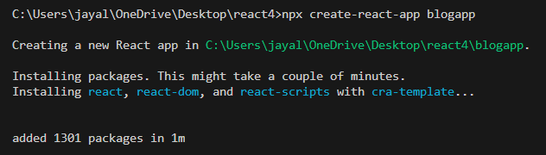
2.Create a new file named as Post.js in src folder with following properties
Post.js code:
class Post {
constructor(id, title, body) {
this.id = id;
this.title = title;
this.body = body;
}
}
export default Post;

3.Create a new class based component named as Posts inside Posts.js file
Posts.js code:
import React from 'react';
class Posts extends React.Component {
constructor(props) {
super(props);

this.state = {
posts: []
};
}

loadPosts() {
fetch('https://jsonplaceholder.typicode.com/posts')
.then(response => response.json())
.then(data => {
this.setState({
posts: data
});
});
}

componentDidMount() {
this.loadPosts();
}

componentDidCatch(error, info) {
alert('An error occurred while loading the posts.');
}
render() {
return (
<div>
{this.state.posts.map(post => (
<div key={post.id}>
<h2>{post.title}</h2>
<p>{post.body}</p>
</div>
))}
</div>
);
}
}
export default Posts;
App.js code:
import Posts from './Posts';
function App() {
return (
<div>
<Posts />
</div>
);
}
export default App;

4.Executing the React App
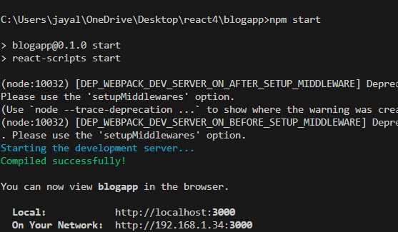
Output:
