ReactJS – Task5
[Submitted by: 231fa04341@gmail.com]
Objective
To style React components using CSS Modules and apply conditional styling based on cohort status.
Steps:
1.Unzip the react application in a folder
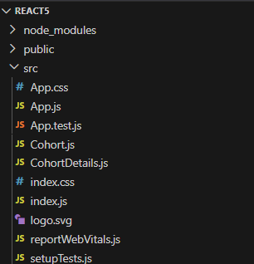
2.Restore the Node Packages
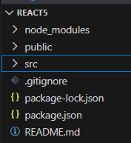
3.Create a new CSS Module in a file called “CohortDetails.module.css”
CohortDetails.module.css code:
.box {
width: 300px;
display: inline-block;
margin: 10px;
padding: 10px 20px;
border: 1px solid black;
border-radius: 10px;
}
dt {
font-weight: 500;
}

CohortDetails.js code:
import styles from './CohortDetails.module.css';
function CohortDetails(props) {
return (
<div className={styles.box}>
<h3
style={{
color: props.cohort.currentStatus === 'ongoing'
? 'green'
: 'blue'
}} >
{props.cohort.cohortCode} -
<span>{props.cohort.technology}</span>
</h3>

<dl>
<dt>Started On</dt>
<dd>{props.cohort.startDate}</dd>
<dt>Current Status</dt>
<dd>{props.cohort.currentStatus}</dd>
<dt>Coach</dt>
<dd>{props.cohort.coachName}</dd>
<dt>Trainer</dt>
<dd>{props.cohort.trainerName}</dd>
</dl>
</div>
);
}
export default CohortDetails;

4.Apply CSS Module styling to the cohort details, including <dt> font weight and conditional <h3> colors
CohortDetails.js code:
import styles from './CohortDetails.module.css';
function CohortDetails(props) {
return (
<div className={styles.box}>
<h3
style={{
color: props.cohort.currentStatus === 'Ongoing'
? 'green'
: 'blue'
}} >
{props.cohort.cohortCode} -
<span>{props.cohort.technology}</span>
</h3>

<dl>
<dt>Started On</dt>
<dd>{props.cohort.startDate}</dd>

<dt>Current Status</dt>
<dd>{props.cohort.currentStatus}</dd>

<dt>Coach</dt>
<dd>{props.cohort.coachName}</dd>

<dt>Trainer</dt>
<dd>{props.cohort.trainerName}</dd>
</dl>
</div>
);
}
export default CohortDetails;

Output:
