Git Branching and Merging Using Git Bash
[Submitted by: 231fa04341@gmail.com]
Objective
- Understand Git branching and merging.
- Create a new branch, make changes, merge it into the main branch, and delete the branch.
Steps
1.Open Git Bash and go to the project folder
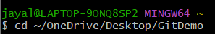
2.Create a new branch.
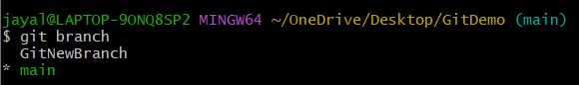
3.Switch to the new branch.
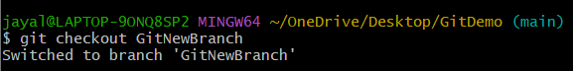
4.Create a file, add content, save it, then add and commit the changes.
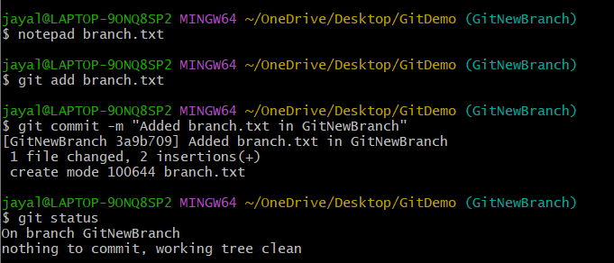
5.Switch back to the main branch.

6.View the differences between branches.
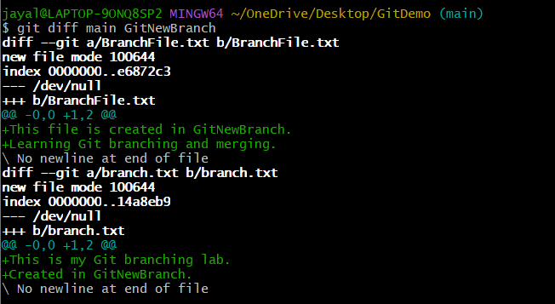
7.Merge the branch into the main branch.
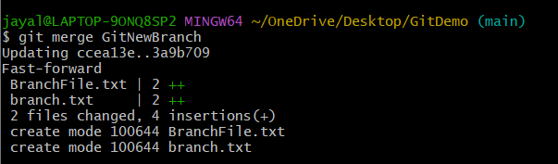
8.View the commit history.
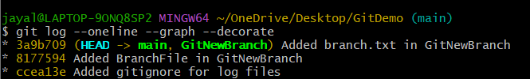
9.Delete the merged branch.
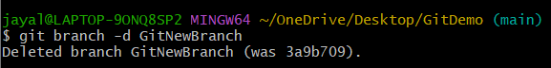
10.Check the final status.
