Git Merge Conflict Resolution
[Submitted by: 231fa04341@gmail.com]
Objective
- Learn how to resolve merge conflicts in Git.
- Create conflicting changes in two branches and merge them successfully.
Steps
1.Verify the repository is clean.
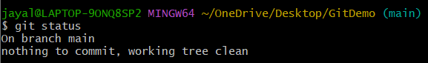
2.Create a new branch.
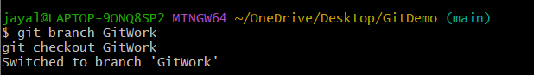
3.Create hello.xml.
4. Check the status.
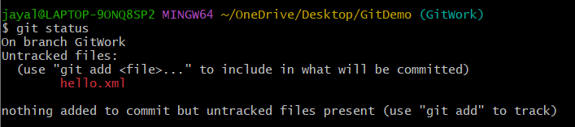
5.Add and commit.
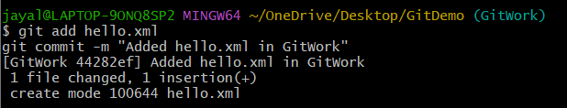
6.Switch to the main branch.
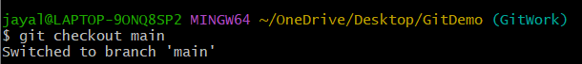

7.Create the same file with different content.
8.Commit it.
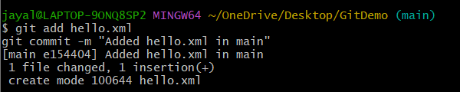
9.View the log
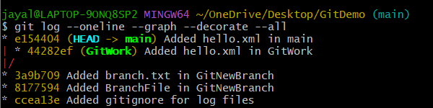
10.View differences
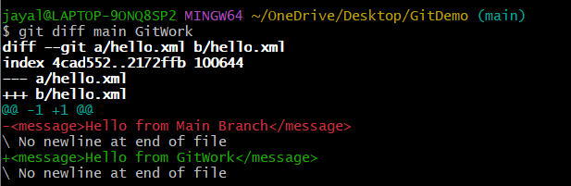
11.Merge the branch.
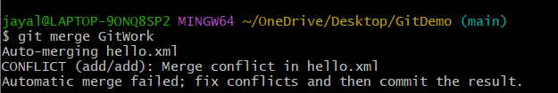
12.Commit the resolved merge.
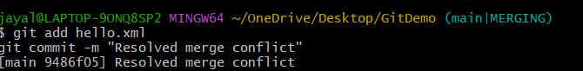
13.Check status
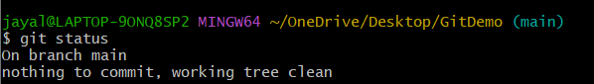
14.Add backup files to .gitignore
15.Save and commit
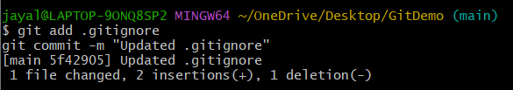
16.List branches.
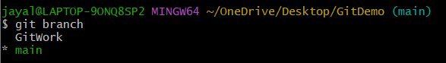
17.Delete the merged branch.
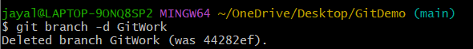
18.View the final log.
