ReactJs – Task13
[Submitted by: 231fa04341@gmail.com]
Objective:
To understand different methods of conditional rendering in React and display components based on conditions.
Steps
Step 1: Create Project
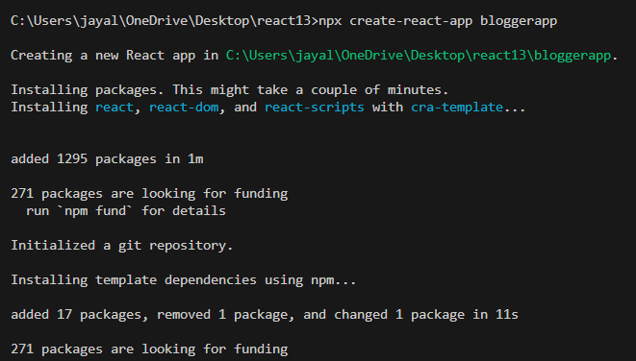
Step 2: App.js
import './App.css';
import BookDetails from './components/BookDetails';
import BlogDetails from './components/BlogDetails';
import CourseDetails from './components/CourseDetails';

function App() {
const books = [
{ id: 101, bname: "Master React", price: 670 },
{ id: 102, bname: "Deep Dive into Angular 11", price: 800 },
{ id: 103, bname: "Mongo Essentials", price: 450 }
];
const blogs = [
{ id: 1, title: "React Basics", author: "John" },
{ id: 2, title: "Understanding JSX", author: "David" },
{ id: 3, title: "React Hooks", author: "Smith" }
];
const courses = [
{ id: 1, cname: "React", fee: 5000 },
{ id: 2, cname: "Angular", fee: 4500 },
{ id: 3, cname: "Node JS", fee: 4000 }
];
return (
<div className="container">

<div className="box">
<h1>Book Details</h1>
<BookDetails books={books} />
</div>
<div className="box">
<h1>Blog Details</h1>
<BlogDetails blogs={blogs} />
</div>
<div className="box">
<h1>Course Details</h1>
<CourseDetails courses={courses} />
</div>
</div>
);
}

export default App;

Step 3: BookDetails.js

function BookDetails(props) {
let bookdet;
if (props.books.length > 0) {
bookdet = (
<ul>
{props.books.map((book) => (
<div key={book.id}>
<h3>{book.bname}</h3>
<h4>Price : {book.price}</h4>
</div>
))}
</ul>
);
} else {
bookdet = <h3>No Books Available</h3>;
}

return (
<div>
{bookdet}
</div>
);
}

export default BookDetails;

Step 4: BlogDetails.js

function BlogDetails(props) {
return (
<div>

{
props.blogs.length > 0 ?

props.blogs.map((blog) => (
<div key={blog.id}>
<h3>{blog.title}</h3>
<h4>{blog.author}</h4>
</div>
)) :

<h3>No Blogs Available</h3>

}

</div>
);
}

export default BlogDetails;

Step 5: CourseDetails.js

function CourseDetails(props) {
return (
<div>

{props.courses.length > 0 &&

props.courses.map((course) => (
<div key={course.id}>
<h3>{course.cname}</h3>
<h4>Fee : {course.fee}</h4>
</div>
))

}

</div>
);
}

export default CourseDetails;

Output:

