ReactJS – Task9
[Submitted by: 231fa04341@gmail.com]
Objective
- Define JSX.
- Understand ECMA Script (ES6).
- Learn React.createElement().
- Create React elements using JSX.
- Render JSX elements to DOM.
- Use JavaScript expressions in JSX.
- Apply inline CSS in JSX.
Steps
1.Create a React application named officespacerentalapp
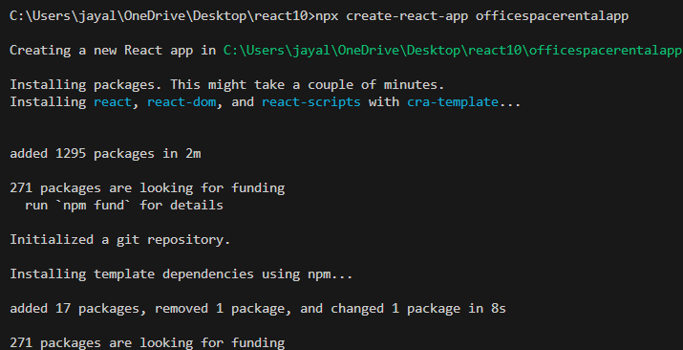

2.App.js code
import React from "react";
function App() {
const element = "Office Space";
const offices = [
{
Name: "DBS",
Rent: 50000,
Address: "Chennai",
Image: "https://images.unsplash.com/photo-1497366811353-6870744d04b2"
},
{
Name: "Tech Park",
Rent: 80000,
Address: "Bangalore",
Image: "https://images.unsplash.com/photo-1497366754035-f200968a6e72"
}
];
return (
<div>
<h1>{element}, at Affordable Range</h1>
{
offices.map((item, index) => {
let rentColor = "";
if (item.Rent < 60000) {
rentColor = "red";
}
else {
rentColor = "green";
}
return (
<div key={index}>

<img
src={item.Image}
width="25%"
height="25%"
alt="Office Space"
/>
<h2>Name: {item.Name}</h2>
<h3 style={{color: rentColor}}>
Rent: Rs. {item.Rent}
</h3>
<h3>
Address: {item.Address}
</h3>
</div>
);
})
}
</div>
);
}
export default App;

Output:

