ReactJS – Task11
[Submitted by: 231fa04341@gmail.com]
Objectives
- Explain React events.
- Explain event handlers.
- Define Synthetic events.
- Identify React event naming conventions.
Steps
1.Create React Application
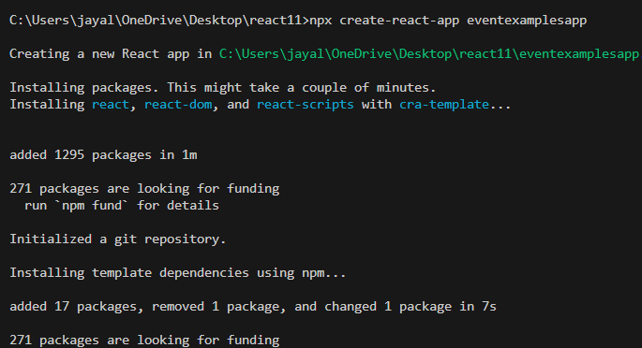
2.App.js code
import React, { Component } from "react";
import "./App.css";
class App extends Component {
constructor(props) {
super(props);
this.state = {
count: 0,
amount: "",
currency: ""
};
}
increment = () => {
this.setState({
count: this.state.count + 1
});

this.sayHello();
};
decrement = () => {
this.setState({
count: this.state.count - 1
});
};
sayHello = () => {
alert("Hello! Welcome to React Events");
};
welcome = (message) => {
alert(message);
};
handleSubmit = (event) => {
event.preventDefault();

let rupees = this.state.amount;
let euro = rupees / 90;

alert(
"Converting INR to Euro Amount is: " + euro
);
};

handleChange = (event) => {
this.setState({
[event.target.name]: event.target.value
});
};

render() {
return (
<div>
<h3>{this.state.count}</h3>
<button onClick={this.increment}>
Increment
</button>
<br/>
<button onClick={this.decrement}>
Decrement
</button>
<br/>
<button onClick={() => this.welcome("welcome")}>
Say Welcome
</button>
<br/>
<button onClick={this.sayHello}>
Click on me
</button>
<h1>Currency Convertor!!!</h1>
<form onSubmit={this.handleSubmit}>
<label>
Amount:
</label>
<input
type="text"
name="amount"
value={this.state.amount}
onChange={this.handleChange}
/>
<br/>
<label>
Currency:
</label>
<input
type="text"
name="currency"
value={this.state.currency}
onChange={this.handleChange}
/>
<br/>
<button type="submit">
Submit
</button>
</form>
</div>
);
}
}
export default App;

Output:

