ReactJS – Task9
[Submitted by: 231fa04341@gmail.com]
Objectives
- List the features of ES6
- Explain JavaScript let
- Identify the differences between var and let
- Explain JavaScript const
- Explain ES6 class fundamentals
- Explain ES6 class inheritance
- Define ES6 arrow functions
- Identify set(), map()
Steps
Step 1: Create React application
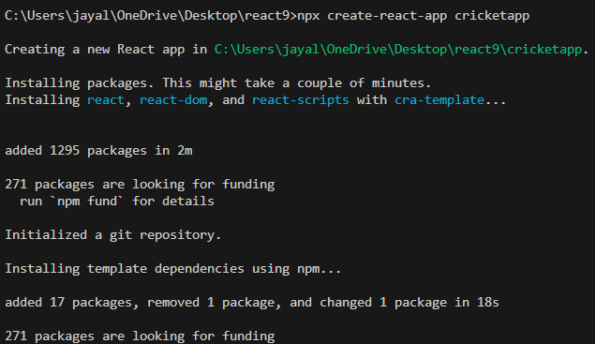

Step 2: Create Components
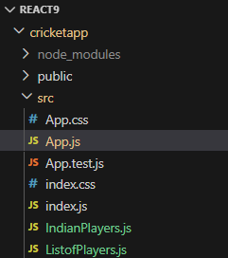
Step 3: Create ListofPlayers Component
ListOfPlayers.js code:
import React from "react";
function ListofPlayers(props) {
let players70 = [];
props.players.map((item) => {
if(item.score < 70)
{
players70.push(item);
}
});

return(
<div>
<h1>List of Players</h1>

{
props.players.map((item)=>
(
<div key={item.name}>
{item.name} - {item.score}
</div>
))
}

<hr/>

<h1>List of Players having Scores Less than 70</h1>
{
players70.map((item)=>
(
<div key={item.name}>
{item.name} - {item.score}
</div>
))
}

</div>
)
}

export default ListofPlayers;

Step 4: Create IndianPlayers Component

IndianPlayers.js code:
import React from "react";

function OddPlayers({first, third, fifth})
{
return(
<div>
<h2>Odd Players</h2>
<p>{first}</p>
<p>{third}</p>
<p>{fifth}</p>
</div>
)
}

function EvenPlayers({second, fourth, sixth})
{
return(
<div>
<h2>Even Players</h2>
<p>{second}</p>
<p>{fourth}</p>
<p>{sixth}</p>
</div>
)
}

function ListofIndianPlayers({IndianPlayers})
{
return(
<div>

<h2>List of Indian Players Merged</h2>

{
IndianPlayers.map((player)=>
(
<p>{player}</p>
))
}

</div>
)
}

function IndianPlayers()
{

const IndianTeam =
[
"First Player",
"Second Player",
"Third Player",
"Fourth Player",
"Fifth Player",
"Sixth Player"
];
const T20Players =
[
"Rohit",
"Virat",
"Dhoni"
];
const RanjiTrophyPlayers =
[
"Rahul",
"Gill",
"Jadeja"
];
const IndianPlayers =
[
...T20Players,
...RanjiTrophyPlayers
];
return(
<div>

<h1>Indian Team</h1>

<OddPlayers
first={IndianTeam[0]}
third={IndianTeam[2]}
fifth={IndianTeam[4]}
/>

<EvenPlayers
second={IndianTeam[1]}
fourth={IndianTeam[3]}
sixth={IndianTeam[5]}
/>
<hr/>
<ListofIndianPlayers
IndianPlayers={IndianPlayers}
/>
</div>
)
}
export default IndianPlayers;

App.js code:

import React from "react";
import ListofPlayers from "./ListofPlayers";
import IndianPlayers from "./IndianPlayers";
function App()
{
let flag=false;
let players =
[
{name:"Sachin",score:95},
{name:"Dhoni",score:85},
{name:"Virat",score:90},
{name:"Rohit",score:65},
{name:"Rahul",score:55},
{name:"Hardik",score:75},
{name:"Jadeja",score:60},
{name:"Bumrah",score:80},
{name:"Pant",score:50},
{name:"Gill",score:68},
{name:"Shami",score:45}
];
if(flag===true)
{
return(
<div>
<ListofPlayers players={players}/>
</div>
)
}

else
{
return(
<div>
<IndianPlayers/>
</div>
)
}
}
export default App;

Output:
