Web Api CRUD operation
[Submitted by: 231fa04341@gmail.com]

Objective
To implement an ASP.NET Core Web API PUT action method that updates employee information using the [FromBody] attribute, validates the employee ID, and tests the API using Postman.
Steps:
1.Create the Employee Model
Employee.cs code:
namespace CrudDemo.Models
{
public class Employee
{
public int Id { get; set; }

public string Name { get; set; } = string.Empty;

public string Department { get; set; } = string.Empty;

public double Salary { get; set; }
}
}

Create EmployeeController
EmployeeController.cs code:
using Microsoft.AspNetCore.Mvc;
using CrudDemo.Models;
namespace CrudDemo.Controllers
{
[ApiController]
[Route("api/[controller]")]
public class EmployeeController : ControllerBase
{
private static List<Employee> employees = new List<Employee>
{
new Employee { Id = 1, Name = "John", Department = "IT", Salary = 50000 },
new Employee { Id = 2, Name = "Alice", Department = "HR", Salary = 45000 },
new Employee { Id = 3, Name = "David", Department = "Finance", Salary = 55000 }
};

[HttpPut("{id}")]
public ActionResult<Employee> UpdateEmployee(int id, [FromBody] Employee employee)
{
if (id <= 0)
{
return BadRequest("Invalid employee id");
}

var existingEmployee = employees.FirstOrDefault(e => e.Id == id);

if (existingEmployee == null)
{
return BadRequest("Invalid employee id");
}

existingEmployee.Name = employee.Name;
existingEmployee.Department = employee.Department;
existingEmployee.Salary = employee.Salary;

return Ok(existingEmployee);
}
}
}

Program.cs code:
var builder = WebApplication.CreateBuilder(args);

builder.Services.AddControllers();

var app = builder.Build();

app.UseHttpsRedirection();

app.MapControllers();

app.Run();

Implement the PUT Action Method

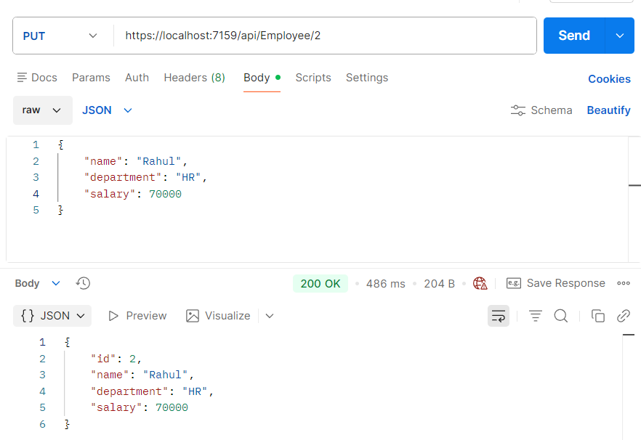

Checks whether the employee ID is valid
