Git Clean Up and Push to Remote Repository
[Submitted by: 231fa04341@gmail.com]
Objective
- Verify the repository is in a clean state.
- Pull the latest changes and push local changes to the remote Git repository
Steps:
1.Check the repository status
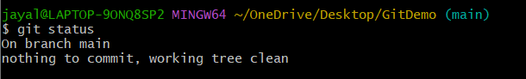
2.List all branches.
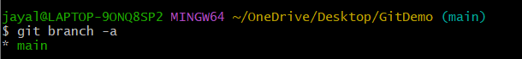
3.Pull the latest changes.
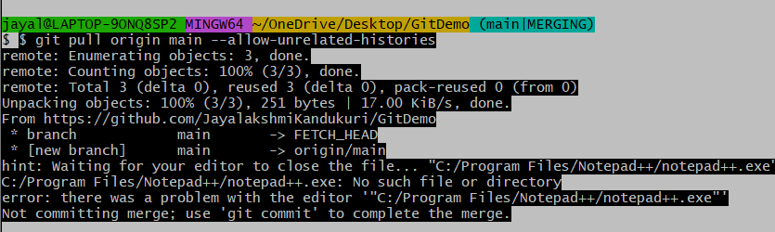
4.Complete the merge
5.Push the changes to GitHub.
git push -u origin main

