Microservices – JWT
[Submitted by: 231fa04341@gmail.com]
Objective:
To implement JWT-based authentication in an ASP.NET Core Web API and secure API endpoints using the [Authorize] attribute.
Steps:
1.Create a new ASP.NET Core Web API project named MicroServices.
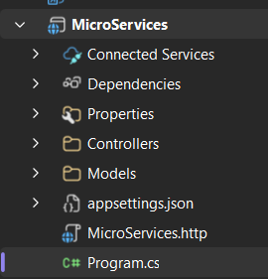
2.Installing dotnet add package Microsoft.AspNetCore.Authentication.JwtBearer
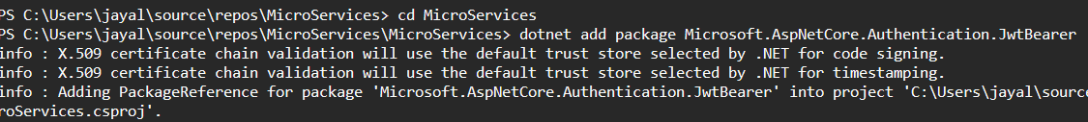
3.Add the JWT settings in appsettings.json and configure JWT authentication and authorization in Program.cs.
4.Create Login Model and AuthController
LoginModel.cs code:
namespace MicroServices.Models
{
public class LoginModel
{
public string Username { get; set; } = string.Empty;

public string Password { get; set; } = string.Empty;
}
}
AuthController.cs code:
using Microsoft.AspNetCore.Mvc;
using Microsoft.IdentityModel.Tokens;
using System.IdentityModel.Tokens.Jwt;
using System.Security.Claims;
using System.Text;
using MicroServices.Models;

namespace MicroServices.Controllers
{
[ApiController]
[Route("api/[controller]")]
public class AuthController : ControllerBase
{
private readonly IConfiguration _configuration;

public AuthController(IConfiguration configuration)
{
_configuration = configuration;
}

[HttpPost("login")]
public IActionResult Login(LoginModel model)
{
if (model.Username == "admin" &&
model.Password == "password123")
{
var token = GenerateJwtToken(model.Username);

return Ok(new
{
Token = token
});
}

return Unauthorized("Invalid username or password");
}

private string GenerateJwtToken(string username)
{
var claims = new[]
{
new Claim(ClaimTypes.Name, username)
};

var key = new SymmetricSecurityKey(
Encoding.UTF8.GetBytes(
_configuration["Jwt:Key"]!
)
);

var credentials = new SigningCredentials(
key,
SecurityAlgorithms.HmacSha256
);

var token = new JwtSecurityToken(
issuer: _configuration["Jwt:Issuer"],
audience: _configuration["Jwt:Audience"],
claims: claims,
expires: DateTime.UtcNow.AddMinutes(
Convert.ToDouble(
_configuration["Jwt:DurationInMinutes"]
)
),
signingCredentials: credentials
);

return new JwtSecurityTokenHandler()
.WriteToken(token);
}
}
}

SecureController.cs code:
using Microsoft.AspNetCore.Authorization;
using Microsoft.AspNetCore.Mvc;
namespace MicroServices.Controllers
{
[ApiController]
[Route("api/[controller]")]
public class SecureController : ControllerBase
{
[HttpGet]
[Authorize]
public IActionResult GetSecureData()
{
return Ok("You are authorized to access this endpoint.");
}
}
}

5. Test Using Postman
