# ModularFPS: JSON-Driven C++ First Person Shooter

An Unreal Engine 5.6.0 FPS built in C++ that dynamically spawns, colors, and tracks damageable boxes based on JSON data. Includes score and destruction pop-ups, and scalable game logic.

---

## 🚀 Overview / Highlights

- 💡 Fetches box definitions from online JSON

- 🎨 Spawns color-customized boxes with variable health and score

- 🔫 Implements line trace shooting and box damage logic

- 🧠 Updates on-screen score UI and shows destruction popups

- 🧱 Fully written in C++, Blueprint-extensible and modular

---

## 🔧 System Logic

### Components:

- **JsonDataManager**: Fetches and parses JSON into C++ structs

- **JsonBoxActor**: Represents in-world boxes with health, color, and score

- **JsonDataManager**: Spawns boxes and tracks score

- **ShooterPlayerController**: Instantiates and manages UI widgets

- **UI Widgets**: Score display and destruction pop-up using `UUserWidget`

### Flow:

1. JsonDataManager fetches data → parses into structs ( MyData )

2. For each entry:

- Matches `type` to a box blueprint

- Initializes its transform, health, score, and color

3. On damage:

- Box reduces health

- If zero: adds score, triggers destruction pop-up, destroys actor

---

## 🧪 Challenges Faced

- Parsing nested arrays from JSON (`[R, G, B]` to `FColor`)

- Implementing json logic so it can be future proof

- Binding UI widgets in C++ without Blueprint errors

---

## 📈 Scalability

- ✅ **Modular Codebase**: Separated folders for header and .cpp ,JSON, box logic, and UI

-Naming json on every file which drive data so it can easy to implement if new logic is given

- 💾 **Flexible Data Source**: Change or extend JSON schema without structural code edits

- 🧩 **Expandable Actor Logic**: Easily add more box types or mechanics (e.g. powerups, moving platforms)

- 🎯 **UI Extensibility**: Add custom panels, kill feed, health effects, or animations

---

## 🔍 How to Test the Features

1. ✅ Launch game in editor

2. 📦 Verify boxes spawn at positions from JSON

3. 🔫 Shoot boxes:

- Health drops visibly

- Score updates on screen

- Destruction widget appears

4. 🧠 Simulate offline mode: verify failure logs when JSON fetch fails

---

## 🖼️ Screenshots

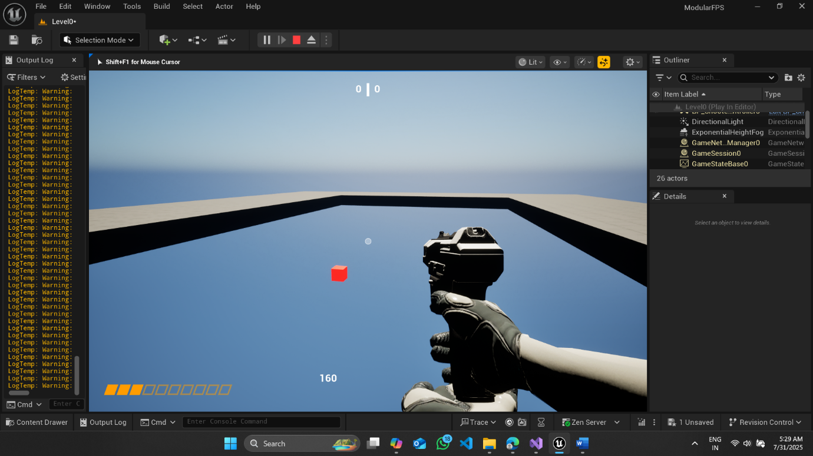

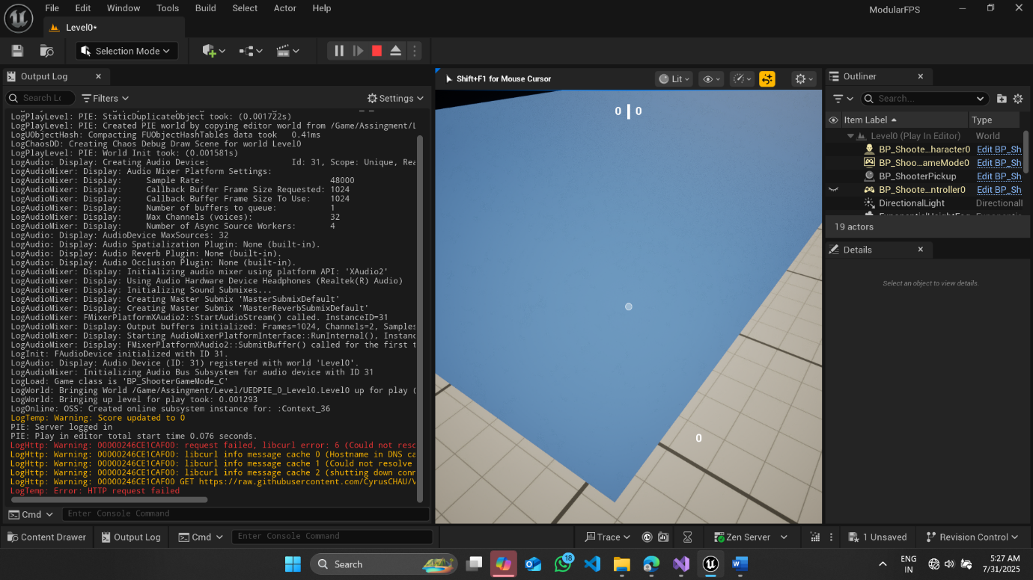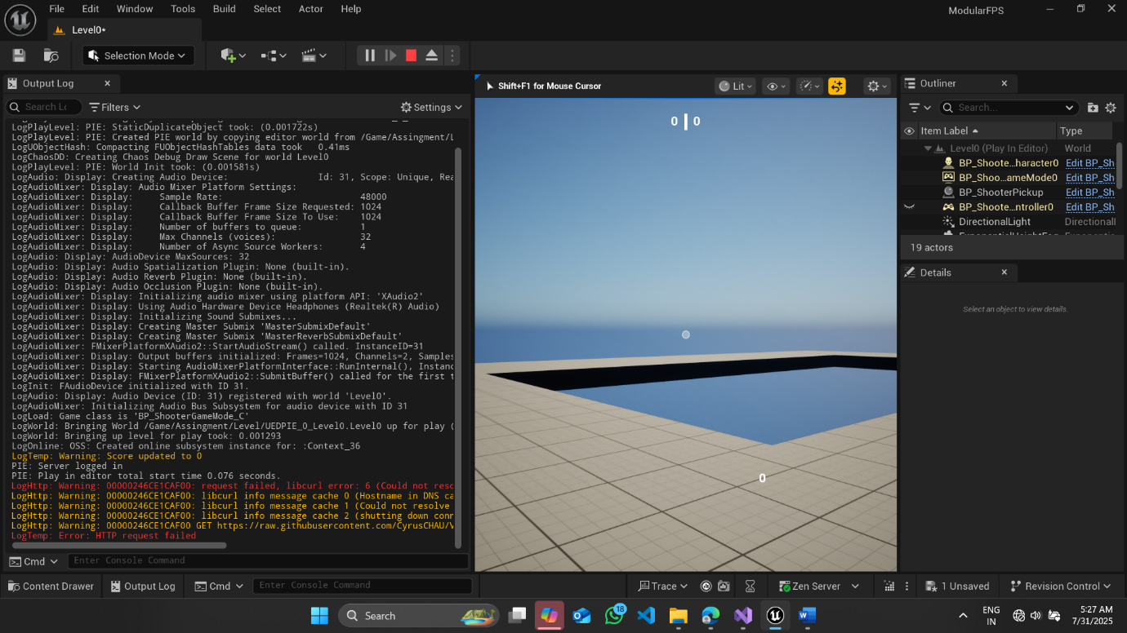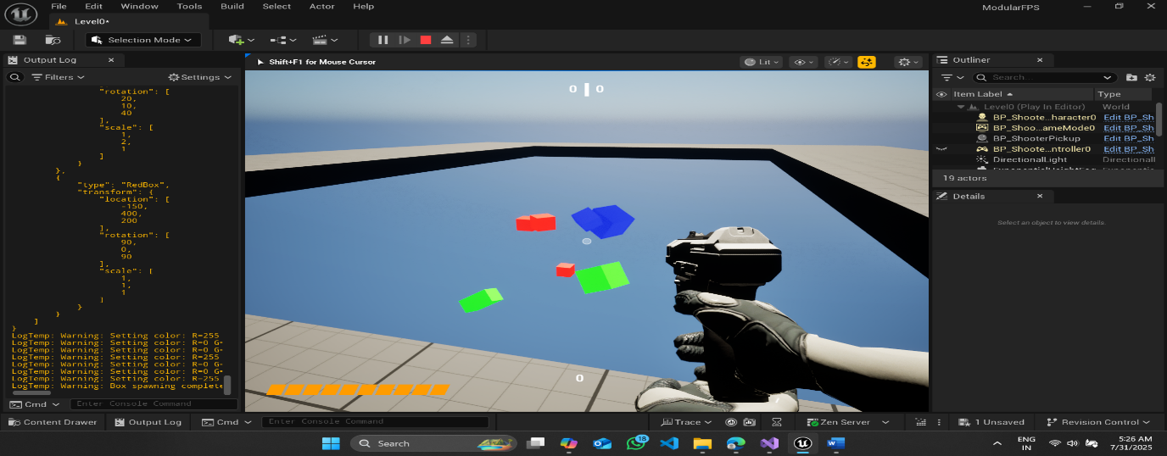

## 👤 Contributors

**Jayam Shukla** — System Designer & Developer