
School of Computing and Engineering

National Institute of Business Management

Kandy

Higher National Diploma in Software Engineering

HNDSE 25.1F

AgroSmart: -

An IoT-Based Smart Precision Agriculture System with

Cloud Monitoring and Multi-Sensor Control
Internet of Things – Proposal
Prepared by (Group 05) -
- A.J. Narampanawa – KAHDSE25.1F-005
- I. S. P. Kularathne – KAHDSE25.1F-007
- R. M. M. B. Rathnayake – KAHDSE25.1F-009
- H. M. A. Rajamanthri – KAHDSE25.1F- 032
Prepared for –
Mr. H. M. H. T. Hikkaduwa
Date of Submission – 11/01/2026

Declaration
We, the undersigned, hereby declare that this proposal report for AgroSmart: IoT-Based Smart Precision Agriculture System with Cloud Monitoring and Multi-Sensor Control has been prepared by us (Group 05) as part of a group coursework for Internet of Things at National Institute of Business Management Kandy.
We confirm that:
- The work presented is our own and has not been submitted previously for any other academic award.
- All sources of information, ideas, and data from other authors have been properly cited and referenced.
- The project is carried out in accordance with the institution’s academic integrity policies.
We take full responsibility for the content and authenticity of this report.
Group Members –
- A.J. Narampanawa – KAHDSE25.1F-005
- I. S. P. Kularathne – KAHDSE25.1F-007
- R. M. M. B. Rathnayake – KAHDSE25.1F-009
- H. M. A. Rajamanthri – KAHDSE25.1F- 032

Mr. H. M. H. T. Hikkaduwa,
Consultant/ Lecturer Kandy Branch,
National Institute of Business Management
Date - 11/01/2026

Abstract
This project, AgroSmart: IoT-Based Smart Precision Agriculture System with Cloud Monitoring and Multi-Sensor Control, aims to develop a smart agriculture monitoring system integrated with a precision agriculture module to assist farmers in making data-driven decisions. The system collects real-time environmental data including temperature, humidity, soil moisture, light intensity, and water levels using IoT sensors connected to an ESP32 microcontroller. Data is uploaded to a cloud platform (Firebase) and visualized through a web and mobile dashboard.
The Smart Precision Agriculture module analyzes collected data using AI and machine learning algorithms to provide actionable insights, such as optimal irrigation schedules, crop selection recommendations, and predictive trends for seasonal climate variations. The project is initially focused on the Kandy region in Sri Lanka but is designed to be modular and expandable for additional sensors and features in the future.
The outcomes of this project demonstrate the potential of combining IoT, cloud computing, and AI for efficient resource management and sustainable agricultural practices. This project is carried out as a group coursework and provides both practical implementation and academic insights into smart farming technologies.

Acknowledgement
We would like to express our sincere appreciation to everyone who supported and contributed to the successful completion of this group coursework. First and foremost, we extend our gratitude to our lecturer for the Statistics for Computing module for the guidance, constructive feedback, and continuous support provided throughout the study. The knowledge and direction offered were invaluable in shaping this research.
We would also like to thank our university for providing the academic resources and learning environment necessary to carry out this coursework. Our sincere thanks go to all the IT professionals who participated in the survey and willingly shared their time and responses, which formed the foundation of this study.
Finally, we would like to acknowledge the cooperation, dedication, and teamwork of all group members. The collective effort, mutual support, and shared responsibility within the group were essential in successfully completing this coursework.
Table of Contents
Declaration ii
Abstract iii
Acknowledgement iii
Executive Summary 1
Project Background 2
Project Aim and Objectives 3
Project Aim 3
Project Objectives 3
Scope of the Project 4
Methodology 5
System Phases 5
1. Hardware Layer: 5
2. Data Collection: 5
3. Data Analysis & AI/ML Module: 5
4. Dashboard and Mobile Application: 5
5. Testing & Validation: 5
Tools and Technologies 6
Project Deliverables 7
Timeline 8
References 9
Appendices 10

Executive Summary
AgroSmart is an IoT-based Smart Agriculture Monitoring System integrated with a Smart Precision Agriculture Module designed to assist farmers by providing real-time environmental monitoring and AI-based actionable insights. The system will monitor temperature, humidity, soil moisture, light intensity, and water levels using a network of sensors connected to an ESP32 microcontroller. Data will be uploaded to the Firebase cloud and displayed on a web and mobile dashboard.
The project aims to improve irrigation efficiency, optimize crop selection, and predict seasonal trends using AI/ML analysis of collected sensor data. AgroSmart will serve as a modular platform, allowing additional features and sensors to be integrated in the future.
Expected outcomes include:
- Real-time environmental data collection
- Cloud-based visualization dashboard and mobile application
- AI/ML-assisted recommendations for irrigation and crop selection
- Academic documentation, including reports and presentations

Project Background
Agriculture in regions like Kandy, Sri Lanka, faces multiple challenges, including inefficient water usage, unpredictable weather patterns, and reduced crop yield. Traditional farming methods lack real-time monitoring and predictive insights, resulting in water wastage, crop loss, and lower productivity.
With the advancement of IoT, cloud computing, and AI, it is now possible to monitor environmental factors in real-time, analyze data, and provide actionable recommendations. Implementing a Smart Agriculture Monitoring System can help farmers make data-driven decisions, optimize water usage, improve crop yields, and reduce resource waste.
The motivation behind AgroSmart is to develop an academic-level prototype that demonstrates the potential of IoT and AI in precision agriculture while providing a foundation for future enhancements.

Project Aim and Objectives

Project Aim
To develop a Smart Agriculture Monitoring System integrated with a Smart Precision Agriculture module that collects real-time environmental data, analyzes it using AI/ML, and provides actionable insights for farmers.

Project Objectives
- Design and implement an IoT sensor network including:
- Temperature & Humidity Sensor (DHT11)
- Soil Moisture Sensors (Capacitive & Normal)
- Light Intensity Sensor (LDR/MH-LDR)
- Ultrasonic Sensor for water level detection
- Relay-controlled pump for smart irrigation
- Collect real-time data and store it on the Firebase cloud platform
- Develop a dashboard and mobile application for visualization of sensor data
- Integrate AI/ML algorithms to provide:
- Irrigation recommendations based on humidity and soil moisture
- Crop selection suggestions
- Seasonal climate trends and predictive insights
- Automate irrigation based on analyzed sensor data
- Ensure modular system design to allow future integration of additional sensors or features

Scope of the Project
- Target a specific area: Kandy, Sri Lanka, for initial implementation
- Monitor environmental parameters: temperature, humidity, soil moisture, light intensity, water levels
- Provide actionable insights for farmers including:
- Optimal irrigation schedule
- Crop selection recommendations
- Predictions of climate and soil trends
- Modular and expandable system for additional sensors or AI modules
- Academic scope: real-time IoT system and AI-based recommendation system
- Focused on proof-of-concept, not large-scale industrial deployment

Methodology

System Phases

Hardware Layer:
- ESP32 microcontroller as the main controller
- Sensors: DHT11, soil moisture, LDR, ultrasonic
- Relay module and water pump for automated irrigation
- Proper power management: 3.3V for low-voltage sensors, 5V external supply for pumps and high-voltage sensors

Data Collection:
- Sensors collect real-time environmental data
- ESP32 uploads data to Firebase Realtime Database

Data Analysis & AI/ML Module:
- Analyze environmental data for irrigation and crop recommendations
- Predict soil moisture trends, humidity patterns, and optimal crop selection
- AI/ML approach:
- Supervised learning if historical labeled data is available
- Unsupervised learning for pattern detection if unlabeled data

Dashboard and Mobile Application:
- Visualize sensor readings in real-time
- Display recommendations and alerts
- Allow remote monitoring of irrigation status

Testing & Validation:
- Test sensors individually and in combination
- Calibrate soil moisture thresholds and water tank levels
- Validate AI predictions using sample datasets

Tools and Technologies
- Microcontroller: ESP32
- Sensors: DHT11, Capacitive/Normal Soil Moisture, LDR, Ultrasonic
- Cloud Platform: Firebase Realtime Database
- AI/ML: Python, TensorFlow / scikit-learn
- Dashboard / App: Web technologies (HTML/CSS/JS) or Flutter for mobile

Project Deliverables
- Hardware Prototype: ESP32 + sensor network + relay/pump system
- Software Module: Cloud-based data storage, web dashboard, mobile app
- AI/ML Module: Data analytics and recommendations for irrigation and crop selection
- Reports & Documentation: Proposal report, final report
- Presentations: Proposal, progress updates, final presentation

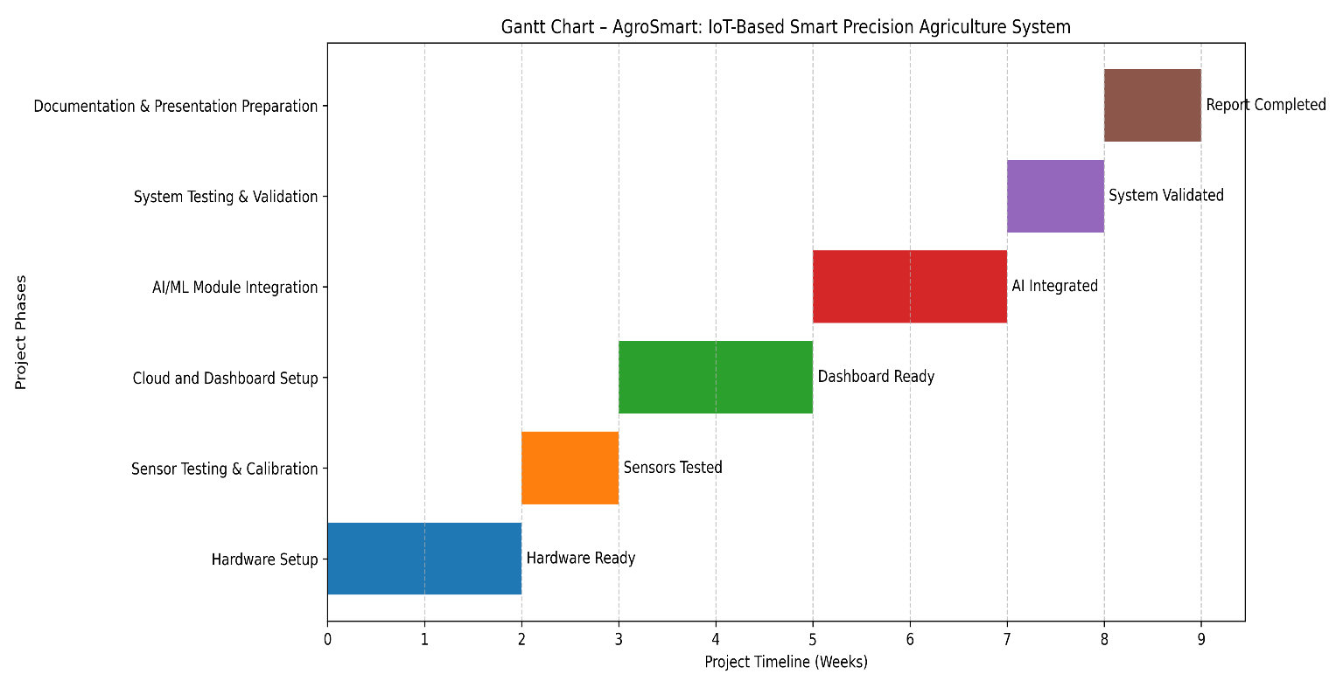
Timeline

Phase | Duration
Hardware setup | 2 weeks
Sensor testing & calibration | 1 week
Cloud and dashboard setup | 2 weeks
AI/ML module integration | 2 weeks
System testing & validation | 1 week
Documentation & presentation preparation | 1 week

References
- Adnan, M., & Smith, J. (2021). IoT applications in precision agriculture. Journal of Smart Farming, 12(3), 45–60.
- Firebase. (2026). Firebase Realtime Database. Retrieved from https://firebase.google.com
- Espressif Systems. (2026). ESP32 Documentation. https://www.espressif.com
- Zhang, L., & Kumar, A. (2020). AI-driven smart irrigation systems: A review. Agricultural Engineering Journal, 15(2), 110–125.

Appendices
- Hardware Block Diagram: ESP32 connected to sensors, relay, and pump
- System Architecture Diagram: Data flow from sensors → ESP32 → Firebase → AI module → Dashboard
- Sample Sensor Data Table: Example readings for temperature, humidity, soil moisture, light intensity
- Additional Figures/Charts: Sensor calibration charts, optional images of sensors

