Quiz-week-5

1. Directory ‘diry’ has 3 files inside listed here: **$HOME/dirx/diry**

**-filex**

**-filey**

**-filez**

1. Write a command to make a directory called ‘new-dir’ in your $HOME directory.

**$mkdir ~/new-dir**

1. Write a command to copy all files from ‘diry’ into the new directory called ’new-dir’ you just created in your home directory. Assume that you are in your home directory.

**$cp -r dirx/diry/f* new-dir**

1. Write a command to rename the ‘diry’ to dir-yy

**$mv dirx/diry dirx/dir-yy**

1. Give the command to create a hard link from a file called ‘filex’.

**$In filex hl_filex**

1. Give the command to create a symbolic link from filex to a new file called ‘sym-filex’
   1. **$In -s filex sym-filex**
2. Change the permission of dir-yy so that the owner of the directory has rwx, r-x for the group, and --- for others.
   1. **$ chmod 750 dir-yy**
3. Set the UID bit on the below script file with the following content.

**$ vi sayit**

**--------------**

#!/bin/bash

echo `date`

echo “how are you”

**--------------**

* 1. Change the permissions of the script file ‘sayit’ to 755.

**chmod 755 sayit**

* 1. Set the UID bit on the file script file called ‘sayit’.

**chmod u+s sayit**

**chmod 4755 sayit**

1. Show how you set your PATH so that your path will have the following directories. **/usr/bin:/usr/sbin:$HOME/bin**

**(export PATH=$PATH:/usr/bin:/usr/sbin:$HOME/bin <- this is to add to the path)**

PATH=”/usr/bin:/usr/sbin:$HOME/bin”

PATH=’/usr/bin:/usr/sbin:/home/cs45aa15/bin’ (need to specify the $HOME directory path when using the single quotes

1. Set the PATH in your **$HOME/.bashrc** file so that it will always be active when you first log onto the system.

Add this command “**export PATH=$PATH:/usr/bin:/usr/sbin:$HOME/bin” in to this file $HOME/.bashrc** file.

1. Make a directory in your home directory called ‘test-data’
   1. **$mkdir ~/test-data**
   2. Copy all files from the /etc directory that begins with the letter ‘p’ followed by the letter ‘r’ followed any other characters to your $HOME/test-data

**$cp -r /etc/pr* ~/test-data**

* 1. What is the size of the data in your test-data directory. Use the ‘du’ command with the proper options all the sizes of the files and also the total space used by the directory.

**$du -sh test-data**

2. Given a directory called ‘diry’ and a file called ‘filex’, please answer the following questions.

1. Write a test command to test if ‘diry’ is a directory
   1. **$test -d diry**

**$echo $?**

The return of ‘echo $?’ will be 0 if ‘diry’ is a directory

1. Write a test command to test if ‘filex’ is a file.

**$test -f filex**

**$echo $?**

The return of ‘echo $?’ will be 0 if ‘filex’ is a file.

1. Write a test command to test if filex is ‘executible’ . If so, include a logical AND ( &&) clause that echo “Yes - filex is a executable”

**$test -x filex && echo “Yes - filex is a executable”**

1. Write a test command to test if filex has a size greater than ‘zero’.

**$test -s filex && echo “Yes – filex is greater than zero”**

1. A file system _inode number_ is allocated every time you create a file.

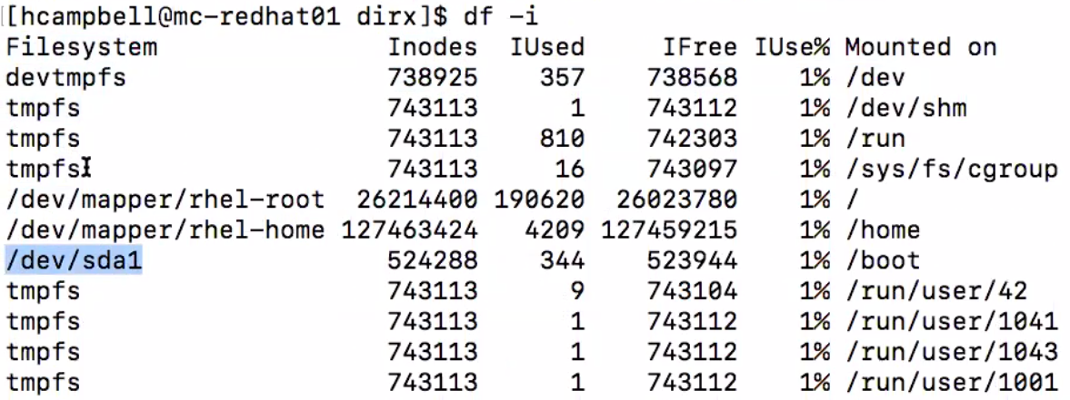

* When a new file is created in any one of these filesystems the ‘IUsed’ of that filesystem increase by one and ‘IFree' number decrease by one.