Instructions for ACL-2018 Proceedings
Abstract
Within this project, a dataset [7], was taken from PAN where a series of scientific events and shared tasks a shared on digital text forensics and stylometry. The dataset contains 48,335 twitter user profiles with 2,181 tweets average per user. Many classifiers were compared and evaluated using K-fold cross validation in addition to many metrics with the use of a validation set. After contrasting many preprocessing methods and classifiers an ensemble was made of the highest performing methods, achieving a XX% accuracy for gender and a XX% accuracy for BirthYear.
- Introduction
Natural language processing is a complex task, one project that has been attempted many times is author profiling [1,2,3]. Author Profiling is a method of analysing a set of texts in order to identify various characteristics of the author, in this particular project, the research question that will be addressed is; ‘Can Age and Gender be inferred from Social Media Posts?’, the two key characteristics that will be determined within the author profiling are birth year and gender.
Author profiling is of key importance in forensic linguistics, marketing and data protection [1,9]. The use of NLP in order to identify a person’s age and gender can be used to prevent child groomers in online chat rooms, in addition to this, new data protection laws introduce a barrier to the information marketers have on the average consumer, however if a user’s age or gender can be inferred from their social media posts, advertisers could use this for targeted marketing. People who are close in age have similar interests, and as a result have similar age-related life events, using this logic, the tweets of a person aged 20 should be closer to someone within 5 years of them as opposed to a person 10 years away from them. Similarly with gender, language features, which are words or phrases used in texts such as metaphors, alliteration and oxymorons are gender-preferential, as opposed to being exclusive to one sex [4]. An example of this being the responses of men and women, both men and women provide minimal responses when listening to a speaker however the context, timing and frequency of the responses vary with gender [5, 6]. However, it is also noted that people of the same gender use different gender preferential features than other members of the same gender, an example of this being members of the same gender such as men speaking in long utterance lengths, whereas other men may use a high number of insults and aggressive utterences, this highlights the challenge of differentiating between genders. Language is always changing, evolving and adapting to the needs of it’s users, and differentiating people’s age based on social media posts can be a challenge due to a person’s age constantly changing along with a persons speech evolving as time goes on. As opposed to identifying a person’s age, as this is relative to the time an age is queried, the birth-year of each user will be predicted instead. In addition to this, a user’s gender will be also predicted, which will be binary result; either male or female in order to answer the question; Can Age and Gender be predicted using text obtained from Social Media posts?
- Related Work
In [1], author profiling was achieved by studying sociolect aspect, which is how language is shared by people. A blog corpus was used with N-grams of POS tags in documents, punctuation symbols and number of links with an SVM was used to determine unknown author’s age and gender that achieved a 64.30% accuracy with age and a 64.73% accuracy for gender. In [1], the only metric that was used for classification evaluation was accuracy, and the data was unevenly distributed with a significantly larger proportion of the corpus coming from ages 25 and above. In [2] a corpus of chat texts was collected from a Belgian social networking site called Netlog. The text was tokenized and the feature set was limited by token and character features only, the feature sets were built by selecting features with the highest χ2 value and an SVM classifier was used to classify age which achieved an accuracy of 71.3%, and when classifying age and gender an accuracy of 66.3% was achived on their whole dataset, it was found that token features outperformed character features in each age classification task. This paper achieved a highest accuracy score of 88.8%, precision score of 91.5%, recall score of 92.9% and best F-score of 91.7% for the adult class of a smaller subset of data. This paper tested the models on data taken from the same site the model was trained on and although the accuracies achieved were 88% and above the data used was non-standard language specific to the Netlog site written by users in Belgium with access to Netlog specific emojis.
A study was conducted [3] where particapants analysed a text that was 50 words long regarding a gender neutral topic, each text had small changes made to them in order to create a male version and a female version of the text and each particapant had to identify 3 different texts as either male or female. It was found that participants could correctly discriminate gender of users, on the basis of linguistic-style when other cues to gender were absent, highlighting the importance of lingustic-style when identifying gender.
- Data
Within this project, tweets from a user’s twitter page was gathered and seperated by gender, and birth year. All of the data that was used in this project originated from PAN [7]. In order to obtain a representitive sample, it was ensured the dataset that was selected contained tweets that were gathered from USA, Australia, UK and Canada. Obtaining a large dataset that contained verified birth-year and gender tags for a series of text proved very challenging, however the data sourced in this project [7], was deemed suitable for the question proposed, as it contains 48,335 user profiles, with verified birth-year and gender tags, and the number of associated tweets contained with each profile are of significant length. However, it is noted that this study is limited by the countries and areas that were selected to gather data from, in addition to the fact that this project has a focus on only tweets written in English. This is a limitation due to the fact that the composure of tweets by Men and Women of different ages may significantly vary when writing in different languages and further inferences could be gained from this information which could significantly improve the models used. Due to many people falsifying their age on social media [CITE] the majority of data that was collected from twitter was from users that were verified on twitter [CITE], all of the data was from celebrities, this ensured the data used to train the models was an accurate representation of text written by the associated age and gender. It is also noted that this data is from celebrities with fame ranging from rising, star and superstar, although the fame level is varied, this dataset is limited by only the tweets that celebrities post, an
d not how the average non-celebrity may tweet. Another limitation is the the fact that this textual data is only from users that have a twitter account, the models used have not been exposed to text outside of twitter, in addition to this, each tweet can have a maximum of 180 chars, which will influence how people write posts on twitter, and hence influence the classifiers used.

- Exploratory Data Analysis

Here, exploratory data analysis has been carried out in order to discover and identify patterns, spot anomalies, check the class distribution and check any assumptions made by producing summary statistics and simple, easily interpret able graphs. Looking at FIGUREXX it is clear that there is an uneven representation of users aged below 1940 and above 2000, this could be explained due to the fact if someone was born in 1940 that would make them 79 and if someone was born in 2000, that would make them 19. Both of these ages are unlikely to be using twitter in the current day, due to 79 year old’s being less likely to use technology and 19 year olds finding twitter to be ‘outdated’ [CITE], because of this, there distribution of the data appears close to a normal distribution with a mean, median and mode of approximately 1979. Another observation that was made was the large class imbalance with regards to gender, there are 40% more males than females within this dataset. The methods used to mitigate the class imbalance have been described in Section 6 Methodology.

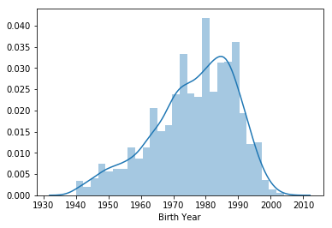

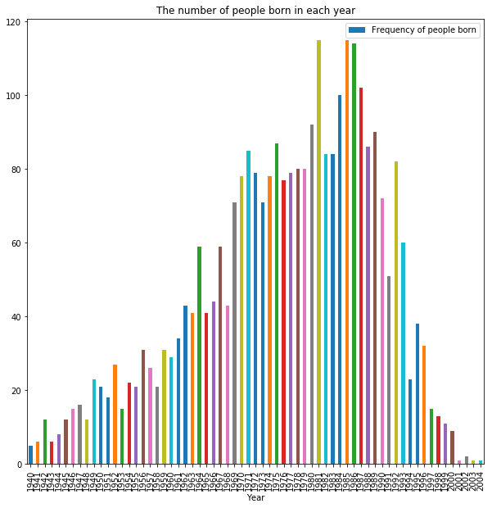

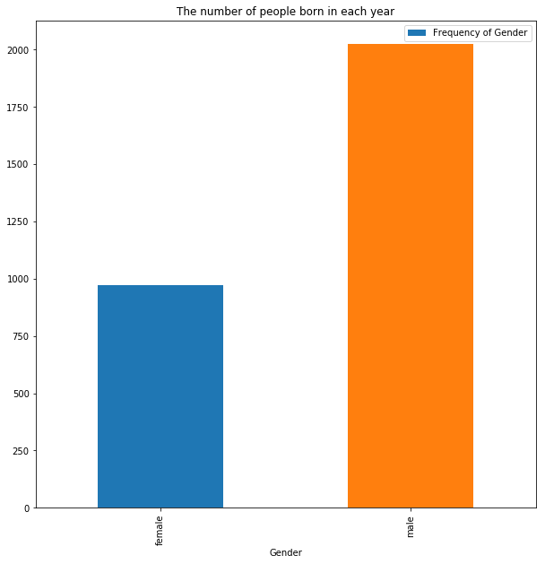

- Ethics
Teenagers have now started to use social media as their main means of communication [11]. Moreover a recent study of adolescents and mobile phones [12] ascertained 70% of 11-12 year olds in the UK now own a mobile phone, this figure is rising to 90% by age 14 [12]. As a result, child grooming has increased and the number of cases every year is on the rise. It is noted that this project could be used by people with bad intentions, by identifying ages/genders of users that wish to remain anonymous. For ecample some users may be young or do not wish to be targeted by certain adverts and by accurately predicting a user’s age and gender this information would not longer be anonymous, with this in mind, this classifier and any associated code will be distributed with caution.

- Methodology
Gathering and Storing Data
To start with a dataset was identified that contained the relevant information required to predict Age and Gender, a large enough dataset was identified that contained the Age and Gender Labels with a sizeable amount of related text in the form of tweets from the popular social media site Twitter. A document class was created to hold a series of attributes in the form of frequencies, these were the parts of speech, the total token ratio, the average token length, the frequency of each token and the frequency of function words. Because the data that was downloaded contained the labels and text data in two separate files, these needed to be aggregated and stored as one json object, in order to maximize memory and use as much of the data possible for training and testing.

Class Imbalance
Once this was completed, exploratory data analysis was carried out and the class imbalance was dealt with. There were 3 main methods that were considered, these were undersampling, oversampling, and SMOTE. Undersampling is when the majority class is undersampled by dropping observations from the majority class and oversampling which is the opposite, involves duplicating observations of the minority class. Finally the third method that was considered was SMOTE, which works by creating synthetic samples based upon existing observations, the midpoint of samples are taken and from these midpoints synthetic samples are made.
After testing both oversampling and under-sampling, it was decided that under-sampling was better than oversampling for this particular problem, as oversampling appeared to introduce a large bias within the training set, because the duplicate observations all have the same values the variance between observations decreased. SMOTE was considered, however finding a mid-point between character features is a challenging task and quite subjective, because of this, undersampling of the class ‘Male’ was applied. It should be noted that great care was taken before applying any re-sampling techniques and re-sampling was applied on the training set only in order to ensure no information leaked into the testing and validation set.

Preprocessing Techniques

Experimenting with Classification and Regression for Age
Once this was completed, separate classes were created of 5 year age group gaps, as it was assumed that a classification problem would be easier to solve than regressing age. However upon evaluating the results it became apparent that this achieved an accuracy of 14%, and when contrasting the results, obtaining a value close to the true birth-year as opposed to associating an instance with a group is a more desirable result, because of this a regression model was created and used for birth year to try and predict the exact birth year instead of classifying an instance as a 5 year group.

Evaluation Metrics
Within all the experiments done, k-fold cross validation was used to gather the metrics and a validation and test set was used, K was defined as 10 due to empirical evidence that k=10 generally provides good estimates [13].

Baseline
In the experiments in order to compare each change made, a baseline was defined, where the most basic methods of preprocessing and simplest classifiers were used. For classifying gender, a baseline pipline that extracted simple text statistics, which were Type-Token Ratio, and the average token length with a logistic regression classifier was used.
After observing the findings shown in table XXX, it became clear that the baseline logistic regression outperformed the other classifiers so a decision was made to ensemble classifiers. The two choices were to either use one pre-processing method and ensemble different classifiers in a voting system, or have the same type of classifier trained on each type of preprocessing methods. The latter was chosen, because as shown in table XX, there are minor differences in the different classifiers, but by using different pre-processing methods, the classifier can learn different information.

How did it compare with other related work

- Results and Findings

Gender Classification

Model | Pre-  Processsing | Gender | Accuracy | Precision | Recall | F1-Score
Logistic Regression  (Lib  Linear Solver) | text_stats | Male | 0.51 | 0.47 | 0.66 | 0.54
Logistic Regression  (Lib  Linear Solver) | text_stats | Female | 0.51 | 0.54 | 0.35 | 0.42
Logistic Regression  (Lib  Linear Solver) | pos_fql | Male | 0.75 | 0.74 | 0.81 | 0.78
Logistic Regression  (Lib  Linear Solver) | pos_fql | Female | 0.75 | 0.77 | 0.69 | 0.73
Logistic Regression  (Lib  Linear Solver) | tokens_fql | Male | 0.87 | 0.87 | 0.90 | 0.88
Logistic Regression  (Lib  Linear Solver) | tokens_fql | Female | 0.87 | 0.88 | 0.85 | 0.86
Logistic Regression  (Lib  Linear Solver) | fws_fql | Male | 0.81 | 0.83 | 0.83 | 0.83
Logistic Regression  (Lib  Linear Solver) | fws_fql | Female | 0.81 | 0.81 | 0.81 | 0.81

Birth Year Regression

Model | Pre-Processing | RMSE | MSLE | R2  Score | MAE
Linear  Regression | text_stats | 12.58 | 4.07 | -269.8 | 10.24
Linear  Regression | pos_fql | 10.79 | 2.99 | -0.87 | 8.5
Linear  Regression | tokens_fql | 60.21 | 0.00098 | 0.048 | 41.43
Linear  Regression | fws_fql | 11.01 | 3.12 | -0.21 | 8.28

Gender Classification

Model | Gender | Accuracy | Precision | Recall | f1-score
Logistic Regression  (Baseline) | Male | 0.87 | 0.87 | 0.90 | 0.88
Logistic Regression  (Baseline) | Female | 0.87 | 0.88 | 0.85 | 0.86
MLPClassifier | Male | 0.83 | 0.92 | 0.74 | 0.82
MLPClassifier | Female | 0.83 | 0.77 | 0.93 | 0.84
RandomForest Classifier | Male | 0.84 | 0.84 | 0.87 | 0.85
RandomForest Classifier | Female | 0.84 | 0.85 | 0.81 | 0.83
Support Vector Machine | Male | 0.70 | 0.67 | 0.85 | 0.75
Support Vector Machine | Female | 0.70 | 0.77 | 0.54 | 0.63

Max iter = 100, liblearner, and default mlpclf, rand forest had 200 estimators, SVM svc was used

Pos_fql was chosen because of the results

Birth Year Regression
Model | RMSE | RSE | MAE | RAE
Linear
Regression
(BaseLine)
Epsilon-Support Vector Regression
Random Forest
Regression
BayesianRidge
Regression

- Conclusion and Future Work
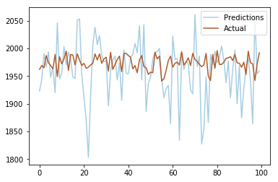
Conclusions and Future Work: what did you conclude from the work? What are the implications of your findings? Any limitations? What would you look at in the future?

pos_fql

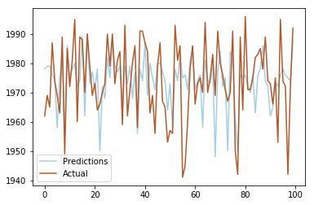

References
[1] Santosh, K., Bansal, R., Shekhar, M. and Varma, V., 2013. Author profiling: Predicting age and gender from blogs. Notebook for PAN at CLEF, 2013.

[2] Peersman, C., Daelemans, W. and Van Vaerenbergh, L., 2011, October. Predicting age and gender in online social networks. In Proceedings of the 3rd international workshop on Search and mining user-generated contents (pp. 37-44). ACM.

[3] Thomson, R. and Murachver, T., 2001. Predicting gender from electronic discourse. British Journal of Social Psychology, 40(2), pp.193-208.

[4] Fitzpatrick, Mary & Mulac, Anthony & Dindia, Kathryn. (1995). Gender-Preferential Language Use in Spouse and Stranger Interaction. Journal of Language and Social Psychology - J LANG SOC PSYCHOL. 14. 18-39. 10.1177/0261927X95141002.

[5] Hannah, A., & Murachver, T. (1999). Gender and Conversational Style as Predictors of Conversational Behavior. Journal of Language and Social Psychology, 18(2), 153–174. https://doi.org/10.1177/0261927X99018002002

[6] Zimmerman, D. H., and West, C., (1975) Sex roles, interruptions and silences in conversation Language and sex: Difference and dominance. pp: 105- 129. Stanford, CA: Stanford University Press.

[7] Pan.webis.de. (2019). PAN @ CLEF 2019 - Celebrity Profiling. [online] Available at: https://pan.webis.de/clef19/pan19-web/celebrity-profiling.html [Accessed 9 Apr. 2019].

[8] Álvarez-Carmona, Miguel Á., et al. "Evaluating topic-based representations for author profiling in social media". Ibero-American Conference on Artificial Intelligence. Springer, Cham, 2016. p. 151-162.

[9] Santosh, Kosgi & Bansal, Romil & Shekhar, Mihir & Varma, Vasudeva. (2013). Author Profiling : Predicting Age and Gender from Blogs Notebook for PAN at CLEF 2013.

[10] Cano, A.E., Fernandez, M. and Alani, H., 2014, November. Detecting child grooming behaviour patterns on social media. In International conference on social informatics (pp. 412-427). Springer, Cham.

[11] Australian Institute of Criminology (AIC). Children’s use of mobile phones. Technical report, GSMA, NTT DOCOMO (2013)

[12] SCAMP Project. Study of cognition, adolescents and mobile phones (scamp). Technical report, Imperial College London (2014)

[13] Kohavi, R., 1995, August. A study of cross-validation and
bootstrap for accuracy estimation and
model selection. In Ijcai (Vol. 14, No. 2, pp. 1137-1145). [Journal]
Available at: https://www.
researchgate.net/profile/Ron_Kohavi/publication/2352264_A_Stu
dy_of_Cross-Validation_and_Bootstrap_for_
Accuracy_Estimation_and_Model_Selection/li

