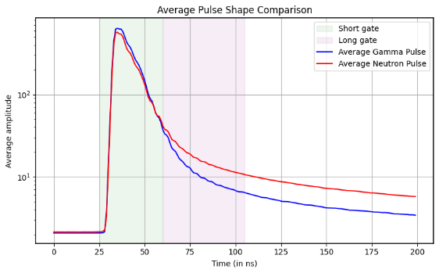
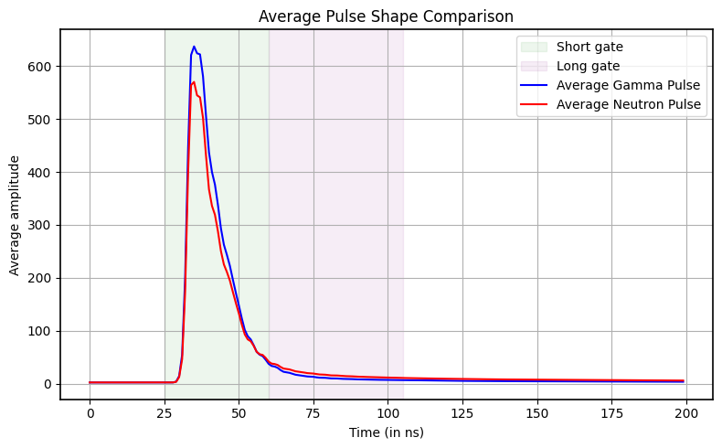
Figure 1
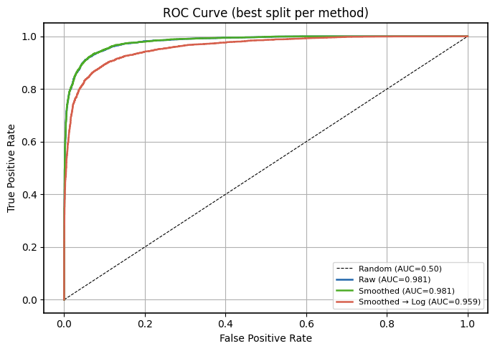
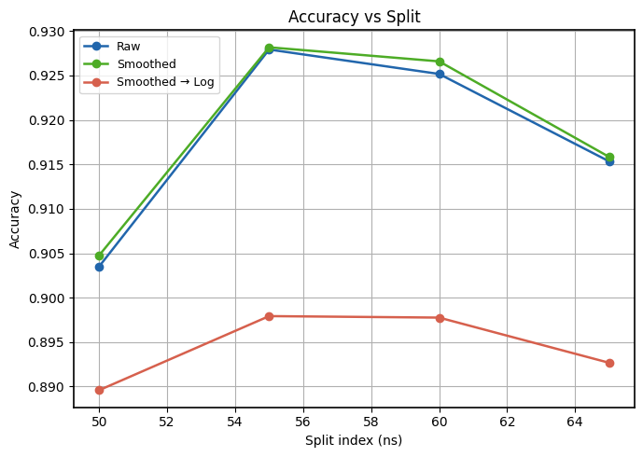

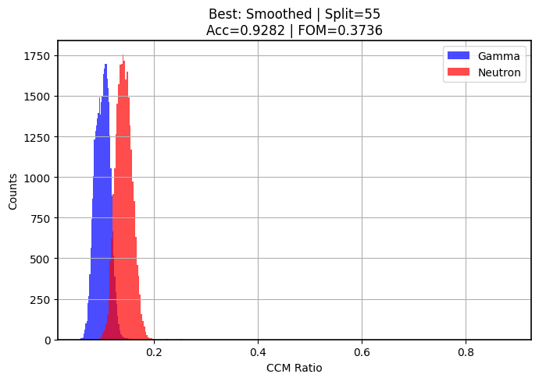
Figure 2

Figure 3

Pile up removal (neutron):
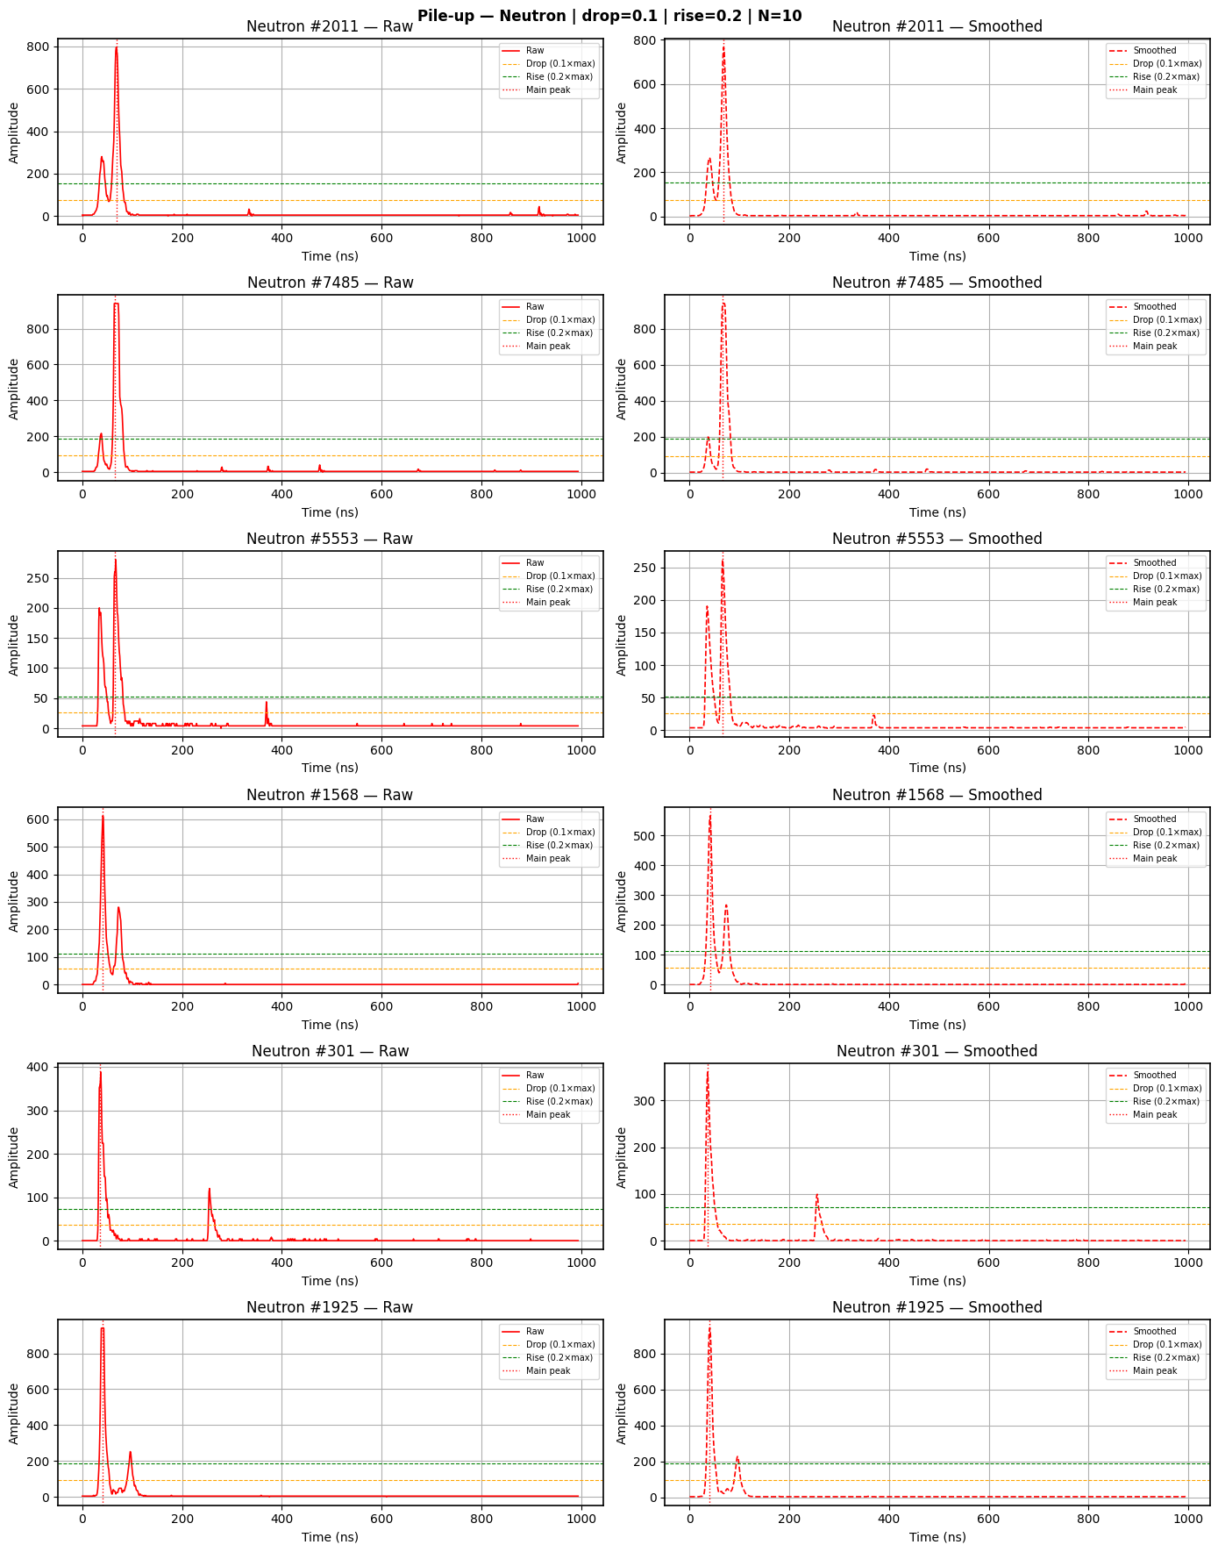

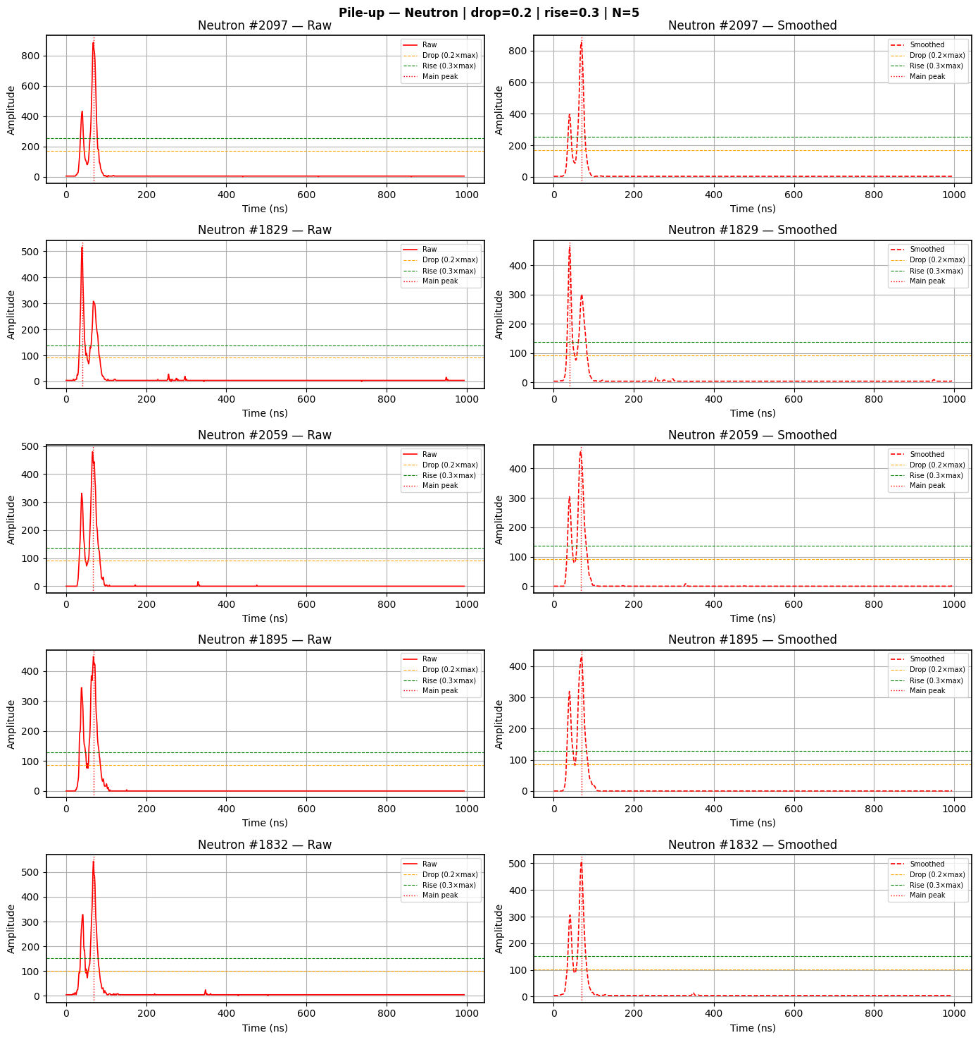
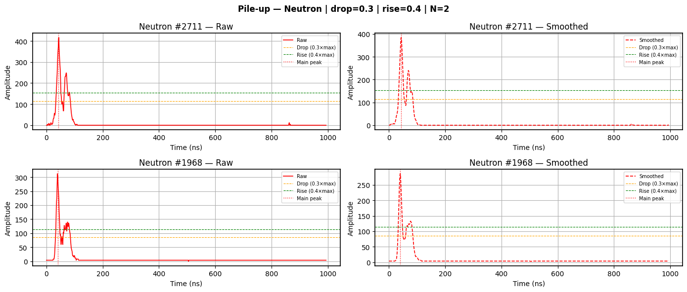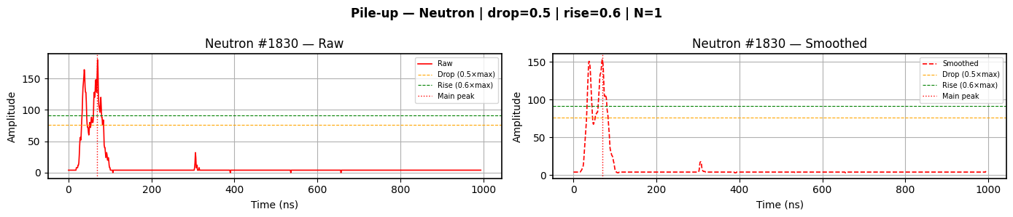
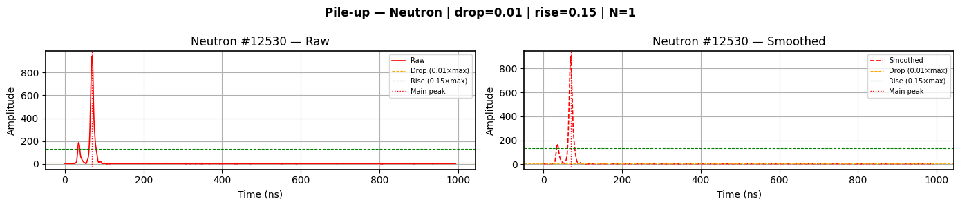
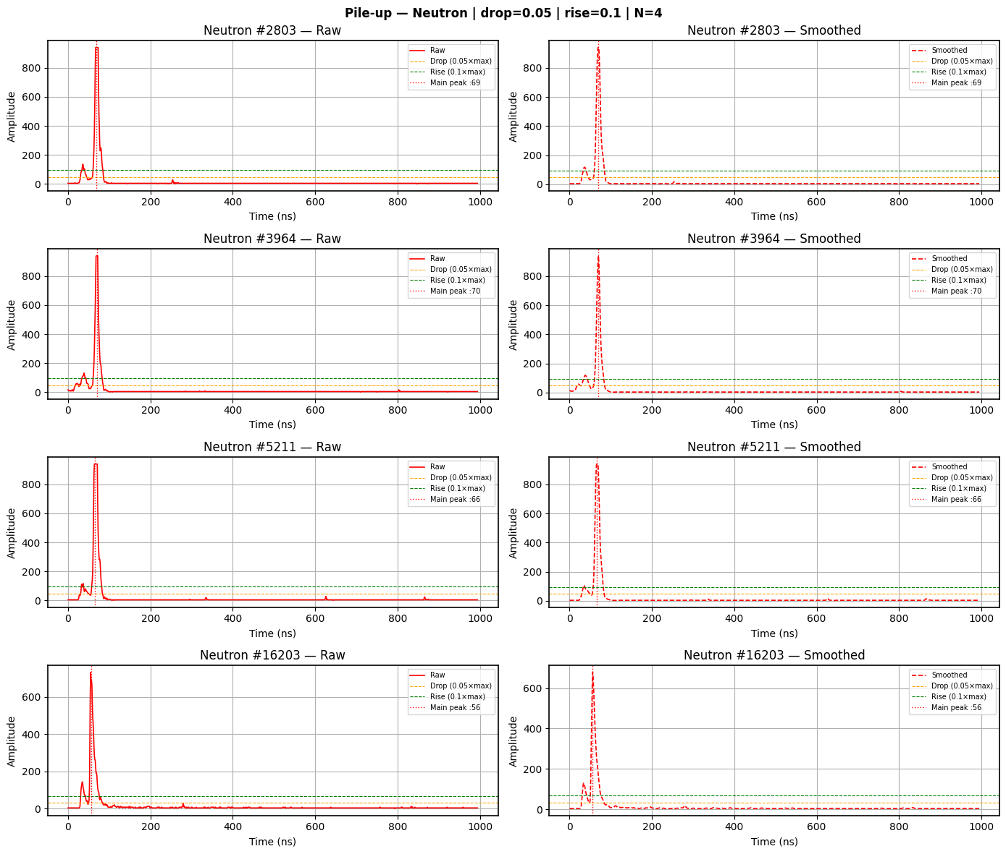
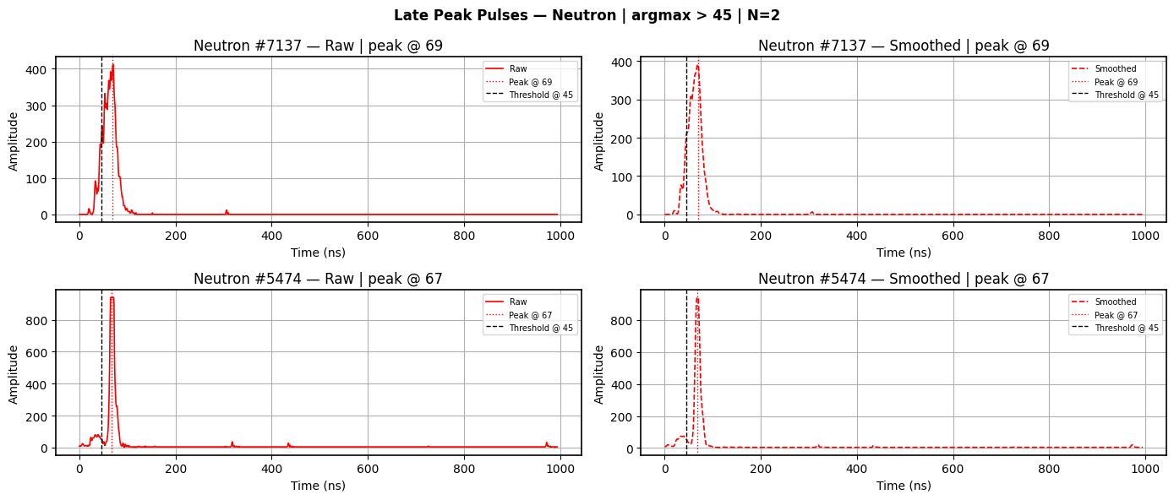

Pile up removal (gamma):
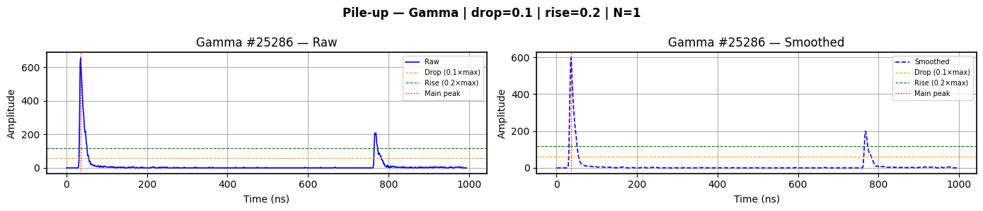

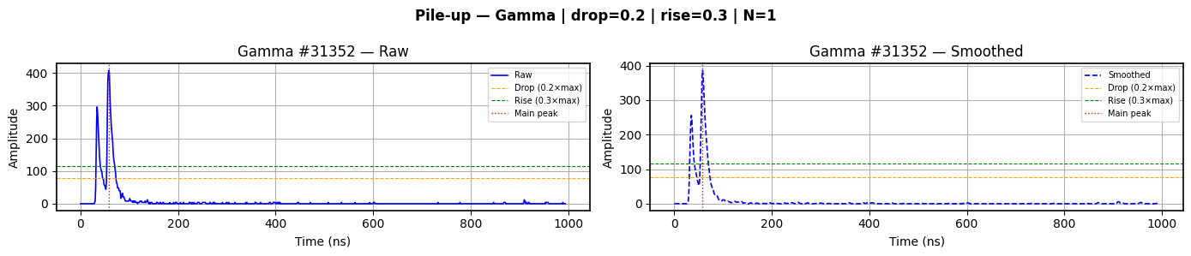

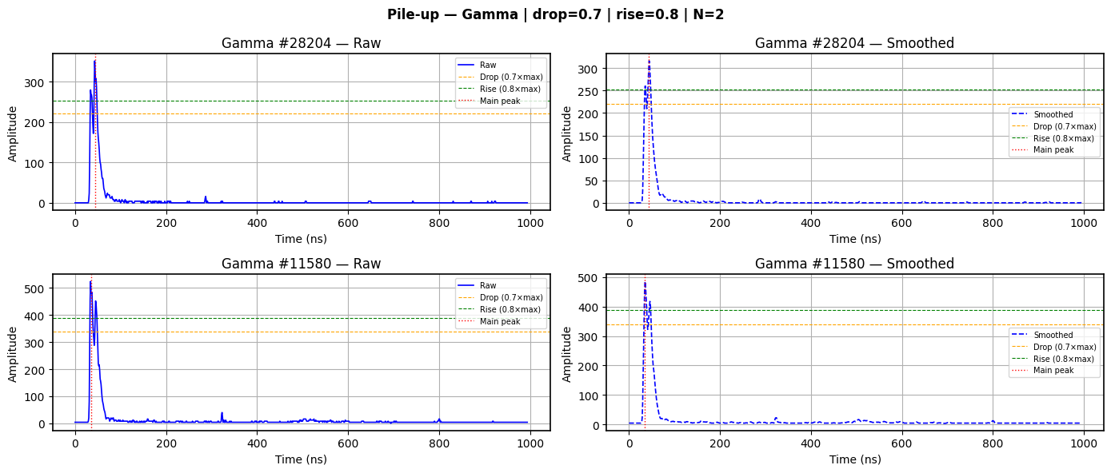

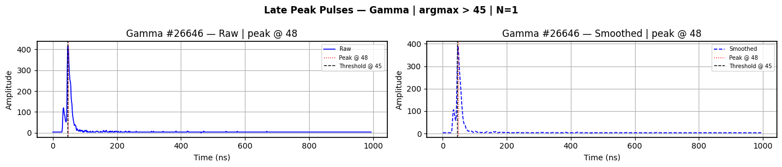

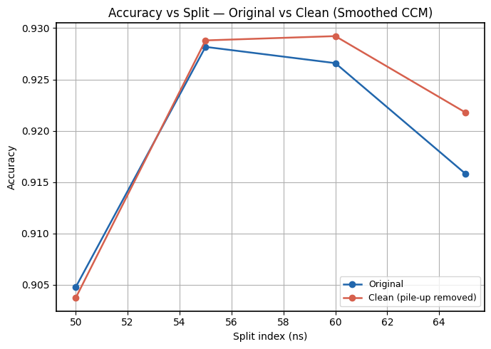
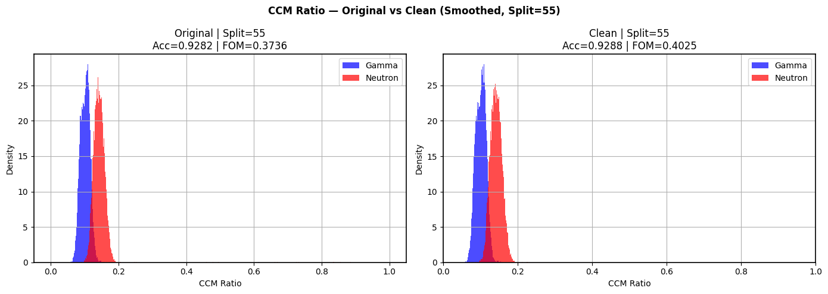
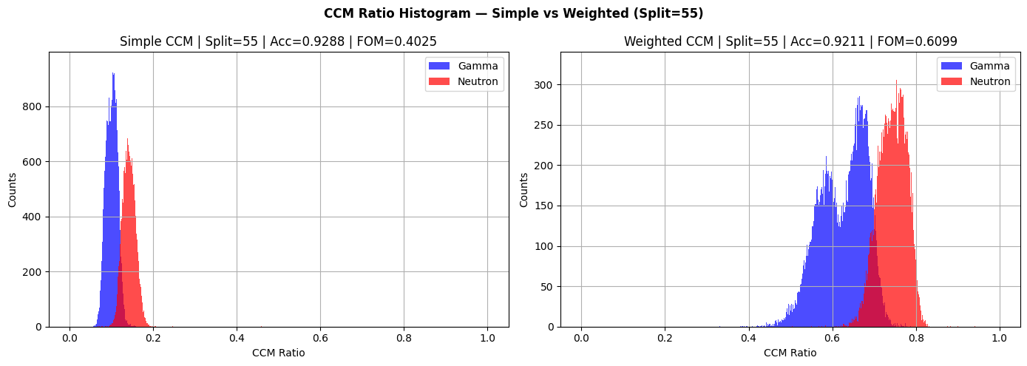
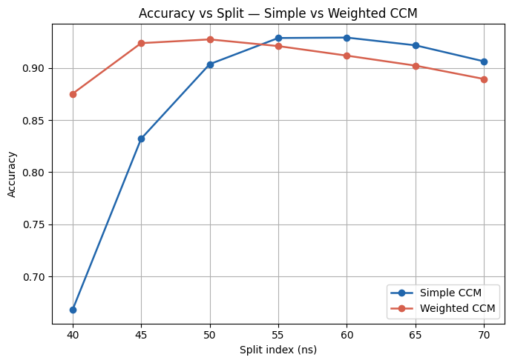
Figure (Weighted CCM)

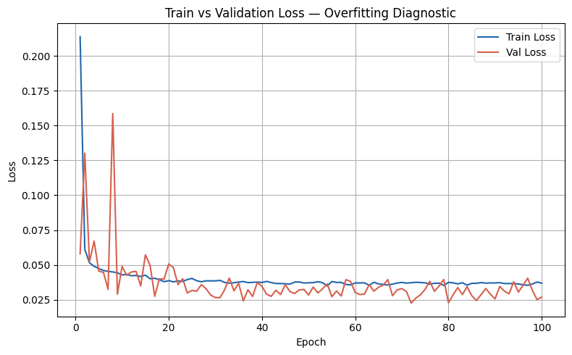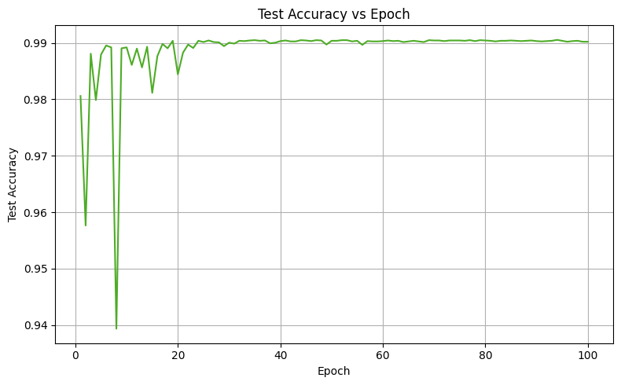

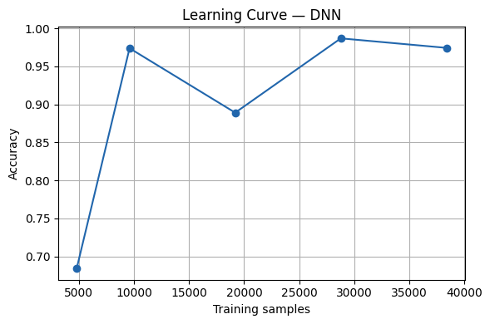
Train size=10% | Acc=0.6845
Train size=20% | Acc=0.9738
Train size=40% | Acc=0.8891
Train size=60% | Acc=0.9868
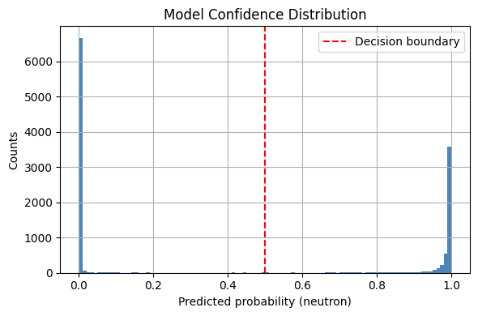
Train size=80% | Acc=0.9743

Shuffled label accuracy (should be ~0.50): 0.5588

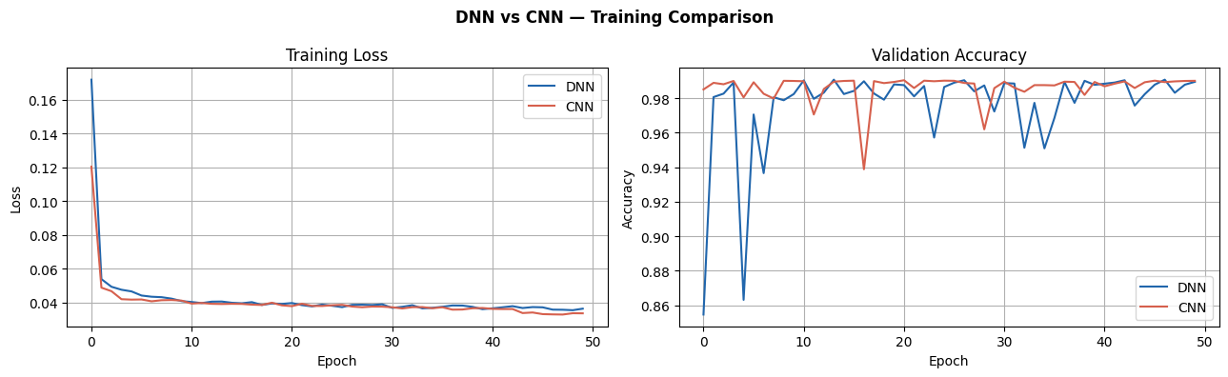

Manual parameter based random forest classifier:
Random Forest (all features) Accuracy: 0.9465
CCM Simple: 0.6576
tail curvature: 0.0964
Tail Slope: 0.0941
Kappa: 0.0572
pulse charge: 0.0550
peak amplitude: 0.0398

Deep Neural Networks:
Firstly, DNN was trained over a 100 epochs with input being the entire pulse indexes from 25 to 185 in set1(normalised) and 15 to 175 in set2(normalised) to match the peak index. The trained DNN was then applied on the independent data without training on the independent data (from the AmBe source). 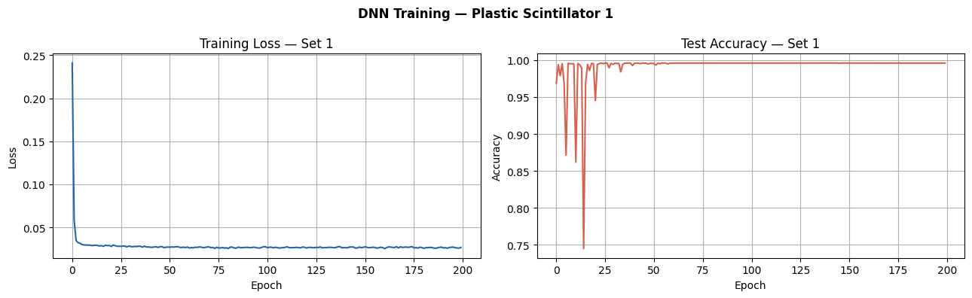
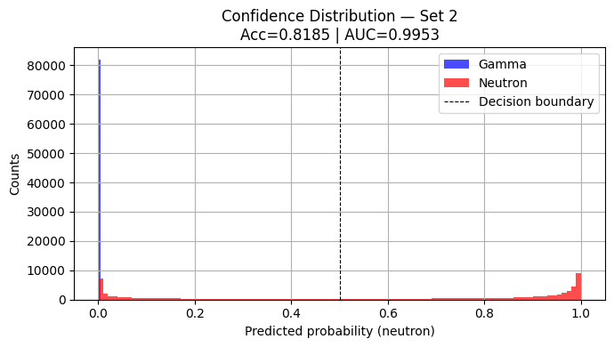
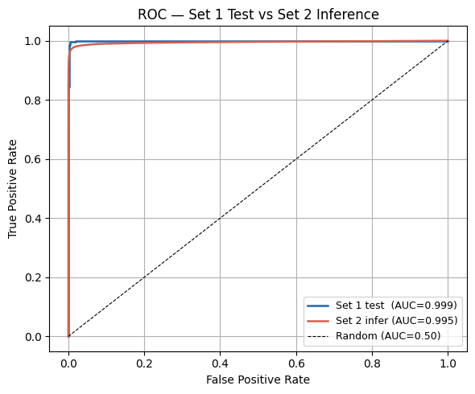
Figure 1 Set 2 Neutrons are much more similar to Set 1 gamma than set1 neutron resulting in them being classified as gamma when set2 gamma are correctly classified

Set 1 Test Accuracy: 0.9959
Loading Set 2 gamma...
Loading Set 2 neutron...
Set 2 — Gamma: (82129, 496) | Neutron: (72061, 496)
After dropping metadata — Gamma: (82129, 496) | Neutron: (72061, 496)

Set 2 — X: (154188, 160) | y: (154188,)
Set 1 input dim: 160 | Set 2 input dim: 160
Set 2 Inference — Accuracy: 0.7944 | AUC: 0.9953

Trying to understand if there is any underlying differences in input data that is causing the loss in accuracy.
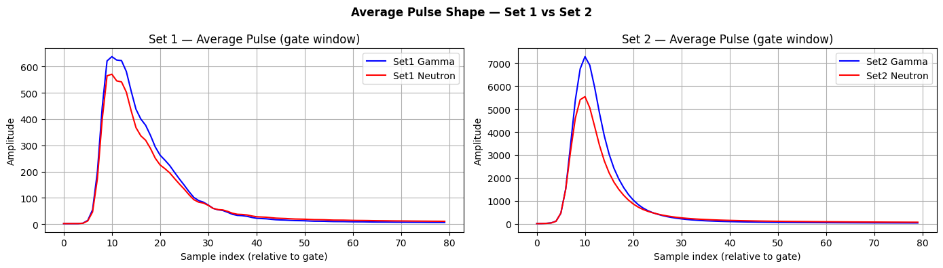
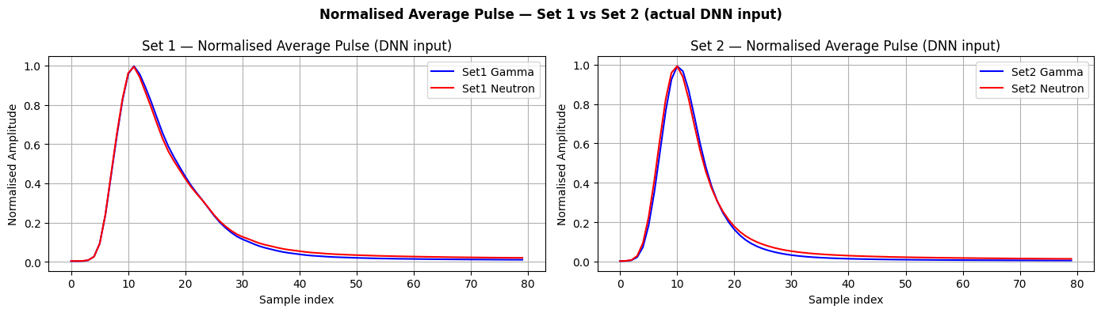

So now, first check the cleanliness of the independent data, plot the scatter plot.
Second, check the dnn performance when instead of the entire dataset, only certain parameters are input (CCM ratio, CCM weighted ratio, Tail slope, Tail curvature)
Third, try implementing other classifiers like random forest, XGBoost, Gradient boost,
Fourth try swapping set1 and set2

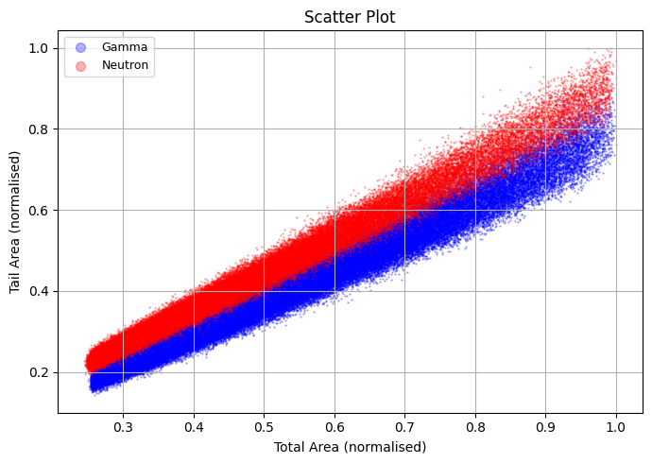
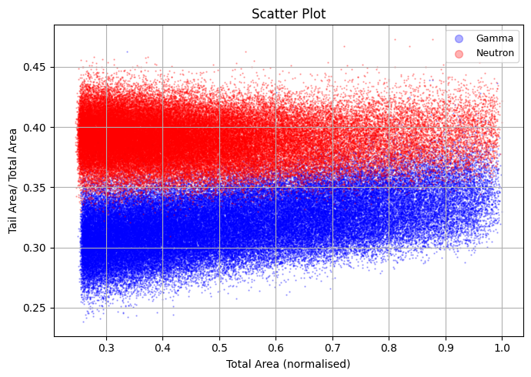
Scatter plots for set2

Since many outliers can be seen in the scatter plot, pile up cases were checked in set2
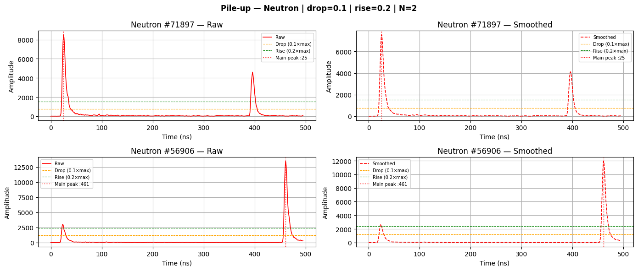

Deep Neural Network when only ccm and ccm weighted are input as parameters
- CCM calculated on the basis of peak index
Set 1 Test Accuracy: 0.9373
Set 2 Inference — Acc: 0.6147 | AUC: 0.9999
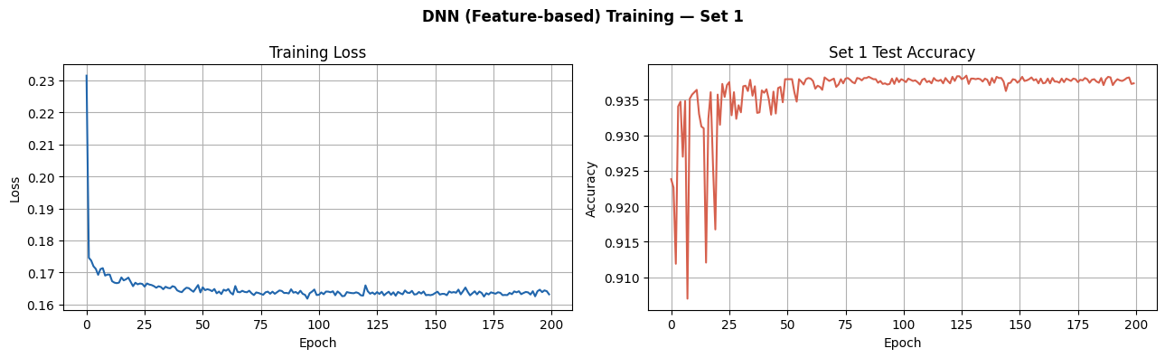
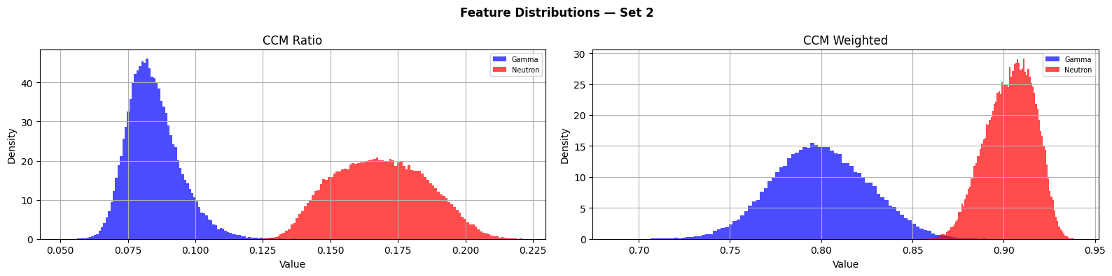

- CCM calculated on the at fixed split (55 for set1 and 35 for set2)
Set 1 Test Accuracy: 0.9358
Set 2 Inference — Acc: 0.6201 | AUC: 0.9995
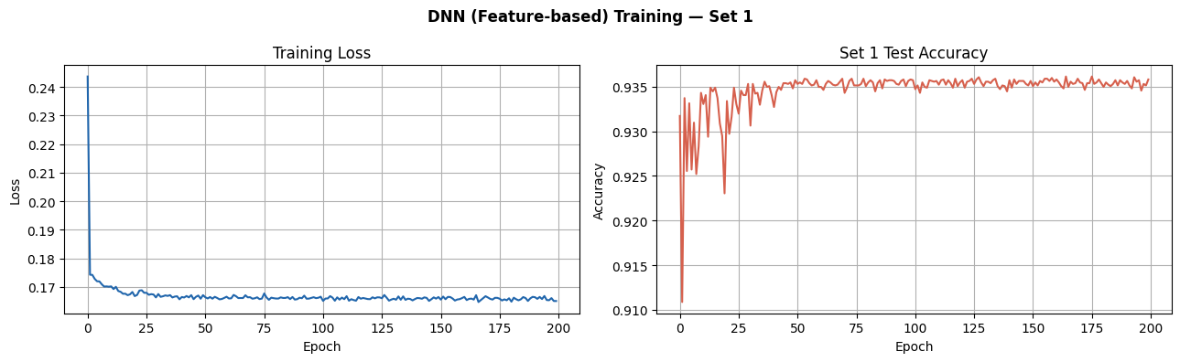

- Deep neural Network with the entire dataset as input
Step by Step: Input taken from both set1 and set2 smoothened with a moving average method (window=5) peak is aligned at a predetermined index = 35) so that both the datasets have equality dnn input being pulse length =150 index values of set1
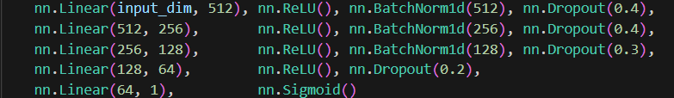
Optimizer = Adam
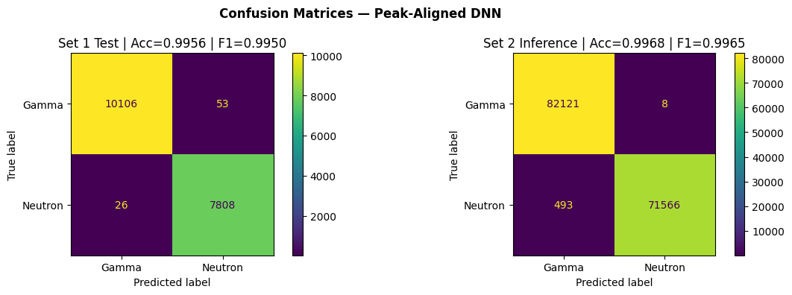
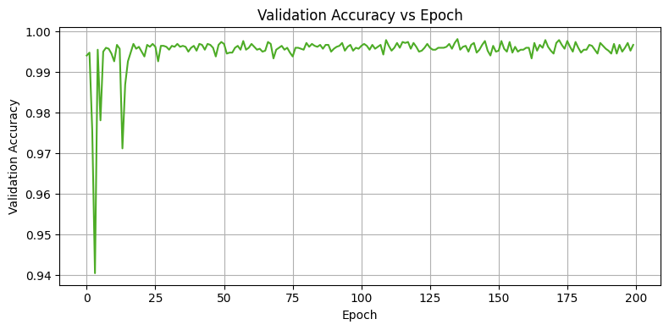
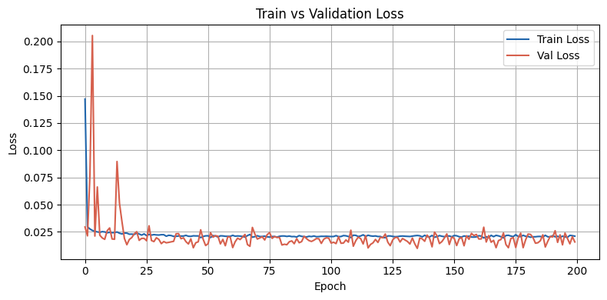
Loss Function = Binary Cross Entropy

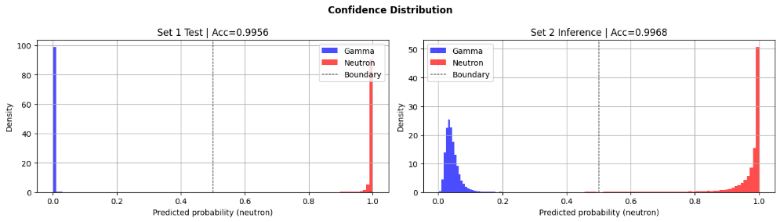

── Final Summary ────────────────────────────────────────────────────────
Metric Set 1 Test Set 2 Infer
──────────────────────────────────────
Accuracy 0.9956 0.9968
AUC 0.9980 1.0000
Precision 0.9933 0.9999
Recall 0.9967 0.9932
F1 Score 0.9950 0.9965

K-means clustering:
K-Means — Acc: 0.9961
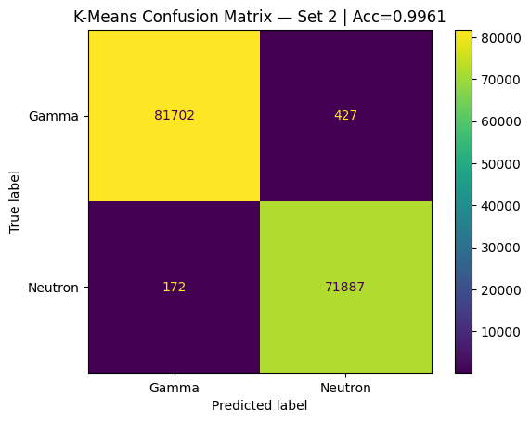
Simple Logistic Regression:
Source 2 (AmBe) — logistic regression on CCM ratios
Pulses: gamma=82129, neutron=72059
Test accuracy (20% holdout, stratified): 0.995590
GMM:
- GMM directly on set2
GMM (Set 2 direct) — Acc: 0.9880 | AUC: 1.0000
[[80284 1845]
[ 0 72059]]
- GMM on set 1 and then applied on set 2
GMM Transfer (Set1→Set2) — Acc: 0.8399 | AUC: 0.9613 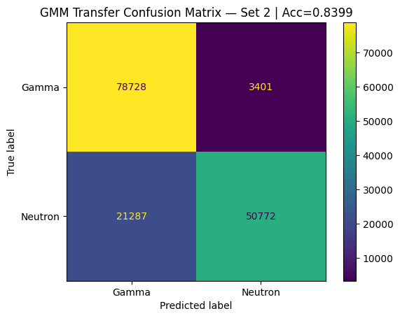

Structure
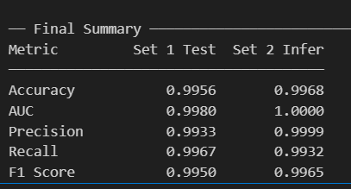
Main is DNN (supervised learning) which is giving the following:

DNN (3 different ways mai kiya hai – Input the entire dimension without peak alignment (73%), Input the CCM and CCM weighted with no peak alignment(62%), Input the entire dimension with peak alignment (99.68%)).
For DNN: accuracy vs training size ; shuffled label diagram,
1D CNN /RNN/ logistic Regression and any other important supervised learning method comparison with DNN models – on the basis of accuracy and time and space cost.
K-means (with 2 inputs and the entire pulse as input), GMM (unsupervised learning) comparison with the DNN model.
Optimum Hyperparameters table for DNN
Pulse plot (with inset Log plot)
Neural Network diagram
Epoch vs losses, accuracy over the epochs
Histograms of the CCM and CCM weighted for both sets
Scatter plots for both set1 and set2
Preprocessing related: accuracy vs split(smoothed, raw and with log, cleaned), ROC curve for the same. As well as pile up removal.
Accuracy vs energy range of the Independent data
Bar graph comparing all accuracies

