Learn Azure Databricks with me

Hi Guys,

Today I start to learn Databricks. You can try Databricks without cloud environment yes more than 14 days using Databricks with Community Edition.

Start Databricks with Community Edition

Go to this link and fill it and you will get below

https://www.databricks.com/try-databricks#account

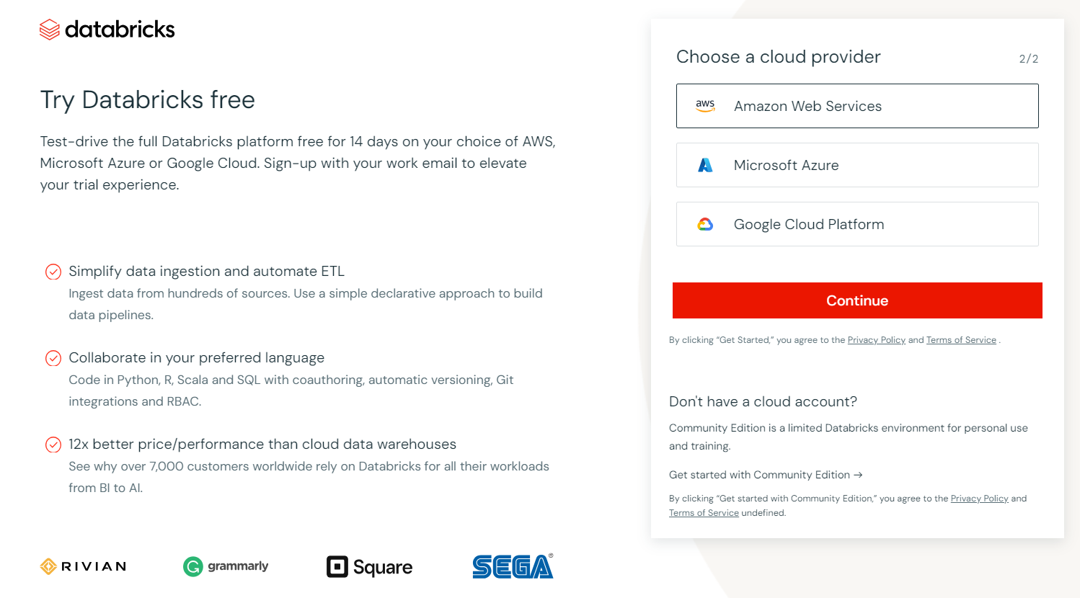

Click start with community edition

Then login using your detail first thing we have to do is creating a cluster

A cluster is a collection of Databricks computation resources. To create a cluster:

1. In the sidebar, click compute icon **Compute**.
2. On the Compute page, click **Create Compute**.
3. On the New Compute page, select **12.2 LTS (Scala 2.12, Spark 3.3.2)** or higher from the Databricks Runtime version dropdown.
4. Click **Create Cluster**.

Then go to workspace and choose notebooks

Then make a small dataframe as follow.Remeber Python Is Case Sensitive.

#creating a dataframe and display it

dataframe_variable=spark.createDataFrame([["Paul","Philips"]])

display(dataframe_variable)

Output

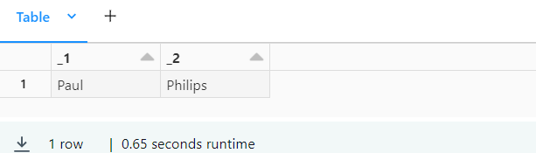

#Save the dataframe as Table

dataframe_variable.write.saveAsTable("test1")

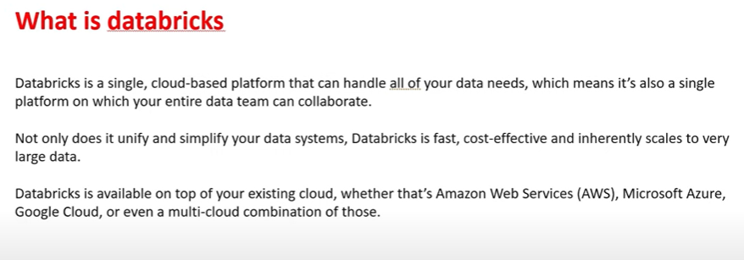

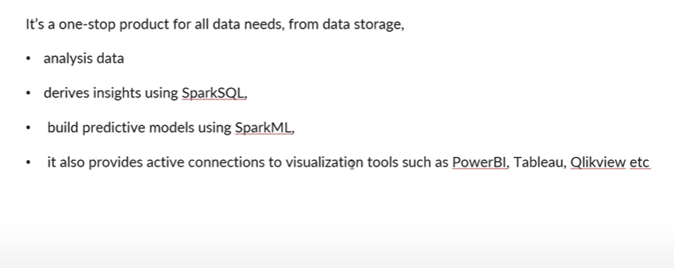

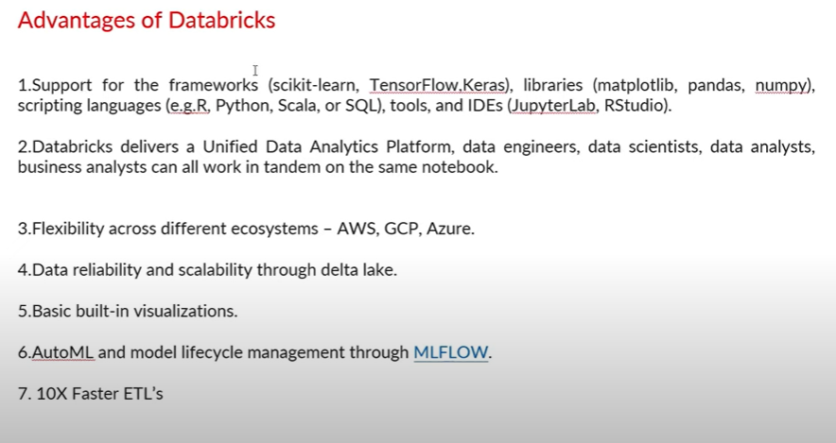

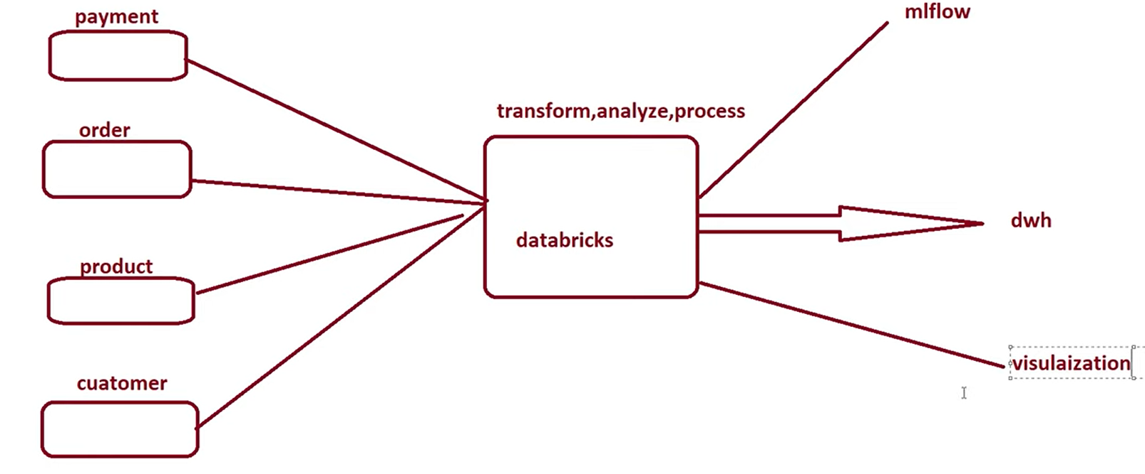

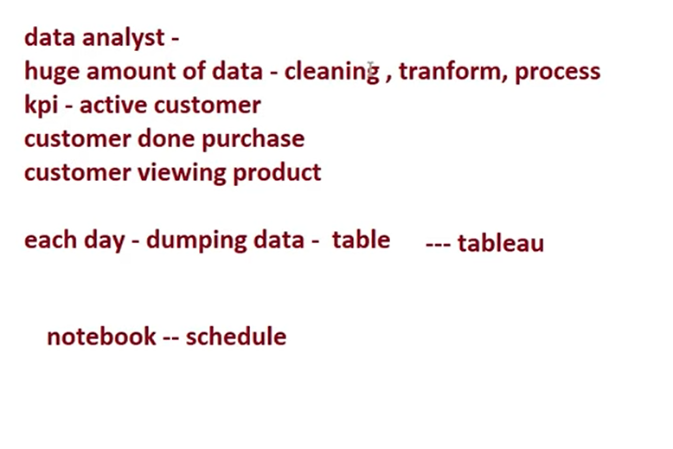

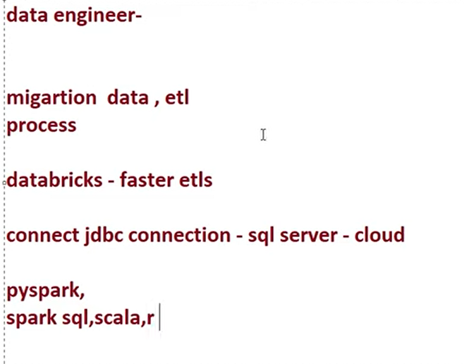

Create table Using uploading a csv file

