Pentaho Report in OpenERP

INDEX
INSTALLING PENTAHO REPORT IN UBUNTU................................................................................................
1. Installing The Penthao Bussiness Analysis Server....................................................................................
2. Installing The Penthao Report Designer...............................................................................................................

3. Pentaho Report with Report Design Wizard....................................................................

4. Design Normal Pentaho Report......................................................................................

5. Design SubReport.........................................................................................................

6. Design Pentaho Report with Parameter...........................................................................

7. Adding Image Field In Report.........................................................................................

8. Adding Barcode Field In Report.....................................................................................
9. Connect with databse of postgress in Pentaho...........................................................................................
10. Make menu in Odoo using Report wizard...................................................................................

Installing Pentaho in Ubuntu
I have been working with Pentaho report, to find the easy way that how users can easily manage the reporting system. Here are the installation steps that, I have used during installation of Pentaho Bussiness Analysis Server on Ubuntu.
Pre – Requirements :
- Install Ubuntu Server
- Install Java

Installing The Penthao Bussiness Analysis Server :
- Download Pentaho Bussiness Analysis Server. If you are using your Terminal, you can also do the following:
wget https://sourceforge.net/projects/pentaho/files/latest/download
- Install zip if it is'nt available in your system.
sudo apt-get install zip
- Unzip and move the Pentaho Business Analysis Server to the appropriate folder.
unzip biserver-ce-5.0.1-stable.zip
sudo mkdir /opt/pentaho
sudo mv biserver-ce /opt/pentaho/biserver-ce-5.0.1
sudo ln -s /opt/pentaho/biserver-ce-5.0.1 /opt/pentaho/biserver-ce
- Create pentaho linux user and group.
sudo addgroup pentaho
sudo adduser --system --ingroup pentaho --disabled-login pentaho
- Change owner of the file.
sudo chown -R pentaho:pentaho /opt/pentaho
- Now , time to add JAVA_HOME variable path in start-pentaho.sh file.
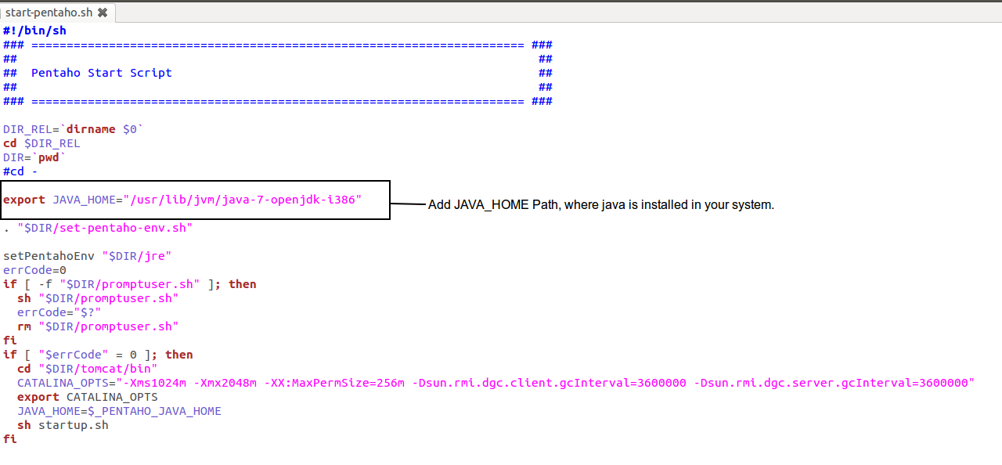
Save the file, and exit the editor.
- Now , you can start the Pentaho Bussiness Application server in terminal.
[ in the home/Pentaho/biserver-ce/ folder ]
$ ./start-pentaho.sh
Start your browser and go to http://localhost:8080/pentaho. Use your loginUser/password to login in server.
When you are done with your work close the browser, and in the terminal shut down the server.
[ in the home/Pentaho/biserver-ce/ folder ]
$ ./stop-pentaho.sh
If somethig goes wrong / any error occure, please check the problem in logs file on:
- /Pentaho/biserver-ce/tomcat/bin/pentaho.log
- /Pentaho/biserver-ce/tomcat/logs/

Installing The Penthao Report Designer :
  - Download Pentaho Report Designer. In terminal, type following command:
wget http://tenet.dl.sourceforge.net/project/pentaho/Data%20Integration/6.1/pdi-ce-6.1.0.1-196.zip
  - Unzip Pentaho Report Designer .
unzip pdi-ce-6.1.0.1-196.zip
  - Extarct the folder in Pentaho folder so you can end up with a:
/Pentaho/report-designer/
  - Make sure the *.sh files are executable.
  - Start the report-designer with ./report-designer.sh
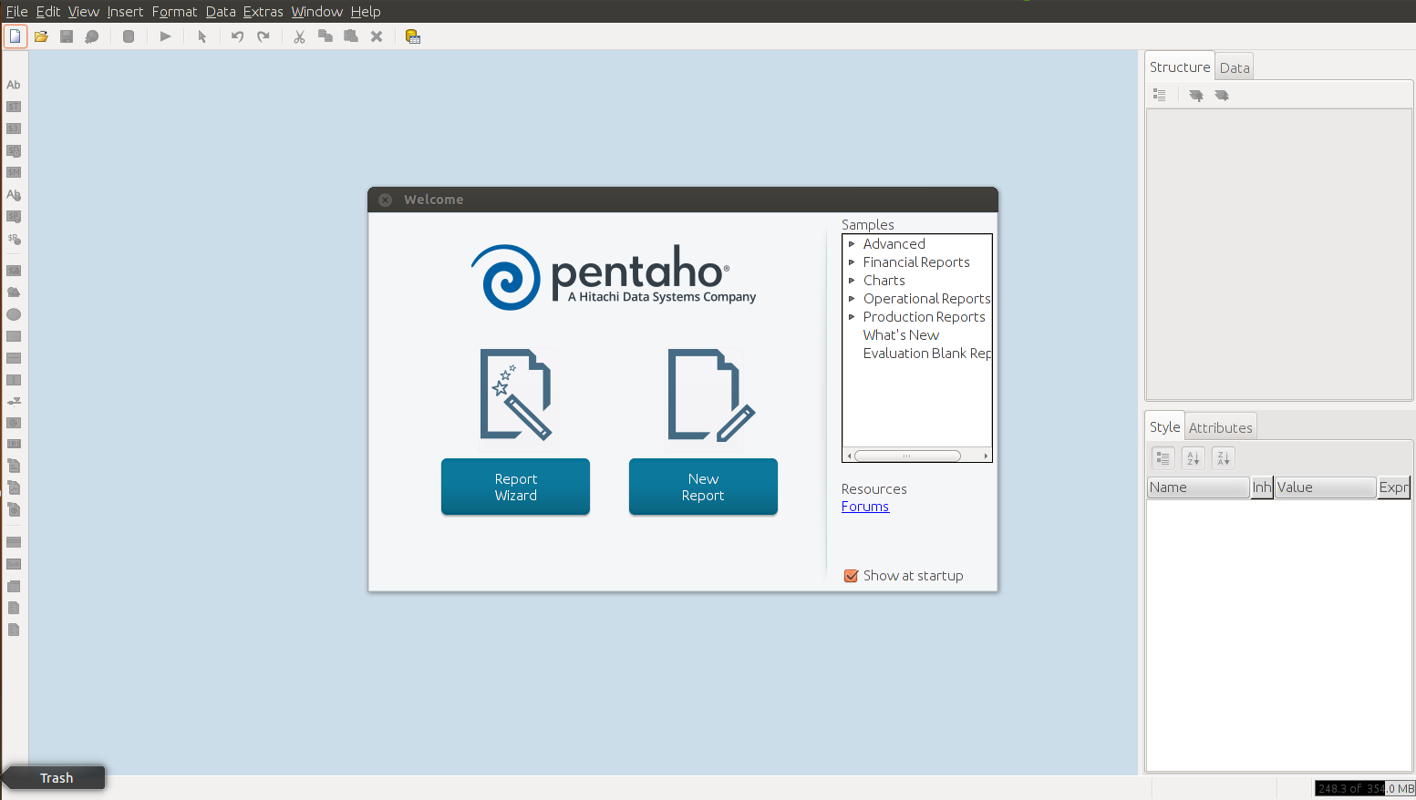

Pentaho Report with Report Design Wizard :
- Click File ->Report Design Wizard , It will open dialoug box to select Look and Feel of Report DesignWizard.
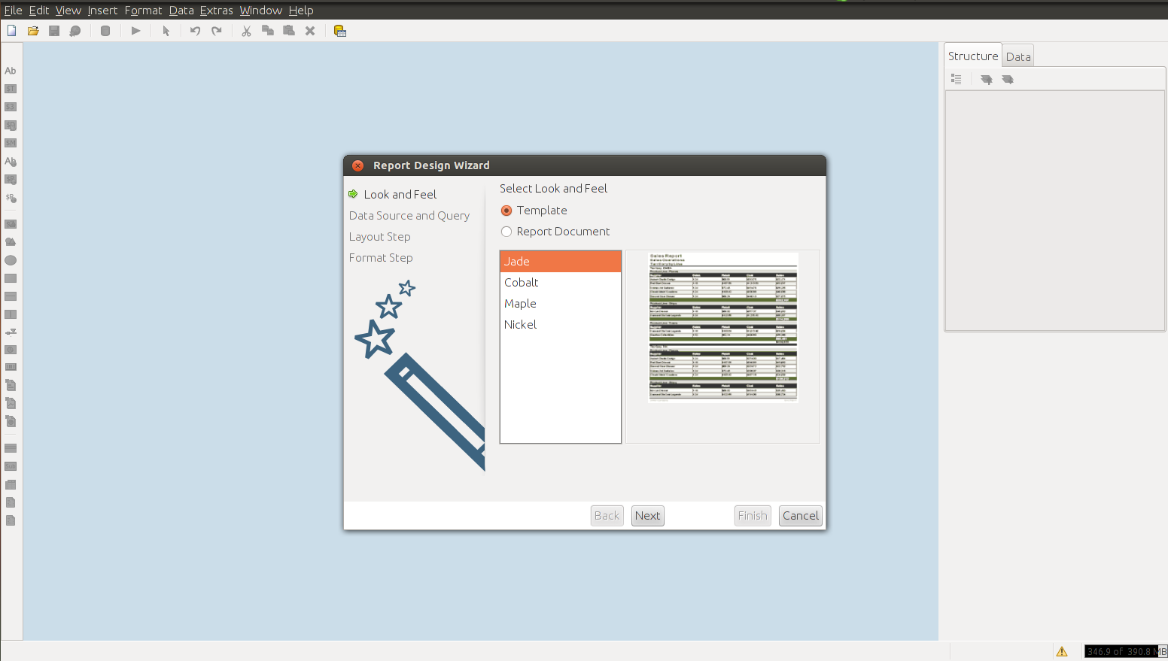
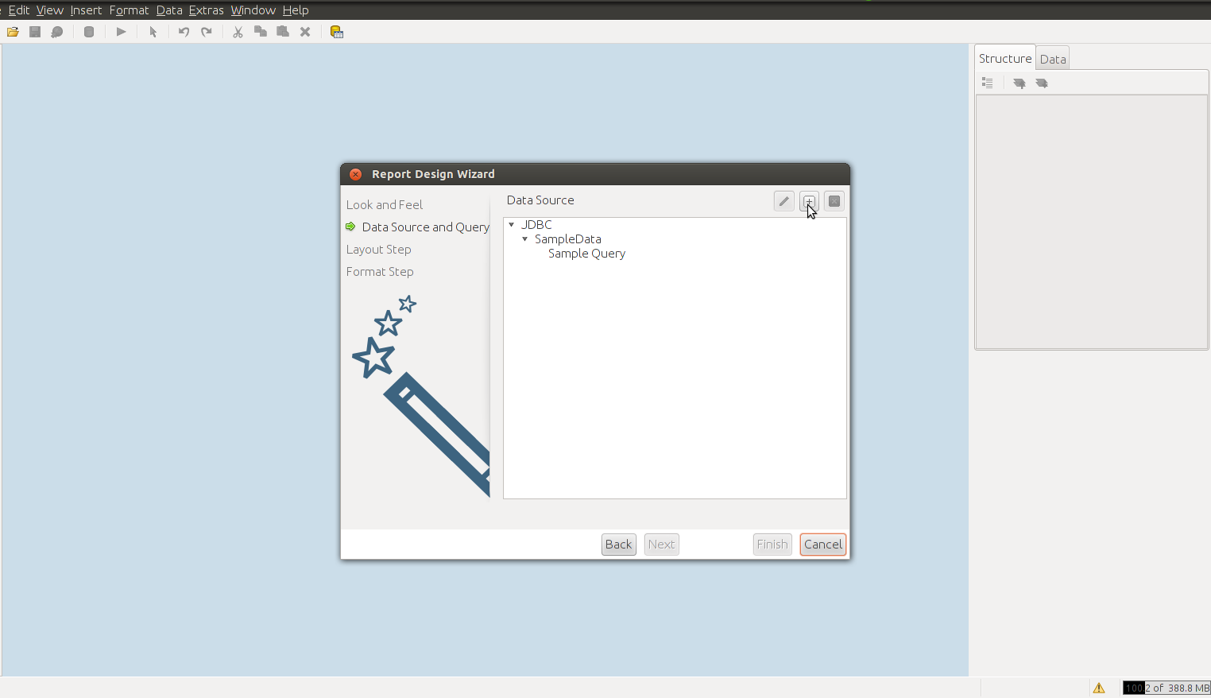
- Click on + Button to add JDBC Data Source, It will prompt dialog box, in that you have to choose JDBC.
- Click on Add button which is highlighted, it will open dialoug box like following, in that you have provide details reagrding database whichever you select.
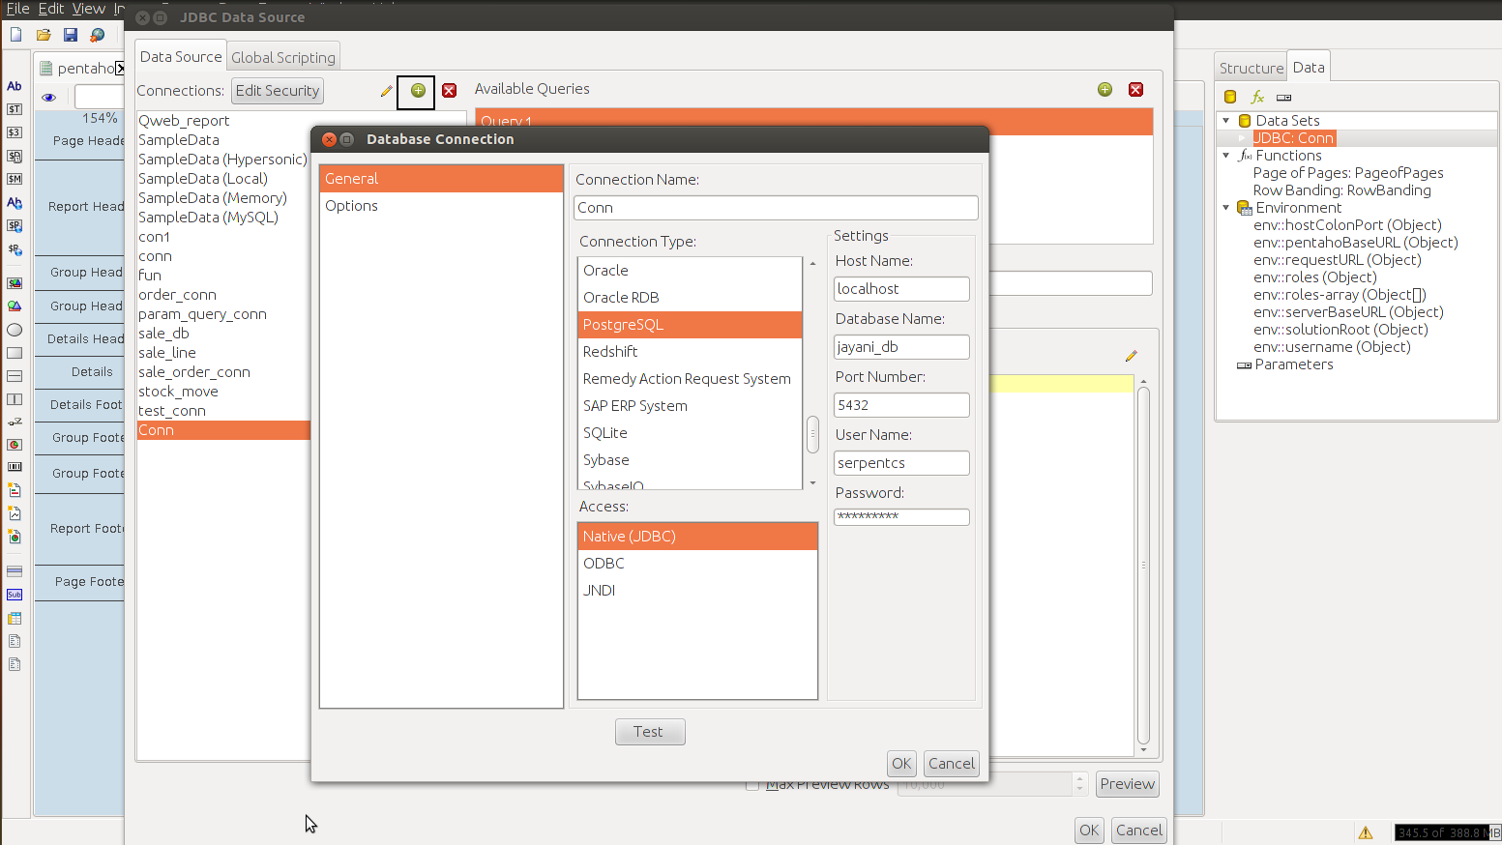
e.g , Here, I select Postgress database, so I have filled details like this :
- Click on Add button, available in right upper corner, it will Add query, rename it if you want, then write query, If you want to check query runs proper or not click on Preview button, appear in bottom and then click on OK button.
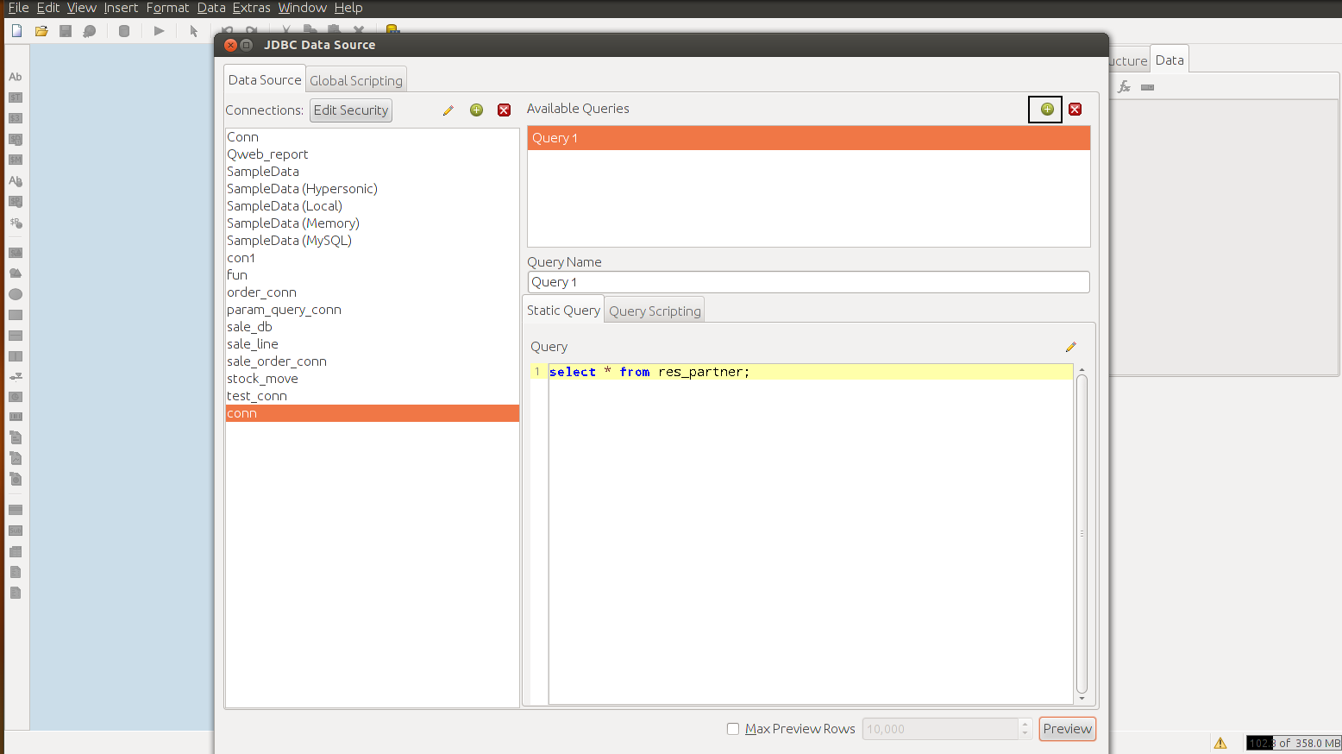
- It will add conn data source in listed datasource list, now click on NEXT, it will show Available Items, in that fields of table shown, you can select field which you want to display in report.
e.g , Here, I'm displaying res_partner table selected fields with Group By city field in my report.
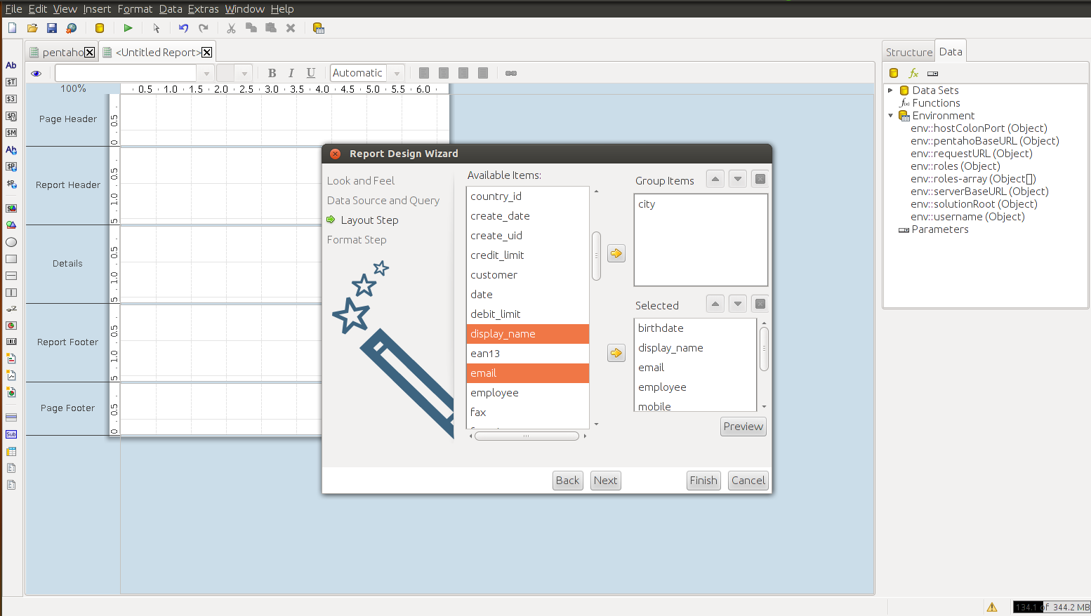
Click on Finish Button, it will create Report like this, you can also drag and drop fileds from Data Sets.
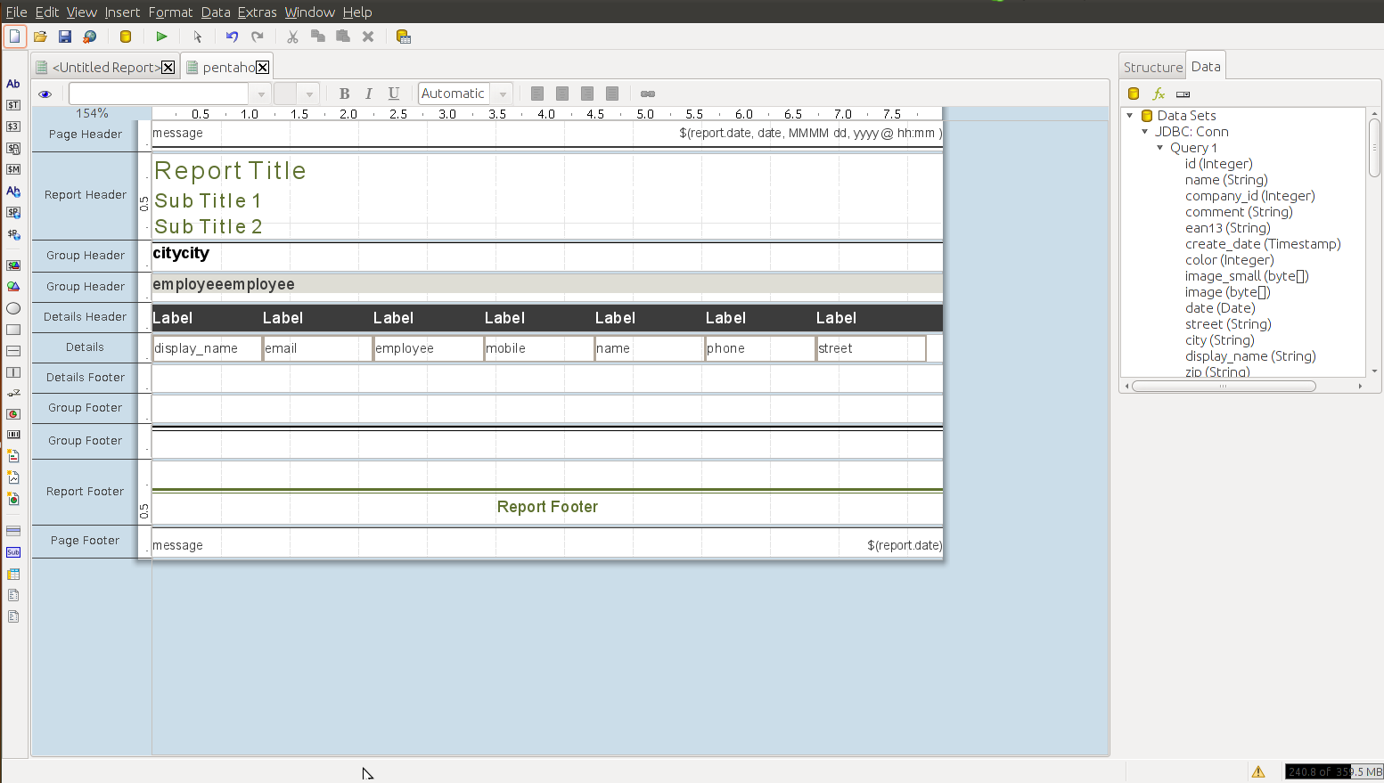
- Yo can preview the report by clicking on green preview button OR eye icon.
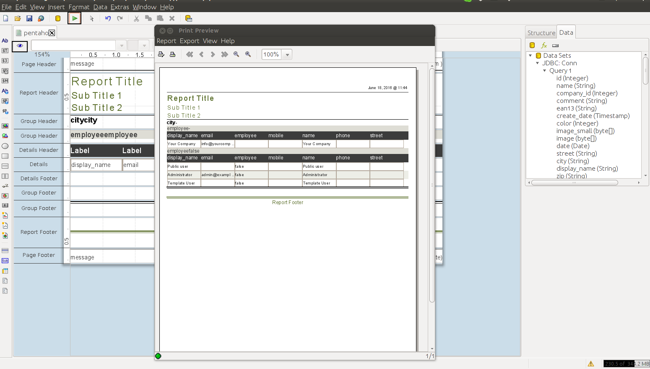

Design Normal Pentaho Report :
Click File ->New, It will open new blank report. In right upper corner in Data tab, right click on Data Sets and select JDBC, create new connection, and fire query it will add fields in Data Sets, from it select those fields which you want display in report.
e.g , Here, I have try to display Sale_Order details in report, and then save it in appropriate location by clciking on File -> Save As menu with .prpt extention.
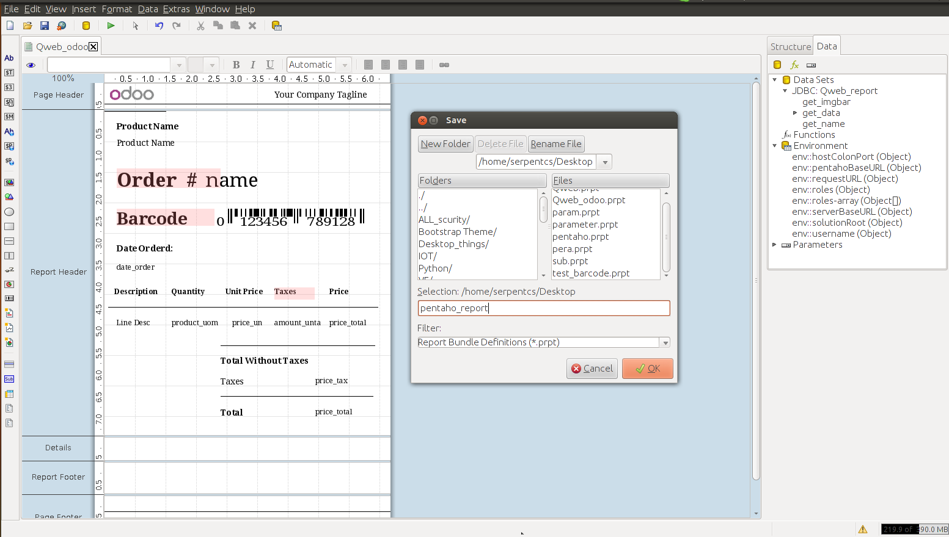

Design SubReport :
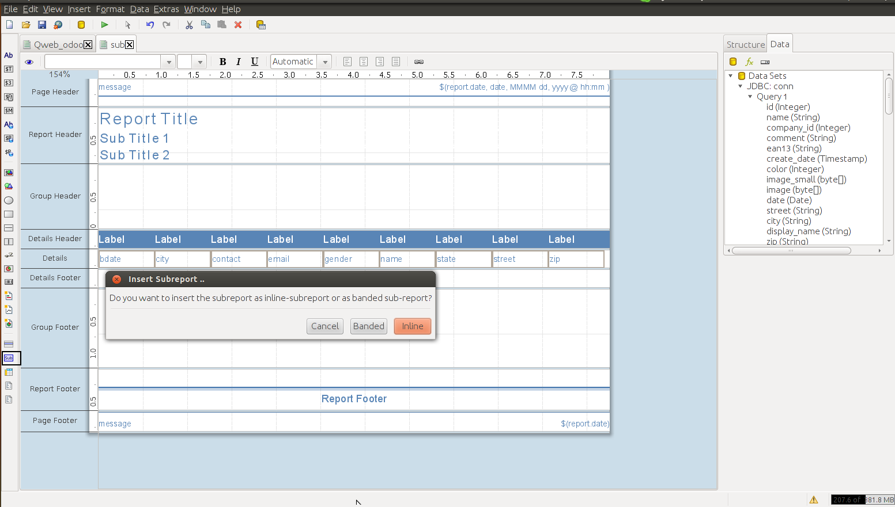
- To design sub report, drag Sub label from left menu panel, and drop it your report, it will ask which typeof report you want, 1) Inline sub-report OR 2) Banded sub-report.
- By cliciking sub report type it will open new blank report, in that you have to select particular query taht query display its fields then darg fileds in this blank report, which you want to display in sub-report.
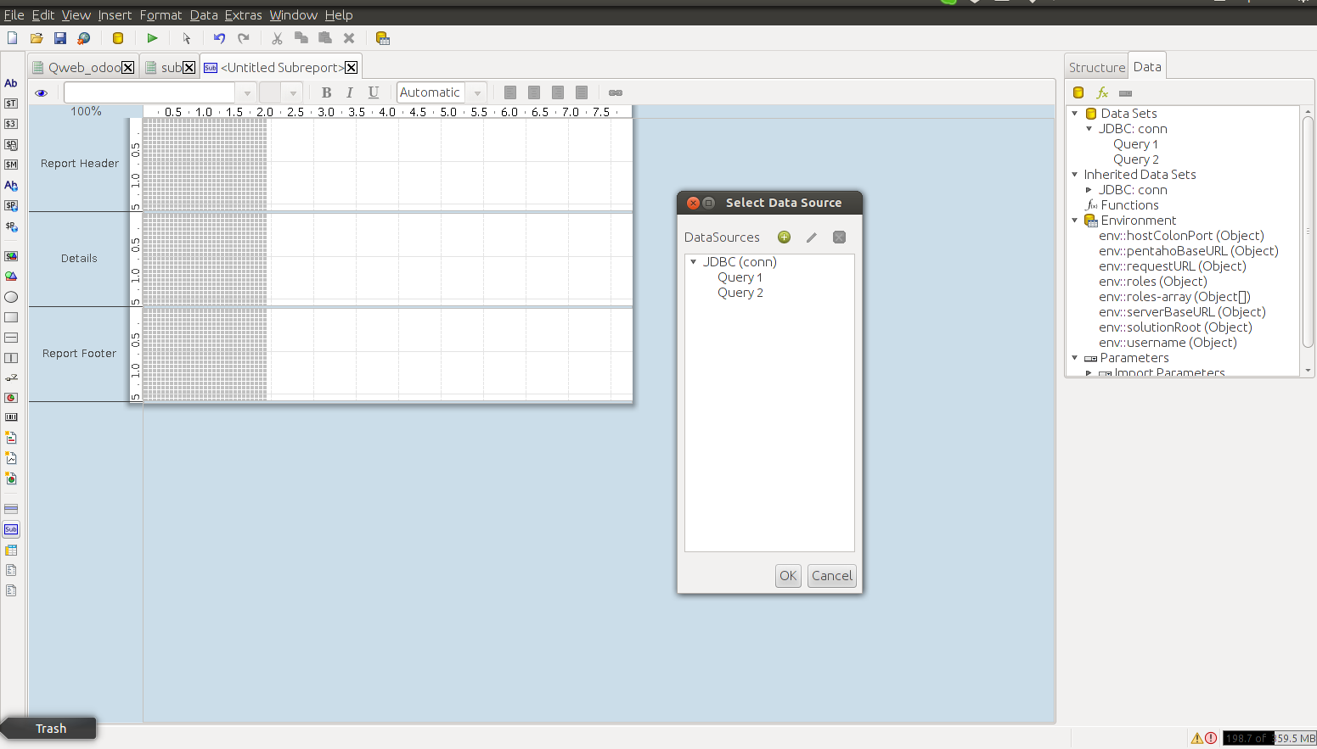

- After drop fields of table it will add in our first report like following :
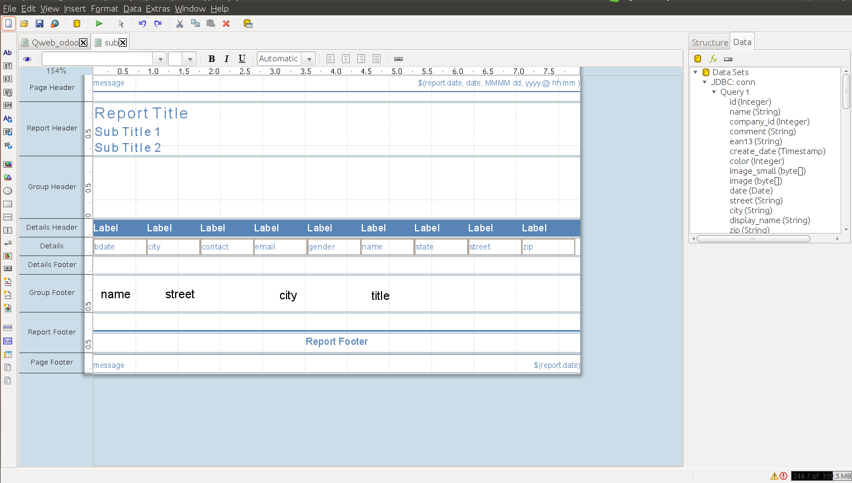
- By clicking on Preview button it will open report like this :
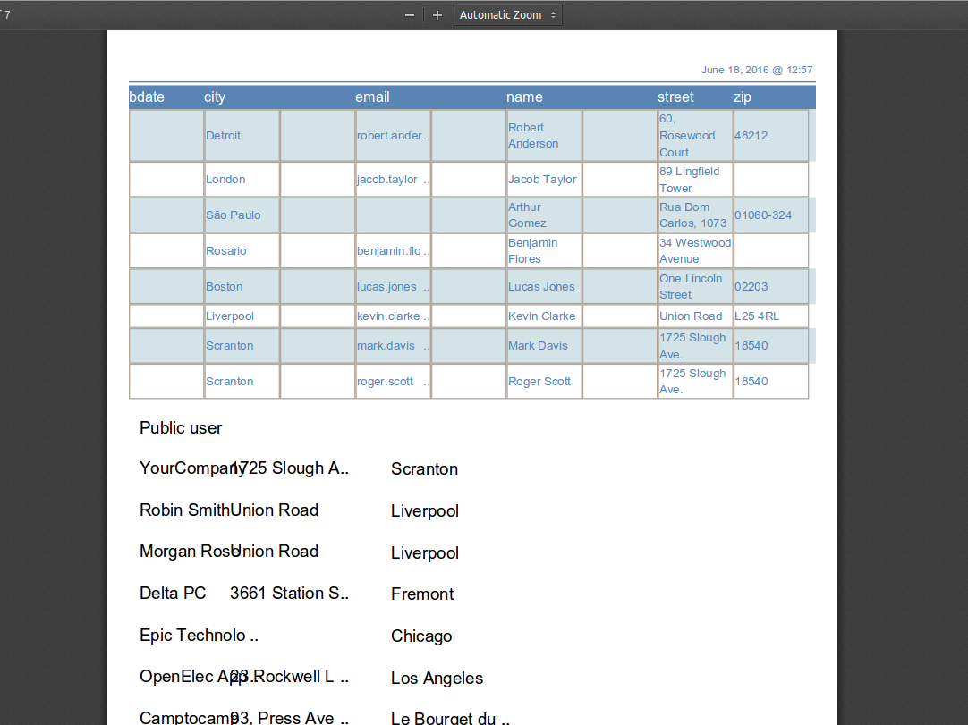

Design Pentaho Report with Parameter :
- Again, Click File ->New, It will open new blank report. In right upper corner in Data tab, right click on Data Sets and select JDBC, create new connection . Now, add queries : 1) On which parameter you want to filter your report and , 2) Fields taht you want to display in report.
e.g , Here, I have try to display Sale_Order details in report, on basis of name field. for that I have made two queries, here On name field I want to filter then make query like this:
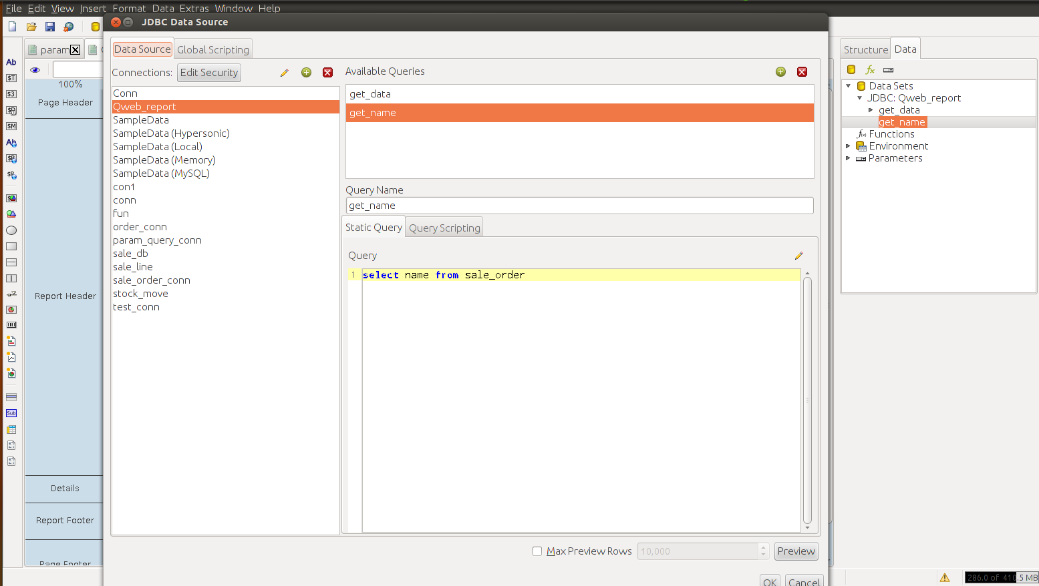
- Now, In right side bar in Data tab, right click on Parameters and select Add parameter, to create new parameter, and give parameter details like this:
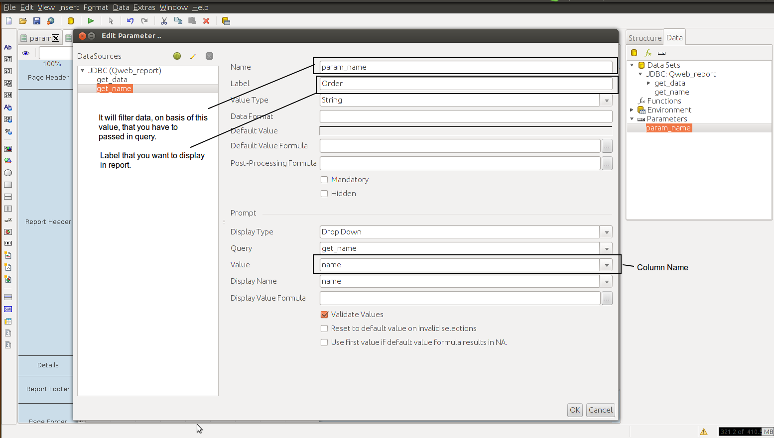
- Now make second query, that display fileds that you want to show in your report.
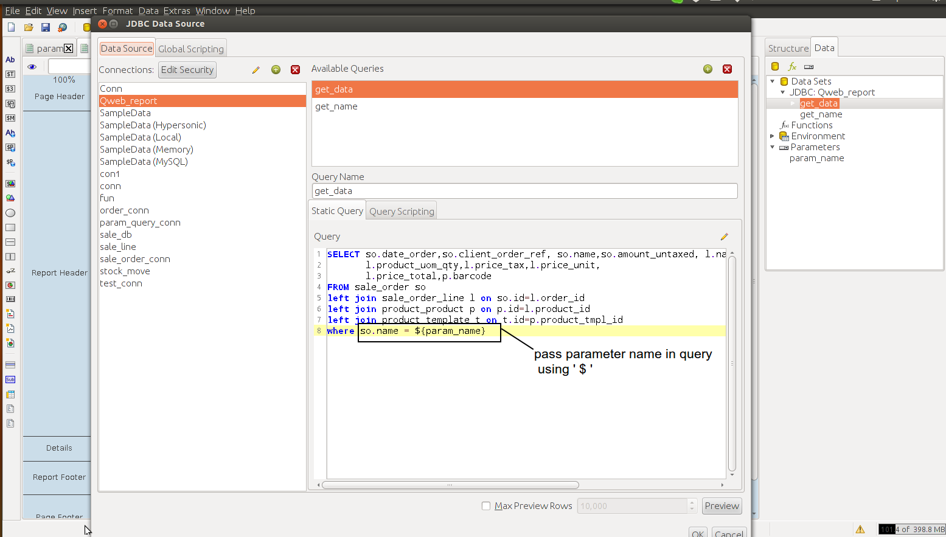
- Next, drag and drop fileds that you want to display in the report , and preview report, it will filter the report based on name field.
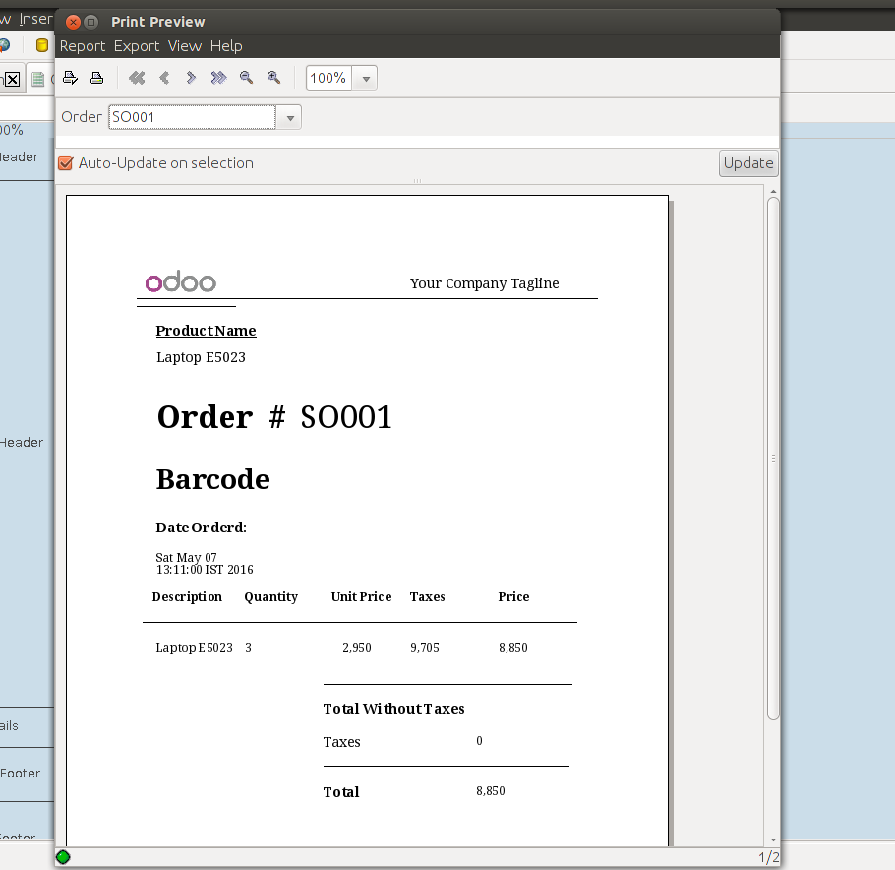

Adding Image Field In Report :
While creating SQL report that need to fetch image from OpenERP , simply selecting column name from table it is not work. OpenERP stores images as base64 encoded, so we have to use decode function to fetch image from OpenERP, So use following query to decode image :
select decode(replace(encode(image,'escape')::text,E'\012',”),'base64') as image from res_partner ;
where, image is column name from res_partner table, this query results all the images from res_partner table configured in an OpenERP databse. Then simply drag your image field in blank report OR Take image-field drop it in your report and set its Attributes property, in that set Attribute named field = image [Column Name]
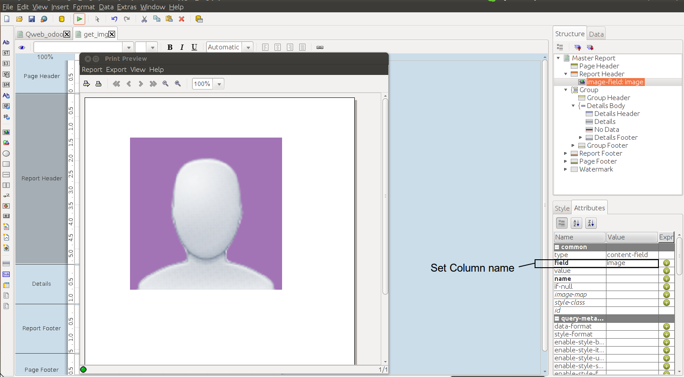

Adding Barcode Field In Report :
Basically, each product have their own barcode. A barcode essentially is a way to encode information in a visual pattern that a machine can read. Barcode have diffrent types e.g, code128, ean13, ean8, isbn, code39 ,etc. By default Pentaho report designer have code128 barcode pattern. So, to read barcode from OpenERP database, we have to simply drop filed of barocde and from Attribute property set barcode type (choose barcode type) . It will give format of barocde depends upon which you have select the barocde type.

Ean13 Barcode Type :
Ean13 have lenght of 13 digit. But, to read barocde needs only 12 digit. In our OpenERP database, barcode field have 13 digits, to show barcode in report we have to select only first 12 digit from database, because last digit of ean13 barcode is checksum, so for that we have to write query like following :
select LEFT(barcode, 12) AS "BARCODE" from product_product ;
It will fetch first 12 digits of Barcode field. Now , drag and drop simple-barcodes from the left panel of the report-designer. Now, set in Attributes property of Barcode , field = BARCODE and type= ean13 , and preview you report.
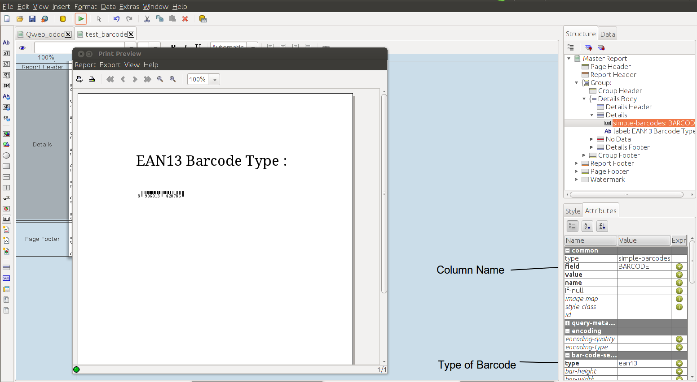

Connect with database of postgress in Pentaho:
To connect with pentaho reporting server with postgress database , you have to go for in Odoo ->Seetings -> Parameters System Parameters, and edit following parameters according to your system environment. e.g, postgress host, login, password, port, server url etc.
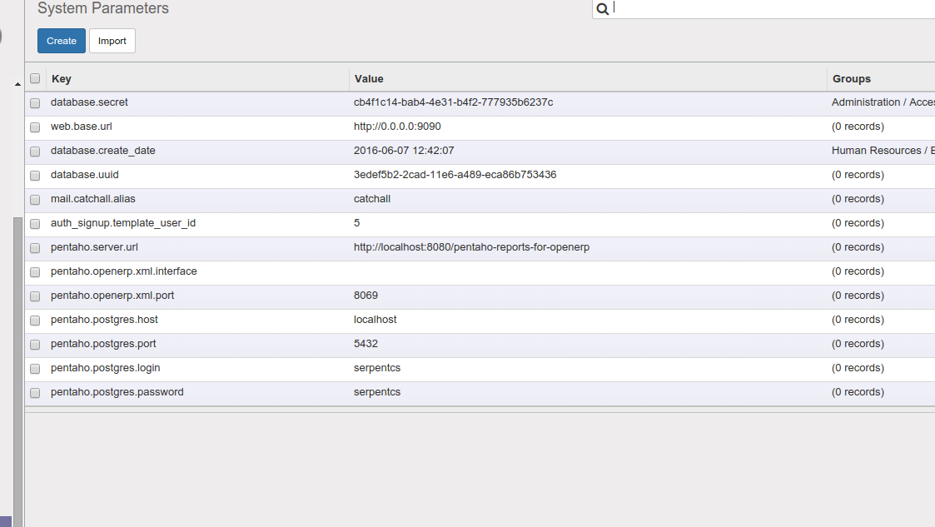
Make menu in odoo using Report Wizard:
To make menu in odoo that print pentaho report , go to Seetings-> Reports->Reports, make new report parameter, like following,
where, Name – Assign name of the menu
Model – Select model that you want to print report , e.g partner
Linked Menu Item – Under whcih you want to show your menu assign that path.
e.g , here I try to show my menu under Sales/Sales.
Report Type – Type of report that you want to print.
Output Format – In which format you want to print your report . e.g, pdf, xls, html etc.
File – In file attribute you have to select .prpt extenstion repot. e.g, Normal, Subreport or Parameter type report.
Template Name – Assign your suitable template name.
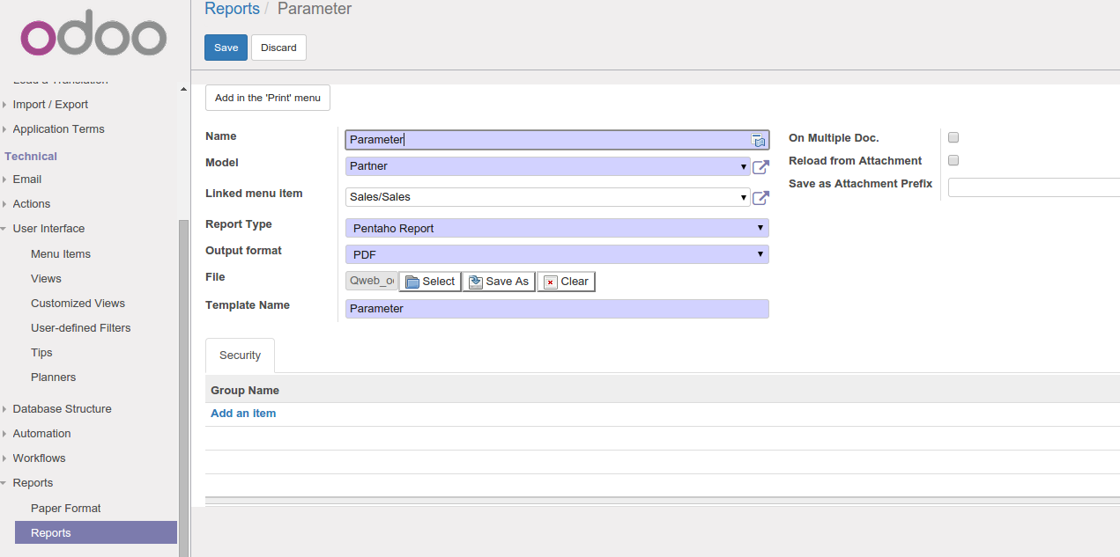
Now, it will appear under Sales -> Sales , likewise here I try to create Pentaho Normal Report, Subreport and Parameter report menus to print report.
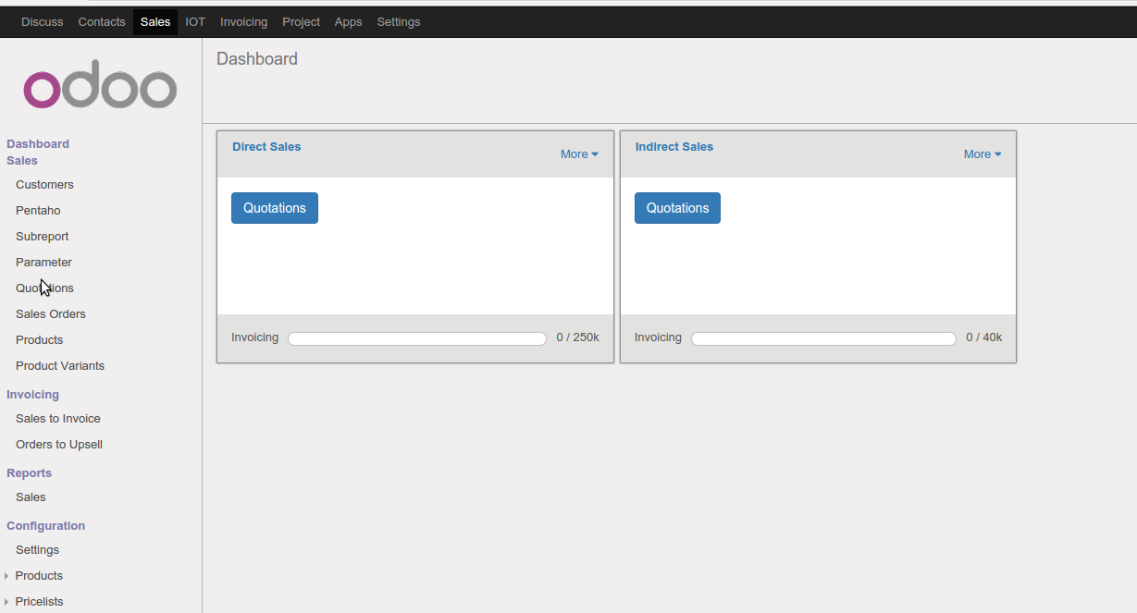
Click on parameter menu, it will open wizard that shows report fromat and attribute which you have made parameter report in pentaho report designer , select id and click on print, it will print report.

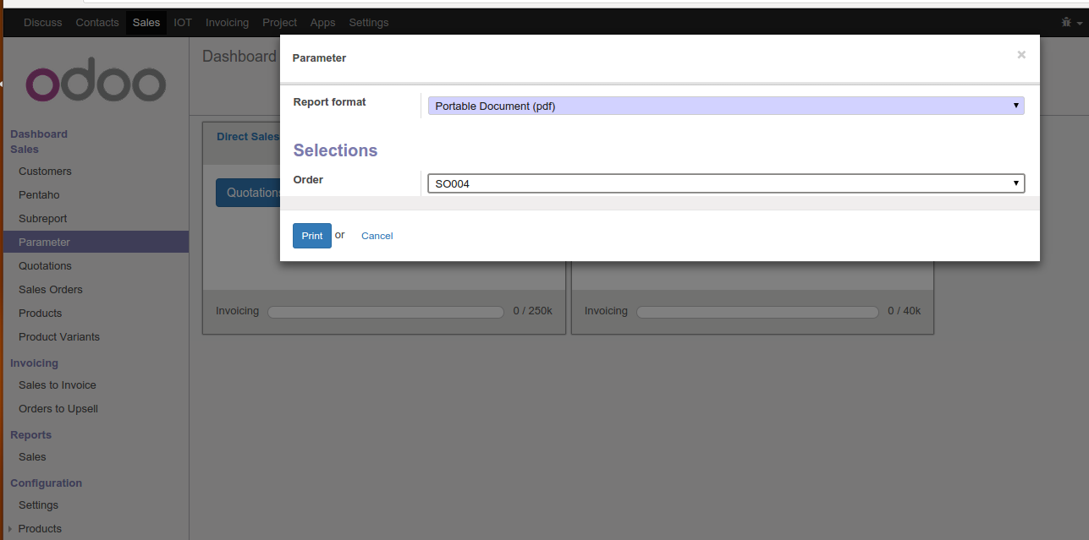
It will print pdf report like following, like wise you can print normal and subreport by creating menus.
