**COMMUNICATION MODEL IN IOT**

*A B.Tech.Seminar Report*

*Submitted in partial fulfilment of*

*the requirements for the*

*Degree of Bachelor of Technology*

*Under Biju Pattnaik University of Technology*

*Submitted by*

**Name:Jayant Panigrahi Roll # ECE201910372**

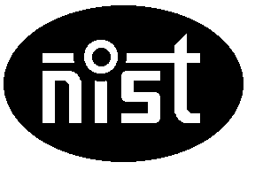

*2019-2023*

*Under the guidance of*

**Dr. Asit Panda**

**NATIONAL INSTITUTE OF SCIENCE & TECHNOLOGY**

**Palur Hills, Berhampur, Odisha - 761008, India**

# ABSTRACT

Now, we are living in an era of Technology where each and every person is completely dependent on it, and has entered the world of Technology intentionally or unintentionally. From last few decades, Technology has acquired its place all over the world, and plays a vital role. This new time furnished with most recent appearances of innovation, enlightening the world as Internet of Things (IoT).

Internet, itself is a revolutionary evolution which has transformed everything. Internet of Things makes the Machine to Machine communication (M2M), the new future. The world is brimming with gadgets, sensors, and other items, and makes human life obviously better and simpler than ever. This report will provide an overview of current research work on IoT in terms of the communication model, its characteristics, benefits, future, security and applications. It also speaks about the most necessary protocols that must be there for the proper communication between various IoT devices.ACKNOWLEDGEMENT

It is my proud privilege to epitomize my deepest sense of gratitude and indebtedness to our advisor **Dr. Asit Panda,** for his valuable guidance, keen and sustained interest, intuitive ideas and persistent endeavour. Her inspiring assistance, laconic reciprocation and affectionate care enabled me to complete my work smoothly and successfully.

I extend our sincere thanks to **Ms Padmaja Mishra, B.Tech. Seminar Coordinator**, for giving us the opportunity and motivating us to complete the Seminar within the stipulated period and providing a helping environment.

I would also like to thank **Dr Sukant K. Mohapatra (Chairman, NIST)**for having been the ultimate source of inspiration and moral support.

I would also like to extend my heartfelt gratitude to my parents and friends for their support and help.

**Jayant Panigrahi**

**Signature of Student**

# TABLE OF CONTENTS

ABSTRACT i

ACKNOWLEDGEMENT ii

TABLE OFCONTENTS iii

LIST OF FIGURES iv

1. INTRODUCTION 1

2. LOGICAL MODEL OF IoT 2

3. SECTIONS OF LOGICAL MODEL 2

4. APPLICATIONS 13

5. CONCLUSION 15

REFERENCES 16

LIST OF FIGURES

**Fig.1.IOT …………………………………..………………………………………1**

**Fig.2. IoT functional Block ………………………………………………….3**

**Fig.3.** **Request & Response Model ..……………………………………………..6**

**Fig.4.** **Publisher-Subscriber Model ……………………………………………...7**

**Fig.5.** **Push-Pull Model ……………………………………………………………8**

**Fig.6.** **Exclusive Pair ………………………………………………………………9**

**Fig.7. REST based communication API………………………………………...10**

**Fig.8. WebSocket based communication API …………………………………13**

# 1. INTRODUCTION

“Internet-of-Things” or IoT is a term which is used as a keyword to cover various aspects associated to the expansion of the Internet and the Web into the physical reality. The Internet of Things is an emerging topic of technical, social, and economic significance [1]. Consumer products, durable goods, cars and trucks, industrial and utility components, sensors, and other everyday objects are being combined with Internet connectivity and powerful data analytic capabilities by widely using spatially distributed devices with embedded identification, sensing and actuation capabilities. In future, IoT devices will be found everywhere and will enable ambient intelligence. It will bring huge changes to the future society, change our way of life and business models. In this document, an overview of the various communication models used in IOT is given.

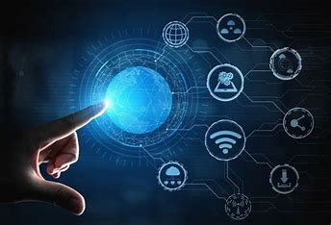

Fig.1

# LOGICAL MODEL OF IoT

The “Logical Design” of IoT is the framework or the imaginary ideal design in which the components including software and the hardware components will be laid out. It doesn’t go into the depth of describing how each component will be built with low-level programming specifics.

* Logic Design of IoT refers to 3 section:

i. IoT functional Block

ii. IoT Communication Model

iii. IoT Communication API

1. **IoT functional Block**

An IoT system consists of a number of functional blocks that provide the system with the capabilities for identification, sensing, actuation, communication and management. The function of the Communication functional block in short **Handles the communication for the IoT system**.

Any IoT system will have several functional blocks like Devices, communication, security, services, and application. With the help of the functional blocks, we provide sensing, identification, actuation, management, and communication capability. These blocks also include the physical components too.

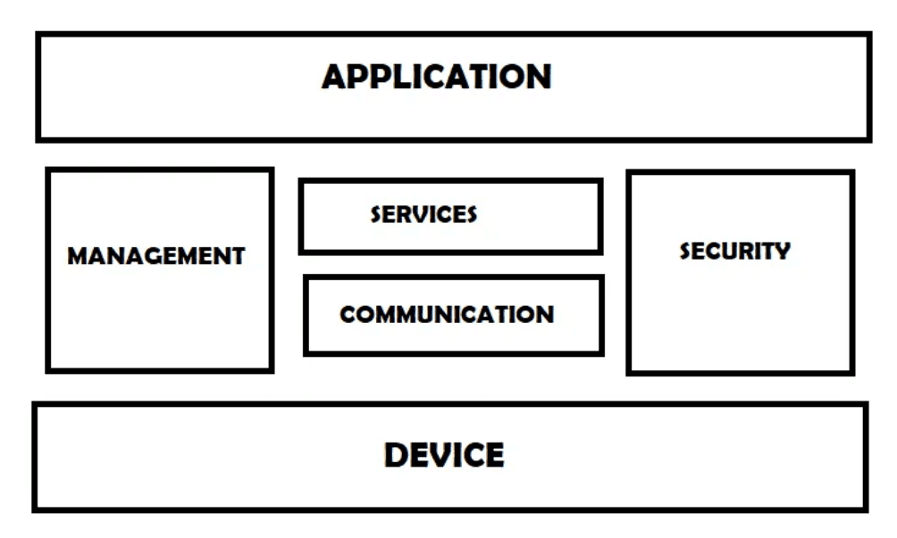

Fig.2

* **Device**: The device enabled with sensing, actuating, monitoring and controling functions.
* **Communication**: This block handles the communication for IoT systems.
* **Services**: IoT systems uses various types of services such as device monitoring, device control services, data publishing services, data publishing services and device discovery services.
* **Management**: This block provides various functions to provide various functions to govern the IoT system.
* **Security**: This IoT system provide various functions like authentication, authorization,message and content integrity and data security.
* **Application**: IoT applications provide an interface that the users can use to control and monitor various aspects of the IoT system. It also allows viewing the system status and view or analysing the processed data.

**ii. IoT Communication Model**

IoT devices are found everywhere and will enable circulatory intelligence in the future. For operational perception, it is important and useful to understand how various IoT devices communicate with each other. Communication models used in IoT have great value. The IoTs allow people and things to be connected any time, any space, with anything and anyone, using any network and any service.

Types of Communication Model :

**1. Request & Response Model –**

This model follows a client-server architecture. The client, when required, requests the information from the server. This request is usually in the encoded format.This model is stateless since the data between the requests is not retained and each request is independently handled. The server Categories the request, and fetches the data from the database and its resource representation. This data is converted to response and is transferred in an encoded format to the client. The client, in turn, receives the response. On the other hand — In Request-Response communication model client sends a request to the server and the server responds to the request. When the server receives the request it decides how to respond, fetches the data retrieves resources, and prepares the response, and sends it to the client.

Fig.3

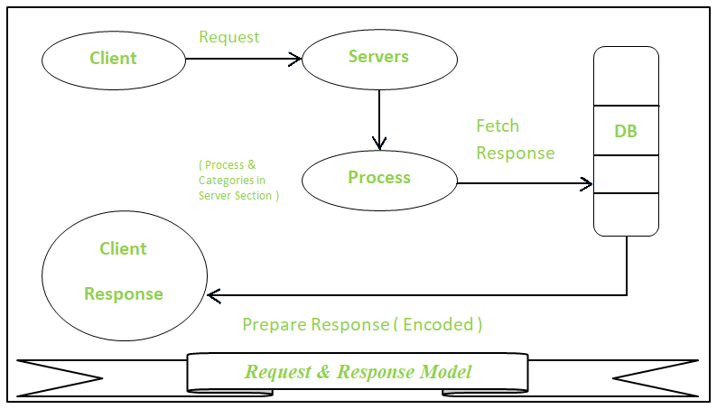

**2. Publisher-Subscriber Model –**

This model comprises three entities: Publishers, Brokers, and Consumers. Publishers are the source of data. It sends the data to the topic which are managed by the broker. They are not aware of consumers.

Consumers subscribe to the topics which are managed by the broker.Hence, Brokers responsibility is to accept data from publishers and send it to the appropriate consumers. The broker only has the information regarding the consumer to which a particular topic belongs to which the publisher is unaware of.

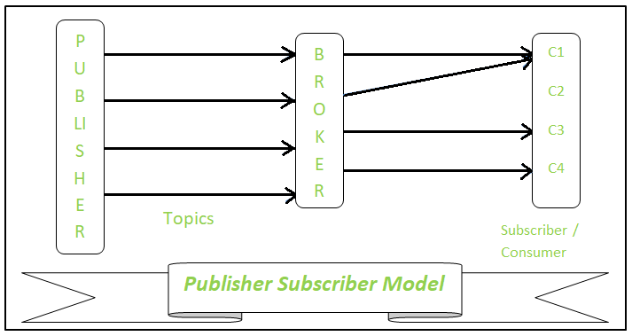

Fig.4

**3. Push-Pull Model –**

The push-pull model constitutes data publishers, data consumers, and data queues.Publishers and Consumers are not aware of each other.

Publishers publish the message/data and push it into the queue. The consumers, present on the other side, pull the data out of the queue. Thus, the queue acts as the buffer for the message when the difference occurs in the rate of push or pull of data on the side of a publisher and consumer.

Queues help in decoupling the messaging between the producer and consumer. Queues also act as a buffer which helps in situations where there is a mismatch between the rate at which the producers push the data and consumers pull the data.

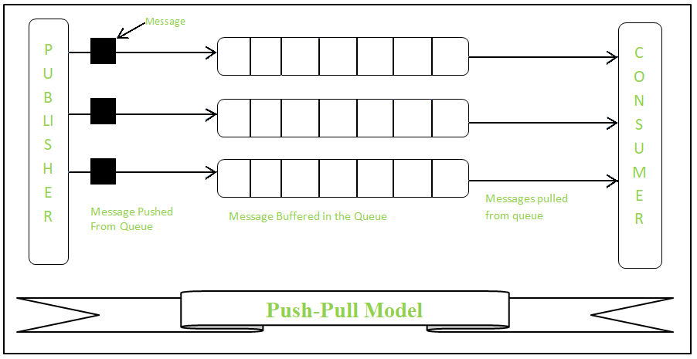

Fig.5

**4. Exclusive Pair –**

Exclusive Pair is the bi-directional model, including full-duplex communication among client and server. The connection is constant and remains open till the client sends a request to close the connection.The Server has the record of all the connections which has been opened.This is a state-full connection model and the server is aware of all open connections. WebSocket based communication API is fully based on this model.

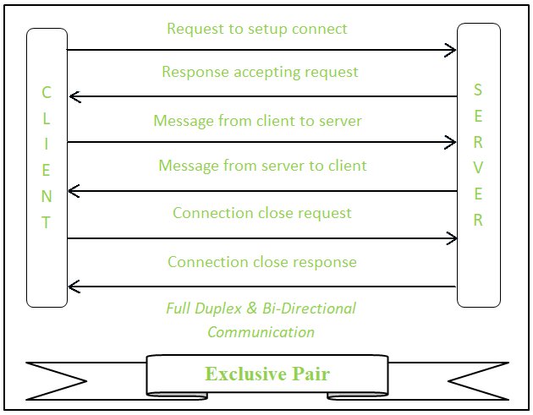

[Fig.6](https://medium.com/m/signin?actionUrl=https%3A%2F%2Fmedium.com%2F_%2Fvote%2Fp%2Fba2a0f8a1c8d&operation=register&redirect=https%3A%2F%2Fmedium.com%2F%40joeshepdcruz%2Flogical-and-physical-design-of-iot-ba2a0f8a1c8d&user=Kotai+Electronics+Pvt.+Ltd.&userId=5a4413e6cf55&source=-----ba2a0f8a1c8d---------------------clap_footer-----------)

**iii. IoT communication APIs:**

What is an API: Application programming interface is a set of requirements that govern how one application can talk to another. API’s do all these things by exposing some of program’s internal functions to the outside world in a limited fashion. Mainly two types of communication APIs are used in IoT.

Those are as follows

• REST based communication API

• WebSocket based communication API

**REST based communication API**

**R**epresentational **S**tate **T**ransfer (REST) is an architectural style that defines a set of constraints to be used for creating web services. **REST API** is a way of accessing web services in a simple and flexible way without having any processing.

REST technology is generally preferred to the more robust Simple Object Access Protocol (SOAP) technology because REST uses less bandwidth, simple and flexible making it more suitable for internet usage. It’s used to fetch or give some information from a web service. All communication done via REST API uses only HTTP request.

**Working:**A request is sent from client to server in the form of a web URL as HTTP GET or POST or PUT or DELETE request. After that, a response comes back from the server in the form of a resource which can be anything like HTML, XML, Image, or JSON. But now JSON is the most popular format being used in Web Services. 

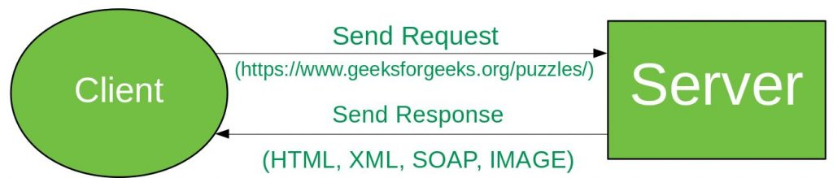

Fig.7

In **HTTP** there are five methods that are commonly used in a REST-based Architecture i.e., POST, GET, PUT, PATCH, and DELETE. These correspond to create, read, update, and delete (or CRUD) operations respectively. There are other methods which are less frequently used like OPTIONS and HEAD.

* **GET:**The HTTP GET method is used to **read** (or retrieve) a representation of a resource. In the safe path, GET returns a representation in XML or JSON and an HTTP response code of 200 (OK). In an error case, it most often returns a 404 (NOT FOUND) or 400(BADREQUEST).
* **POST:** The POST verb is most often utilized to **create** new resources. In particular, it’s used to create subordinate resources. That is, subordinate to some other (e.g. parent) resource. On successful creation, return HTTP status 201, returning a Location header with a link to the newly-created resource with the 201 HTTP status. *.*
* **PUT:**It is used for **updating** the capabilities. However, PUT can also be used to **create** a resource in the case where the resource ID is chosen by the client instead of by the server. In other words, if the PUT is to a URI that contains the value of a non-existent resource ID. On successful update, return 200 (or 204 if not returning any content in the body) from a PUT. If using PUT for create, return HTTP status 201 on successful creation. PUT is not safe operation but it’s idempotent.
* **PATCH:**It is used to **modify** capabilities. The PATCH request only needs to contain the changes to the resource, not the complete resource. This resembles PUT, but the body contains a set of instructions describing how a resource currently residing on the server should be modified to produce a new version. This means that the PATCH body should not just be a modified part of the resource, but in some kind of patch language like JSON Patch or XML Patch. PATCH is neither safe nor idempotent.
* **DELETE:**It is used to **delete** a resource identified by a URI. On successful deletion, return HTTP status 200 (OK) along with a response body.

**Idempotence:**An idempotent HTTP method is a HTTP method that can be called many times without different outcomes. It would not matter if the method is called only once, or ten times over. The result should be the same. Again, this only applies to the result, not the resource itself.

**WebSocket based communication API**

API stands for Application Programming Interface. API can be defined as a predefined set of instructions that describes how different applications can communicate with one another. So one can think of API as a middleman for transferring data between a web server and the application. Every app is using some kind of API to transfer data between applications. API provides the ability for different applications to open up their functionalities and data to other external parties to make use of it and develop new applications. Google Maps API, Twitter API are some well-known examples.

**WebSocket:** WebSocket is a communication protocol that is mainly used for communication between a client and server.

**Features of WebSocket are:**

* **Full-Duplex Protocol:** WebSocket is a full-duplex protocol as it allows the application to send and receive data at the same time.
* **Stateful Protocol:** It means the connection between server and client will not be terminated until and unless closed by any one of them either by the client or by the server. Once the connection is terminated from one end it is also closed by another end.
* **3-way handshake:**Websocket uses a 3-way handshake also known as TCP connection for establishing communication between a client and server.

**WebSocket API:** WebSocket API allows us to create web sockets, it is a javascript API that is capable of full-duplex communication using a TCP connection. WebSocket uses port 80 by default.

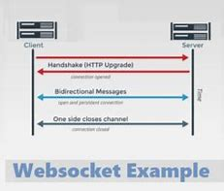

Fig.8

**Features of WebSocket API are:**

* Bidirectional means data can be sent and received by both sides client-side as well as the server-side.
* Use of full-duplex model for communication.
* It uses a single TCP connection for communication between client and server.
* Mainly used in real-time applications like chat applications, video calls applications, etc.
* Fast transmission of data can be achieved using web sockets.
* Scaling is possible but only vertically.

**Use of WebSocket API:**There is a wide range of uses of WebSocket API’s some of them are:

* **Online Education Sector:** Web sockets are obviously used in online education applications because these applications need real-time data for video streaming or for sharing screen which makes web sockets a very good choice because it has the capability to provide all these functionalities.
* **Gaming:**The world is going crazy after games, users want real-time games to play with multiple players along with chat and call facilities so to achieve all these things it is a must for anyone to use web sockets for developing different gaming applications.
* **Collaborative applications:** We all have used google docs which makes it possible for multiple persons to use the same workspace and work concurrently, these applications are built using HTML5 WebSockets.
* **Real-time data visualization:** Visualisation of real-time data in an appealing manner was a quite tough task earlier but with the use of html5 web sockets it is really easy.
* **Event Update applications:**Web sockets are extensively used in making applications for giving real-time updates of all platforms to some common platform.
* **Tracking User Behaviour:** Organisations are really interested in knowing user’s behavior while interacting with a web application so to give better recommendations about the content or product the user is looking for. In achieving all these things web socket is a must-go choice.

**IoT Applications in Various Domains**

Some applications of IoT in real-life includes:

* **Wearables**

Smartwatches have met the growing demand in the global market. But, how do they work? These smart devices are equipped with sensors and the installed software part that collects data and information about users. This data is then processed in advance to extract important information about the user.

* **Connected Cars**

Digital automotive technology focuses on increasing the internal functioning of automobiles. But now, this is growing in improving the information in the car. A connected car is a vehicle that can fulfill its full functionality, care and comfort for passengers using the sensors mounted and an internet connection.

* **Industrial Internet**

The industrial internet is a new phenomenon in the industrial sector, also known as the Industrial Internet of Things (IIoT). It empowers industrial engineering with sensors, software and data analytics to build intelligent machines. The driving philosophy behind IIoT is that smart devices are more accurate and flexible than people in communicating with data. Also, this data can help companies identify inefficiencies and problems quickly.

* **IoT use cases in Agriculture**

With the world’s growing population, the demand for food increases dramatically. Governments are helping farmers use advanced techniques and research to increase food production. [Smart farming is one of the fastest-growing fields in IoT](https://www.airtel.in/blog/business/iot-in-agriculture-enabling-smart-farming-for-maximizing-productivity-yield/). Farmers use sound data from the database to get better returns on investment. Feeling the soil moisture and nutrients, controlling water use for plant growth, and cutting custom fertilizers are some of the easiest ways to use IoT.

* **Smart Retail**

The potential of IoT in the retail sector is enormous. IoT provides an opportunity for retailers to connect with customers to improve store information. Smartphones allow retailers to stay in touch with their customers even when they are not in the store. Working with smartphones and using Beacon technology can help marketers better serve their customers.

* **IoT in Healthcare**

Connected healthcare is still a giant of the Internet of Things wireless communication app. IoT in healthcare aims to empower people to live healthier lives by wearing connected devices. The data collected will help in the personal analysis of a person’s health and provide strategies designed to fight the disease.

**CONCLUSION:-**

It will be possible to innovate technology and increase the economy via effective IoT communication modules, IoT communication patterns, IoT communication standards, etc. As more gadgets become interconnected, they will be able to use data streams to develop new goods. Under the device-to-device communication paradigm, devices can communicate directly without needing an application server. The protocol used is often proprietary. The Internet of Things’ stateless communication style allows devices to connect across several networks.

# 

# REFERENCES

[1] John A. Stankovic, “Research Directions for the Internet of Things” *IEEE Internet of Things Journal*, Vol.1, No.1, pp. 3-9

[2] P. F. E. Silva, V. Kaseva, and E. S. Lohan, ‘‘Wireless positioning in IoT:A look at current and future trends,’’ *Sensors,* vol. 18, no. 8, p. 2470, 2018.

[3] O. Liberg, M. Sundberg, E. Wang, J. Bergman, and J. Sachs, “*CellularInternet of Things: Technologies, Standards, and Performance*.” New York,NY, USA: Academic, 2017.