Aim: practical to analyze a network packet image file in Wireshark

Questions:

**1.** For what server did the client try to resolve an IPv6 address?

Steps:

1. An IPV6 address resolution looks for the value AAAA in the DNS query. So first apply DNS has a filter option in Wireshark.

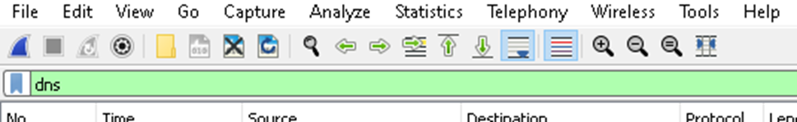

2. these will return packets with DNS protocol, search for value AAAA in queries of the packet.

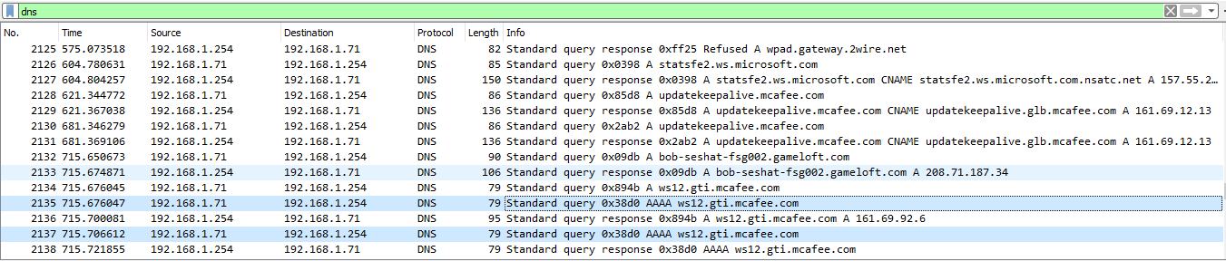

3.when we select the packet with AAAA value. We can see that query is done by ws12.gti.mcafee.com.

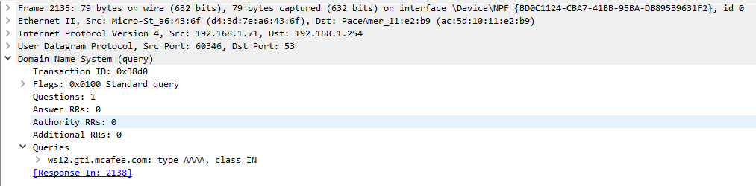

**2.** What operating system do you think the client is running?

Steps:

1. to detect the OS in the packet is from the user-agent header, so we have to look at every HTTP request.for this purpose we will apply http has a filter option.

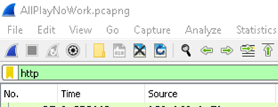

2.select a packet, HTTP tab, and we will set the user-agent header as column view so it will make our task easier to view user-agent for all HTTP requests. Right-click on user-agent and select Apply As Column.

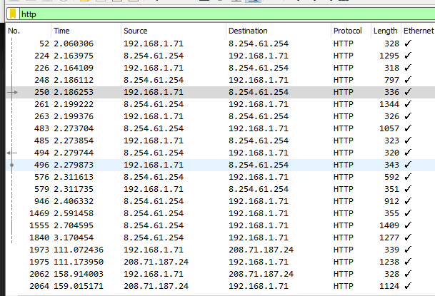

3.This will add a User-Agent column and display the User operating system