**Name-**Jayanta Ghosh

**Roll no-**190112

**Write a program to exhibit**

i) structural equivalence,

ii) automatic equivalence, &

iii) regular equivalence from a network.

**Implementation:-**

library(sna)

library(igraph)

links2 <-read.csv("D:\\Pictures\\SNA\\Dataset2-Media-User-Example-EDGES.csv", header=T, row.names=1)

eq<-equiv.clust(links2)

plot(eq)

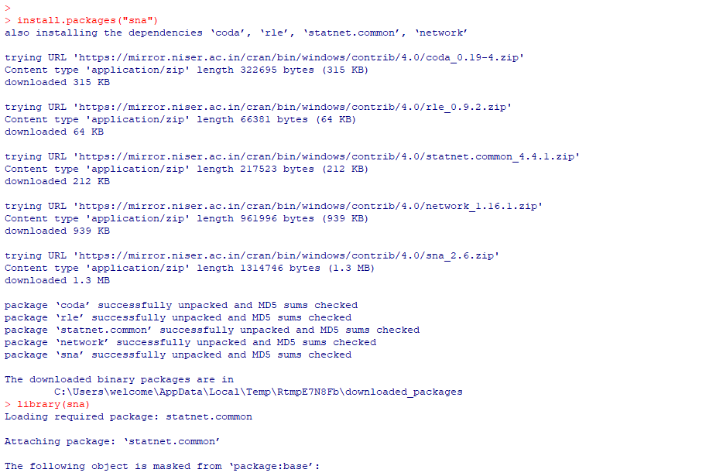

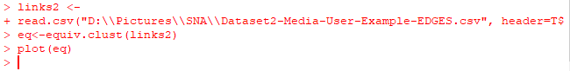

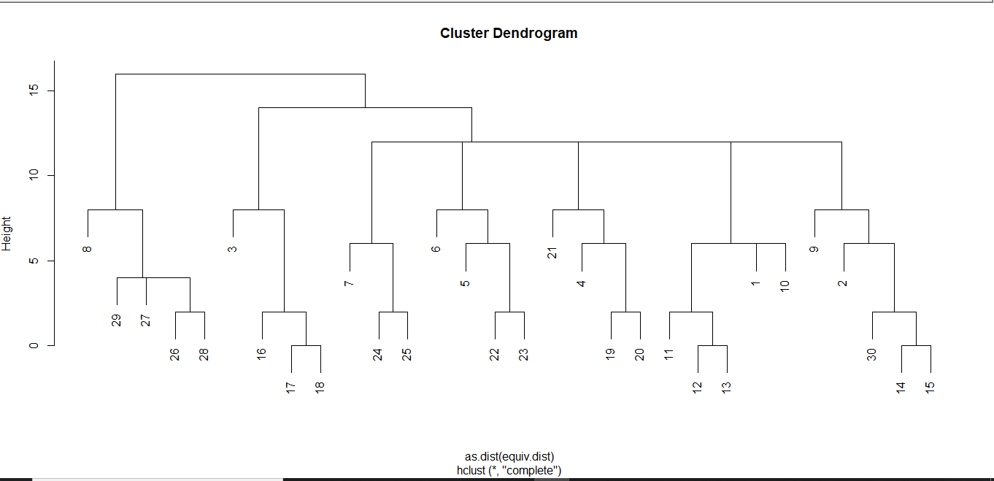

**Get Structural Equivalence distances**

g.se<-sedist(links2)

**Plot a metric MDS of vertex positions in two**

**dimensions**

plot(cmdscale(as.dist(g.se)))

D:\Pictures\SNAPrac6\4.PNG

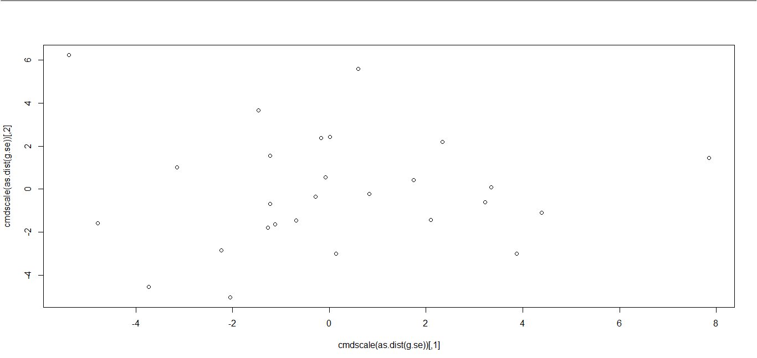

**Blockmodeling**

b<-blockmodel(links2, eq, h=10)

plot(b)

D:\Pictures\SNAPrac6\6.PNG

