**Displaying Bipartite network in the graph format**

**Implementation:-**

library(igraph)

davis <- read.csv(file.choose("

g<- graph.data.frame(davis, directed=FALSE)

plot(g)



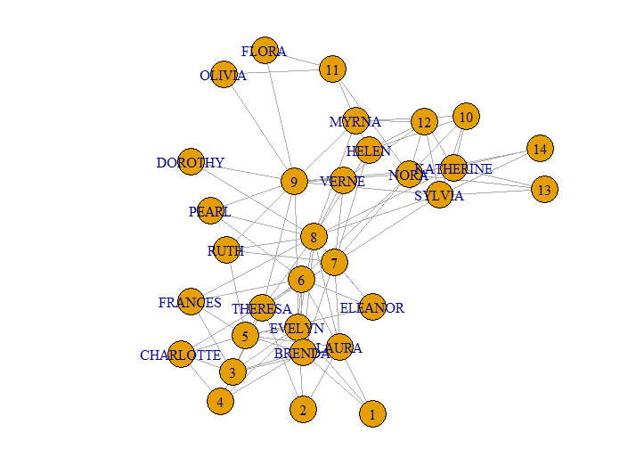

bipartite.mapping(g)

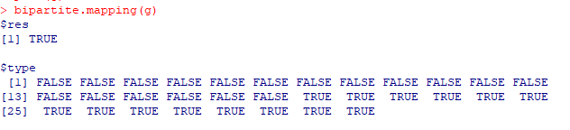

V(g)$type <- bipartite_mapping(g)$type

plot(g)

D:\Pictures\SNAPrac9\4.PNG

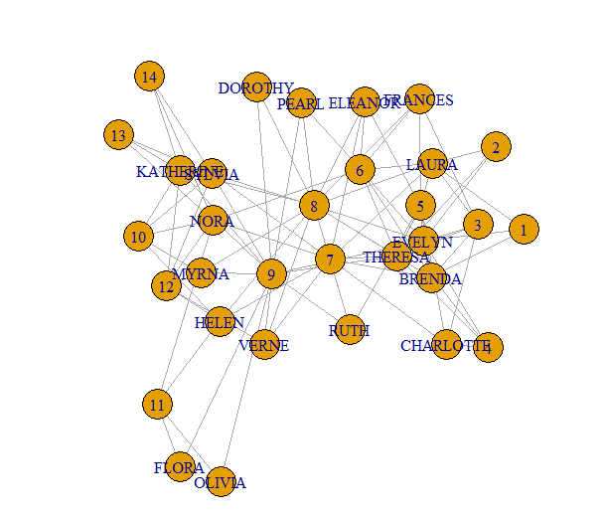

plot(g, vertex.label.cex = 0.8, vertex.label.color ="black")

D:\Pictures\SNAPrac9\6.PNG

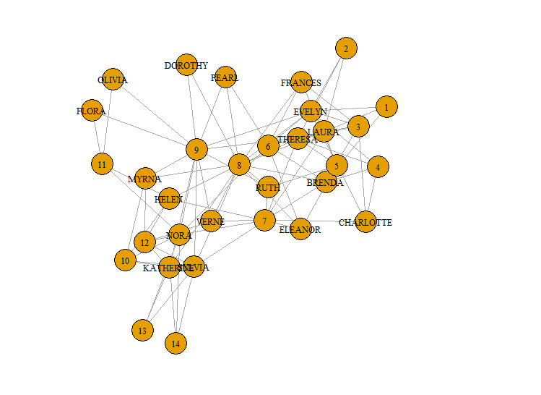

V(g)$color <- ifelse(V(g)$type, "lightblue", "salmon")

V(g)$shape <- ifelse(V(g)$type, "circle", "square")

E(g)$color <- "lightgray"

plot(g, vertex.label.cex = 0.8, vertex.label.color ="black")



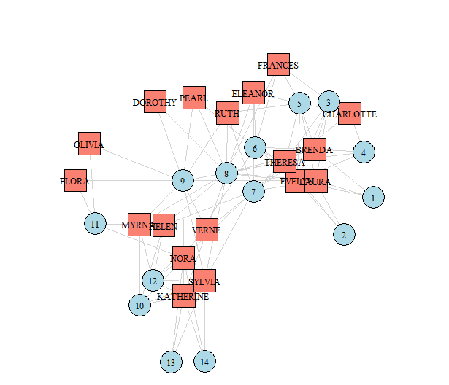

V(g)$label.color <- "black"

V(g)$label.cex <- 1

V(g)$frame.color <- "gray"

V(g)$size <- 18

plot(g, layout = layout_with_graphopt)



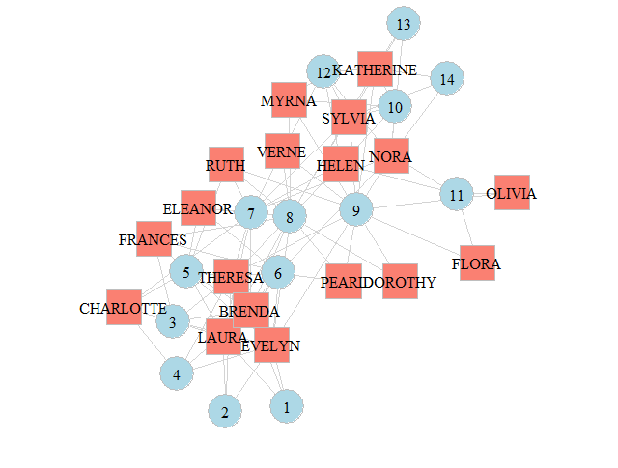

plot(g, layout=layout.bipartite, vertex.size=7,vertex.label.cex=0.6)

