Single LIF Neuron:

Figure 1.

Op-amp U4 amplifies output voltage signal to activate NMOS M2 which drains the input voltage to the resting voltage of 60mV. An inductor L2 is placed at the gate of the NMOS to sustain the applied gate voltage, thereby inducing a “refractory” period. The oscillations should not be of concern due to the hysteresis mechanism of the Schmitt trigger.

Input Current and Input Voltage:

Figure 2.

Refractory Period

Output Spike (same input spike pattern as fig 2):

Figure 3.

Problem: How to change width of output current spike. Looking into sample and hold circuit.

TWO NEURON NETWORK:

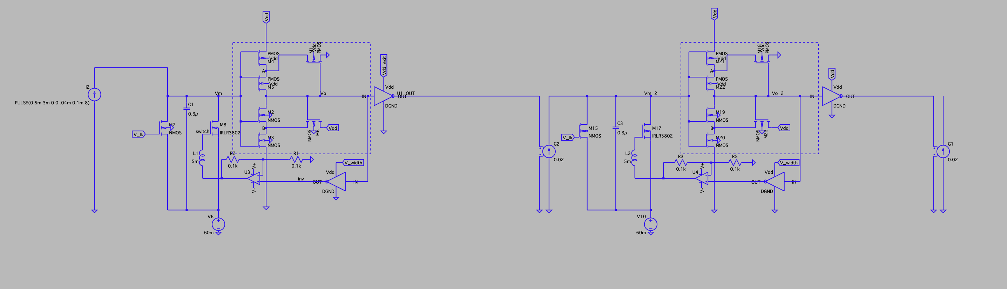

Figure 4.

Input voltage and output current spike of N1

Figure 5.

Input voltage and output current spike of N2:

Figure 6.

Input and output current spike of N2:

Figure 7.

Note that the output spike of N2 is larger than N1’s current spike. This can be overcome by changing the gain value of the voltage-controlled-current source.

THREE NEURON NETWORK:

Figure 8.