Organ Donate



A project report submitted to

Rajiv Gandhi Proudyogiki Vishwavidhyalaya, Bhopal

towards partial fulfillment of

the degree of

**MASTER OF COMPUTER APPLICATION**

**{2020-21}**

**Submitted by:**

Jayant Talwar

0801CA191011

**Guided By:**

Mr Upendra Singh

*Department of Information*

*Technology*

Department of Information Technology

**SHRI G.S. INSTITUTE OF TECHNOLOGY AND SCIENCE**

**INDORE (M.P.)**

**SHRI G.S. INSTITUTE OF TECHNOLOGY AND SCIENCE**

**INDORE (M.P.)**



**Recommendation**

The project report entitled **“Fee App”** submitted by **Jayant Talwar** students of Second year in the session 2020-21, towards partial fulfillment of the degree of **Master of Computer Applications** of Rajiv Gandhi Proudyogiki Vishwavidhyalaya, Bhopal, is a satisfactory account of his work and is recommended for the award of degree**.**

**Upendra Singh**

Project Guide

Department of IT

**Head**

Department of IT

**Dean(Academics)**

**S.G.S.I.T.S.,Indore**

**SHRI G.S. INSTITUTE OF TECHNOLOGY AND SCIENCE**

**INDORE (M.P.)**



**Certificate**

The project report entitled **“*Fee App”*** submitted by **Jayant Talwar** students of Second year in the session 2020-21, towards partial fulfillment of the degree of **Master of Computer Applications** of Rajiv Gandhi Proudyogiki Vishwavidhyalaya, Bhopal, is a satisfactory account of their work and is approved for award of the degree.

**Internal Examiner External Examiner**

**Date**

**Acknowledgement**

I am heartily pleased to acknowledge all those people who have helped me in the successful completion of this project. With great pleasure i express my heartfelt gratitude to our esteemed guide, **Mr. Upendra Singh** Lecturer Department of information Technology, S.G.S.I.T.S. Indore. His persistent encouragement, perpetual motivation, everlasting patience and valuable technical inputs in discussions have enabled the successful completion of this project. His invaluable help, advice and constant encouragement helped us a lot and provide impetus to the progress of the project. We extend our profound indebtedness to the Head of the department **Ms. Sunita Varma,** the word loose their worth for her invaluable guidance, continuous encouragement and cooperation in every respect.

I sincerely wish to express our gratitude to all the members of staff of M.C.A.who have extended their cooperation at all times and have contributed in their own way in developing the project. Successful completion of a project is not an individual effort. It is an outcome of the cumulative effort of a number of persons, each having his own importance to the objective. We are thankful to our parents for being a constant source of encouragement in all our endeavors. Indeed it is their support that helps us through the ups and downs of life. The support and suggestion of our friends are worth appreciation and thankfulness. *A blend of gratitude, pleasure, great satisfaction and indebtedness is what, we feel to convey to all those who have directly or indirectly contributed to the successful completion of our project work.*

**Jayant Talwar**

***Table of Contents***

**Chapter 1.**

**Introduction**

1.1 Objective …1

1.2. Scope …1

1.3. Technologies used …1

**Coding 2-5**

**Output 6-7**

**References**

**Chapter 1**

**Introduction**

* 1. **Objective**

Aim of “**Fee App**” to maintain the student record and fee details .

* 1. **Scope**

 To view the **fee** details provided by the administrator **.**

* 1. **Technology used**

1. Java

**Coding**

package com.FeeApp;

import java.util.Iterator;

import java.util.List;

import java.util.Scanner;

import com.bean.Student;

import com.model.StudentModelImpl;

import com.model.StudentModelInt;

import com.util.FeeUtility;

public class FreeReportApp {

private static Scanner sc = new Scanner(System.in);

private static StudentModelInt model = new StudentModelImpl();

private static FeeUtility util = new FeeUtility();

public static void main(String[] args) {

int ch = 0;

boolean b = true;

while (b) {

util.header();

ch = sc.nextInt();

switch (ch) {

case 1:

add();

break;

case 2:

viewAll();

break;

case 3:

findById();

break;

case 4:

deleteRecord();

break;

default:

break;

}

}

System.out.println("\n");

}

private static void findById() {

System.out.println("Enter Student Id");

long id = sc.nextLong();

Student bean=model.findById(id);

if (bean == null) {

System.out.println("Invalid Id");

} else {

System.out.println(

"| Id | Name | EmailId | MobileNo | Gender | Dob | Address | Course Name | Price | Pay Amount | Due |");

System.out.println("| " + bean.getId() + " | " + bean.getName() + " | " + bean.getEmail()

+ " | " + bean.getMobileNo() + " | " + bean.getGender() + " | " + bean.getDob()

+ " | " + bean.getAddress() + " | " + bean.getCourseName() + " | "

+ bean.getPrice() + " | " + bean.getTotalPrice() + " | " + bean.getDue()

+ " |");

}

}

private static void viewAll() {

List<Student> list = model.list();

if (list == null && list.size() == 0) {

System.out.println("Record Not Found");

} else {

Iterator<Student> it = list.iterator();

System.out.println(

"| Id | Name | EmailId | MobileNo | Gender | Dob | Address | Course Name | Price | Pay Amount | Due |");

while (it.hasNext()) {

Student bean = (Student) it.next();

System.out.println("| " + bean.getId() + " | " + bean.getName() + " | " + bean.getEmail()

+ " | " + bean.getMobileNo() + " | " + bean.getGender() + " | " + bean.getDob()

+ " | " + bean.getAddress() + " | " + bean.getCourseName() + " | "

+ bean.getPrice() + " | " + bean.getTotalPrice() + " | " + bean.getDue()

+ " |");

}

}

}

private static void deleteRecord() {

System.out.println("Enter Student Id");

long id = sc.nextLong();

if (model.findById(id) == null) {

System.out.println("Invalid Id");

} else {

model.delete(id);

util.getSuccessDelete();

}

}

private static void add() {

Student bean = null;

bean = selectFaculty();

System.out.println("Enter Studnet Detail :");

System.out.println("|--------------------------------------------------------------------|");

System.out.println("Enter Id :");

bean.setId(sc.nextLong());

System.out.println("Enter Name :");

bean.setName(sc.next());

System.out.println("Enter Email Id :");

bean.setEmail(sc.next());

System.out.println("Enter Mobile No. :");

bean.setMobileNo(sc.next());

System.out.println("Enter Gender :");

bean.setGender(sc.next());

System.out.println("Enter Date of Birth");

bean.setDob(sc.next());

System.out.println("Enter Address");

bean.setAddress(sc.next());

System.out.println("Enter Pay Amount");

bean.setTotalPrice(sc.next());

bean.setDue(String.valueOf(Long.parseLong(bean.getPrice()) - Long.parseLong(bean.getTotalPrice())));

model.add(bean);

util.getSuccess();

util.getStudnetDetail(bean);

}

private static Student selectFaculty() {

Student bean = null;

int ch = 0;

util.getFaculty();

ch = sc.nextInt();

switch (ch) {

case 1:

bean = selectFaculty1Course();

break;

case 2:

bean = selectFaculty2Course();

break;

default:

System.out.println("Select at least one");

selectFaculty();

break;

}

return bean;

}

private static Student selectFaculty1Course() {

Student bean = new Student();

int ch = 0;

util.getFaculty1Course();

ch = sc.nextInt();

switch (ch) {

case 1:

bean.setCourseName("C");

bean.setPrice("3000");

break;

case 2:

bean.setCourseName("C++");

bean.setPrice("2000");

break;

case 3:

bean.setCourseName("Core Java");

bean.setPrice("4500");

break;

case 4:

bean.setCourseName("Advance Java");

bean.setPrice("4000");

break;

default:

System.out.println("Select at least one");

selectFaculty1Course();

break;

}

return bean;

}

private static Student selectFaculty2Course() {

Student bean = new Student();

int ch = 0;

util.getFaculty2Course();

ch = sc.nextInt();

switch (ch) {

case 1:

bean.setCourseName("Pythone");

bean.setPrice("5000");

break;

case 2:

bean.setCourseName("Machine learning");

bean.setPrice("4000");

break;

default:

System.out.println("Select at least one");

selectFaculty2Course();

break;

}

return bean;

}

}

**Result**

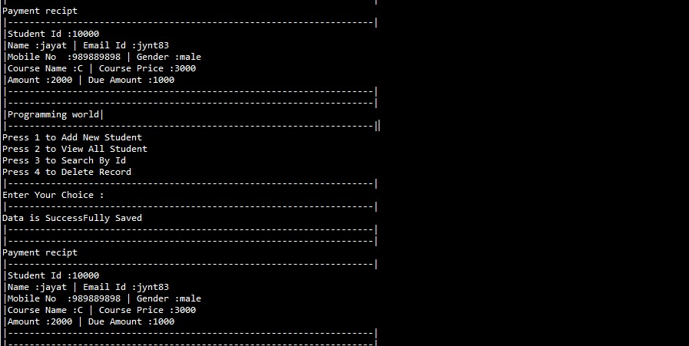

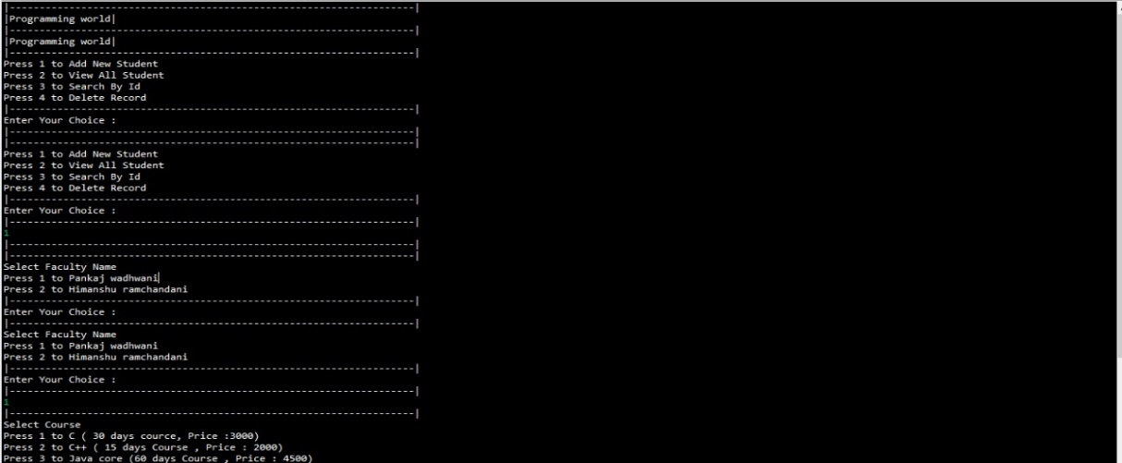

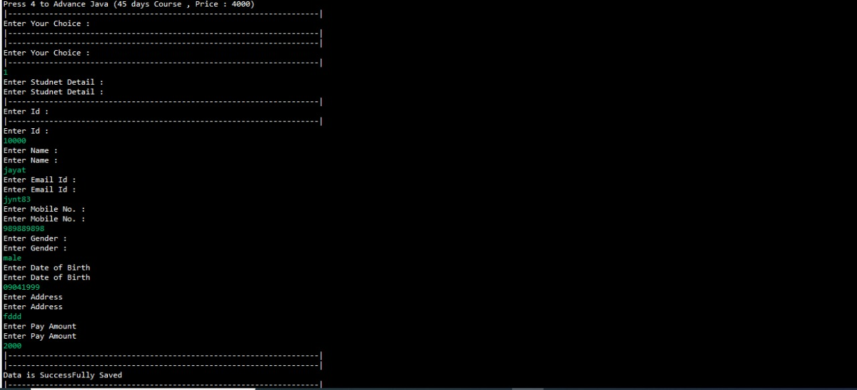

**References**

* [www.google.com](http://www.google.com)
* [www.javatpoint.com](http://www.javatpoint.com)
* [www.geeksforgeeks.com](http://www.geeksforgeeks.com)
* [www.stackoverflow.com](http://www.stackoverflow.com)