**CONTENTS**

1. **INTRODUCTION**
2. **PROJECT DESCRIPTION**
3. **MAPPINGS**
4. **WORKFLOWS**
5. **BUSINESS REQUIREMENTS**
6. **CONCLUSION**

**INVENTORY MANAGEMENT SYSTEM**   **INTEGRATION**

**INTRODUCTION**

I am working as a Informatica Developer in a company, the company has collected data of inventory data of a warehouse over the years, I am assigned to create dimensional tables and to load the data into target and build report of fact table.

**SET UP CHECKUP LIST**

Minimum System Requirements

* Intel i5 or higher
* Microsoft windows 10 and above
* SQL Developer
* Informatica Developer (latest version)
* Memory: 8Gb of Ram or more recommended.

**PROJECT DESCRIPTION**

The purpose of this inventory management system is to transfer inventory related information from one system to another. This could involve moving data from source systems to target systems, consolidating data from multiple sources into single database.

The goals of inventory management system typically include improving data accuracy and integrity during the process.

**SIGNIFICANCE OF INFORMATICA**

The significance of using informatica for employee data migration lies in capabilities as an industry leading ETL tool. Here, are some key reasons comprehensive why informatica is commonly chosen for data migration process.

1. Robust connectivity
2. Data transformation
3. Scalability
4. Data quality and governance
5. Workflow design
6. Performance optimization
7. Metadata management
8. Comprehensive monitoring and logging

**BUSINESS REQUIREMENT DOCUMENT**

INVENTORY_2.CSV  
  
**TECHNOLOGY USED**

* Oracle sql developer
* Windows
* ETL: Informatica

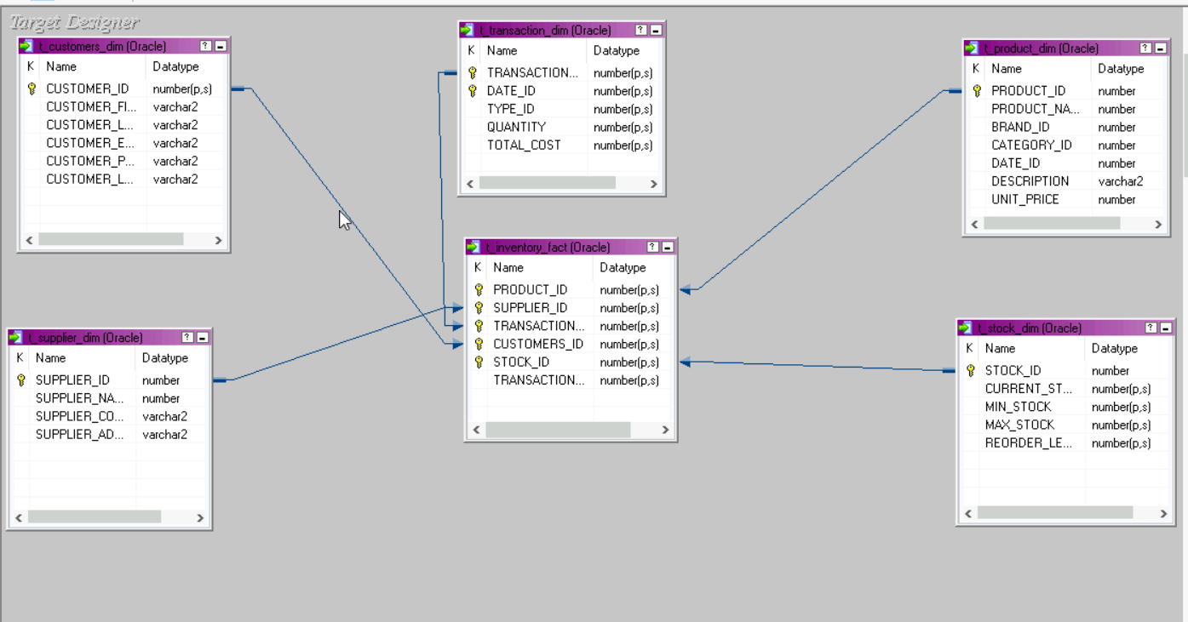

**DIMENSIONAL TABLES:**

DIM_PRODUCT

DIM_CUSTOMERS

DIM_SUPPLIERS

DIM_TRANSACTION

DIM_DATE

DIM_STOCK

**FACT TABLE:**

FACT_INVENTORY

**MAPPINGS**

**SOURCE_TARGET_MAPPING:**

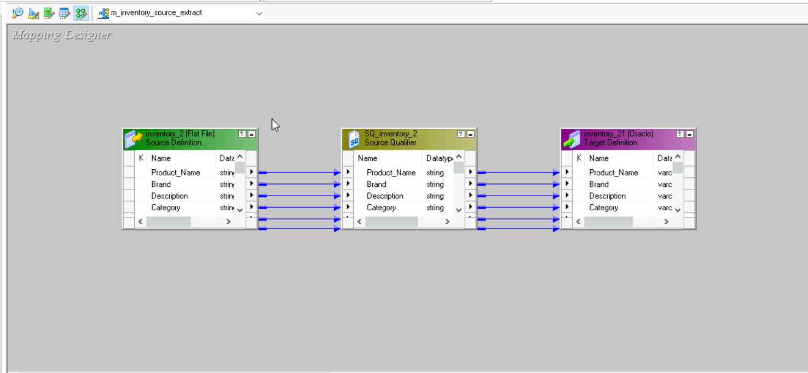

**OUTPUT:**

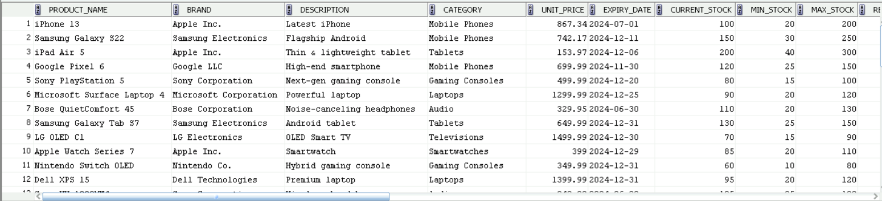

**DIM_PRODUCT:**

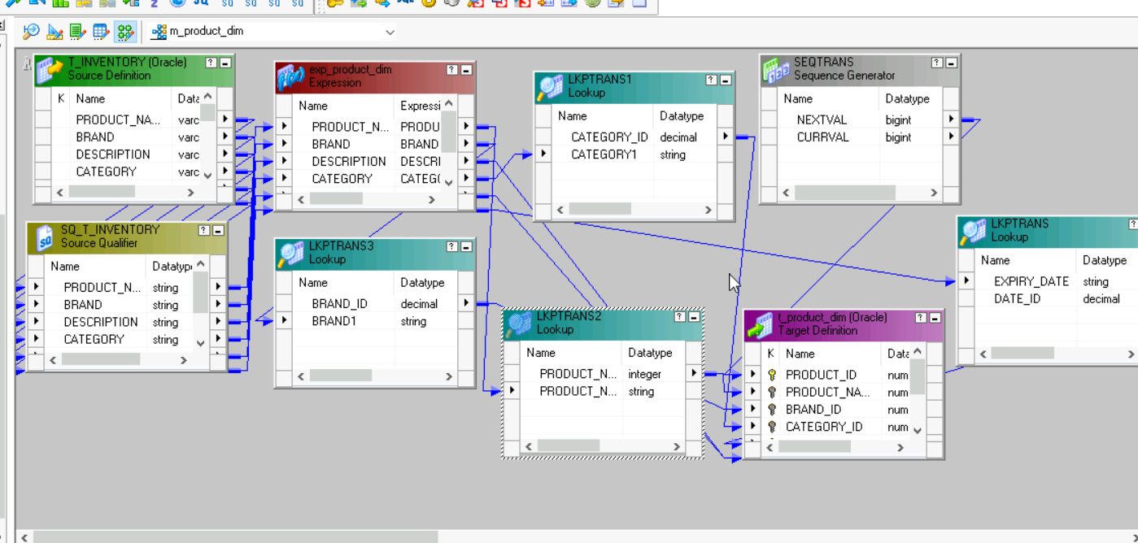

**TRANSFORMATIONS USED:**

* Expression
* Lookup
* Sequence Generator

**OUTPUT:**

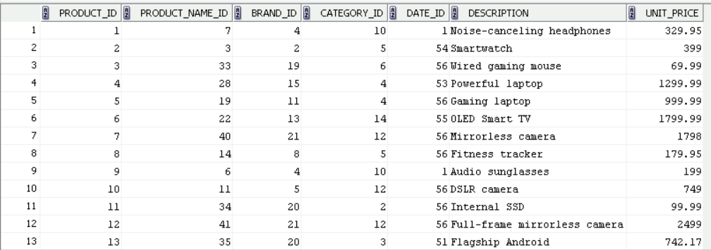

**DIM_CUSTOMERS:**

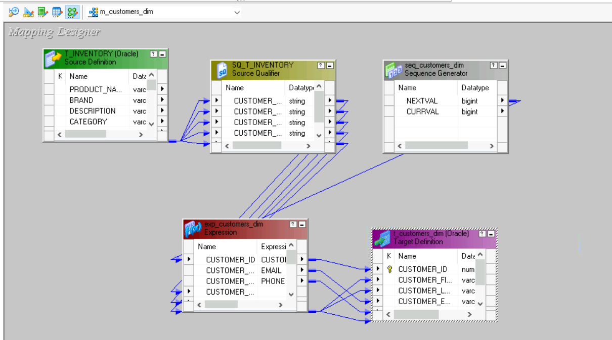

**TRANSFORMATIONS USED:**

* Expression
* Sequence generator

**OUTPUT:**

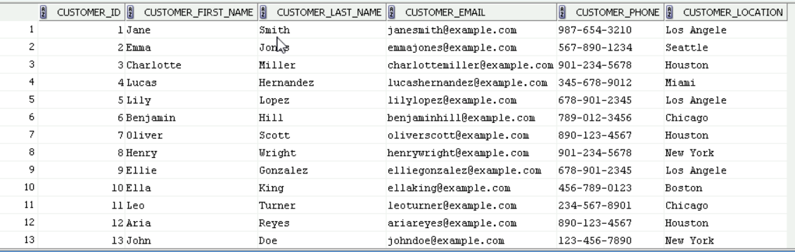

**DIM_SUPPLIERS:**

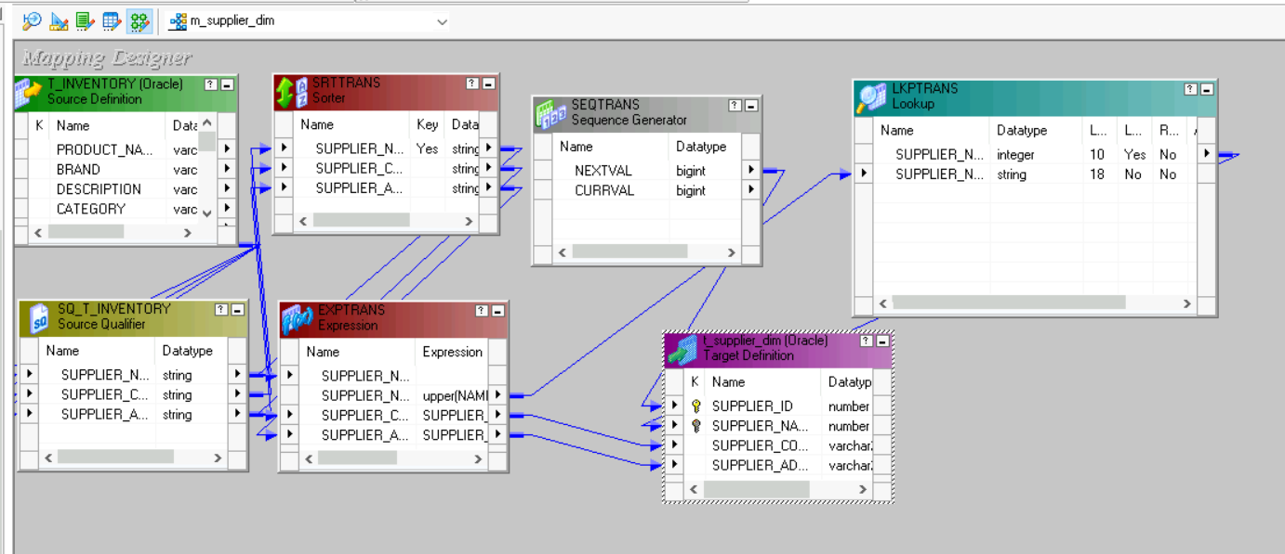

**TRANSFORMATIONS USED:**

* Expression
* Lookup
* Sequence generator
* Sorter

**OUTPUT:**

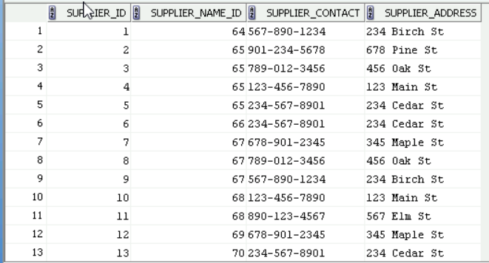

**DIM_STOCK:**

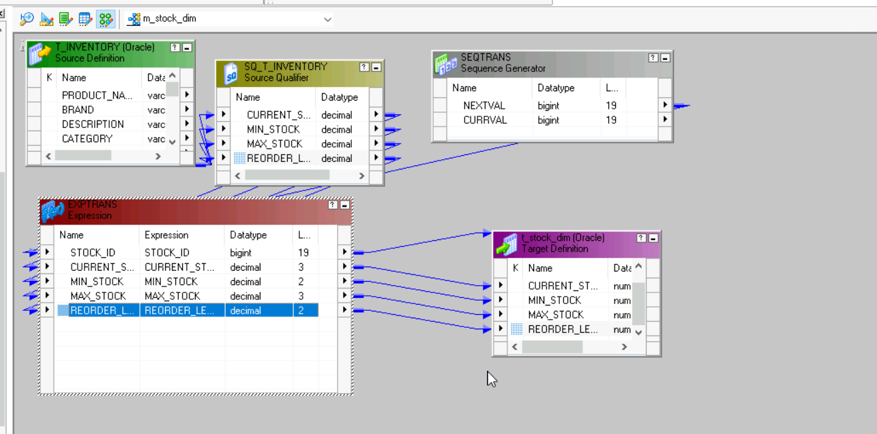

**TRANSFORMATIONS USED:**

* Expression
* Sequence generator

**OUTPUT:**

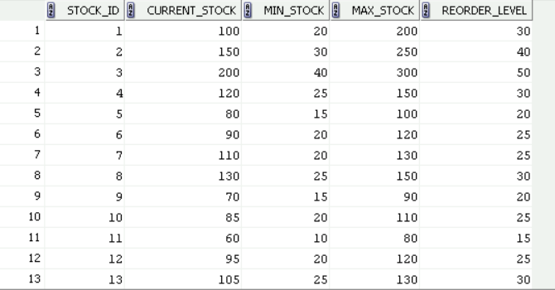

**DIM_TRANSACTION:**

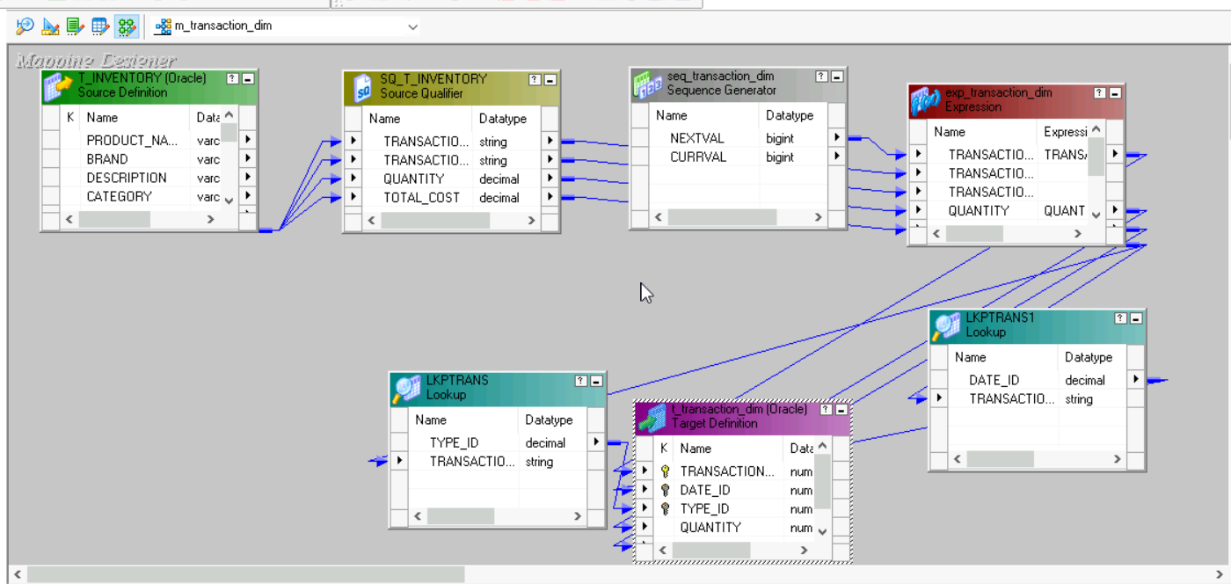

**TRANSFORMATIONS USED:**

* Expression
* Sequence generator
* Lookup

**OUTPUT:**

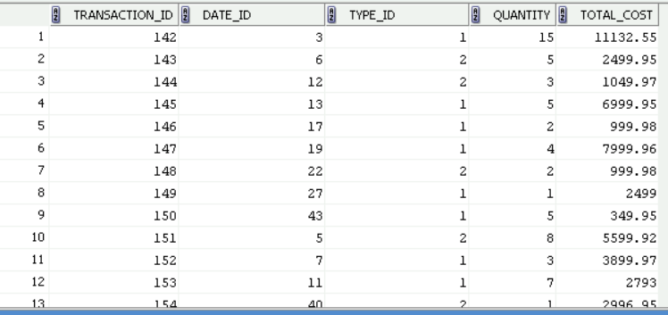

**DIM_DATE:**

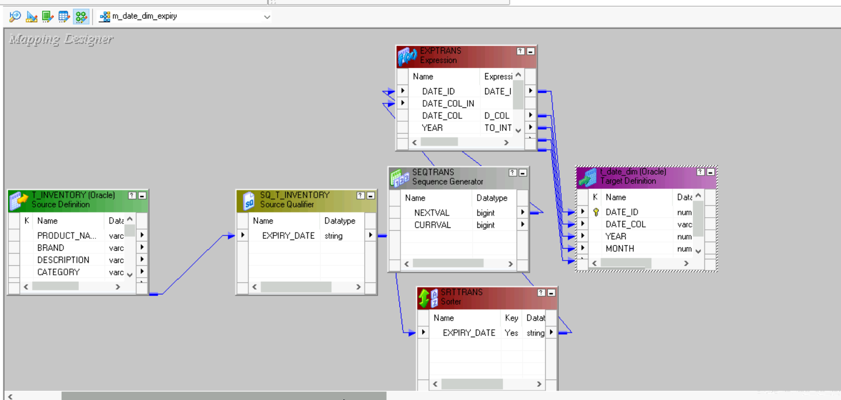

**TRANSFORMATIONS USED:**

* Expression
* Sorter
* Sequence generator

**OUTPUT:**  
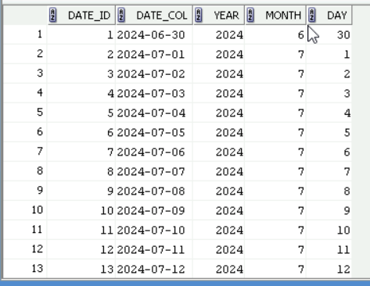

**FACT_TABLE:**  
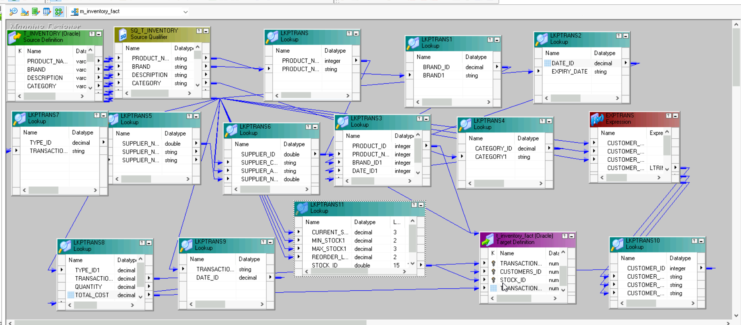

**TRANSFORMATIONS USED:**

* Expression
* Lookup(Dimensional tables)

**OUTPUT:**

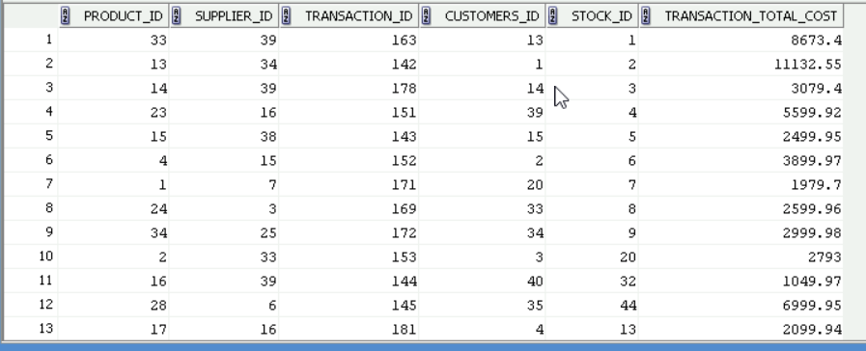

**WORKFLOWS**

**SOURCE_EXTRACT:**

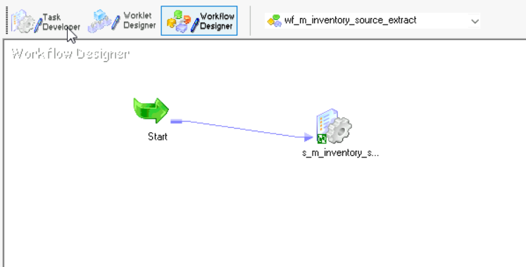

**DIMENSION WORKFLOW:**

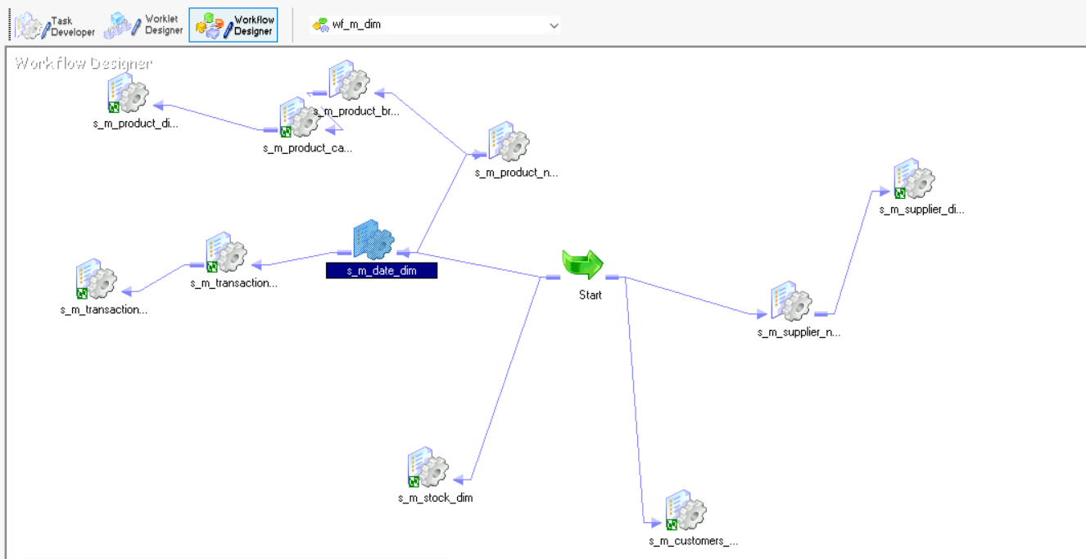

**FACT-WORKFLOW:**

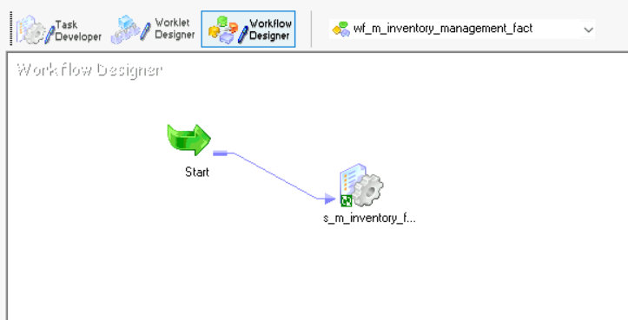

**BUSINESS REQUIREMENTS:**

1. Calculate the total sales amount per product category and customer location.
2. Determine the average purchase amount per customer.
3. Identify the top-selling products based on the total quantity sold.

**Calculate the total sales amount per product category and customer location.**

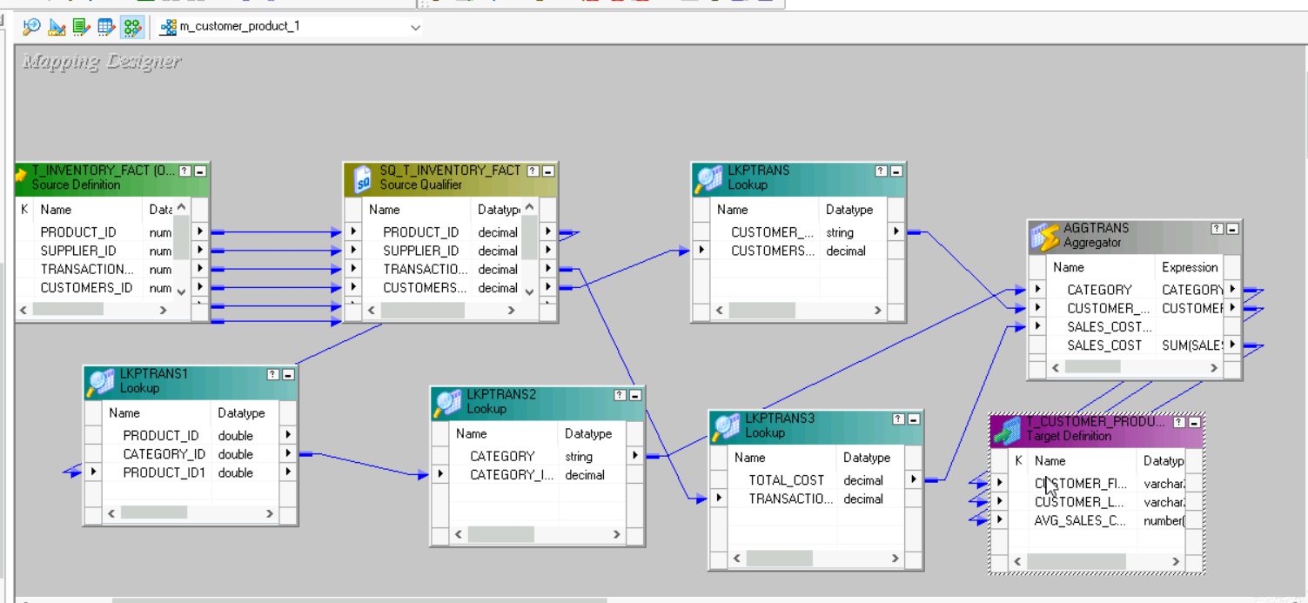

**TRANSFORMATIONS USED:**

* Fact table as source qualifier
* Aggregator
* Look up

**OUTPUT:**

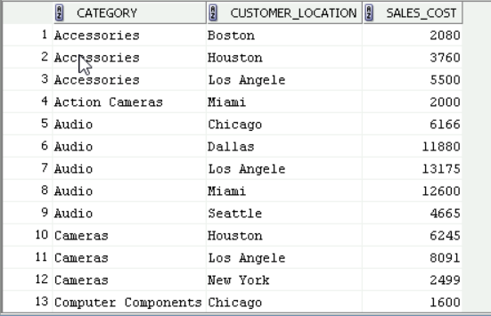

**Determine the average purchase amount per customer.**

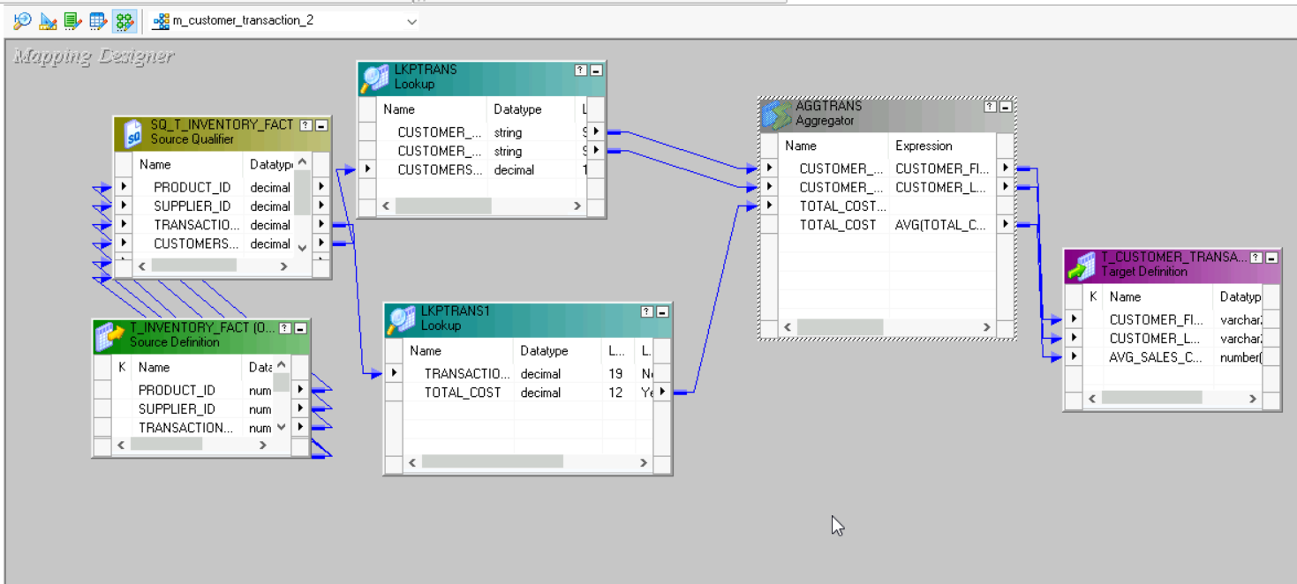

**TRANSFORMATIONS USED:**

* Fact table as source
* Aggregate
* Lookup

**OUTPUT:**

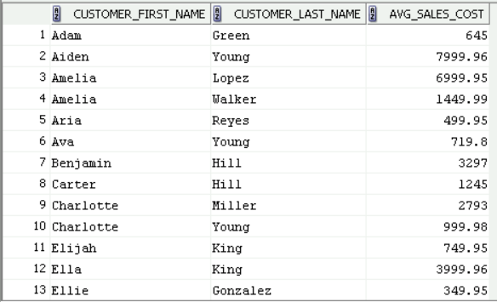

**WORKFLOW**

**REQUIREMENT WORKFLOW:**

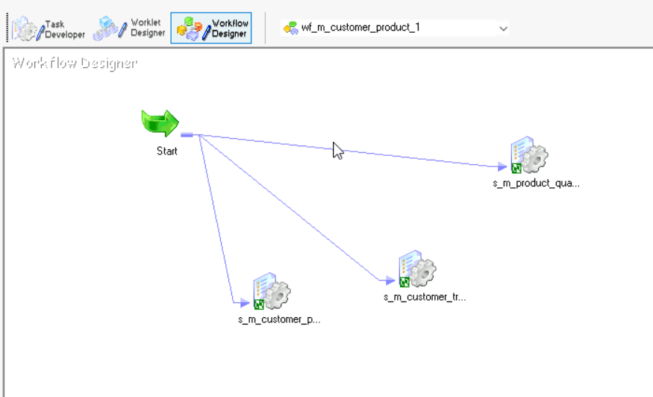

**CONCLUSION:**

The inventory management system integration project aims to successfully migrate inventory data from the source system to the target system using informatica power center. By aligning with the established objectives, scope, and timelines, our goal is to facilitate a seamless and effective migration process while minimizing any impact on business operations.