**Analysis and Visualization of Global Superstore Sales Data**

**Introduction:**

The following report presents a comprehensive analysis and visualization of the Global Superstore sales data. The dataset comprises 51,290 rows and 26 fields, detailing various aspects of orders, customers, products, and shipping. The primary goal of this project is to gain insights into sales trends, profitability, and shipping patterns across different categories, sub-categories, segments, and regions.

**Visualization and Analysis:**

**1. Profit by Category:**

A bar graph was generated to visualize the sales, discounts, and profit for each category (Furniture, Office Supplies, Technology). It was observed that despite heavy discounts, the Furniture category experienced a reduction in profit.

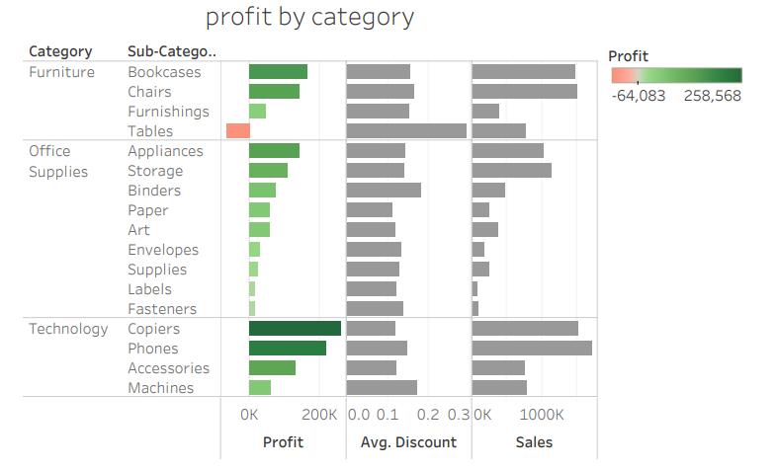

**2. Shipping Modes:**

A donut chart was used to represent the distribution of shipping modes.

The "Standard Class" shipping mode emerged as the most popular choice, accounting for 60% of shipments.

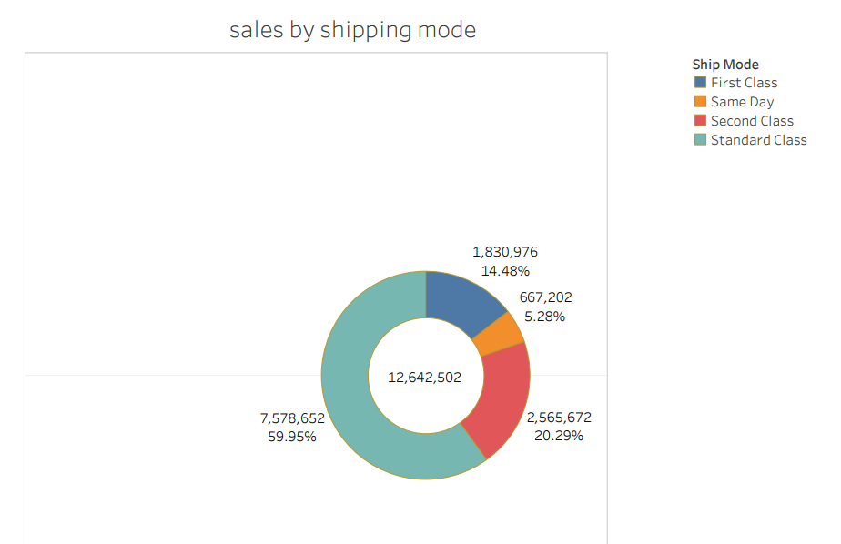

**3. Sales by Segment:**

A bar graph was created to showcase the sales for different segments (Consumer, Corporate, Home Office). The consumer segment exhibited the highest sales, reaching 6,500,000 units.

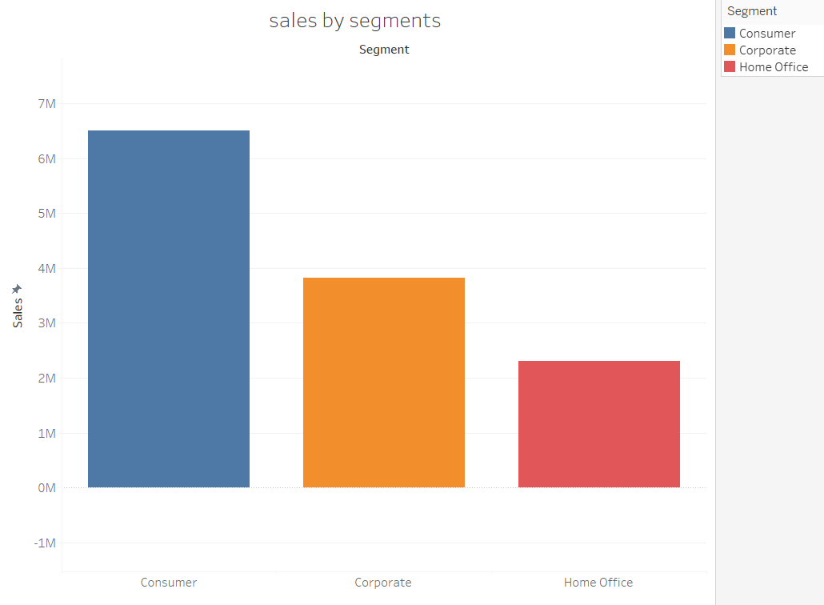

**4. Category Comparison:**

A bar graph was generated to compare the sales performance of different categories. Technology products were the top sellers, while Office Supplies showed the lowest sales.

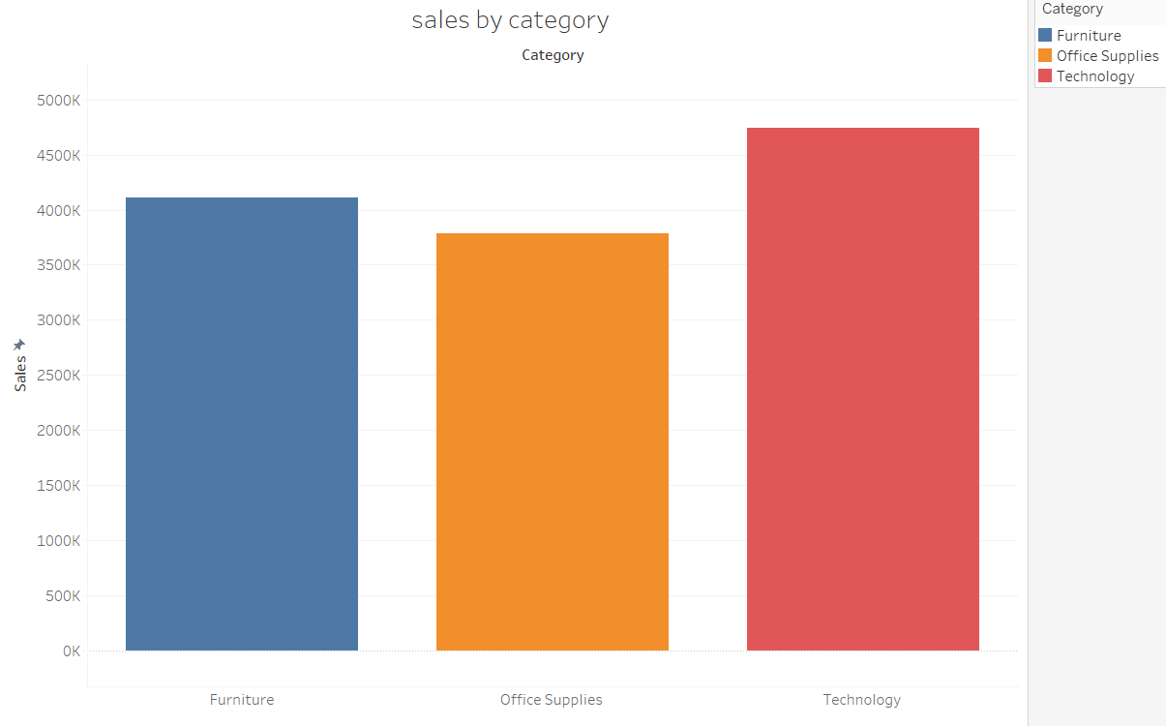

**5. Sales vs. Profit by Sub-Category:**

A bar graph was utilized to display sales values, with a superimposed line graph illustrating the fluctuation of profit across sub-categories. This visualization helped to understand the correlation between sales and profit for various sub-categories.

**6. Table Dashboard:**

A comprehensive table dashboard was created, integrating all the key visualizations. A filter was added to the "Sales by Country" graph, allowing users to focus on countries with higher profits (dark green) or losses (red). The dashboard is responsive and updates dynamically when the selected country is changed.

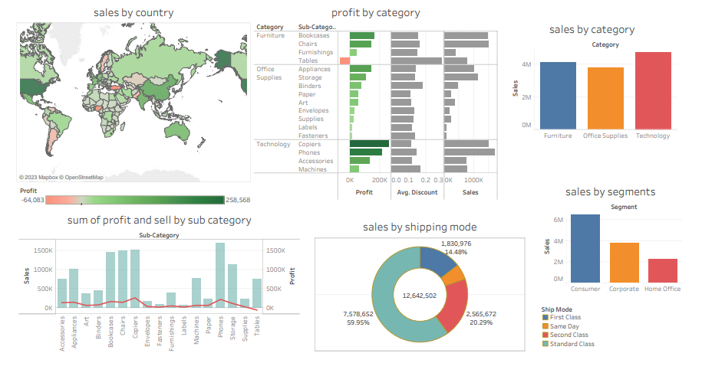

Dashboard design

**7. Key finding and Proposed Strategies**

**Key Finding**

1. **Identifying Profit Loss Factors:**

A detailed examination of the sub-category revealed that heavy discounts were the primary factor contributing to the loss. While discounts can attract customers, they can also erode profitability if not strategically managed.

1. **Impact of Excessive Discounts:**

It was evident that the profitability of the identified sub-category was significantly impacted by the application of heavy discounts. Despite healthy sales figures, the profit margin experienced a considerable decline, highlighting the need for a balanced approach to discounting.

**Proposed Strategies:**

Based on the analysis, several strategies were proposed to address the issue of profit loss due to excessive discounts:

1. **Discount Rationalization:** Implementing data-driven approaches to determine optimal discount levels for each product by analyzing historical data, market trends, and competition.
2. **Value-Added Services:** Exploring the addition of value to furniture items through services like extended warranties, assembly assistance, or customization options to justify a premium price.
3. **Bundle Offers:** Offering bundle deals on related furniture items to encourage multiple purchases without relying heavily on individual product discounts.
4. **Targeted Marketing:** Tailoring marketing efforts towards segments that are less price-sensitive by emphasizing quality, durability, and unique features.

**Conclusion:**

Through the analysis of the Global Superstore sales data, several key insights were uncovered. The project demonstrated the significance of understanding the relationship between sales, discounts, and profit. The prominence of the "Standard Class" shipping mode and the consumer segment highlights important patterns in customer behavior. Additionally, the dominance of the Technology category underscores the preference for tech-related products. The inclusion of a dynamic table dashboard provides an interactive experience for users, allowing them to explore sales trends and profitability across different regions and categories.

In conclusion, this project exemplifies the power of data visualization and analysis in extracting valuable insights from a large dataset like the Global Superstore sales data. By leveraging these insights, businesses can make informed decisions to optimize their sales strategies and enhance profitability.