Consolidated Project Report
Data Analysis & Machine Learning Assignments
Harsh Gupta (Sr. No: 20961)
Compiled September 2026

Projects Covered
- 1. Duckworth–Lewis Cricket Resource Modelling (Assignment 1)
- 2. Mars Orbit Reconstruction — Kepler-style Model Fitting (Assignment 2)
- 3. Community Detection in Graphs — Spectral Clustering & Louvain (Assignment 3)
- 4. Genomic Read Alignment for Colour-Blindness Diagnosis (Assignment 4a)
- 5. COVID-19 SEIRV Epidemic Modelling & Control (Assignment 4b)
- 6. Movie Recommendation System — SVD, CUR & Matrix Factorization (Assignment 5)

Overview
This report consolidates six independent assignments completed as part of a data analysis / machine-learning coursework track. Each project applies numerical optimization, linear algebra, or graph-theoretic techniques to a real dataset — from cricket scoring resource curves and historical Mars observations, to social/financial graphs, genomic reads, epidemiological case counts, and movie ratings. For every project this report summarizes: the problem statement, the dataset used, the code / algorithms implemented, and the key plots and results generated.

1. Duckworth–Lewis Cricket Resource Modelling
Files: Assignment1.py, Initial_notebook1.ipynb, notebook2.ipynb, Report1.pdf
Dataset: 04_cricket_1999to2011.csv — ball-by-ball ODI cricket data (1999–2011) with columns for Innings, Over, Runs, Wickets-in-Hand, Total Overs, and an Error-in-Data flag

Problem
Reproduce a Duckworth–Lewis-style 'resource remaining' model: estimate, for every combination of wickets-in-hand and overs-remaining, how many runs a team is expected to score, and convert that into a resource percentage curve used to adjust rain-affected targets.

Approach & Code Summary
- Data cleaning: rows flagged with Error.In.Data == 1 are dropped; Over.Remaining is derived as Total.Overs − Over; only first-innings rows are analysed.
- Exploratory notebook (Initial_notebook1.ipynb): correlation heatmaps, count/box/joint plots of Wickets-in-Hand, Over, Runs.Remaining; an early single-parameter Duckworth-Lewis curve Z0*(1-exp(-b*x/Z0)) is fit per wicket count with scipy.optimize.curve_fit, then several alternative optimizers (Powell, TNC, COBYLA, CG, Nelder-Mead, L-BFGS-B) are compared for a joint 11-parameter fit.
- Final model (Assignment1.py / notebook2.ipynb): a run-production function run_production_function(overs_rem, Z, L) = Z*(1-exp(-L*overs_rem/Z)) is fit jointly across all 10 wicket levels plus a shared slope parameter L, using a single sum-of-squared-errors loss_function minimized with scipy.optimize.minimize(method='L-BFGS-B').
- Resulting Z1..Z10 (average runs obtainable with i wickets in hand) and L are converted to a 'resources remaining' percentage curve by normalising every production curve against the maximum achievable score (10 wickets, 50 overs), producing the classic DLS-style resource table.

Key Results
Fitted parameters (Z1…Z10, L) from the joint L-BFGS-B optimisation:
Z1 | Z2 | Z3 | Z4 | Z5 | Z6 | Z7 | Z8 | Z9 | Z10 | L
12.70 | 30.12 | 49.75 | 81.56 | 110.30 | 145.90 | 178.63 | 218.62 | 253.74 | 298.56 | 7.96

Mean Squared Error of the fit: 250,564,361.18
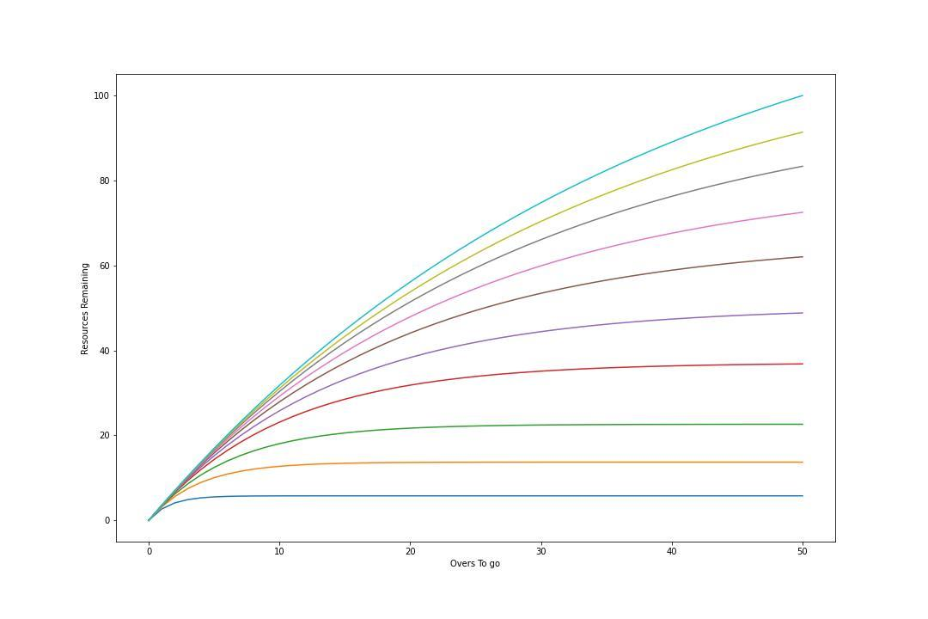
Figure 1.1 — Resources Remaining (%) vs. Overs To Go, one curve per wickets-in-hand (1 = bottom, 10 = top).

2. Mars Orbit Reconstruction
Files: Assignment2.py, helper.py, Report2.pdf
Dataset: 01_data_mars_opposition_updated.csv — 12 historical recorded Mars 'oppositions' (date/time + geocentric longitude in Zodiac-index/degree/minute/second form)

Problem
Recreate Kepler's geometric method for determining Mars's orbit from naked-eye opposition data: fit a circular orbit (centre c, radius r), an equant point (distance e1, angle e2), and the mean angular motion (z, s) so that the predicted longitudes at the 12 opposition times match the observed longitudes as closely as possible.

Approach & Code Summary
- get_times / get_oppositions (helper.py): convert the raw date/angle columns into a continuous day-count timeline and a continuous longitude value per opposition.
- MarsEquantModel(c, r, e1, e2, z, s, times, oppositions): places the equant on a line rotating at rate s from origin z, computes the geometric intersection of that line with the candidate circular orbit (solving a quadratic in x), and returns the angular error at every opposition plus the maximum absolute error.
- BestOrbitInnerParams(r, s, times, oppositions): for fixed r and s, performs a coordinate-wise exhaustive grid search over z, e2, e1 and c (round-robin, 5 passes) to get a good starting point, then refines with scipy.optimize.minimize(method='Nelder-Mead').
- BestR / BestS: exhaustively scan r over [4,10] and s over the plausible Mars sidereal-period range to find the values that minimise the max error returned by BestOrbitInnerParams.
- bestMarsOrbitParams: outer loop alternating BestR and BestS until convergence (or 4 iterations), returning the final (r, s, c, e1, e2, z) and the residual errors.
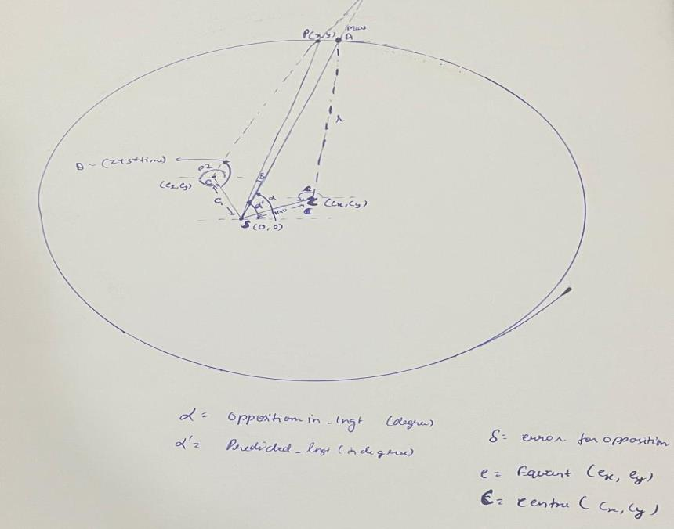
Figure 2.1 — Geometric construction: Sun S, orbit centre C, equant E, and the predicted vs. actual opposition angle.

Key Results
Best-fit parameters found by the full pipeline:
- r (orbit radius) ≈ 8.1695
- s (mean angular rate) ≈ 0.5241°/day
- c (orbit-centre direction) ≈ 148.76°
- e1 (equant distance) ≈ 1.518
- e2 (equant direction) ≈ 149.02°
- z (reference angle) ≈ 55.93°
- Maximum angular error ≈ 0.0726° (≈ 4.35 minutes of arc, about 21 seconds away from the ideal ~4-minute target used historically by Kepler)

3. Community Detection in Graphs
Files: community_harshGupta.py, Assignment3_template.py, Community_harsh_gupta.pdf
Datasets: facebook_combined.txt — undirected, unweighted Facebook ego-network (edge list); soc-sign-bitcoinotc.csv — directed, weighted Bitcoin-OTC trust network (source, target, rating)

Problem
Detect natural communities in a social graph and a trust graph using two classical unsupervised techniques — spectral clustering (Fiedler-vector bisection, applied recursively) and one iteration of the Louvain modularity-optimisation algorithm — and compare their behaviour and computational cost.

Approach & Code Summary
- spectralDecomp_OneIter: builds the graph with networkx, computes the normalized Fiedler (2nd-smallest-eigenvalue) eigenvector via nx.fiedler_vector, and splits nodes into two communities by the sign of the Fiedler value (community id = lowest node id in each group).
- spectralDecomposition: repeatedly re-runs the one-iteration bisection on the current largest remaining community until k communities have been produced (k=8 for Facebook, k=5 for Bitcoin), removing inter-community edges at each step with removeEdges.
- createSortedAdjMat: reorders the adjacency matrix rows/columns by community id and renders it as an image — a block-diagonal pattern indicates well-separated communities.
- Louvain (modularity_matrix, initialize_communities_and_partitions, delM, max_modularity_change, louvain_one_iter): builds the modularity matrix B_ij = A_ij − k_i k_j / 2m, then greedily moves each node to whichever neighbouring community gives the largest increase in modularity, for one full pass over all nodes.
- import_bitcoin_data: loads the weighted, directed CSV, discards components smaller than 3 nodes, and treats it as an undirected weighted graph for clustering purposes.

Key Results / Plots
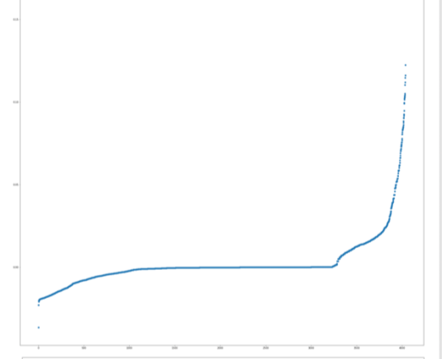
Figure 3.1 — Sorted Fiedler vector, Facebook graph (one bisection).
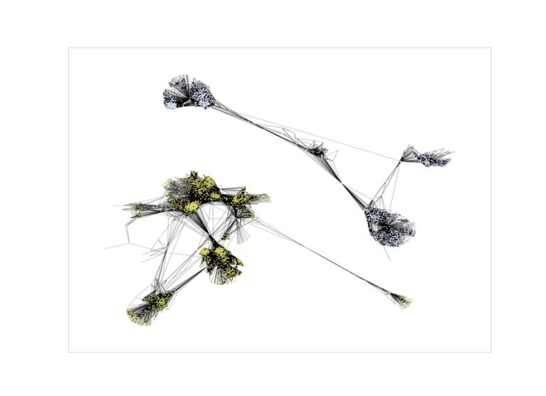
Figure 3.2 — 2-way spectral partition of the Facebook graph.
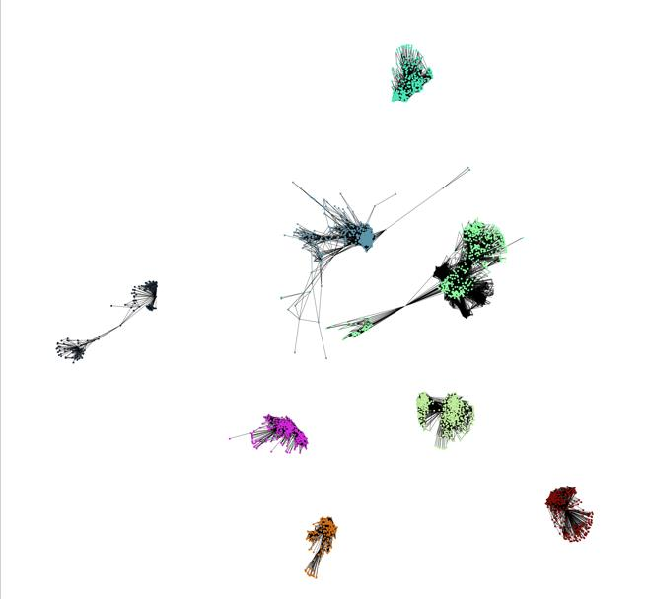
Figure 3.3 — Recursive spectral clustering into 8 communities (Facebook).
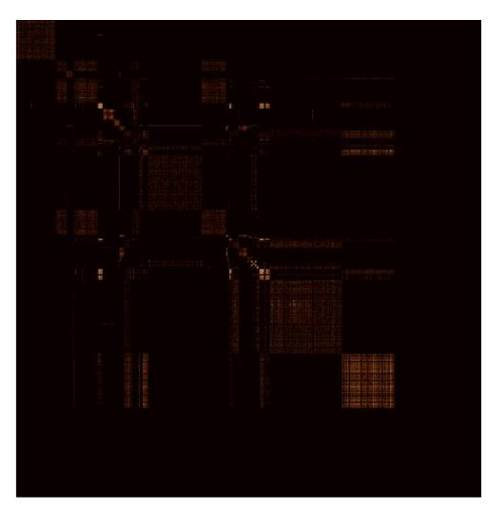
Figure 3.4 — Adjacency matrix sorted by community id (Facebook) — block structure indicates community separation.
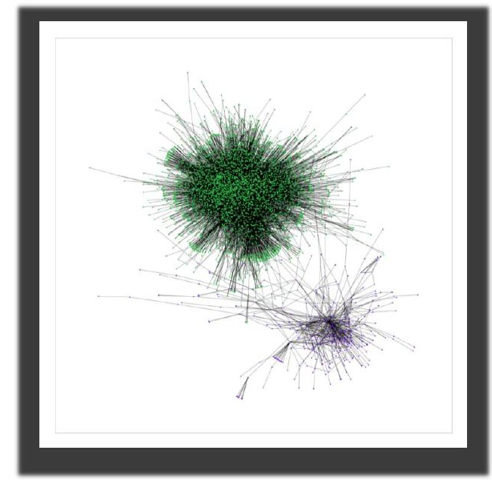
Figure 3.5 — 2-way spectral partition of the Bitcoin-OTC trust graph.
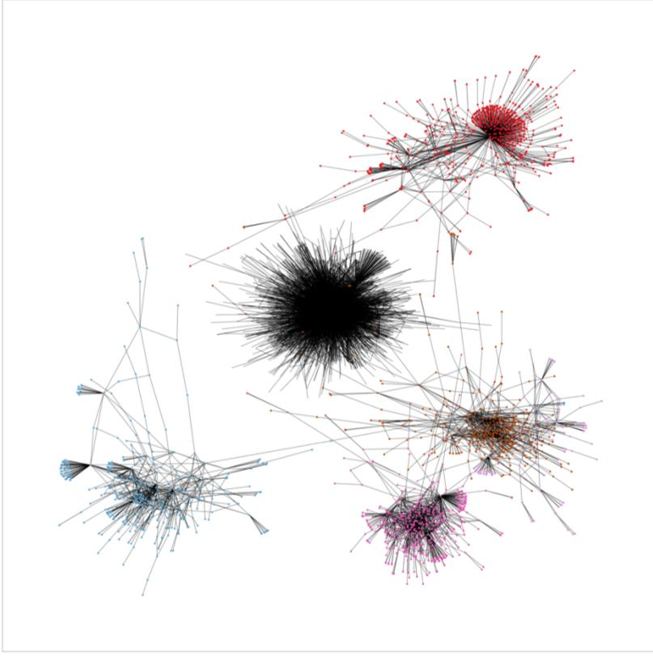
Figure 3.6 — Recursive spectral clustering into 5 communities (Bitcoin-OTC).
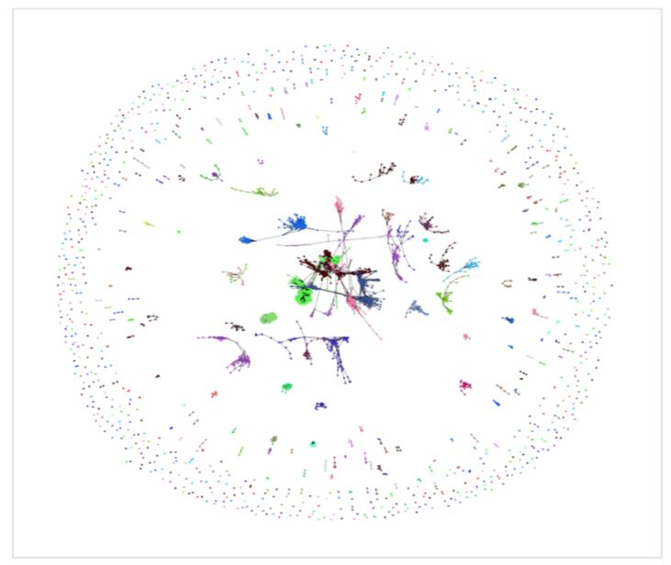
Figure 3.7 — One iteration of the Louvain algorithm on the Facebook graph (converged to 93 communities from ~4,000: 4000→647→174→104→98→93→93).

Complexity comparison (from the report)
- Spectral clustering: O(n³) — dominated by eigenvector computation; accurate but expensive for large graphs.
- Louvain: O(N log N) + O(n²) — divide-and-conquer style modularity optimisation with an O(n²) modularity-matrix pre-processing cost; needs more iterations to fully converge but scales better in practice.

4. Genomic Read Alignment for Colour-Blindness Diagnosis
Files: Assignment4.py, Report4.pdf
Dataset: chrX_last_col.txt (BWT last column of chromosome X), chrX.fa (reference sequence), reads (short DNA reads), chrX_map.txt (BWT-to-reference index map)

Problem
Diagnose the genetic configuration behind red-green colour blindness by aligning short sequencing reads to the red/green opsin exons on chromosome X using an FM-index / Burrows-Wheeler-Transform based search, then use exon read-coverage ratios to infer which of four known gene-configuration hypotheses is the best match.

Approach & Code Summary
- loadLastCol builds the FM-index Rank matrix and First-occurrence table from the BWT last column, counting cumulative occurrences of A/C/G/T at every position.
- MatchReadToLoc implements exact + up-to-2-mismatch backward search (matchRead) over the BWT, trying both the read and its reverse complement, and returns all candidate genomic positions.
- WhichExon checks each candidate position against the six known Red-exon and six Green-exon coordinate ranges (RedExonPos / GreenExonPos), splitting counts evenly when a read maps ambiguously to both a Red and Green exon at the same position.
- ComputeProb turns raw exon-2..5 read counts into 4 probability ratios (Red-count / Green-count per exon).
- BestMatch compares the observed probability vector against 4 canonical configuration templates ([0.5,0.5,0.5,0.5], [1,1,0,0], [0.33,0.33,1,1], [0.33,0.33,0.33,1]) using Euclidean distance and returns the closest match.

Key Results
Raw exon match counts [R0..R5, G0..G5]:
[74.5, 66.5, 55.0, 127.0, 243.0, 198.5, 74.5, 210.5, 110.0, 112.0, 310.0, 198.5]
Computed Red/Green probability ratios for exons 2–5: [0.316, 0.5, 1.134, 0.784]
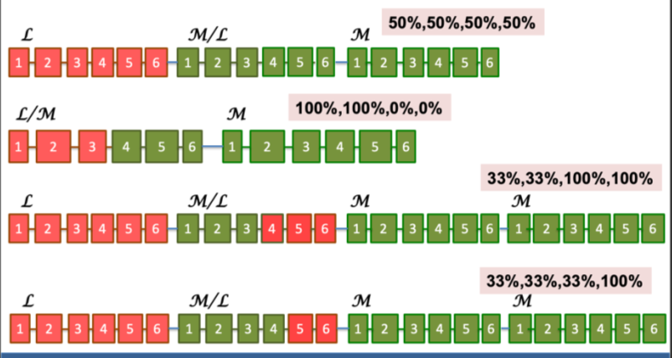
Figure 4.1 — The four candidate gene configurations compared against the observed exon ratios; Configuration 2 was the closest match.
Result: Configuration 2 is the best match.

5. COVID-19 SEIRV Epidemic Modelling & Control
Files: Assignment5.py, Report5.pdf
Dataset: COVID19_data.csv — daily national Confirmed cases, Tested counts, and First-Dose-Vaccinated counts from 8 March 2021 onward

Problem
Fit an SEIRV (Susceptible–Exposed–Infected–Recovered–Vaccinated) compartmental model to observed daily case data using a coordinate-wise gradient descent, then use the fitted model to simulate 'what-if' interventions: open-loop control at several fixed transmission-reduction levels, and a closed-loop control policy that adapts transmission rate to the current case load.

Approach & Code Summary
- Model constants: total population N = 70,000,000; vaccine efficacy eff = 0.66; incubation rate alpha = 1/5.8 days; recovery rate gamma = 1/5 days.
- COVID19Cases(params): runs the discretised SEIRV difference equations day-by-day (SEIR_model updates dS/dE/dI/dR, with delW modelling waning immunity/vaccine protection re-entering the Susceptible pool after 30 or 180 days), converts the Exposed compartment into a lagged, CIR-adjusted daily case estimate via CIR(t, CIR0) (a test-positivity correction factor), and returns both the loss (log-scale weekly-averaged squared error vs. reported Confirmed cases) and a discrete coordinate-wise gradient.
- gradientDescent: performs up to 100,000 iterations of gradient-step updates with a 1/iteration decaying step size, snapping S/E/I/R to integers and re-enforcing population conservation (S+E+I+R = N) every 10,000 iterations, keeping the best (lowest-loss) parameter set found.
- openLoopCOntrol(params, rate): re-simulates the fitted model with beta scaled by a fixed rate (1, 2/3, 1/2, 1/3) to show counterfactual case trajectories under different constant levels of social-distancing / transmission reduction.
- ClosedLoopCOntrol(params): re-simulates with beta adapting dynamically to the current infection level i[t] — full beta below 10,000 daily cases, 2β/3 below 25,000, β/2 below 100,000, and β/3 above that — approximating a realistic tiered lockdown policy.

Key Results / Plots
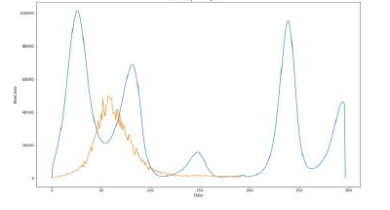
Figure 5.1 — Simulated new daily cases (blue) vs. reported new cases (orange), open-loop control at Beta = 1 (no reduction).
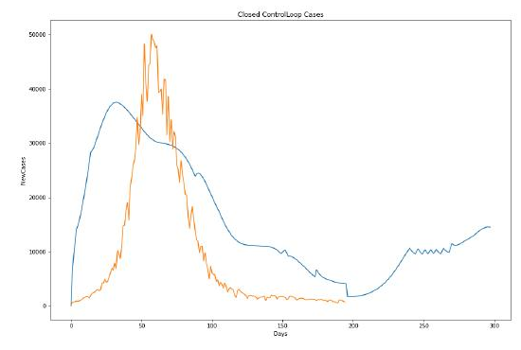
Figure 5.2 — Simulated new daily cases under the closed-loop (adaptive) control policy (blue) vs. reported cases (orange).
The open-loop simulations at reduced beta (2/3, 1/2, 1/3) reproduce the same qualitative multi-wave shape but shift the wave timing and height, while the closed-loop policy flattens the peak substantially by throttling beta once case counts cross the defined thresholds — illustrating the trade-off between a fixed reduction and a reactive, case-triggered policy.

6. Movie Recommendation System — SVD, CUR & Matrix Factorization
Files: Recommender_harsh_20961.py, Recommender_harsh_20961.pdf
Dataset: MovieLens 'ml-latest-small' ratings.csv — userId, movieId, rating triples

Problem
Build and compare three classical matrix-decomposition approaches to collaborative-filtering recommendation on the user–movie ratings matrix: full SVD, CUR decomposition, and gradient-based PQ (latent-factor) matrix factorization.

Approach & Code Summary
- get_matrix(X, y): converts the (userId, movieId, rating) table into a dense user×movie ratings matrix.
- SVD: np.linalg.svd on the full ratings matrix; for each k, the Frobenius-norm reconstruction loss from dropping all but the top-k singular values is computed directly from the singular-value spectrum (Eckart–Young), for k = 1..500ish and plotted.
- CUR(matrix, k): implements columnSelect (probabilistic column/row sampling proportional to squared column-norm / 'energy') to build C and R, forms the small k×k intersection matrix W, and computes U as the Moore–Penrose pseudoinverse of W via SVD (small singular values below a 0.1 threshold are zeroed before inverting). Loss ||matrix − C·U·R|| is computed for k = 1..500.
- matrix_factorization(matrix, P, Q, K, ...): plain stochastic-gradient-descent PQ factorization with L2 regularisation (lambda) and learning rate alpha, updating P (n_users×K) and Q (n_movies×K) per non-zero rating entry until the Frobenius loss drops below 1 or mx_itr iterations are used.
- run_dataset: orchestrates all three methods on an 80/20 train/test split, reporting wall-clock time and both training and held-out test MSE for the PQ model (K = 30 latent factors, 500 iterations).

Key Results / Plots
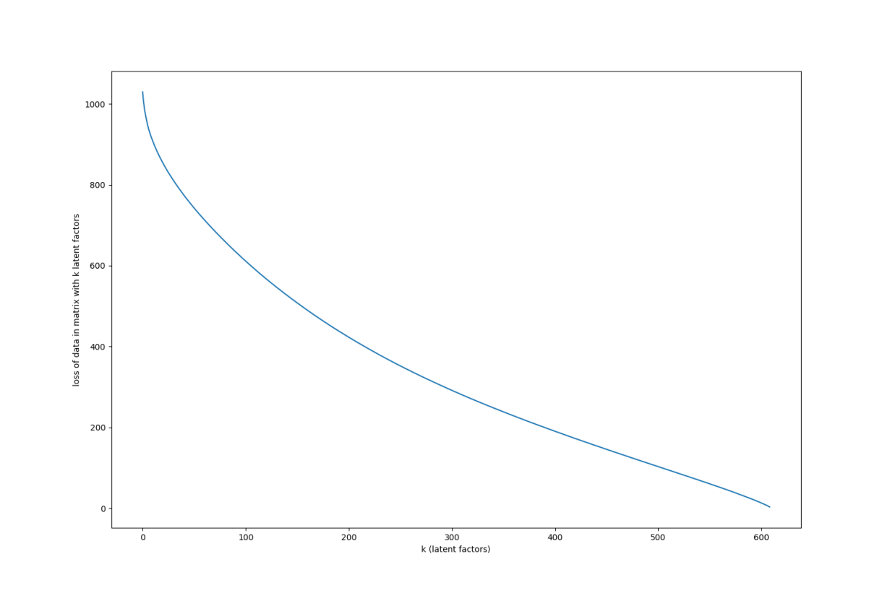
Figure 6.1 — SVD reconstruction loss vs. number of retained latent factors k (Young–Eckart bound).
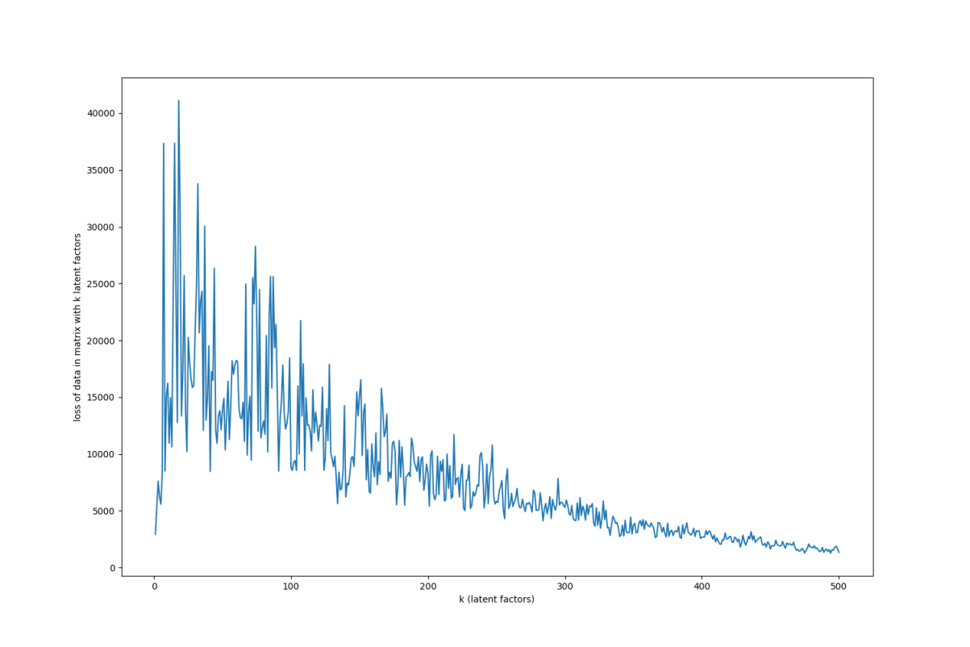
Figure 6.2 — CUR decomposition reconstruction loss vs. k (noisier than SVD due to random column/row sampling, but trending down).
PQ (gradient) factorization results:
- 30 latent factors, 500 iterations: converges in ≈1.2 hours.
- 400 latent factors, 600 iterations: lowest overall loss, but ≈2 days to converge.
- Training error per entry: 0.663
- Test error per entry: 0.91

Appendix — Supporting / Utility Files
- helper.py — Mars-orbit geometry and optimisation helper functions, shared by Assignment2.py (documented in Section 2).
- Assignment3_template.py — unfilled starter template for the community-detection assignment, defining the expected function signatures later implemented in community_harshGupta.py.
- temp.py — a small scratch utility (color_list) that generates n random hex colours, used for distinguishing communities/clusters in the graph-partition plots (Section 3).

