Task 1:

1. Install Jupyter notebook and run the first program and share the screenshot of the output.

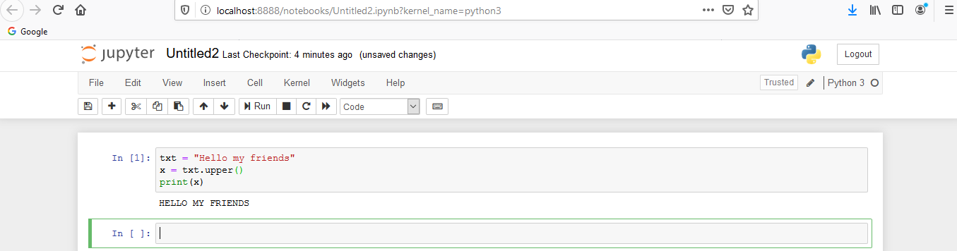

2. Write a program which will find all such numbers which are divisible by 7 but are not a multiple of 5, between 2000 and 3200 (both included). The numbers obtained should be printed in a comma-separated sequence on a single line

Ans :

nl=[]

for x in range(1500, 2701):

if (x%7==0) and (x%5!=0):

nl.append(str(x))

print (','.join(nl))

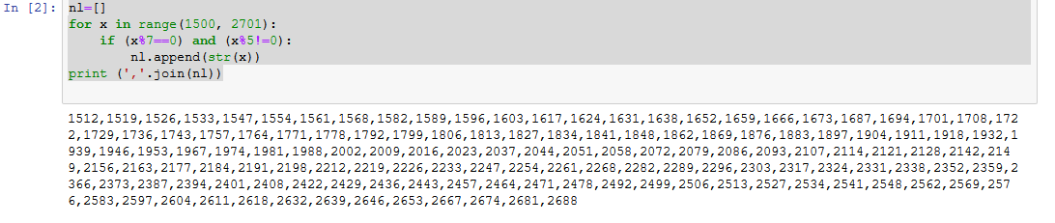

3. Write a Python program to accept the user's first and last name and then getting them printed in the the reverse order with a space between first name and last name.

Ans : firstname = input("What is your first name?:")  
lastname = input("What is your last name?")  
print(firstname[::-1] + " " + lastname[::-1])

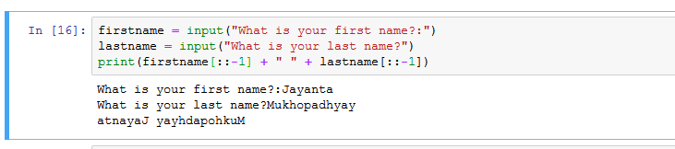

4.Write a Python program to find the volume of a sphere with diameter 12 cm. Formula: V=4/3 * π * r 3

Ans pi=22/7

diameter= 12

radian = float(diameter/2)

volume = (4/3) * (pi * radian ** 3)

print("Volume is: ", volume)

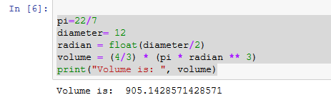

Task 2:

1. Write a program which accepts a sequence of comma-separated numbers from console and generate a list.

Ans   
# input comma separated elements as string

str = str (input("Enter comma separated integers: "))

print ("Input string: ", str)

# convert to the list

list = str.split (",")

print("list: ", list)

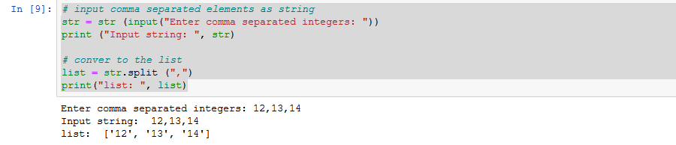

3. Write a Python program to reverse a word after accepting the input from the user.

Ans

strname = "AcadGild"

print(strname[::-1] )

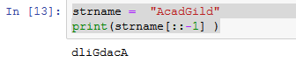

4. Write a Python Program to print the given string in the format specified in the ​sample output.

WE, THE PEOPLE OF INDIA, having solemnly resolved to constitute India into a SOVEREIGN, SOCIALIST, SECULAR, DEMOCRATIC REPUBLIC and to secure to all its citizens

Ans :

string = "WE, THE PEOPLE OF INDIA,{}having solemnly resolved to constitute India into a SOVEREIGN,{}SOCIALIST, SECULAR, DEMOCRATIC REPUBLIC{}and to secure to all its citizens{}"

print(string.format('\n\t','!\n\t\t','\n\t\t',':'))

