Q. WRITE A PROGRAM TO READ THE BASIC SALARY,ALLOWANCES,DEDUCTIONS OF AN EMPLOYEE .

AND TO PRINT THE GORSS AND NET SALARY.THE EMPLOYE IS CREDITED WITH BONUS AS PER YEARS OF EXERIENCE.THE CONDTITIONS ARE:

1)EXPERIENCE >5 YEARS THEN 3 MONTS OF NET SALARY AS BONUS.

2)EXPERIENCE >3 YEARS THEN 2 MONTHS OF NET SLARY AS BONUS.

3)OTHERWISE , 1 MONTH OF NET SALARY AS BONUS

A. #include<stdio.h>

int main()

{

int basic_sal,alwncs,dedctns,bonus,yoe,gross_sal,net_sal;

basic_sal=alwncs=dedctns=bonus=gross_sal=net_sal=0;

printf("Enter basics salary:");

scanf("%d",&basic_sal);

printf("Enter allowances:");

scanf("%d",&alwncs);

printf("Enter deductions:");

scanf("%d",&dedctns);

printf("Enter years of experience:");

scanf("%d",&yoe);

gross_sal=basic_sal+alwncs;

net_sal=gross_sal-dedctns;

printf("The gross salary is %d\n",gross_sal);

printf("The net salary is %d\n",net_sal);

if(yoe>=5){

bonus=net_sal*3;

printf("The bonus is %d",bonus);

}else{

if(yoe>=3&&yoe<5){

bonus=net_sal*2;

printf("Your bonus is %d",bonus);

}else{

bonus=net_sal;

printf("Your bonus is %d",bonus);

}

}

return 0;

}

OUTPUT:

1.WITH MORE THAN 5 YEARS OF EXPERIENCE

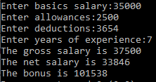

2.WITH MORE THAN 3 YEARS EXPERIENCE

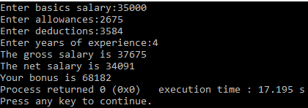

3.WITH LESS THAN 3 YEARS OF EXPERINCE

