Q. WRITE A PROGRAM TO DISPLAY THE FUNCTIONING OF ESCAPE SEQUENCE CHARACTERS.

1. #include<stdio.h>

int main()

{

printf("My\nName\nis\nJayanth");

printf("\nI\nam\n17\nyears old...");

return 0;

}

2. #include<stdio.h>

int main()

{

printf("WELCOME TO DELHI PUBLIC SCHOOL");

printf("SNo.\tMarks1\tMarks2\tMarks3\tMarks4\tMarks5\tTotal");

printf("\n...............................................\n");

return 0;

}

3. #include<stdio.h>

int main()

{

printf("\n...........................\n");

printf("Java\bprogramming");

printf("\nJava\bprogramming\b\b\bpython\n");

printf("\n...........................\n");

return 0;

}

4. . #include<stdio.h>

int main()

{

printf("All my files are stored in d:\\c_examples and d:\\c_lab examples");

return 0;

}

5. #include<stdio.h>

int main()

{

printf("C programming language is \"powerful\" and \"easy\" to learn");

return 0;

}

OUTPUT:

1. 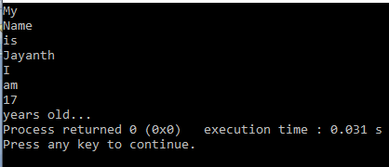

2. 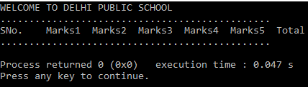

3. 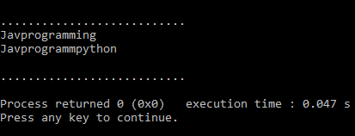

4. 

5.

