Q. WRITE A PROGRAM TO REVIEW THE FUNCTIONING OF THE POST/ PRE INCREMENTATION

1. #include<stdio.h>

int main()

{

int a=10,b=20,c;

c=a++ + b++;//Here the + operator does not consider the incremented value because + has grater precedence over ++

printf("\nc=%d",c);

return 0;

}

2. #include<stdio.h>

int main()

{

int a=10,b=20,c;

c=a++ + ++b;//Hre the incremented value of b is added to fixed value of a

printf("c=%d",c);

return 0;

}

3. #include<stdio.h>

int main()

{

int a=10,b=20,c;

c=++a + b++;//Incremented value of a is added to original value of b

printf("c=%d",c);

return 0;

}

4. #include<stdio.h>

int main()

{

int a=10,b=20,c;

c=++a + ++b;//The sum is equal to incremented values of a and b

printf("c=%d",c);

return 0;

}

c=++a + ++b;//The sum is equal to incremented values of a and b

printf("c=%d",c);

return 0;

}

OUTPUT:

1.

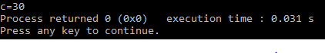

2.



3.



4.

