Q. WRITE A PROGRAM TO READ AND DISPLAY 10 ELEMENTS OF AN ARRAY.

THIS PROGRAM HAS TWO DIFFERENT CODES.

2. #include<stdio.h>

int main()

{

int i;

int arr[10]={12,31,13,25,46,75,89,10,3,8};

for(i=0;i<10;i++)

{

printf("%d\n",arr[i]);

}

return 0;

}

SHORTER IN LENGTH,RELIABLE AND EASIER TO MAINTAIN.

1. #include<stdio.h>

int main()

{

int i,arr[10];

for(i=0;i<10;i++)

{

printf("Enter the value of index %d:",i);

scanf("%d",&arr[i]);

}

for(i=0;i<10;i++)

{

printf("%d\n",arr[i]);

}

return 0;

}

LONGER,AND NOT EASY TO MAINTAIN AND REUSE.

1.

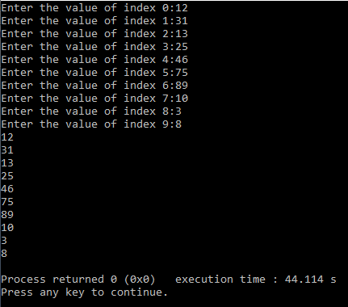

2.

