Service Now Project Documentation

Introduction
- Project Title: Educational Organisation Using ServiceNow

Project Overview
- Purpose: To develop a robust Educational Management System using ServiceNow to manage admissions, student progress, and institutional data with automated workflows and form configurations.

Features:
  - Online admission form with approval workflow
  - Student and teacher data management
  - Academic progress tracking dashboard
  - Notifications for task status and approvals
  - Role-based access control for admins, teachers, and students

Architecture

Frontend:
- Developed using HTML, CSS, and JavaScript
- UI built through ServiceNow UI Pages and Catalog Items

Backend:
- Business logic implemented via ServiceNow Script Includes, Business Rules, and Flow Designer

Database:
- Tables created using the Table module in ServiceNow
- Data stored in platform-native schema with relationships and references

Setup Instructions

Prerequisites:
- ServiceNow Developer Account
- Personal Developer Instance (PDI)
- Basic knowledge of ServiceNow Studio

Installation Steps:
Step 1: Sign in at https://developer.servicenow.com
Step 2: Request and activate your Personal Developer Instance Step 3: Create Update Set → Tables → Forms → Process Flows Step 4: Deploy Client Scripts for automation

Folder Structure (Logical in Studio)
EducationalOrganisation/
├── Tables/
│ ├── x_edu_student
│ ├── x_edu_teacher
│ ├── x_edu_admission
│ └── x_edu_progress
├── UI Pages/
│ ├── admission_form
│ └── student_dashboard
├── Script Includes/
│ └── AdmissionWorkflowUtils
├── Client Scripts/
│ └── validate_form.js
└── Styles/
└── styles.css

Running the Application
To run the application:
- Login to your ServiceNow PDI
- Navigate to the created application

- Use the left navigation pane to open modules such as:
  - Admission Form
  - Student Records
  - Progress Dashboard
- Perform form submissions and automation testing

API Documentation
- GET /api/x_edu_org/students
- Response:
- {
- "student_id": "STU102",
- "name": "A. Chaithanya",
- "department": "Computer Science"
- }

Authentication
- Role-based access is implemented using admin, teacher, and student roles, managed through ServiceNow Access Control Rules (ACLs).

User Interface
- Designed with HTML, CSS, and JavaScript using ServiceNow UI Pages for a clean and responsive layout.
- Includes dashboards, admission forms, student profiles, and result tracking interfaces.
- Role-based access displays relevant modules for admin, teacher, and student users.

Testing
- Manual testing was done through the ServiceNow form submission interface.
- Validations verified via onChange and onLoad client scripts.
- Fields were tested for automation, data flow, and visual updates.

Screenshots or Demo

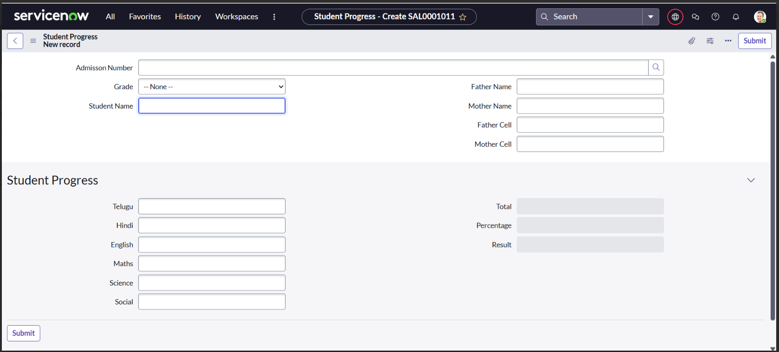
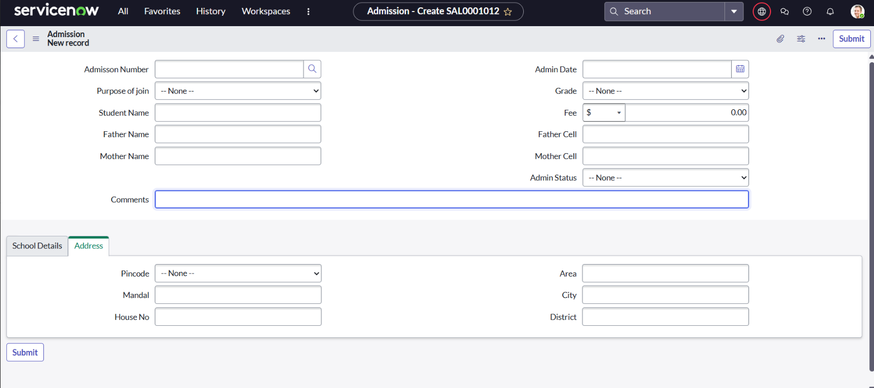
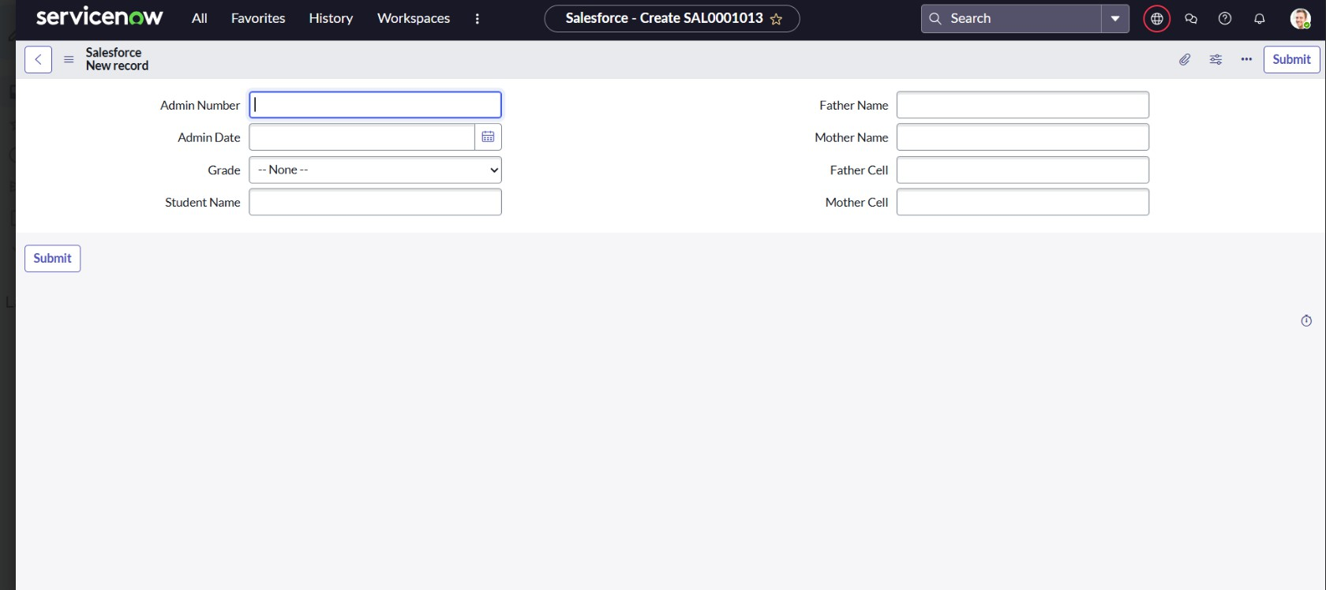

Known Issues
- Form layout may vary slightly on different devices.
- Client Scripts dependent on exact field naming — ensure accuracy.

Future Enhancements
- Add role-based user dashboards
- Integrate notifications (email/SMS) for admission status
- Extend to manage teacher data and fee structure
- Add reporting dashboards using ServiceNow Performance Analytics

