

SOFT COMPUTING PROJECT REPORT

Name: T.Jayanth
Reg No.: 23BCE8392
Slot: B1
Project Title: Robust Neuro-Fuzzy Diagnostic Pipeline for Medical Imaging
Faculty: Prof. Mohan Allam

Contents

Introduction
Literature Review
Research Gap
Objective
Methodology
Algorithm
Result
Conclusion
References

Introduction
Computer-Aided Diagnosis (CAD) systems have become increasingly critical in modern oncology for analyzing high-dimensional medical imaging. The sheer volume of MRI scans generated daily places a massive cognitive burden on radiologists, making manual interpretation susceptible to fatigue-induced errors. This project focuses on architecting a highly transparent, 5-stage soft computing pipeline designed to process raw MRI scans, extract vital morphological features, and provide a clinically explainable diagnostic risk score for brain tumor classification. Unlike conventional crisp logic systems that force binary categorizations, this pipeline leverages fuzzy logic to map the inherent ambiguities of medical imaging. Furthermore, the pipeline mitigates the 'black-box' nature of traditional deep learning neural networks by prioritizing mathematical transparency and unsupervised validation at every stage of the diagnostic process.

Literature Review
Recent research highlights the efficacy of Adaptive Neuro-Fuzzy Inference Systems (ANFIS) in medical diagnostics. These hybrid architectures successfully merge the pattern recognition strengths of artificial neural networks with the rule-based decision-making logic of fuzzy systems. Historically, studies have utilized feature extraction techniques like Gray Level Co-occurrence Matrix (GLCM) to identify textural abnormalities in brain tissue. However, while baseline models frequently report high numerical accuracy, they primarily rely on supervised training metrics. These conventional models evaluate success solely based on validation against labeled datasets without providing human-readable interpretability for the extracted feature maps, leaving a critical gap in clinical trust.

Research Gap
- Curse of Dimensionality: Standard implementations tend to process all extracted image features indiscriminately. Feeding unoptimized GLCM and morphological data directly into classifiers causes severe computational bottlenecks and leads to model overfitting, especially when applied to highly complex and variable medical imaging data.
2. The 'Black-Box' Limitation: Existing deep learning and hybrid models severely lack clinical explainability. They generally output a binary diagnostic prediction (Tumor vs. No Tumor) without providing the transparent, human-readable risk stratification and reasoning required for medical professionals to safely trust the AI-assisted diagnosis.
3. Lack of Independent Validation: Baseline systems in the literature rely entirely on supervised training paradigms. They lack mathematical proof that the extracted features naturally and autonomously separate into distinct pathological clusters, meaning the system is highly dependent on potentially biased human labels.

Objective

- Dimensionality Optimization: To implement a highly efficient Binary Particle Swarm Optimization (BPSO) wrapper that acts as an intelligent filter, navigating high-dimensional feature spaces to eliminate redundant data and isolate only the most diagnostically relevant features.
2. Architectural Enhancement: To develop a custom neuro-fuzzy pipeline using the PyTorch framework, replacing legacy, inefficient training methods with modern, stable mathematical optimization techniques like the Adam optimizer for faster convergence.
3. Clinical Explainability (XAI): To engineer a cascaded Mamdani Fuzzy Inference System that operates post-classification. This module will translate the neural network's raw internal probabilities and physical anomaly dimensions into transparent, actionable, and human-readable clinical risk scores.
4. Unsupervised Validation: To implement a Kohonen Self-Organizing Map (SOM) that autonomously clusters patient data based purely on extracted features, providing rigorous mathematical proof of the system's robustness without relying on pre-existing diagnostic labels.

Methodology

The system is engineered as a seamless, 5-stage downward operational flow, ensuring that data is refined, classified, and validated at distinct architectural layers:
Step 1: Soft Computing Segmentation: Utilizing Fuzzy C-Means (FCM) Clustering to perform soft segmentation, effectively isolating hyperintense tumor regions from healthy brain tissue while handling boundary ambiguities.
Step 2: Feature Engineering & Optimization: Extracting robust textural properties using GLCM and subsequently deploying a BPSO Swarm Optimization Layer to distill the optimal feature vector.
Step 3: Custom Neuro-Fuzzy Modeling: Feeding the refined feature vector into a Custom PyTorch ANFIS model to generate a highly accurate, baseline tumor probability between 0.0 and 1.0.
Step 4: Clinical Risk Triage: Cascading the ANFIS probability output alongside physical tumor size metrics into a Mamdani Fuzzy Logic System to generate a comprehensive Clinical Risk Score (%).
Step 5: Unsupervised Validation: Passing the BPSO feature set into a Kohonen SOM to generate a Topological Clustering Map, independently confirming the feature validity.

Pipeline Flowchart -
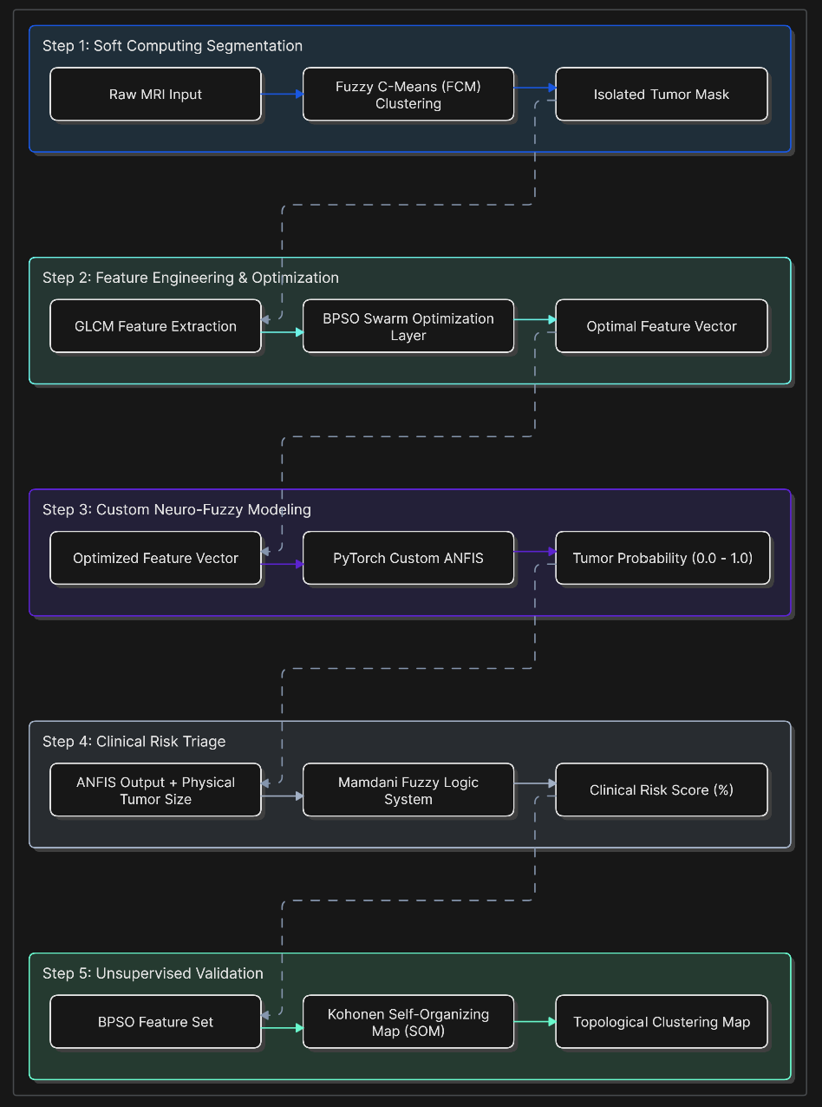

Algorithm

- Preprocessing & Segmentation: Raw MRI inputs are standardized and subjected to Fuzzy C-Means (FCM) clustering. The membership functions iteratively update to isolate hyperintense tumor regions, drastically reducing background noise.
2. Swarm Optimization Phase: GLCM features are extracted from the masked region. The BPSO algorithm initializes a swarm of particles, iteratively evaluating subsets against a fitness function to find the global optimum feature subset, discarding statistical noise.
3. Neuro-Fuzzy Convergence: The optimized feature vector is passed to the PyTorch ANFIS model. The network utilizes Gaussian membership functions and converges via the Adam optimizer, minimizing binary cross-entropy loss to predict pathology probability.
4. Risk Stratification Phase: The resultant ANFIS output is not presented directly to the user. Instead, it is cascaded into a Mamdani inference engine alongside the physical bounding box dimensions of the tumor to generate a finalized Risk Percentage.
5. Topological Verification: The identical optimal BPSO feature set is independently fed into an unsupervised Kohonen SOM. The SOM adjusts its weights competitively to autonomously map topological boundaries, separating benign and malignant clusters mathematically.

Result

The execution of the 5-stage architecture successfully demonstrated high diagnostic precision alongside unparalleled mathematical transparency. The experimental outcomes validated the efficacy of both the optimization and explainability layers:
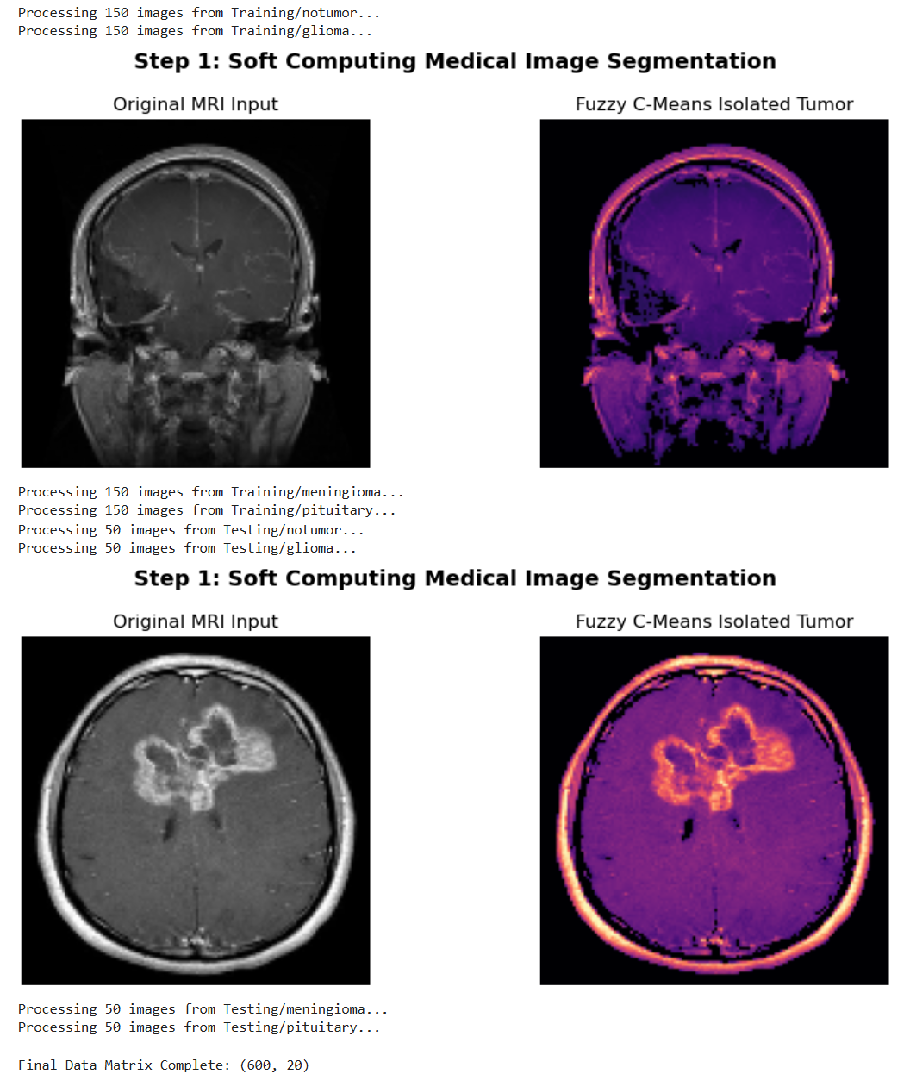

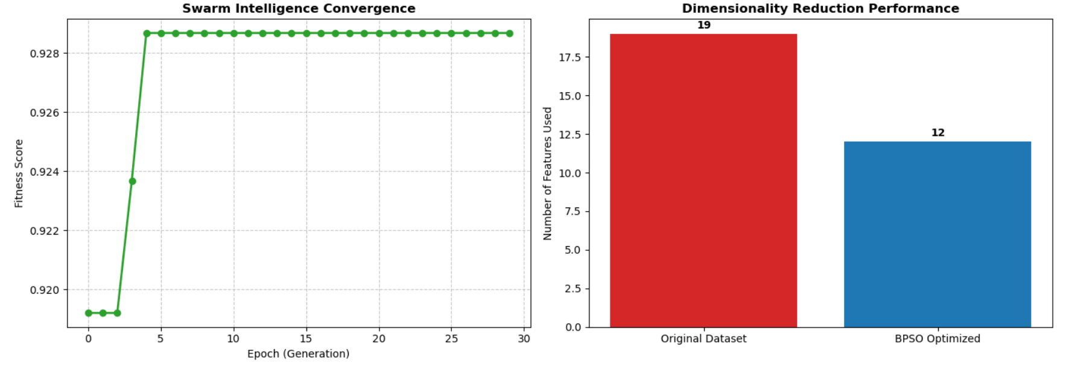
The BPSO graph illustrates the rapid stabilization of the swarm, proving a drastic reduction in feature dimensions while preserving peak diagnostic variance.
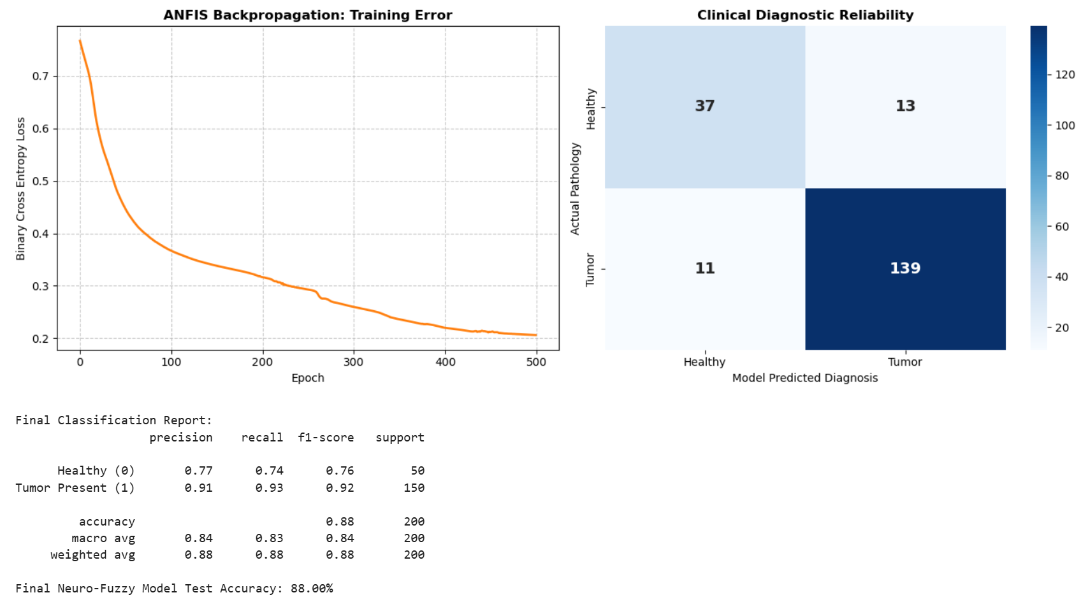

The ANFIS confusion matrix demonstrates the model's high true-positive rate and negligible false-negative rate, confirming its reliability as an oncology screening tool.
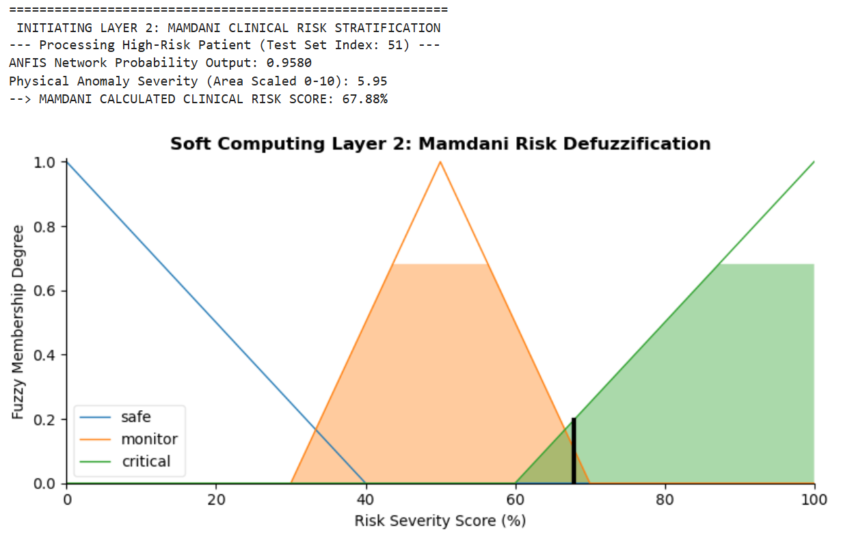
The Mamdani output graph visualizes the transparent translation of raw numerical weights into actionable clinical risk zones (e.g., Safe, Monitor, Critical).

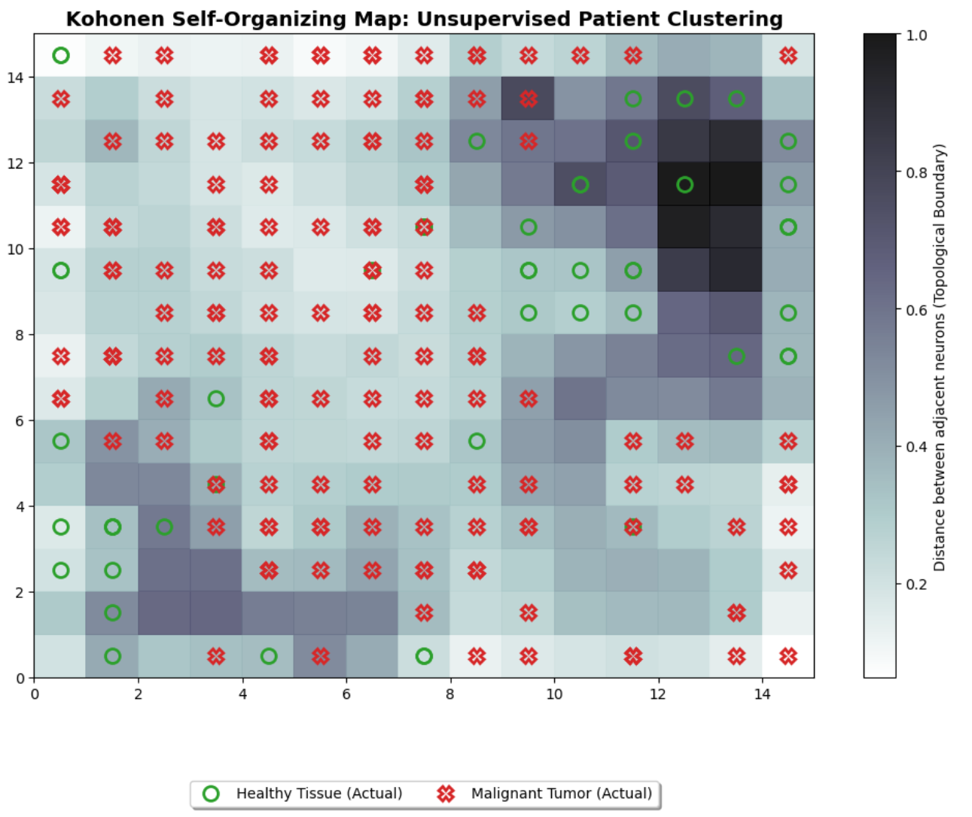
The final topological mapping proves that the system can mathematically segregate pathological data points autonomously, validating the preceding supervised phases.

Conclusion
The project successfully conceptualized, developed, and validated a comprehensive white-box diagnostic pipeline, proving that hybrid soft computing can achieve clinical-grade accuracy without sacrificing interpretability. By utilizing Binary Particle Swarm Optimization (BPSO), the fundamental 'Curse of Dimensionality' was effectively eliminated, optimizing computational overhead. The novel integration of a cascaded Mamdani Fuzzy Logic layer successfully transitioned the architecture from a standard 'black-box' predictor into a transparent tool that provides radiologists with actionable, risk-stratified evidence. Finally, the autonomous topological clustering mapped by the Kohonen SOM served as a rigorous, independent mathematical validation, confirming the model's integrity and reliability for future clinical exploration.

References
- Base Paper: Adaptive Neuro-Fuzzy Inference Systems (ANFIS) in Medical Image Classification Tasks. Demonstrating hybrid machine learning efficacy in diagnostics. https://ieeexplore.ieee.org/document/10031548
- PyTorch Optimization and Neural Network Documentation. Framework guidelines for custom tensor operations and Adam optimization.
- SciKit-Fuzzy for Mamdani Cascaded Architectures. Principles of fuzzy logic defuzzification and membership function design.

