DIET PATH-1 / MANTHAN HACKATHON
CUSTOMER
CHURN RISK
BUSINESS REPORT / DECISION-READY ANALYSIS
A clear account of the business problem, evidence from the Q3 customer dataset, priority retention opportunities, and the decisions recommended to management.
DOCUMENT PROFILE | DETAIL
Business area | Telecommunications customer retention / commercial operations
Dataset | 4,225 customer records · 52 fields · Q3 snapshot
Analysis method | Exploratory data analysis (descriptive; no predictive model)
Primary audience | Customer Retention Lead / Commercial Operations Manager
Prepared by | BEYOND BINARY
Submission date | 31-10-26

THE BUSINESS PROBLEM
A telecom provider is losing customers. The retention team needs to know which observable customer groups show elevated churn, what exit reasons are recorded, and where limited retention resources should be focused.

WHAT THIS ANALYSIS SOLVES
This notebook turns one Q3 customer-level dataset into a practical prioritisation view: establish the churn baseline, compare customer lifecycle and service groups, quantify gross monthly-charge exposure, identify high-risk segments, and recommend actions that can be tested.

EXECUTIVE DECISION IN ONE SENTENCE
Prioritise first-year customers—especially month-to-month Fiber Optic customers—for service diagnosis and a measured retention pilot; do not roll out blanket discounts or treat the observed associations as proven causes.

AT A GLANCE
26.53% | 47.58% | 72.51% | $82,829.60
Overall churn | 0–12 month churn | Highest-risk segment | Monthly charges attached to churned customers

HOW TO USE THIS REPORT
Pages 2–3 establish the dataset, data-quality decisions and churn baseline. Pages 4–5 explain the contract, service, charge and relationship evidence. Page 6 identifies the priority segments. Pages 7–8 translate those findings into actions, pilot design and a management decision.
The evidence statements in this report are taken from FINAL_ONE.ipynb. The implementation sequence and pilot governance are recommendations for the business team to approve and test; they are not outcomes already measured by the notebook.

01 SCOPE, DATASET & DATA INTEGRITY
The analysis is based on the uploaded FINAL_ONE.ipynb notebook and its Q3 customer dataset.

The decision context
The decision user defined in the notebook is the Customer Retention / Commercial Operations team. The analytical question is not simply “who churned?” It is: which customer groups show elevated churn, what patterns are visible in contract, tenure and services, and what actions should the business test?

Dataset profile and audit
Audit item | Notebook result | Interpretation
Dataset shape | 4,225 rows × 52 columns | Customer-level Q3 snapshot.
Duplicate rows | 0 | No duplicate records detected.
Duplicate customer IDs | 0 | No repeated customer identifiers detected.
Data types | 30 integer · 14 object · 8 float | Mixed categorical and numeric fields.
Churn target | 0 / 1 | 1 = churned; 0 = all other records.

Missing-value treatment
Field | Missing | Treatment supported by notebook
Churn Category | 3,104 | Expected for non-churned customers; not imputed.
Churn Reason | 3,104 | Expected for non-churned customers; interpret only among churned.
Internet Type | 886 | All align with Internet Service = 0; retain as no internet service.
Offer | 2,324 | Meaning is not proven by a codebook; leave missing, do not relabel.

Validation and analytical boundaries
The notebook validates Churn as binary and cross-checks Customer Status: 1,121 Churned records have Churn = 1; 2,832 Stayed and 272 Joined records have Churn = 0. Missing Internet Type occurs only where Internet Service = 0.
- No records were removed: duplicate checks found none.
- Direct identifiers and location coordinates are excluded from public-facing analysis.
- Scope is descriptive EDA only: no predictive modelling, deep learning or clustering.
Interpretation boundary: this is one quarter of data. It does not support seasonality or quarter-over-quarter trend claims.

ANALYTICAL WORKFLOW
The notebook follows a reproducible sequence: load a preserved copy of the source data; inspect shape, data types, duplicates and missingness; validate the binary churn target and Customer Status consistency; define tenure bands; calculate within-category churn rates; compare charges and selected numeric relationships; then construct overlapping segment masks and rank them by churn rate and customer count.
For every category-level rate, the denominator is the number of customers in that category. For the overall rate, the denominator is all 4,225 rows, including the 272 Joined records coded as not churned. The 28.36% sensitivity rate excluding Joined customers is shown separately so the denominator choice is transparent.

02 CHURN BASELINE & CUSTOMER LIFECYCLE
The baseline quantifies the scale of churn; tenure shows where in the customer relationship it is concentrated.

Overall churn
Measure | Result | Why it matters
Customers in dataset | 4,225 | Full denominator used for official dataset-wide rate.
Churned | 1,121 · 26.53% | Observed churn in this dataset.
Not churned | 3,104 · 73.47% | Includes Stayed and Joined statuses.
Joined customers | 272 | Coded as Churn = 0 in source data.
Rate excluding Joined | 28.36% | Sensitivity check; denominator excludes Joined.
Mean monthly charge | $61.66 retained / $73.89 churned | Churned group has higher mean charge.
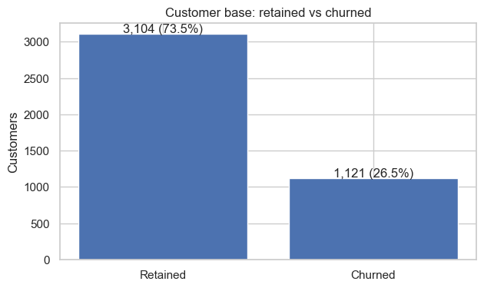
FIGURE 1 / Customer base: retained versus churned.
Interpretation. 1,121 of 4,225 customers churned. The mean monthly charge is higher among churned customers ($73.89) than non-churned customers ($61.66). This is an observed association, not evidence that price caused departure.

Tenure is the strongest lifecycle signal
The notebook groups customers into four tenure bands and reports both segment size and within-band churn rate. Churn is highest in the first 12 months and declines across later tenure groups.
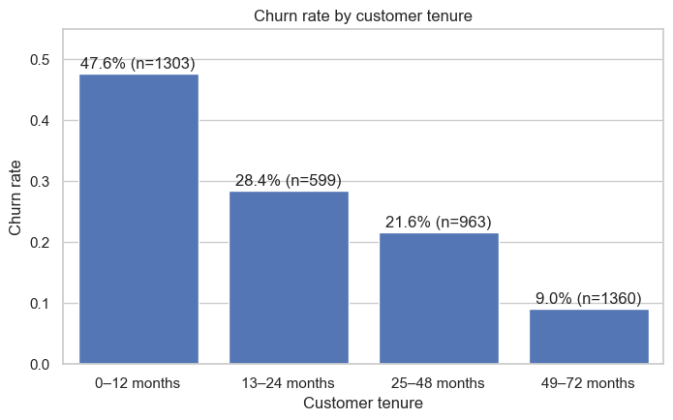
FIGURE 2 / Churn rate by tenure band; labels show customer count.
Business meaning. The first year is the clearest lifecycle priority. Management should examine onboarding, activation, billing clarity, early support and service experience. The snapshot does not reveal the exact moment or cause of an individual customer's decision to leave.

03 CONTRACT, BILLING & SERVICE PATTERNS
Category-level churn rates reveal where customer experience and commercial policy deserve closer investigation.

Contract type
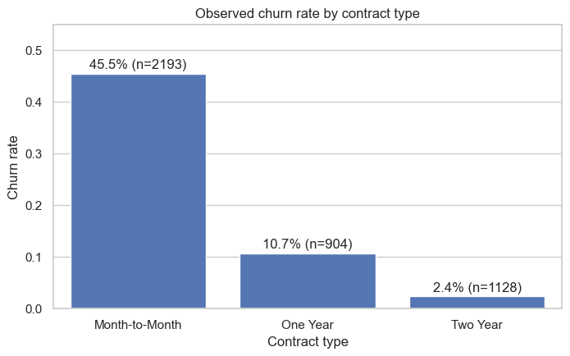
FIGURE 3 / Observed churn rate by contract type; n is customers in each category.
Contract | Customers | Churn rate
Month-to-Month | 2,193 | 45.46% (997 churned)
One Year | 904 | 10.73%
Two Year | 1,128 | 2.39%
The month-to-month group has substantially higher observed churn than fixed-term contract groups. This is a strong prioritisation signal, but contract duration may be related to tenure, customer mix and other factors.

Payment and paperless billing
Paperless billing is associated with 33.76% churn versus 16.03% without it. Mailed-check customers show 35.00% churn and bank-withdrawal customers 33.63%, compared with 15.60% for credit-card customers. These differences should prompt investigation—not assumptions about customer motivation.

Internet and optional services
Fiber Optic customers have 40.08% churn, compared with Cable at 24.70%, DSL at 19.84%, and no internet service at 7.22%.
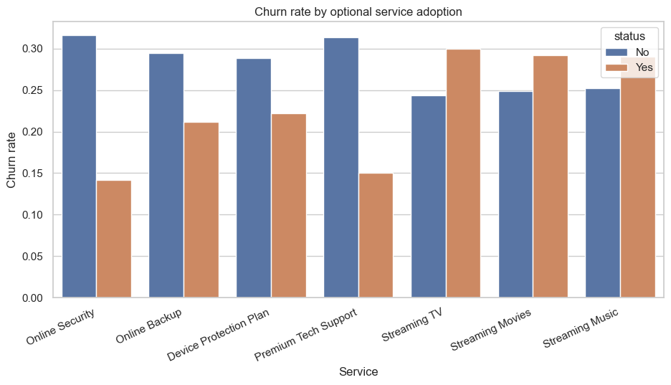
FIGURE 4 / Churn rate by optional service adoption (No versus Yes).
Customers without Online Security show 31.65% churn versus 14.16% with it; without Premium Tech Support, 31.39% versus 15.00% with it. The business should investigate service reliability, support experience and perceived value. The analysis does not establish that selling add-ons will reduce churn.

04 CHARGES, CUSTOMER PROFILE & RELATIONSHIPS
Quantify exposure carefully and avoid treating post-outcome variables as predictive evidence.

Monthly-charge exposure
Metric | Retained | Churned
Mean monthly charge | $61.66 | $73.89
Mean total charges | $2,592.40 | $1,513.25
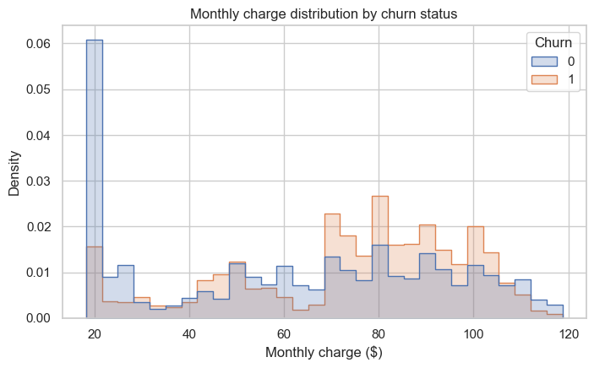
FIGURE 5 / Monthly-charge distribution by churn status.
The sum of monthly charges attached to churned customers is $82,829.60, equal to 30.20% of all recorded monthly charges ($274,229.80). This is a gross monthly-charge exposure proxy. It is not net revenue, profit, customer lifetime value, or a guaranteed recoverable amount.

Customer profile and relationships
The notebook reviews gender, senior-citizen status, partner/dependent status and Under-30 status. It also examines a contract-by-tenure pivot and selected numeric correlations. The report does not infer demographic causes from these descriptive comparisons.
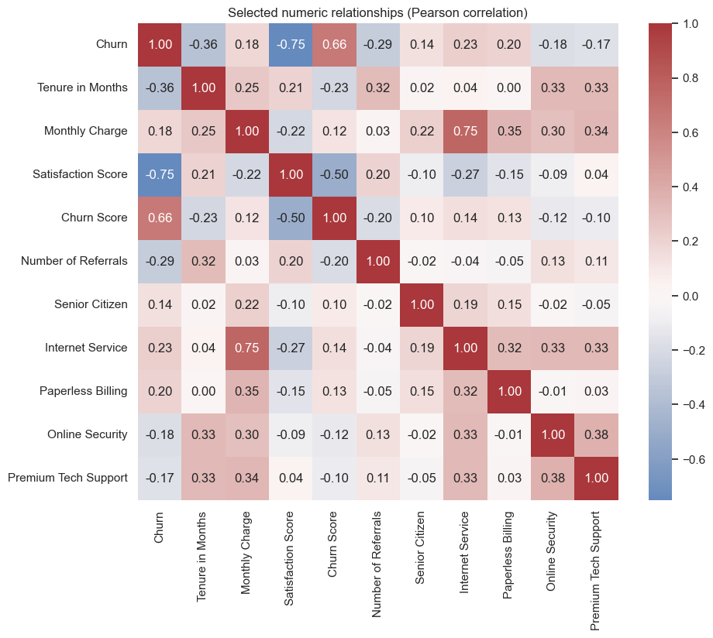
FIGURE 7 / Pearson correlations among selected numeric fields.

A critical warning: outcome leakage
Churn correlates with Satisfaction Score (-0.75) and Churn Score (0.66). In this file, every score-1 and score-2 Satisfaction Score record churned, while no score-4 or score-5 record churned. The notebook warns that these fields may be recorded at/after churn or constructed using outcome information. Do not present them as validated pre-churn predictors.

05 HIGH-RISK SEGMENTS & PRIORITY SELECTION
Use churn rate and segment size together. The three groups overlap and their counts must not be added.
The notebook creates seven segment definitions and ranks them by churn rate, then customer count. The highest-risk combined segment is month-to-month contract + Fiber Optic internet + 0–12 months tenure.
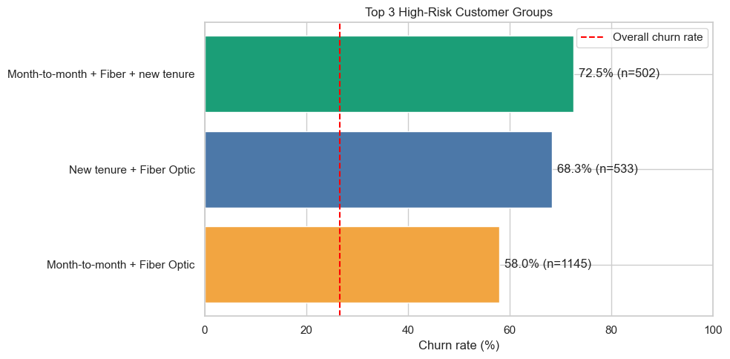
FIGURE 8 / Top three high-risk groups versus the overall churn baseline (red dashed line).
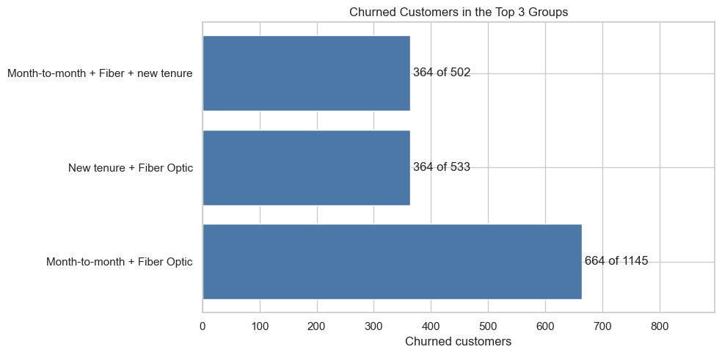
FIGURE 9 / Churned customer counts in the same groups; groups overlap.
Priority segment | Customers | Churned | Churn rate
Month-to-month + Fiber + new tenure | 502 | 364 | 72.51%
New tenure + Fiber Optic | 533 | 364 | 68.29%
Month-to-month + Fiber Optic | 1,145 | 664 | 57.99%

What makes the first segment the lead priority?
It combines the highest observed churn rate (72.51%) with a defined population of 502 customers. The broader first-year Fiber Optic segment covers 533 customers at 68.29%, while the month-to-month Fiber Optic group is larger (1,145 customers) with 57.99% churn. Management should choose an intervention scope based on both expected reach and ability to act.

Competitor-related exits
The notebook's final conclusion reports competitor reasons for 486 of 1,121 churned customers (43.35%). This supports reviewing competitor pricing, offers, product fit and perceived value. It does not identify which competitor feature caused each departure.
Segment interpretation note: the combined segments overlap by design. Do not sum their populations or churned counts to estimate a total addressable market.

06 RECOMMENDATIONS & BUSINESS ACTIONS
The notebook specifies three practical recommendations. Each is framed as a testable action, not a guaranteed outcome.

01 Improve new-customer onboarding
Action. Introduce check-ins during the first 30, 60 and 90 days. Confirm installation and activation, explain the first bills and plan features, identify early service problems, and route unresolved issues to support.
Why this action. The 0–12 month tenure group has 47.58% churn (620 of 1,303), the highest lifecycle rate in the notebook.
Measure. First-year churn rate; completion of onboarding touchpoints; issue-resolution time; repeat support contacts; customer feedback.

02 Investigate Fiber Optic service experience
Action. Review installation quality, reliability, speed complaints and support interactions for Fiber Optic customers. Identify recurring operational issues and address the root service problems before proposing commercial changes.
Why this action. Fiber Optic customers show 40.08% churn. The first-year Fiber Optic segment shows approximately 68.29% churn.
Measure. Fiber Optic churn rate; repeat service incidents; complaint resolution; first-year Fiber Optic churn.

03 Test targeted retention benefits
Action. For eligible month-to-month customers, test relevant loyalty benefits or transparent longer-term plan options. Begin with the month-to-month + Fiber Optic + first-year segment. Check customer preferences, offer cost and margin; avoid blanket discounts.
Why this action. The priority combined segment has 72.51% churn (364 of 502). Month-to-month customers overall show 45.46% churn.
Measure. Save/retention rate; offer acceptance; post-intervention churn; monthly charges retained; contribution margin after discounts and operating costs.

Prioritisation matrix
Order | Target | Recommended first move
1 | Month-to-month + Fiber + 0–12 months | Focused diagnostic and small retention pilot.
2 | All customers with 0–12 months tenure | Structured 30/60/90-day onboarding journey.
3 | Month-to-month / competitor-related exits | Review value proposition; test suitable plan options.

Operating guardrails
- Use the report to target investigation; do not describe correlation as causation.
- Do not treat gross monthly charges as guaranteed recoverable revenue.
- Evaluate incremental retention and margin before scaling an offer.

PILOT DESIGN CHECKLIST
Before contacting customers, define the eligible segment using the same contract, internet-type and tenure rules used in the notebook. Confirm the current eligible customer count; the Q3 count of 502 is an analytical baseline, not a live audience list.
Assign one accountable retention owner. Ask the service team to diagnose installation, reliability and support issues; ask the commercial team to define any plan or loyalty option; and ask analytics to prepare the customer selection, comparison approach and scorecard.
Record, at minimum, eligibility, contact date, channel, whether the customer was reached, response, offer or service action, cost, issue resolution, subsequent churn status and any opt-out or complaint. Use a suitable comparison group where operationally and ethically feasible.

07 DECISION REQUIRED & IMPLEMENTATION PLAN
This is the step after reading the report: turn recommendations into an owned pilot and a measurable management decision.

Decision requested from management
Approve a limited retention pilot focused first on month-to-month Fiber Optic customers in their first 12 months. In parallel, approve a first-year onboarding improvement and a diagnostic review of Fiber Optic service experience. Do not approve a company-wide discount programme on the basis of descriptive EDA alone.

Execution sequence
Stage | Owner action | Required output
1. Validate baseline | Analytics owner rechecks segment masks, denominators, missing-value treatment, and all chart/report figures against the final notebook. | Signed-off baseline and segment definitions.
2. Diagnose friction | Retention and service teams review installation, reliability, billing, support and competitor-related reasons in the target group. | Evidence-backed hypotheses to test.
3. Design pilot | Set eligibility, treatment, duration, contact channel, offer cost, comparison group and customer safeguards. | Approved pilot brief with owner and budget.
4. Run pilot | Contact eligible customers; log reach, response, acceptance, issue resolution, costs and outcomes. | Complete intervention dataset.
5. Evaluate | Compare churn/retention with baseline or a suitable comparison group; account for discounts and operating costs. | Incremental retention and net contribution estimate.
6. Decide | Management reviews results and customer impact; choose scale, modify or stop. | Documented decision and next iteration.

Pilot scorecard
Measure | Decision use
Churn rate in target segment | Did customer loss reduce?
Save / retention rate among contacted customers | Did the intervention change customer behaviour?
Incremental retained monthly charges | What gross charge value remained with the business?
Net contribution after discounts and costs | Was the intervention commercially worthwhile?
Service incidents and resolution time | Did the underlying experience improve?
Complaints / opt-outs | Did the action preserve customer trust?

Limitations to carry into the decision
This is a single-quarter descriptive analysis. Segment associations do not prove causes; groups overlap; the $82,829.60 figure is a gross monthly-charge exposure proxy; and Satisfaction Score / Churn Score may contain outcome leakage. Any intervention must be tested before scale.

Final management takeaway
Prioritise the first-year customer experience, investigate Fiber Optic service issues, and test targeted retention benefits for the highest-risk month-to-month segment. Assign an owner, approve the pilot design, measure incremental retention and net contribution, then make a scale / modify / stop decision from observed results.
Source: FINAL_ONE.ipynb, DIET Path-1 | Manthan Hackathon. Team details and submission date to be completed by the team.

THE SCALE / MODIFY / STOP DECISION
SCALE / If the pilot shows a credible improvement in retention versus the comparison or baseline, and the net contribution remains positive after discounts and operating costs, expand carefully to the next eligible cohort.
MODIFY / If customers respond but retention, service outcomes or economics are mixed, refine the offer, timing, eligibility or service intervention and run another measured test.
STOP / If the pilot does not improve retention, creates unacceptable cost, or increases complaints and customer friction, stop the intervention and return to diagnosis.

POST-PILOT DELIVERABLES
The business team should retain four outputs: (1) the approved pilot brief and eligibility definition; (2) the intervention and contact log; (3) the evaluation showing retention, service outcomes and net contribution; and (4) a dated management decision recording whether to scale, modify or stop.

