PROJECT WORKFLOW DOCUMENT

Customer Churn
Risk Analysis
Exploratory Data Analysis (EDA)
DIET Path-1 | Manthan Hackathon

TEAM: BEYOND BINARY
Pamarthi Jayanth • Marthala Navya • Uddanti Rishikesh
Chamarthi Venkat Varun Krishna Raju • Bandi Sanju

Purpose: To understand customer churn patterns, identify high-risk customer groups, and translate data findings into practical retention recommendations.

1. Project Overview
Customer Churn Risk Analysis is a data-analysis project focused on understanding why customers may discontinue a telecom service. The team worked with a customer-level dataset and used Exploratory Data Analysis (EDA) to examine churn across customer tenure, contract type, payment method, internet service, optional add-on services, charges and customer profile attributes.
The main objective was not to build a prediction model, but to study the available records, identify meaningful patterns, highlight customer groups with comparatively high churn, and provide business teams with clear actions that can be tested to improve retention.

Project Scope and Dataset
Dataset size | 4,225 customer records
Available fields | 52 columns
Reporting period | Q3 customer dataset
Churned customers | 1,121
Customers not marked as churned | 3,104
Overall churn rate | 26.53%
Tools and libraries | Python, Pandas, NumPy, Matplotlib and Seaborn
Analysis approach | Descriptive analysis and visualisation (EDA)

Business Question
Which customer groups show higher churn, what patterns are visible in the available data, and which practical steps should the telecom provider investigate to strengthen customer retention?

2. End-to-End Analytical Workflow

Step 1 — Load, audit and clean the dataset
The customer churn dataset is loaded into Python using Pandas. We inspect the number of rows and columns, missing values, duplicate records, data types, and inconsistent category labels.Cleaning makes the data reliable for analysis. Missing values and duplicates are handled carefully, and category names are standardized so similar values are not treated as different groups.

Step 2 —Define churn and measure the overall rate
Customer churn means a customer stops using or paying for the company’s service. Retained customers continue using the service.The overall churn rate is calculated as:Churn Rate = (Number of Churned Customers ÷Total Customers) × 100This gives a general picture of how many customers the business is losing.
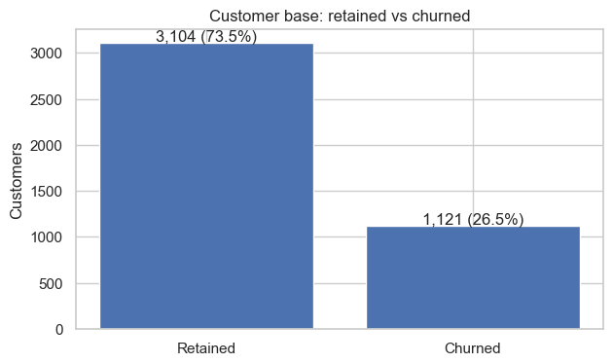

Step 3 — Churn by customer tenure
Tenure represents how long a customer has been with the company. Customers are divided into groups such as 0–12 months, 13–24 months, and longer-term groups.Churn rates are compared across these groups. A high churn rate among new customers may indicate onboarding or early service problems. Higher churn among long-term customers may suggest dissatisfaction or better competitor offers.
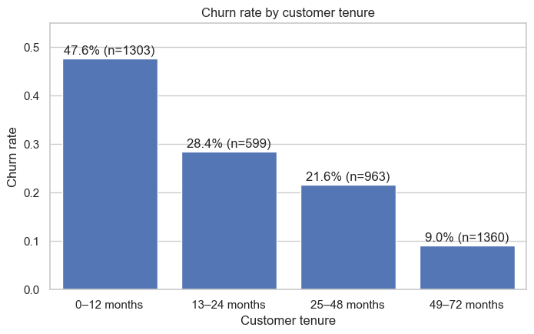

Step 4 — Contract, billing and payment method
Churn is compared across contract types, payment methods, and paperless billing categories.This analysis helps identify whether customers with flexible monthly contracts churn more often than customers with longer contracts. Payment method and billing preferences may also reveal friction points that could be improved
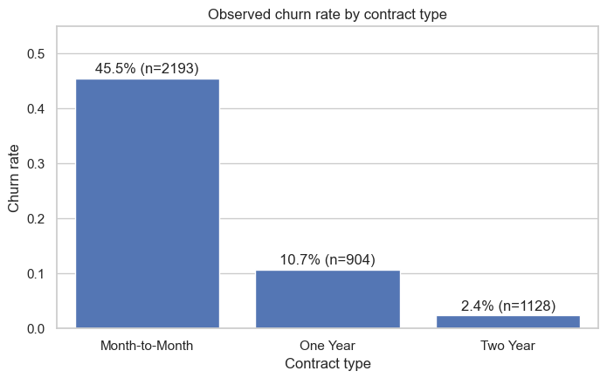

Step 5 —Internet and add-on services
Customers are grouped by internet type and additional services such as online security, online backup, device protection, technical support, and streaming.Comparing churn across these groups helps determine whether customers who lack certain services or experience service-related problems are more likely to leave.
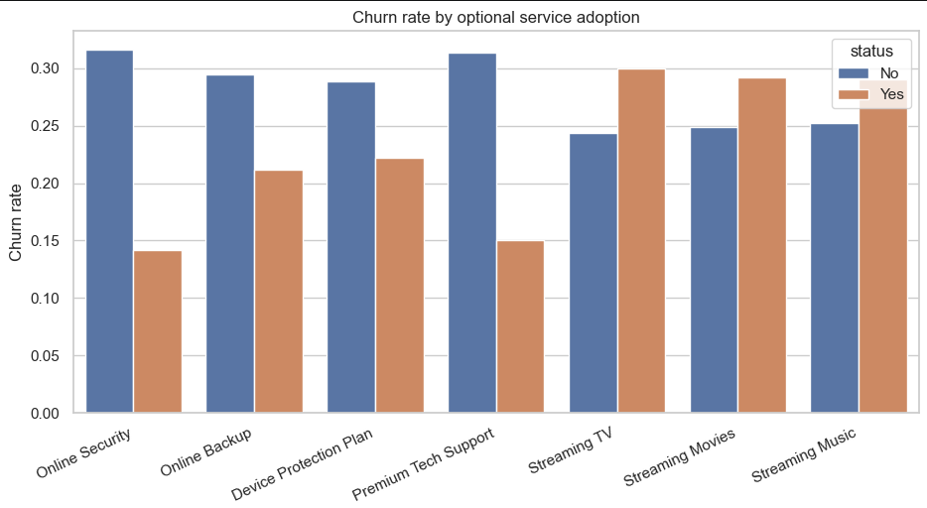

Step 6 — Charges and revenue at risk
Monthly charges and total charges are compared between churned and retained customers.Monthly revenue at risk can be estimated by adding the monthly charges of customers who churned:Monthly Revenue at Risk = Sum of Monthly Charges for Churned CustomersThis is an estimate of the monthly billing associated with churned customers, not a guarantee of future revenue loss.
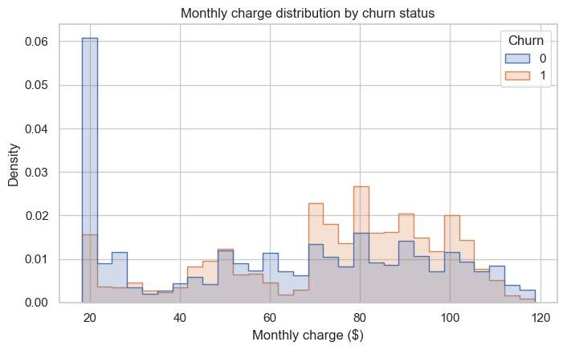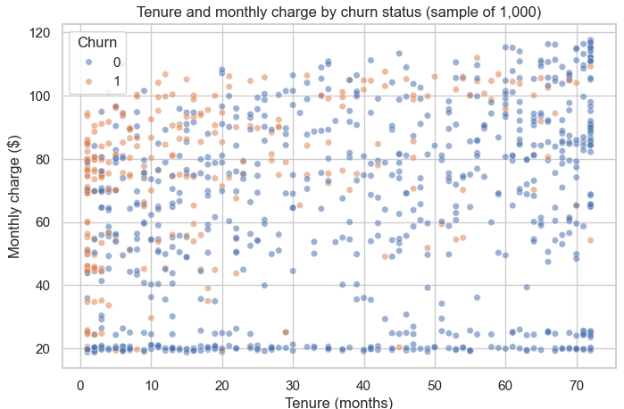

Step 7 — Customer profiles and variable relationships
Customer profiles may include age, gender, senior-citizen status, partner status, and dependents, depending on the columns available in the dataset.The analysis compares churn across customer groups and examines relationships between numerical variables. Correlation can show that variables move together, but it does not prove that one variable causes churn.
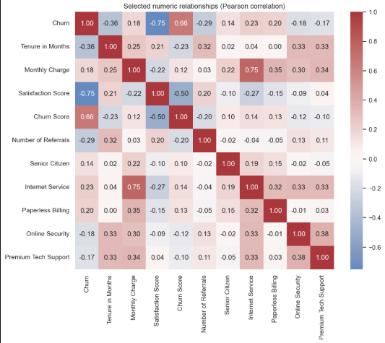

Step 8 —High-Risk Customer Segments & Business Recommendations

Step 8.1 — Visualise High-Risk Groups
Bar charts and heatmaps can display churn rates across different customer segments.Visualizations make it easier to spot groups with comparatively high churn. The results should be interpreted alongside each group’s customer count so that a small group does not appear more important than it is.
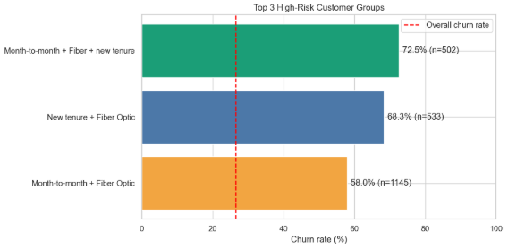

Step 8.2 — Compare Churned Customer Counts
The number of churned customers is compared across selected groups, such as contract type, tenure, payment method, or service category.Churn rate and churn count provide different information:
•Churn rate shows the proportion of a group that left.
•Churn count shows how many customers actually left.
Both measures are important when prioritizing retention actions.
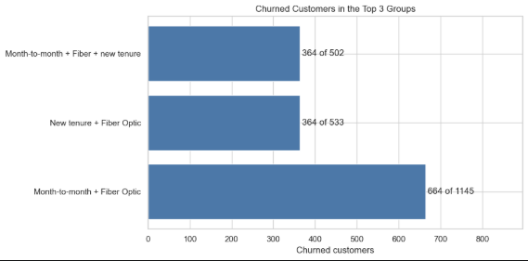

Step 8.3 — Key Findings & Three Business Recommendations
Recommendation 1 — Improve early customer experienceIf churn is high among new customers, provide onboarding support, setup guidance, and regular check-ins during the first months.Recommendation 2 — Encourage suitable long-term contractsIf month-to-month customers have higher churn, offer transparent long-term plan benefits and appropriate incentives to encourage contract renewal.Recommendation 3 — Review pricing and service valueIf churn is high among customers with large monthly charges, review plan suitability, explain billing clearly, and offer relevant bundles or alternatives.These recommendations should be matched to the actual high-risk segments identified in the dataset.

Final executive conclusion
Customer churn analysis helps the business understand which customers are leaving, when they are leaving, and which factors are associated with their decisions.By studying tenure, contracts, billing, services, charges, and customer profiles, the company can identify groups that may need additional support. Visualizations and churn counts help prioritize these groups, while revenue analysis estimates the financial exposure.The recommended approach is to use data-driven retention strategies, test them with selected customer segments, and measure their impact through churn rate, retention rate, customer satisfaction, and revenue retained.

3. Key Findings from the Analysis
Analysis area | Observed result
Overall churn | 1,121 out of 4,225 customers churned, resulting in an overall churn rate of 26.53%.
Tenure pattern | Customers in the 0–12 month tenure group had the highest observed churn rate at 47.58% (620 out of 1,303). The rate reduced across later tenure groups.
Contract pattern | Month-to-month customers showed 45.46% churn, compared with 10.73% for one-year contracts and 2.39% for two-year contracts.
Internet type | Fiber Optic customers had a 40.08% churn rate, compared with 24.70% for Cable and 19.84% for DSL.
Service adoption | Customers without Online Security and Premium Tech Support showed higher churn rates than customers with those services.
Monthly charge comparison | The average monthly charge was $73.89 among churned customers and $61.66 among customers not marked as churned.
Revenue exposure estimate | Churned customers were associated with $82,829.60 in recorded monthly charges, equal to 30.20% of the total recorded monthly charges.
Highest-risk combined segment | Month-to-month Fiber Optic customers in their first 12 months showed 72.51% churn (364 out of 502 customers).

4. Visualisation and Interpretation
Charts were used to make comparisons easier to understand. The visual analysis included retained-versus-churned customer counts, churn rates by tenure and contract type, service adoption comparisons, monthly-charge distributions, selected correlation patterns, and charts comparing high-risk segments. These visuals supported the written interpretation and helped connect the numerical results to business decisions.
The team interpreted the results as associations in the supplied dataset. For example, a higher churn rate among customers with a particular contract or service type does not, by itself, prove that the contract or service caused customers to leave.

5. Business Recommendations

Improve early customer onboarding
Introduce customer check-ins during the first 30, 60 and 90 days. Use these interactions to identify installation, billing, connectivity or support issues before they become reasons to leave.

Investigate Fiber Optic service experience
Review installation quality, internet reliability, speed-related complaints and support response times. Focus on identifying recurring issues rather than assuming that the internet type alone causes churn.

Test targeted retention benefits
Evaluate suitable loyalty benefits, clearer plan comparisons or longer-term contract options for month-to-month customers. Run small, measurable pilots and assess both retention outcomes and costs.

6. Data Handling, Limitations and Responsible Interpretation
- No exact duplicate rows or duplicate customer IDs were found in the dataset.
- Missing churn category and churn reason values were treated as structurally expected for customers who had not churned.
- Missing Internet Type values aligned with records indicating no internet service; these customers were retained as a separate meaningful group.
- Missing Offer values were not assigned guessed labels because the dataset did not provide enough evidence to interpret them.
- The overall 26.53% churn rate includes 272 newly joined customers coded as not churned. Excluding those records gives a churn rate of 28.36%; both figures were disclosed.
- The $82,829.60 figure represents recorded monthly charges associated with churned customers. It is not a forecast, profit loss, margin estimate or guaranteed recoverable revenue.
- Correlation and group comparisons are descriptive. Some fields, such as churn score or satisfaction score, may contain information recorded at or after the churn event and should not automatically be treated as pre-churn predictors.
- High-risk customer groups overlap. Their customer counts should not be added together.

7. Conclusion
Through this workflow, the team converted a raw telecom customer dataset into a structured view of churn behaviour. The analysis showed that early-tenure customers, month-to-month contract customers and Fiber Optic customers deserve closer attention, with the combined early-tenure month-to-month Fiber Optic segment showing the highest observed churn rate. The findings provide a practical starting point for retention experiments and service improvements. The next step for the business would be to test the recommended actions, track customer outcomes over time, and evaluate whether the interventions improve retention in a cost-effective way.

Team
Beyond Binary
Pamarthi Jayanth | Marthala Navya | Uddanti Rishikesh | Chamarthi Venkat Varun Krishna Raju | Bandi Sanju

