**Earthquake Prediction Model**

**INTRODUCTION**

Earthquakes are something which almost everyone has heard about or experienced at some point or the other. Earthquakes are basically a naturally occurring event which occurs when there is a sudden release of energy in the Earth’s crust resulting in vibrations or shaking of the ground. Under the surface of the earth, there are large sections called tectonic plates which make up the outer layer of earth. These sections are frequently moving and interact with each other. As a result of this interaction and movement, these plates can get locked due to friction, which in turn causes stress to build up.

Over time, as the stress keeps getting accumulated, at one point it reaches a point at which the rocks along the boundaries of the plates rupture, releasing the vast amount of stored energy. This energy which is released, propagates as Seismic waves through the earth’s crust and thus causing the ground to shake and tremble. The strength as well and intensity of an earthquake is measured using a standard scale known as Richter scale.

**DATASET**

The earthquake dataset contains detailed information regarding the various earthquakes which have happened around the world between 1-01-2001 and 1-01-2023. It is structured data related to Seismic events. Such data is collected and maintained by organisations like seismological institutes, research institutes etc. This dataset can be used to build and train various Machine Learning models which can predict earthquakes which would help in saving people’s lives and also to take necessary measures to reduce the damage caused.

The dataset can be downloaded using this [link](https://www.kaggle.com/datasets/warcoder/earthquake-dataset)

The dataset contains 782 rows and 19 attributes (columns) in total. A brief description of the attributes are:

**title:** Refers to the name/title given to the earthquake

**magnitude:** Used to describe the strength or intensity of the earthquake

**date_time:** Indicates date and time of the earthquake

**cdi:** CDI represents the highest level of reported intensity recorded for the given earthquake

**mmi:** MMI stands for Modified Mercalli Intensity and indicates the maximum reported instrumental intensity for the earthquake

**alert:** This attribute refers to the alert level which indicates the possible threat or risk associated with a particular earthquake

**tsunami:** Indicates whether the earthquake caused a tsunami or not

**sig:** Used to describe how significant an earthquake is. The significance of the earthquake is directly proportional to this number

**net:** Indicates the id of the source which collected the data.

**nst:** This attribute is used to describe the overall count of seismic stations utilised for establishing the location of the earthquake.

**dmin:** Indicates the closest station’s horizontal distance from the epicentre.

**gap:** Used to determine the horizontal position of the earthquake. A smaller value indicates a greater reliability in determining the horizontal position of the earthquake

**magType:** This refers to the type of algorithm used to calculate the magnitude of an earthquake

**depth:** Indicates the depth at which the earthquake begins to rupture

**latitude, longitude:** Indicates the location of the earthquake using a coordinate system

**location:** Indicates the specific location within the country

**continent:** Refers to the continent where the earthquake occurred

**country:** Indicates the country affected by the earthquake

**TOOLS AND LIBRARIES USED**

The project makes use of the following Python libraries:

* NumPy
* Matplotlib
* Seaborn
* Pandas
* Scikit-Learn

**PREREQUISITES REQUIRED:**

The prerequisites required are:

NumPy:

* Understanding of arrays and matrix operations.
* Ability to perform numerical computations efficiently.

Pandas

* Proficiency in handling and analysing structured data.
* Understanding of DataFrames and Series.
* Ability to manipulate and preprocess seismic data, including cleaning, filtering, and transforming data.

Matplotlib

* Knowledge of basic plotting techniques, including line plots, scatter plots, and histograms.
* Understanding of subplots for creating multiple plots in a single figure.
* Familiarity with advanced plot types, such as heatmaps, contour plots, and geographical visualisations.

Seaborn:

* Understanding of statistical data visualisation techniques.
* Knowledge of Seaborn functions for creating visually appealing and informative plots.

scikit-learn:

* Familiarity with machine learning concepts, such as supervised and unsupervised learning.
* Understanding of model selection, training, and evaluation procedures.

**STEPS FOR EARTHQUAKE DETECTION USING MACHINE LEARNING**

1. Importing the required libraries.

|  |
| --- |
| import pandas as pd import numpy as np import matplotlib.pyplot as plt import seaborn as sns |

2. After importing the required libraries, the dataset can be read and displayed. The dataset can be read using the **read_csv()** function and the first 5 rows of the dataset can be displayed using the **head()** function.

|  |
| --- |
| data = pd.read_csv('earthquake_data.csv') data.head() |

Output:

The output displays the first 5 rows of the dataset.

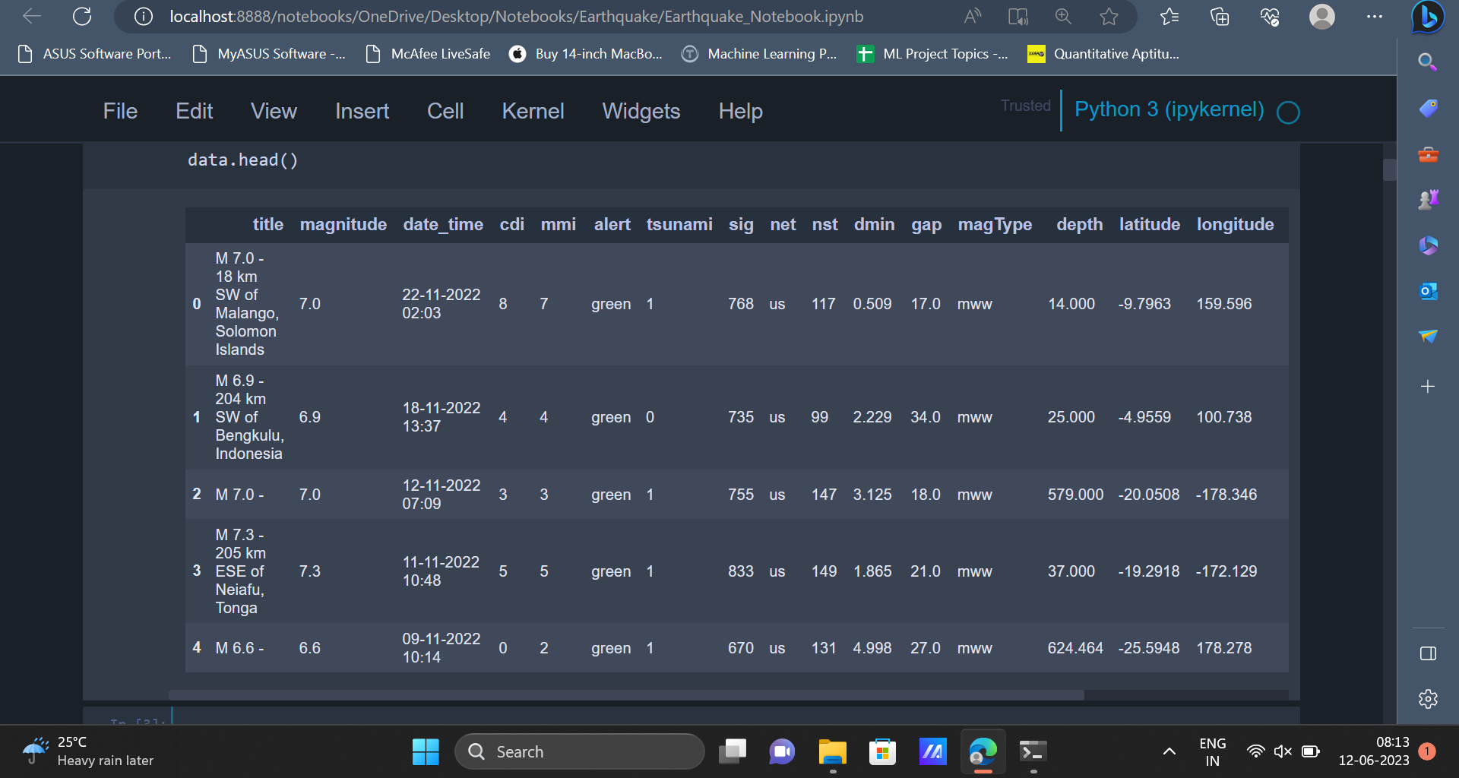

3. Once the data has been read, some basic exploratory data analysis can be carried out on the data in order to gain some insights about the data and to understand more about the data.

|  |
| --- |
| data.info() |

Output:

The **info()** function is used to get information regarding the attributes present in the dataset, number of rows in the dataset, number of missing values in each attribute, data type of each attribute etc.

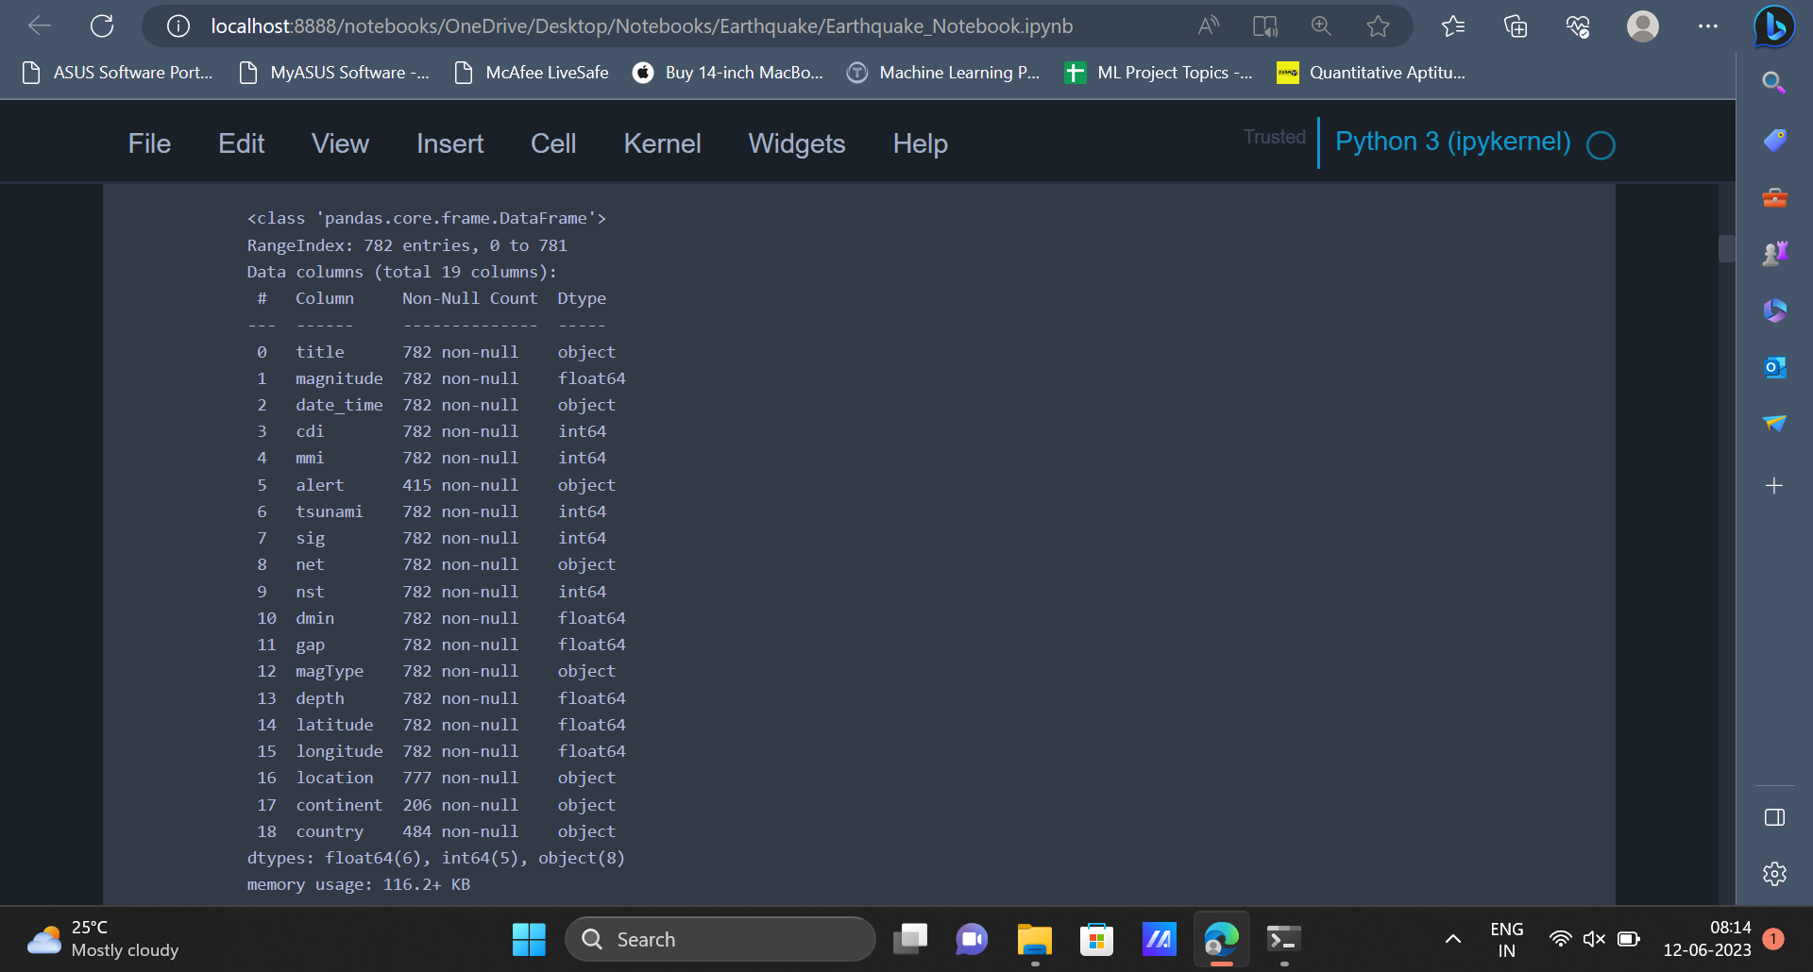

4. Apart from the **info()** function, the **describe()** function can also be used to get statistical information about the dataset.

|  |
| --- |
| data.describe().transpose() |

Output:

The **describe()** function gives statistical insights like min value, max value, mean value, standard deviation etc for all the attributes belonging to the dataset.

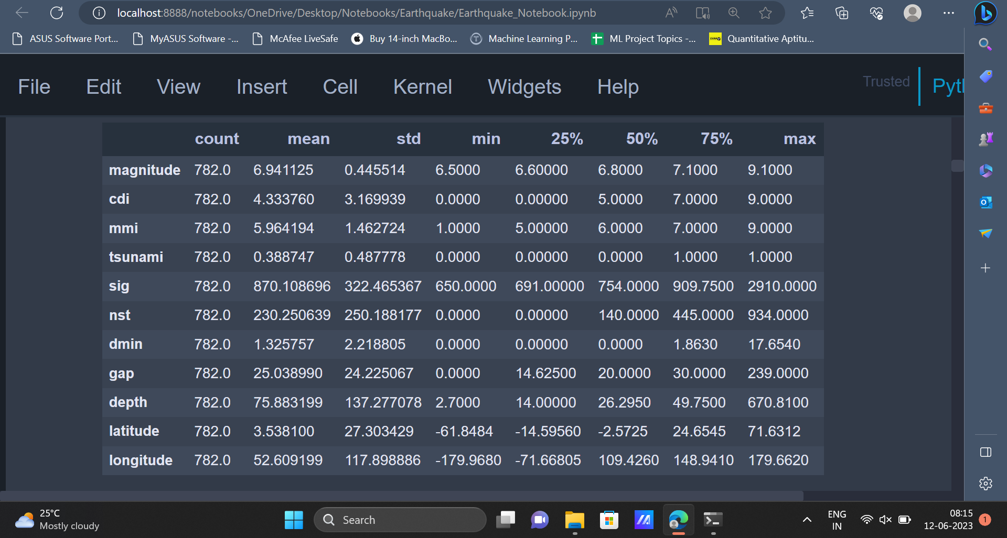

5. The **isnull()** function can be used to find out if there are any null values present in the dataset and the aggregate function **sum()** is used to get the total number of null values in each attribute of the dataset.

|  |
| --- |
| data.isnull().sum() |

Output:

The output image displays the total number of null values in all the attributes of the dataset. The columns **alert**, **continent** and **country** have **367**, **576** and **298** null values respectively.

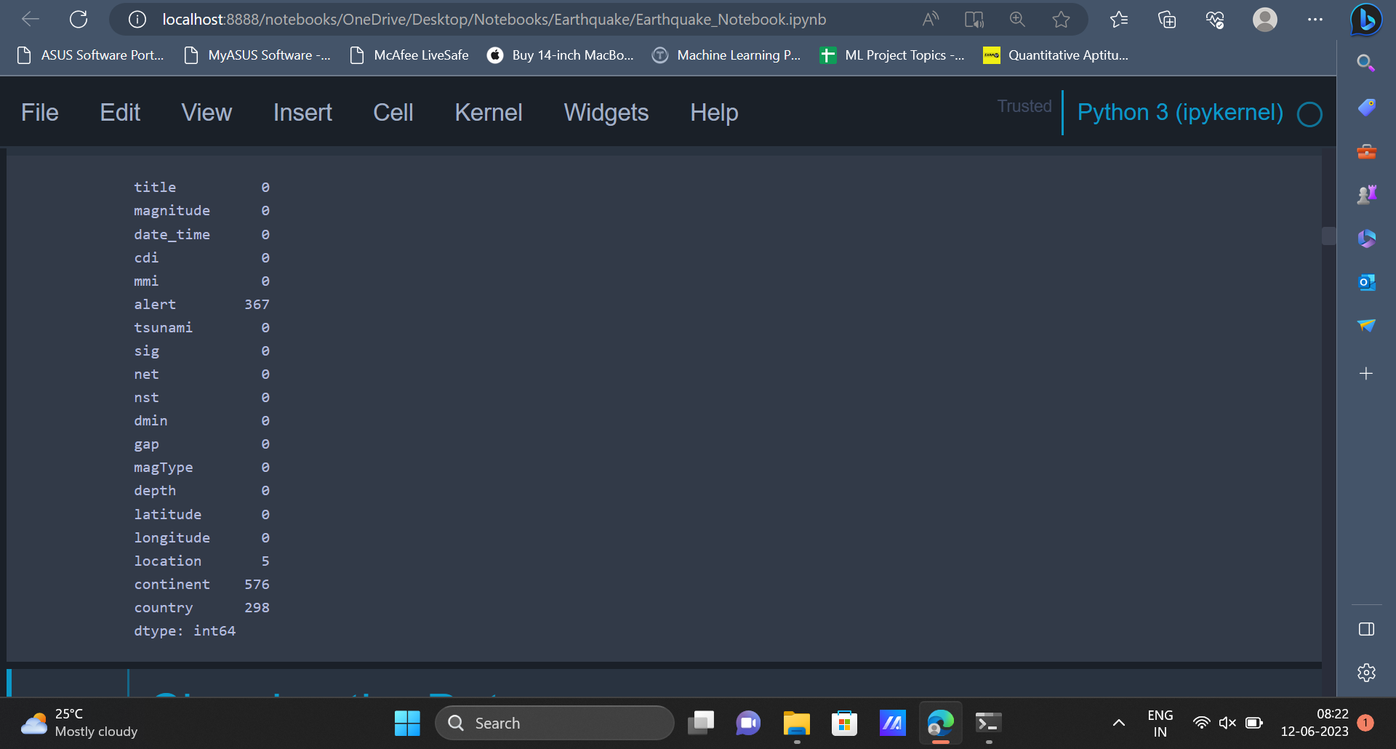

6. After gaining some basic insights about the data, we can go ahead and clean the dataset. Cleaning the dataset will help in transforming it into a better form which can be later used to train various machine learning models.

|  |
| --- |
| features = ["magnitude", "depth", "cdi", "mmi", "sig"] target = "alert" data = data[features + [target]]  data.head() |

Output:

In the code given above, we create a list called **features** which contains the attributes named

**magnitude**, **depth**, **cdi**, **mmi**, **sig**. We will be using machine learning models to predict the values of the

**alert** attribute.

The **alert** attribute is stored in a variable called **target**. In the next step, we will be creating a dataframe and selecting only those columns/attributes mentioned in the **features** list along with the **target** variable.

The first 10 rows of the new dataframe can be displayed using the **head()** function.

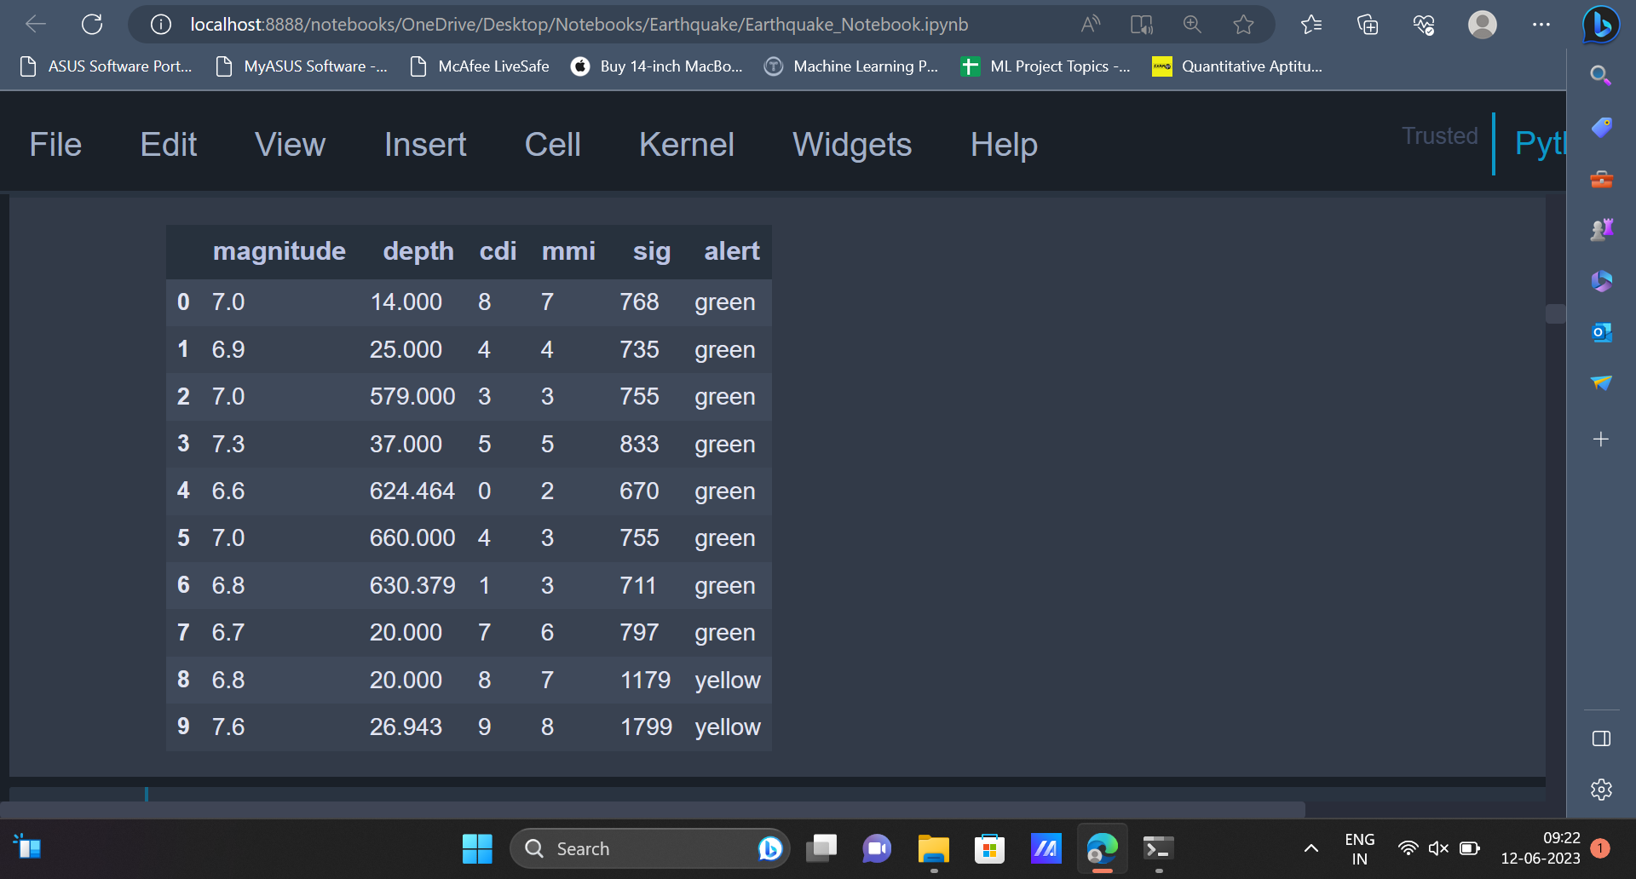

7. The count of all the values present in the **alert** attribute can be displayed using **pie chart.**

|  |
| --- |
| plt.figure(figsize = (6,12)) plt.pie(x = data[target].value_counts(), labels = ['blue','orange','green','red'], autopct = '%.2f') plt.title("Distribution of values in alert column") plt.legend() plt.show() |

Output:

The pie chart displays the distribution of various values present in the **alert** column. The percentage of occurrence of various values is: **blue = 78.31%**, **orange = 13.49%**, **green = 5.30%**, **red = 2.89%**.

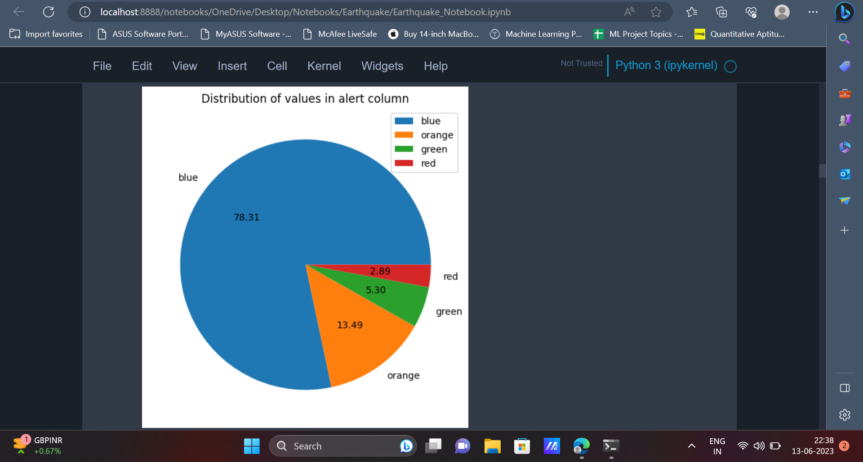

8. Earlier we had seen that some attributes in the dataset contain certain null values. Since there are not many null values, these values can be removed from the dataset using the **dropna()** function.

|  |
| --- |
| data.dropna(inplace=True) data.info() |

Output:

The null values are removed using the **dropna()** function and in the next line, the **info()** function is used to get some basic information about the dataset.

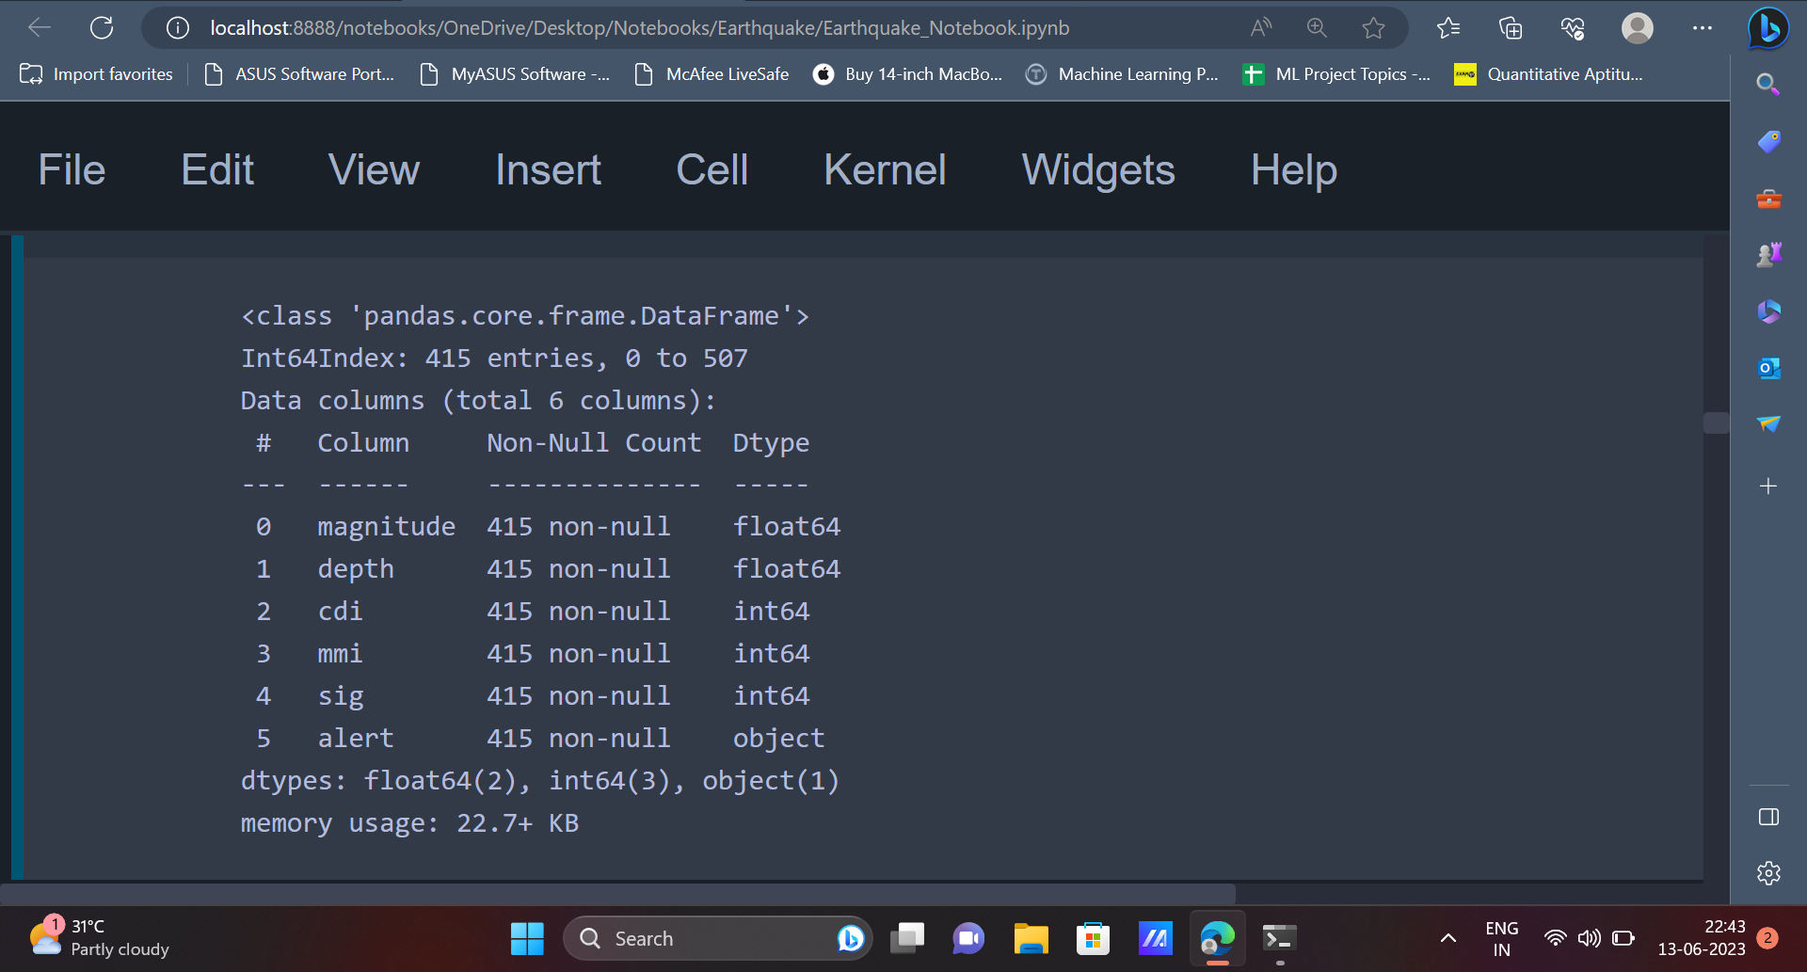

9. In the next step, we will be pre-processing the data. In this step, data types of certain attributes will be changed. In the code the attributes **cdi, mmi, sig** are converted from type **int64** to type **int8** and the attribute **depth** is converted from type **float64** to **int16**. The attribute **alert** is also converted from type **object** to **category**. These transformations are mostly done for memory optimization. Other reasons to convert the data types would be, to represent the data in a better way using integer numbers rather than floating point numbers.

|  |
| --- |
| data = data.astype({'cdi': 'int8', 'mmi': 'int8', 'sig': 'int8', 'depth': 'int16', 'alert': 'category'}) data.info() |

Output: Once the data types of the attributes are converted, the **info()** function can be used to display the

information about the attributes and their data types.

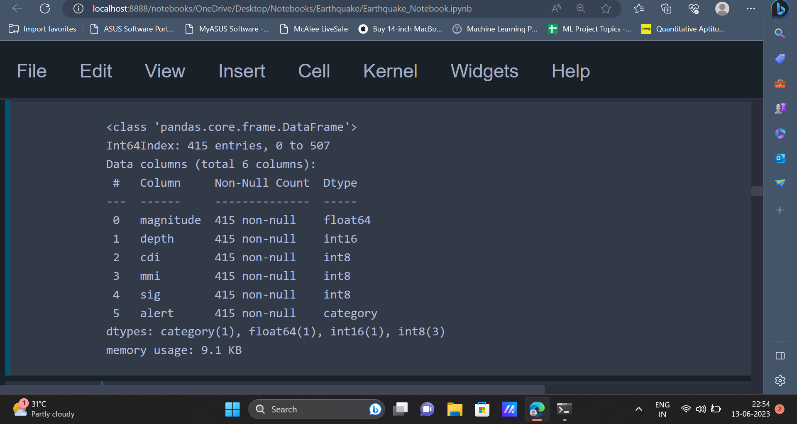

10. Now, let’s check the count of various values present in the target (**alert**) column. We can use the bar-plot for this purpose.

|  |
| --- |
| data[target].value_counts().plot(kind='bar', title='Count (target)', color=['green', 'yellow', 'orange', 'red']); |

Output: The output image is a bar-plot displaying the count of all the values in the **alert** attribute. The

values are **green, yellow, orange, red**. The majority of the values are **green**, followed by **yellow, orange**

and **red**.

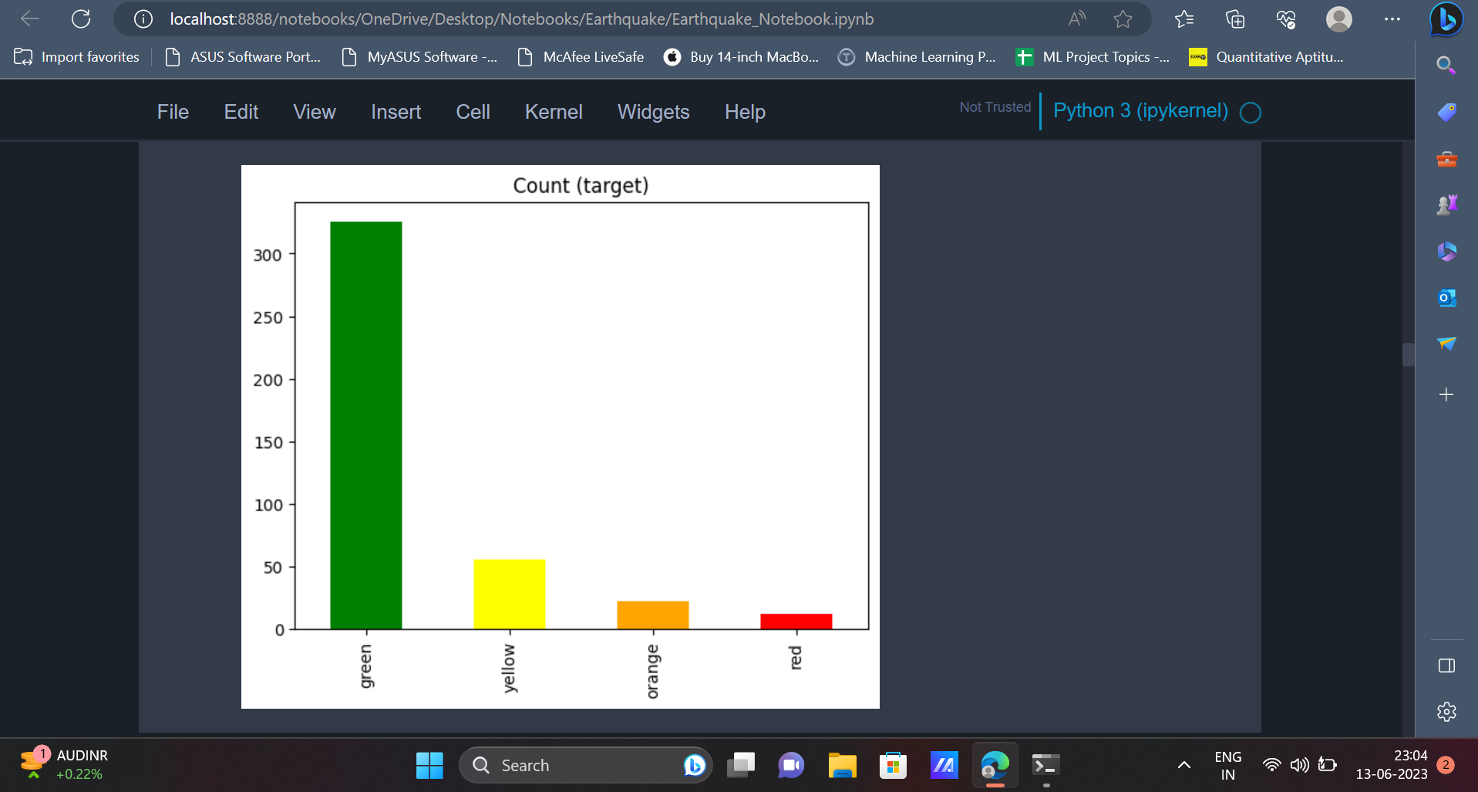

11. In the previous step, it was seen that the most frequently occurring value in the **alert** attribute is the

value **green**. This indicates the **alert** attribute is imbalanced, i.e values in the **alert** attribute do not have

the same number of occurrences. To overcome the problem of imbalance in the **alert** attribute, we can

perform **over-sampling**. **Over-sampling** also helps the model to perform well, since it eliminates the

chances of being biassed towards the value which has the highest occurrence.

|  |
| --- |
| X = data[features] y = data[target]  X = X.loc[:,~X.columns.duplicated()]  sm = SMOTE(random_state=42) X_res, y_res= sm.fit_resample(X, y,)  y_res.value_counts().plot(kind='bar', title='Count (target)', color=['green', 'orange', 'red', 'yellow']); |

In the first two lines the variable X is initialised to a dataframe named data. This **features** is a list of

attributes which have been specified earlier.

The variable y is initialised with the target (**alert)** column of the dataframe.

In the next line, the code removes any duplicated columns from the X value. Only those columns which

are not duplicated and will be stored in X.

Once this is done, we create a new instance of the **SMOTE** algorithm. **SMOTE** stands for **S**ynthetic

**M**inority **O**versampling **T**echnique. This is a commonly used technique used to solve the problem of

class imbalancing in Machine Learning.

After creating an instance of the **SMOTE** algorithm, this instance can be used to apply the **SMOTE**

resampling technique to variables **X** and **y**. The value obtained after applying the **SMOTE** algorithm is

stored in variables named **x_res** and **y_res** respectively.

Once this is done, we can use the barplot to plot the values present in **y_res** variable.

Output:

From the barplot it is evident that all the values present in the **y_res** variable have equal number of

occurrences now.

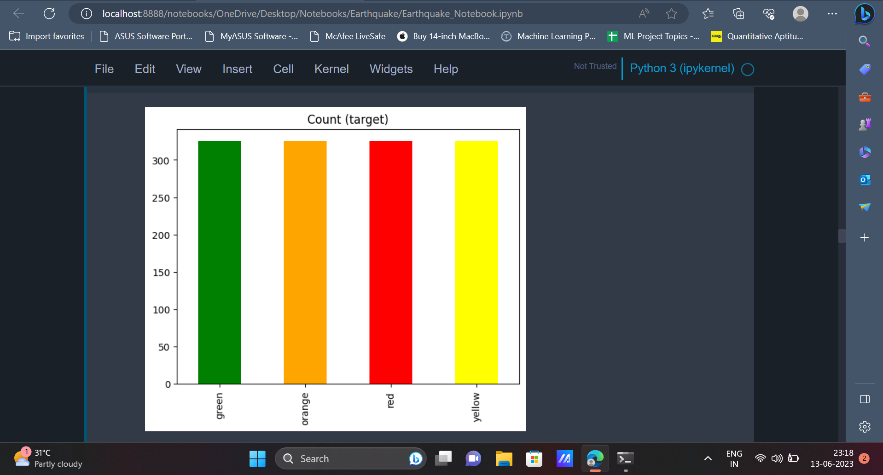

12. Moving forward, we can split the data into training data and testing data using the **train_test_split()**

function.

|  |
| --- |
| from sklearn.model_selection import train_test_split X_train, X_test, y_train, y_test = train_test_split(X_res, y_res, test_size=0.2, random_state=42) |

Note that, in the above code we have used the variables **X_res** and **y_res** as independent variable and

dependent variable respectively. We use **X_res** and **y_res** since it does not have the problem of

imbalance in the **alert** attribute. The original dataframe faced the problem of imbalance in the **alert**

attribute.

13. Before we start implementing models on our dataset, we will have to bring the data to a standard

scale which would eventually help the machine learning model understand the data in a better way.

This can be done using the **StandardScaler()** function.

|  |
| --- |
| from sklearn.preprocessing import StandardScaler scaler = StandardScaler() X_train = scaler.fit_transform(X_train) X_test = scaler.transform(X_test) |

14. We can plot the correlation between various values present in the dataset. The correlation matrix indicates the relationship between various variables present in the dataset and how each variable is affected by every other variable. It can also be plotted using the below code.

|  |
| --- |
| plt.figure(figsize = (10,6)) sns.heatmap(data.corr(), annot=True, fmt=".2f") plt.plot() |

Output:

The correlation matrix represents the correlation coefficients between various values present in the dataset.

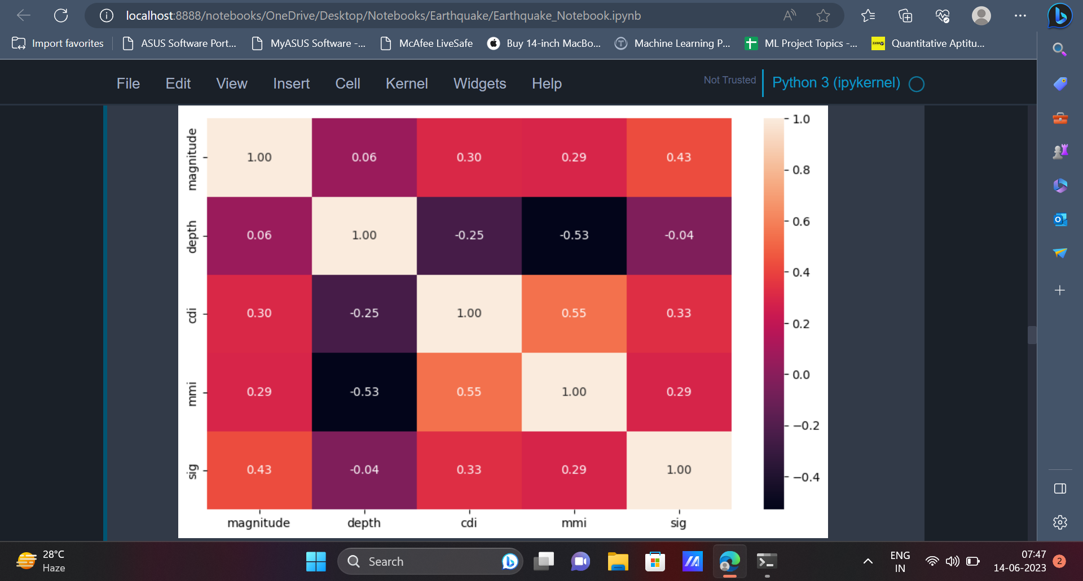

15. In the next step, we can train various Machine Learning models on the training dataset and the

performance of these models can be evaluated using the testing dataset.

|  |
| --- |
| models = [] from sklearn.tree import DecisionTreeClassifier dt = DecisionTreeClassifier(random_state=42) dt.fit(X_train, y_train) |

Predictions from the model can be made using the **predict()** method.

The performance of the models can be evaluated using metrics **accuracy_score**, **classification_report**,

**confusion_matrix**.

|  |
| --- |
| from sklearn.metrics import classification_report, confusion_matrix, accuracy_score dt_pred = dt.predict(X_test) print(accuracy_score(dt_pred,y_test)*100) print(classification_report(dt_pred, y_test)) sns.heatmap(confusion_matrix(dt_pred, y_test), annot = True) plt.plot() |

Output: The values present in the diagonal of the confusion matrix (54,64,60,51) represent

the number of data points which have been correctly classified by the model. From the accuracy

score, it is evident that Decision Tree Classifier has an accuracy of **88.07%**.

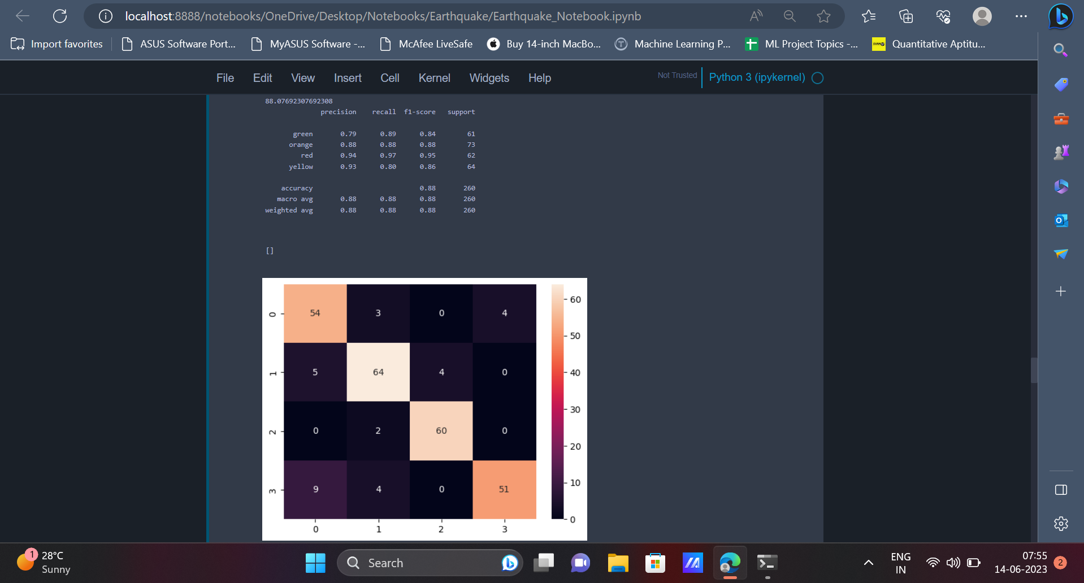

16. The next model which we will be implementing is KNN.

|  |
| --- |
| from sklearn.neighbors import KNeighborsClassifier knn = KNeighborsClassifier() knn.fit(X_train, y_train) |

The predictions from the model are made in a way similar to how it was made earlier.

|  |
| --- |
| knn_pred = knn.predict(X_test) print(accuracy_score(knn_pred, y_test)*100) print(classification_report(knn_pred, y_test)) sns.heatmap(confusion_matrix(knn_pred, y_test), annot = True) plt.plot() |

Output:

The confusion matrix and accuracy score can be displayed like earlier. From the output it is evident that

**KNN** has an accuracy of **89.23%**.

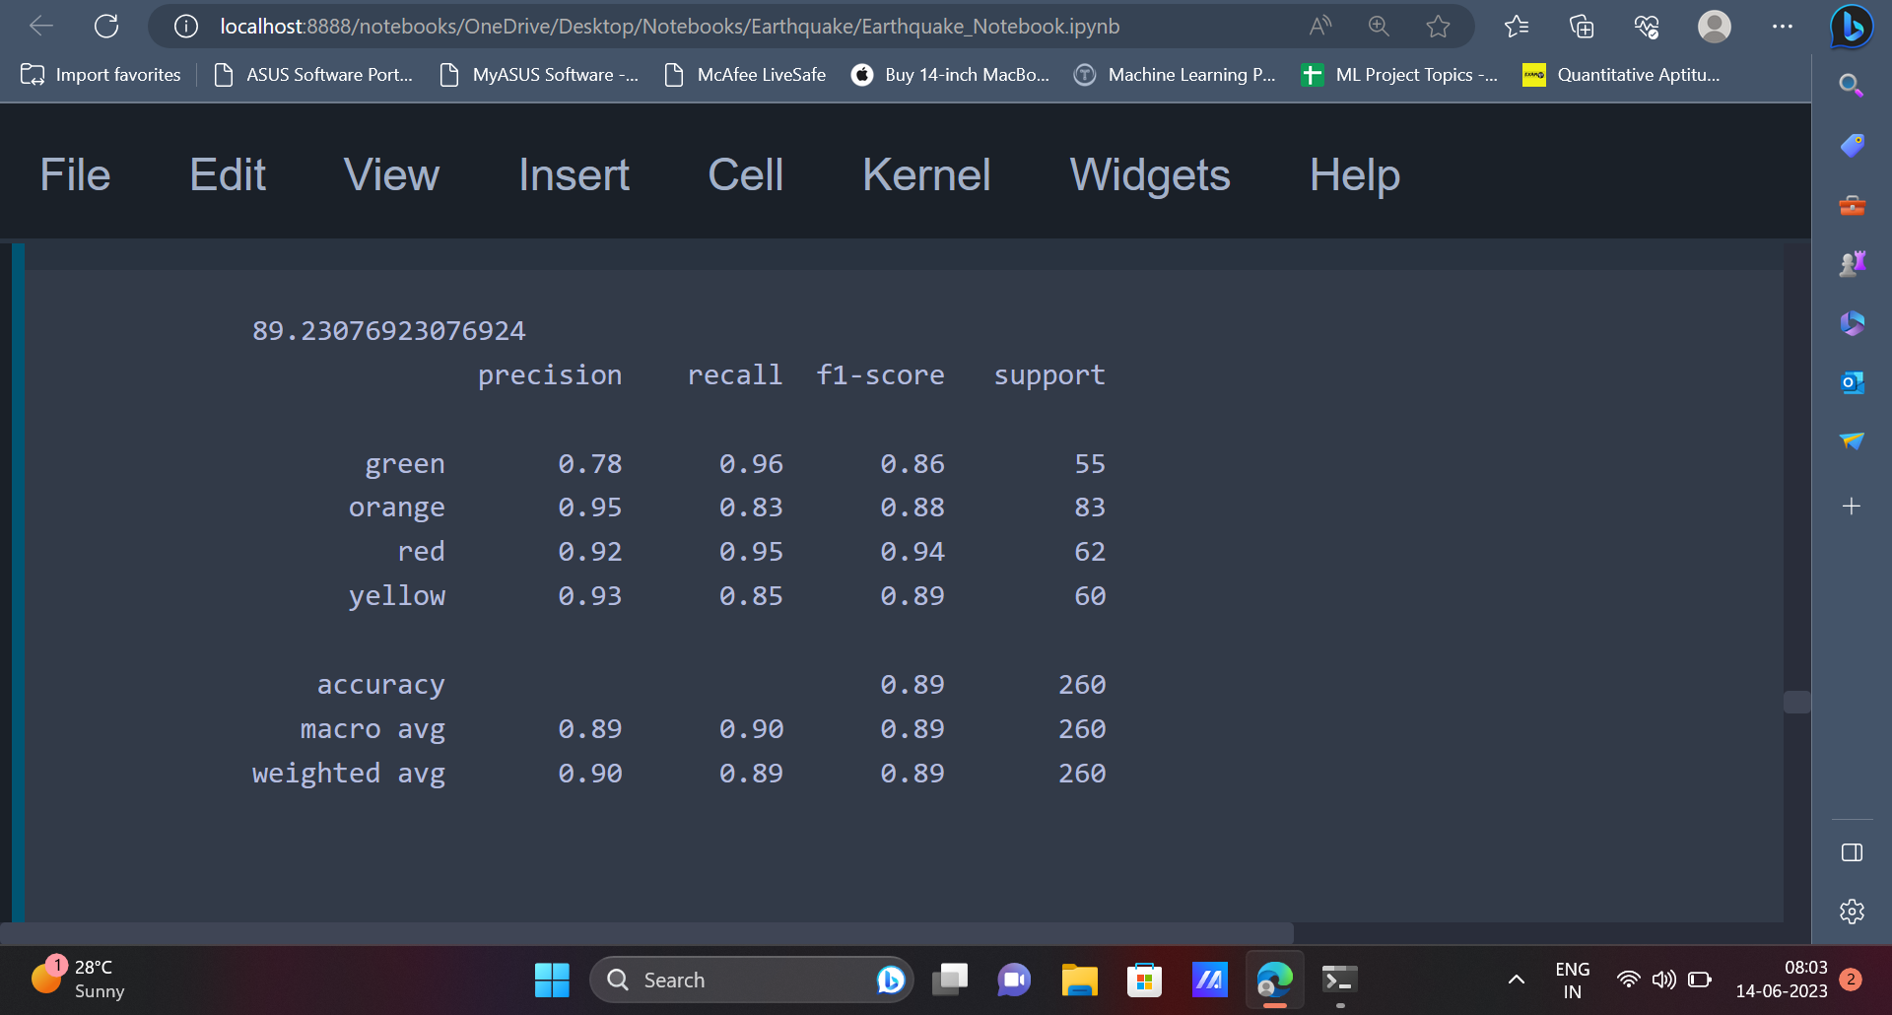

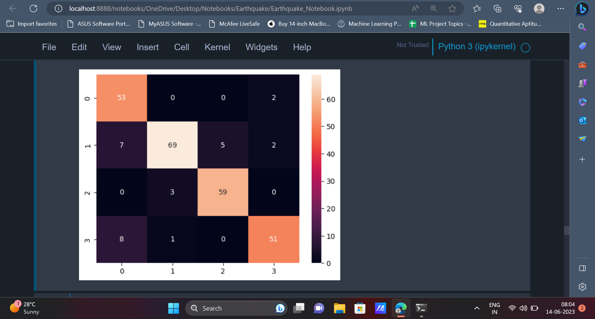

17. After using the KNN algorithm, we can use the Random **Forest Classifier** on the dataset.

|  |
| --- |
| from sklearn.ensemble import RandomForestClassifier rf = RandomForestClassifier(random_state=42) rf.fit(X_train, y_train) |

The predictions from the Random Forest Classifier can be made using the **predict()** method. The

confusion matrix and accuracy score can be displayed like earlier.

|  |
| --- |
| rf_pred = rf.predict(X_test) print(accuracy_score(rf_pred, y_test)*100) print(classification_report(rf_pred, y_test)) sns.heatmap(confusion_matrix(rf_pred, y_test), annot = True) plt.plot() |

Output: It can be seen that the Random Forest Classifier has an accuracy of **91.15%**.

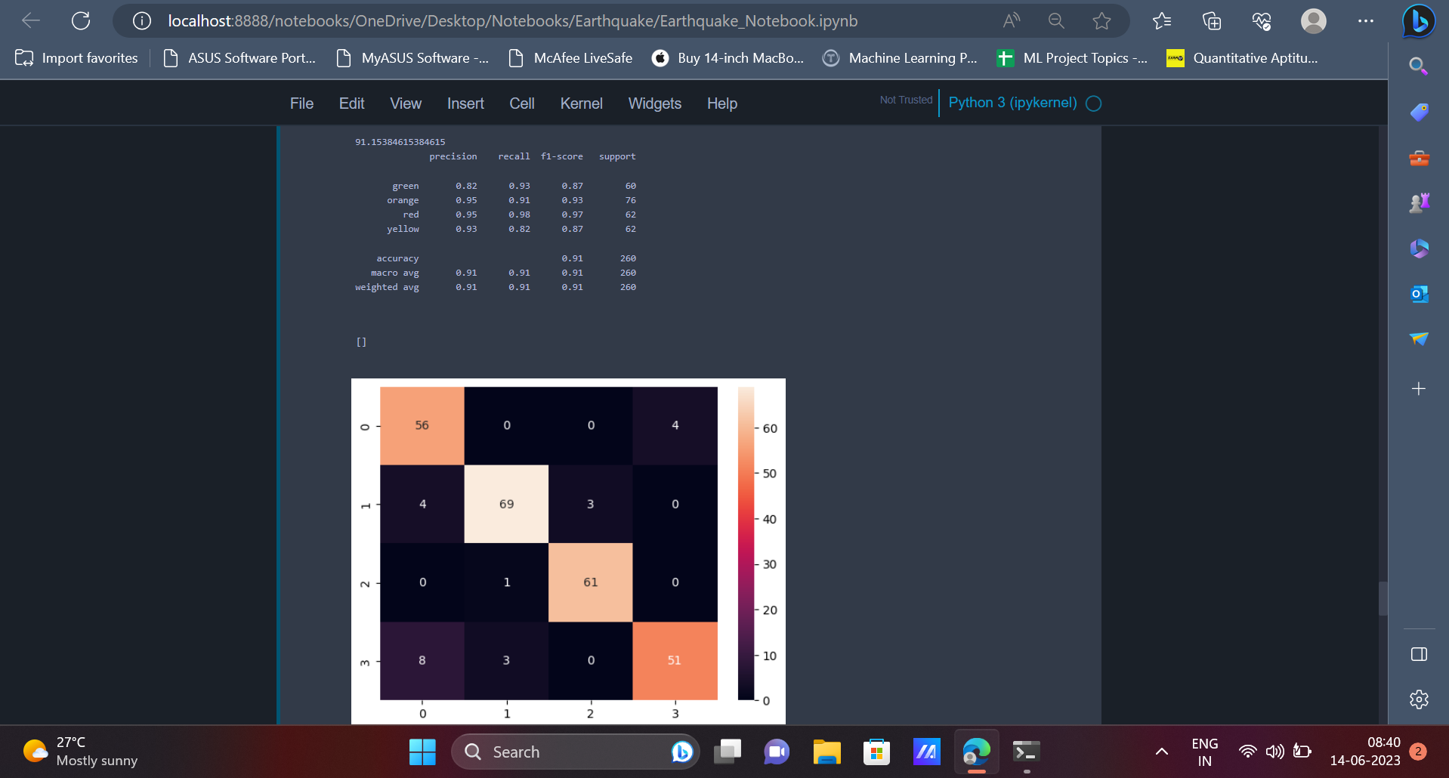

18. The last model which we will be implementing is the **Gradient Boosting Classifier**.

|  |
| --- |
| from sklearn.ensemble import GradientBoostingClassifier gb = GradientBoostingClassifier(random_state=42) gb.fit(X_train, y_train) |

The confusion matrix and accuracy can be displayed like earlier.

|  |
| --- |
| gb_pred = gb.predict(X_test) print(accuracy_score(gb_pred, y_test)*100) print(classification_report(gb_pred, y_test)) sns.heatmap(confusion_matrix(gb_pred, y_test), annot = True) plt.plot() |

Output: The **Gradient Boosting Algorithm** has an accuracy of **92.69%**.

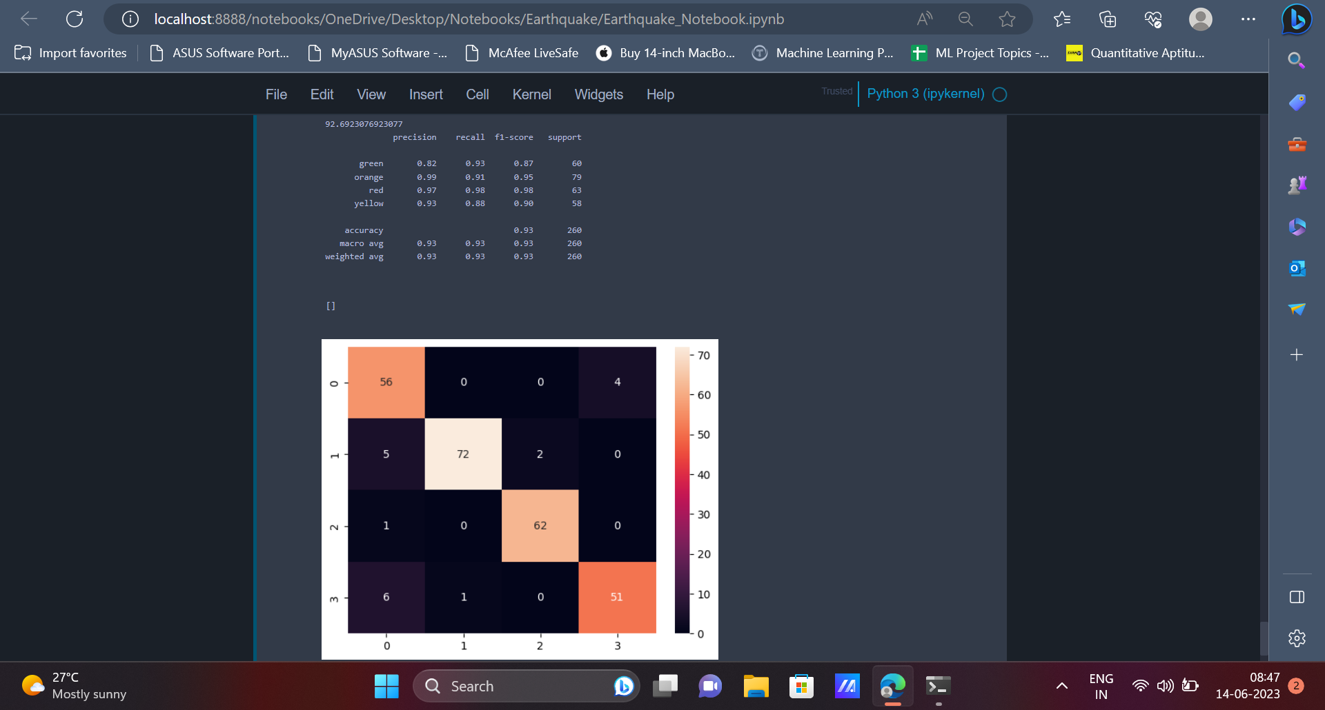

**CONCLUSION**

In conclusion, machine learning techniques have shown promising results in the prediction of earthquakes. By analysing various data sources like seismic recordings, geospatial information etc, machine learning models can learn patterns, trends, relationships which can help in identifying potential earthquake occurrences.

While machine learning models can assist in the prediction of earthquakes, it is important to note that it is an ongoing research area and achieving reliable as well as accurate predictions remains a complex task. Collaborative efforts between domain experts and machine learning engineers are crucial to advance the field and develop robust models which can help in early detection of earthquakes.