YOUTUBE TRENDING DATA ANALYSIS USING AWS

Project Overview
This project focused on designing and implementing a robust cloud-based data pipeline for analyzing YouTube trending video datasets. Leveraging Amazon S3, AWS Glue, AWS Lambda, Amazon Athena, and Amazon QuickSight, the solution provided scalable data storage, efficient preprocessing, automated schema detection, and interactive visualization.
The aim was to extract insights into video popularity trends, user engagement patterns, and regional variations, enabling data-driven decisions for content creators, marketers, and analysts.

Methodology
The project followed an end-to-end cloud data pipeline approach:
- Data Ingestion – Raw JSON and CSV datasets were stored in Amazon S3.
- Data Cataloging – AWS Glue crawlers were configured to detect and register table schemas.
- Data Preprocessing – AWS Lambda functions, written in Python, were used to clean and transform data for consistency.
- Data Querying – Amazon Athena allowed interactive SQL queries on processed data without the need for a dedicated database.
- Visualization – Amazon QuickSight dashboards displayed trends in top categories, total revenue (views/likes), and engagement metrics across regions.
AWS IAM roles were applied throughout the pipeline to ensure secure and controlled access.

Key Achievements
- Implemented a fully automated AWS-based data pipeline for YouTube trending video analytics.
- Resolved schema mismatch issues in AWS Glue, enabling consistent and reliable data querying.
- Developed QuickSight dashboards highlighting top-performing video categories, regional engagement trends, and audience interaction patterns.
- Improved query performance by optimizing schema design and partitioning datasets for Athena queries.

Impact and Benefits
The project provided a framework for analyzing large-scale video datasets in a scalable, secure, and cost-effective manner.
Benefits include:
- Faster insights into viewer preferences and content trends.
- Support for data-driven content strategies.
- Reusable architecture for other social media or streaming analytics use cases.

Introduction
Project Background:
With billions of users worldwide, YouTube generates massive amounts of engagement data daily. The "Trending" section reflects content gaining significant traction, making it a valuable source for understanding audience preferences. This project aimed to demonstrate how AWS cloud services can integrate to process, analyze, and visualize this high-volume dataset.
Scope of the Project:
- Storing raw datasets in Amazon S3.
- Automating schema detection with AWS Glue.
- Cleaning and transforming data via AWS Lambda.
- Querying structured data in Amazon Athena.
- Creating interactive dashboards in Amazon QuickSight.
Objectives:
- Automate ingestion and processing of YouTube trending datasets.
- Ensure accurate and consistent schema detection.
- Provide actionable insights through interactive visualizations.
Significance:
The project showcases AWS’s capability to handle big data analytics workflows with minimal operational overhead, providing an adaptable template for other media analytics projects.
Methodological Approach:
The approach involved sequential stages — ingestion, cataloging, transformation, querying, and visualization — orchestrated through AWS services to ensure scalability and security.

Dataset Description
https://www.kaggle.com/datasets/datasnaek/youtube-new?select=CA_category_id.json
The dataset consisted of JSON and CSV files containing details of trending YouTube videos, including:
- Video ID, Title, Channel
- Publish Time
- Views, Likes, Dislikes, Comments
- Category ID
- Regional data
The dataset spanned multiple regions, enabling comparative analysis of viewing trends.

Pipeline Stages
1. Data Ingestion – Raw files uploaded to Amazon S3 in a structured folder hierarchy.
2. Data Cataloging – AWS Glue crawlers identified schema and updated the Glue Data Catalog.
3. Data Preprocessing – AWS Lambda scripts cleaned null values, standardized formats, and mapped category IDs to category names.
4. Querying – Athena SQL queries aggregated data for trend analysis.
5. Visualization – QuickSight dashboards presented KPIs and trends for stakeholders.

Data Pipeline Architecture
The architecture was designed to ensure modularity, scalability, and automation:
- Amazon S3 – Central storage for raw and processed datasets.
- AWS Glue – Automated schema discovery and catalog updates.
- AWS Lambda – Serverless ETL functions triggered after data ingestion.
- Amazon Athena – On-demand SQL query execution on S3 data.
- Amazon QuickSight – Visualization and reporting platform.z
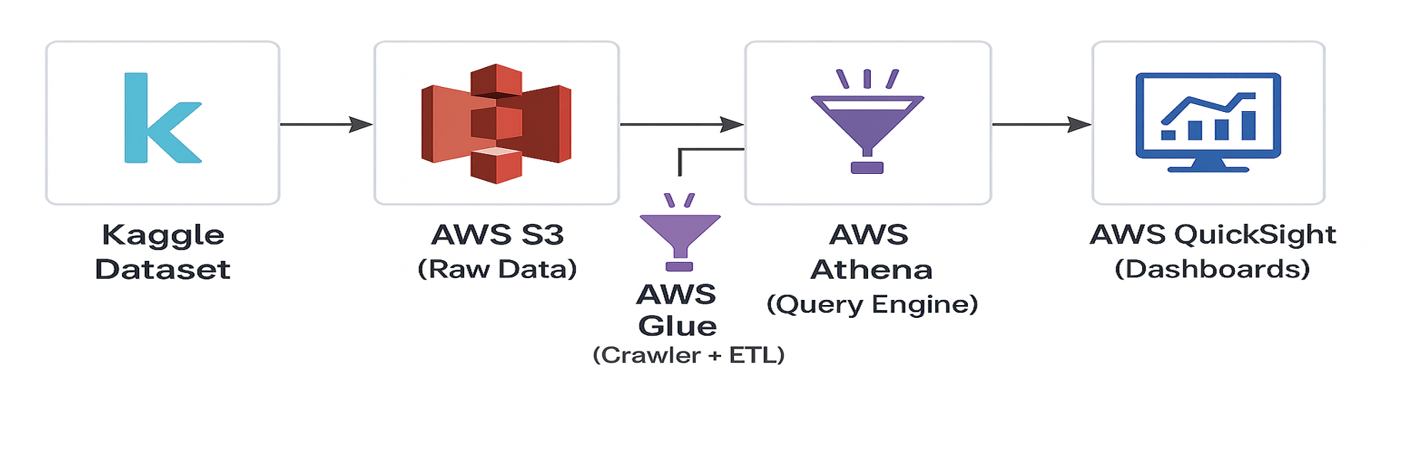

Data Loading and Storage
Initial Data Ingestion:
Data was ingested into S3 buckets categorized by region and data type (raw vs. processed).
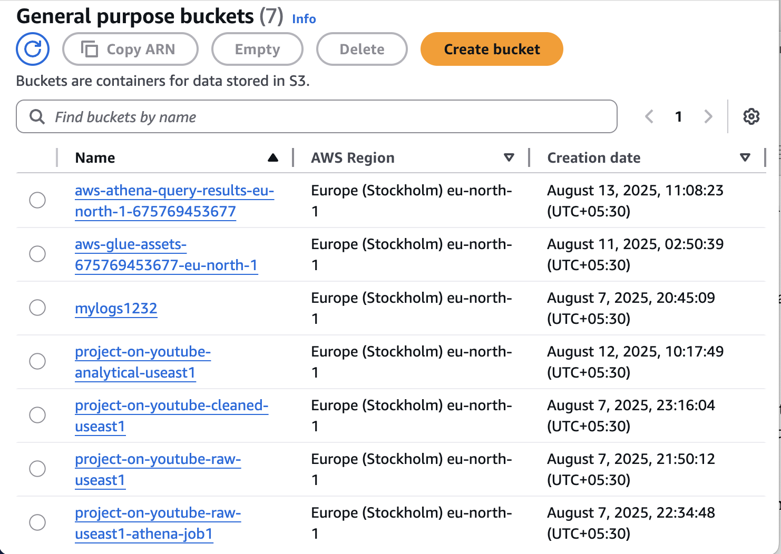
Schema Detection and Cataloging:
AWS Glue crawlers were scheduled to run automatically when new datasets arrived, detecting structure and populating the Glue Data Catalog.
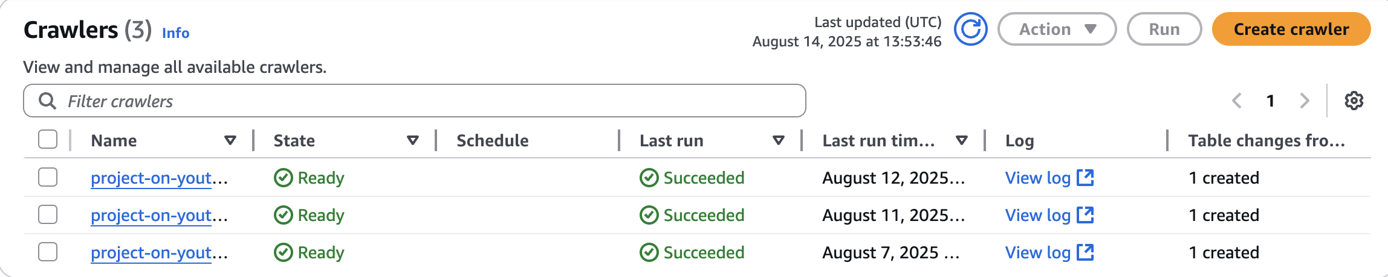
Storage Strategy:
Data was partitioned in S3 by region and upload date, improving Athena query performance and cost efficiency.
Security Measures:
IAM roles restricted access to specific services and S3 paths. S3 bucket policies enforced encryption at rest.


Challenges and Solutions
Challenge 1: Glue schema mismatches for Category ID fields.
Solution: Applied explicit schema mapping in ETL jobs and standardized data types.
Challenge 2: Large file query latency in Athena.
Solution: Partitioned datasets in S3 and optimized Athena queries with column filtering.
Challenge 3: JSON field parsing failures.
Solution: Converted JSON to Parquet format during preprocessing for better query performance.

Data Transformation
AWS Lambda scripts handled:
- Standardizing timestamp formats.
- Mapping category IDs to human-readable category names using reference files.
- Filtering incomplete records.
- Generating aggregated tables for QuickSight dashboards.
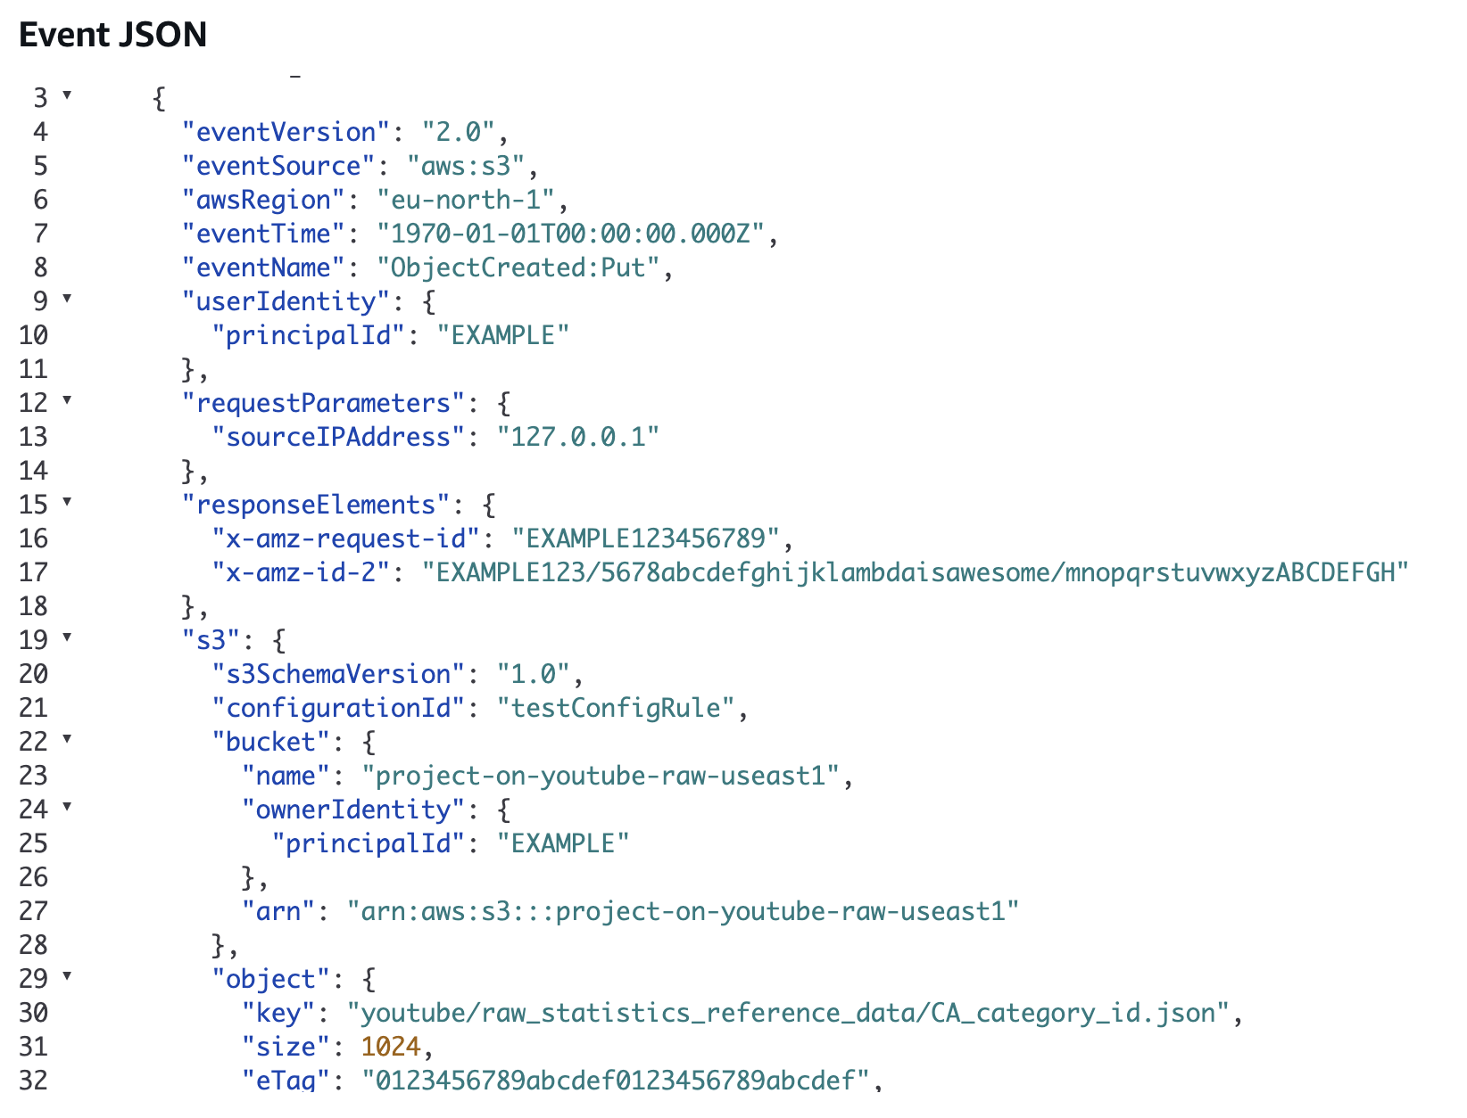

Data Quality Assurance
Although AWS Glue provided schema detection, manual validation queries in Athena ensured:
- No missing values in critical fields (video ID, views, likes).
- Correct mapping between category IDs and names.
- Removal of duplicate entries.
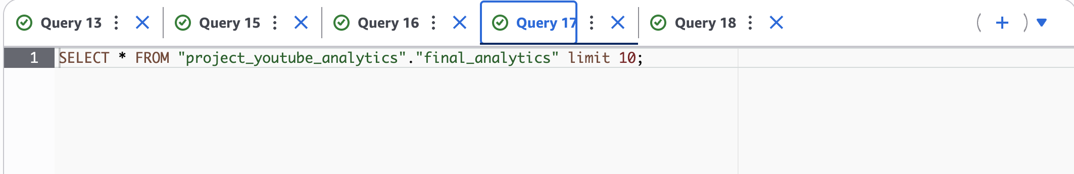
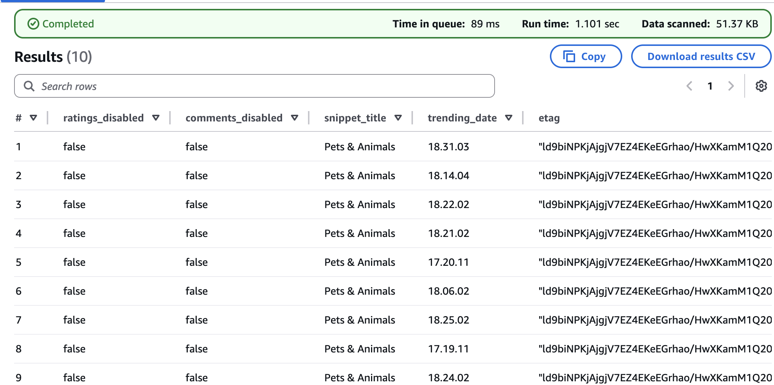

Visualization and Reporting
Amazon QuickSight Dashboards presented:
- Top Categories by Views and Likes.
- Regional Popularity Trends.
- Engagement Metrics Over Time.
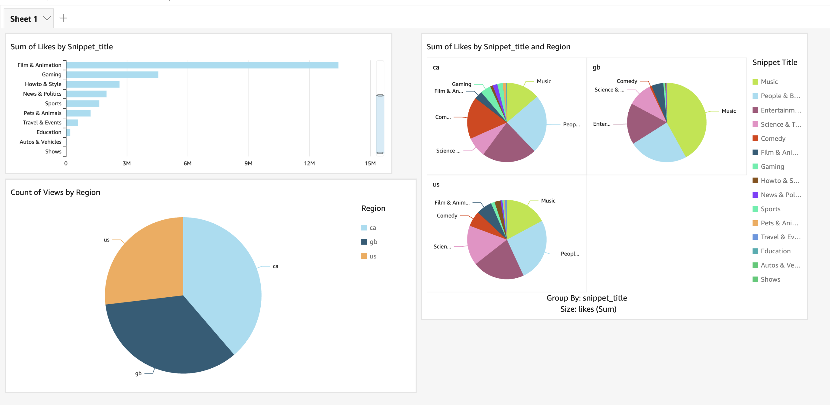
These visualizations helped identify content types and regions driving the most interaction.

Conclusion
Key Achievements:
- Automated ingestion and processing pipeline using AWS services.
- Resolved schema issues in Glue, enabling smooth Athena querying.
- Created interactive dashboards highlighting video popularity trends and audience engagement.
Impact on Decision-Making:
The project provided clear insights for content strategy and regional targeting, offering data-driven guidance for YouTube channels and marketing teams.
Lessons Learned:
- Schema consistency is critical for analytics pipelines.
- Partitioning and format optimization significantly improve performance in Athena.
Future Directions:
- Integrate real-time streaming data from YouTube APIs.
- Apply machine learning models in SageMaker for predicting video popularity.

