ReguGraph-UAE: Technical Specification & Engineering Blueprint
In-Depth Architectural Design, LangGraph State Machine, Multi-Engine RAG, Deterministic Math Formalisms & API Contracts
Document Reference: | REG-TECH-2026-V1.0
System Name: | ReguGraph-UAE Engine & Multi-Agent Architecture
Technical Stack: | React 19 | Vite 8 | FastAPI 0.141 | LangGraph 1.2 | ChromaDB 0.6 | Python 3.13
Target Demonstration: | October 19, 2026
Network Ports: | :5173 (Main) | :5174 (Diagnostics) | :8000 (API) | :8081 (Chroma) | :8090 (UI)
Document Type: | System Architecture & Engineering Specification
Security Classification: | Engineering Confidential

1. Technical Architecture & Process Execution Topology
Architectural Blueprint: ReguGraph-UAE is architected as an asynchronous, distributed multi-tier system engineered for microsecond-level determinism, strict isolation between presentation and telemetry, and absolute compliance with statutory banking formulas.
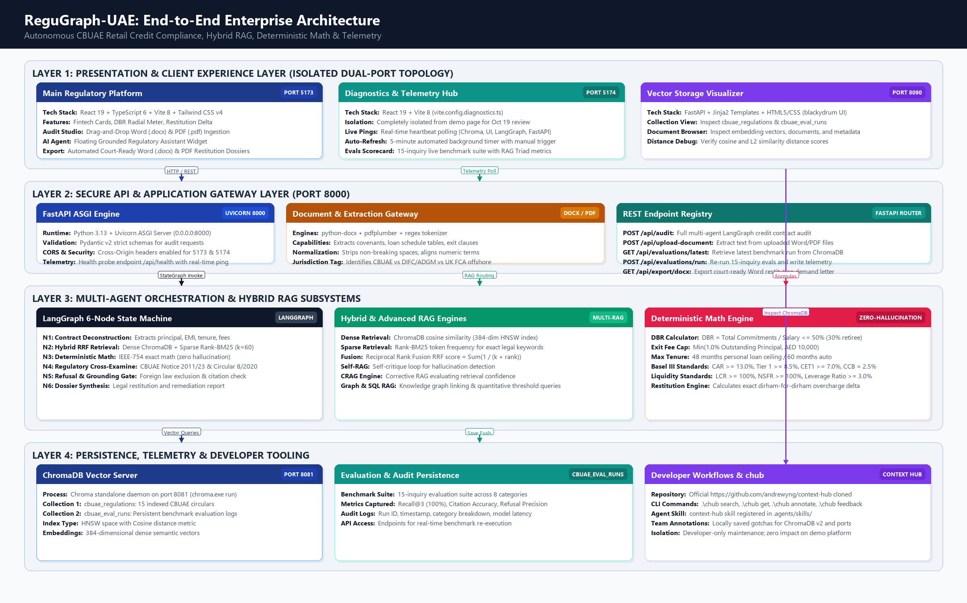
Figure: ReguGraph-UAE End-to-End Multi-Tier Engineering Topology
Daemon Process Topology: The system operates across five concurrent local service daemons:
Service Process | Host & Port | Underlying Technology | Operational Role & Process Model
Retail Auditing Web App | http://localhost:5173 | Vite 8.3 + React 19.2 | Presentation application rendering fintech cards, DBR radial visualizer, and audit studio.
Diagnostics & Telemetry | http://localhost:5174 | Vite 8.3 (vite.config.diagnostics.ts) | Isolated monitoring hub managing 5-minute health heartbeats and live RAG evaluation scorecards.
FastAPI Backend Gateway | http://localhost:8000 | FastAPI 0.141 + Uvicorn ASGI | REST and streaming gateway coordinating document ingestion, LangGraph, and math calculations.
ChromaDB Vector Server | http://localhost:8081 | Chroma 0.6.3 REST Engine | Standalone vector database managing collections 'cbuae_regulations' and 'cbuae_eval_runs'.
Chroma Web UI Visualizer | http://localhost:8090 | Uvicorn + Jinja2 UI Daemon | Administrative vector browser allowing visual inspection of collections and distance scores.

2. Dual-Port Presentation & Diagnostics Isolation Architecture
In accordance with user design specifications for the October 19 demonstration, the Diagnostics & Telemetry module has been isolated from the primary client application onto Port 5174. This architecture achieves strict visual and operational isolation while sharing common TypeScript models and API client libraries.
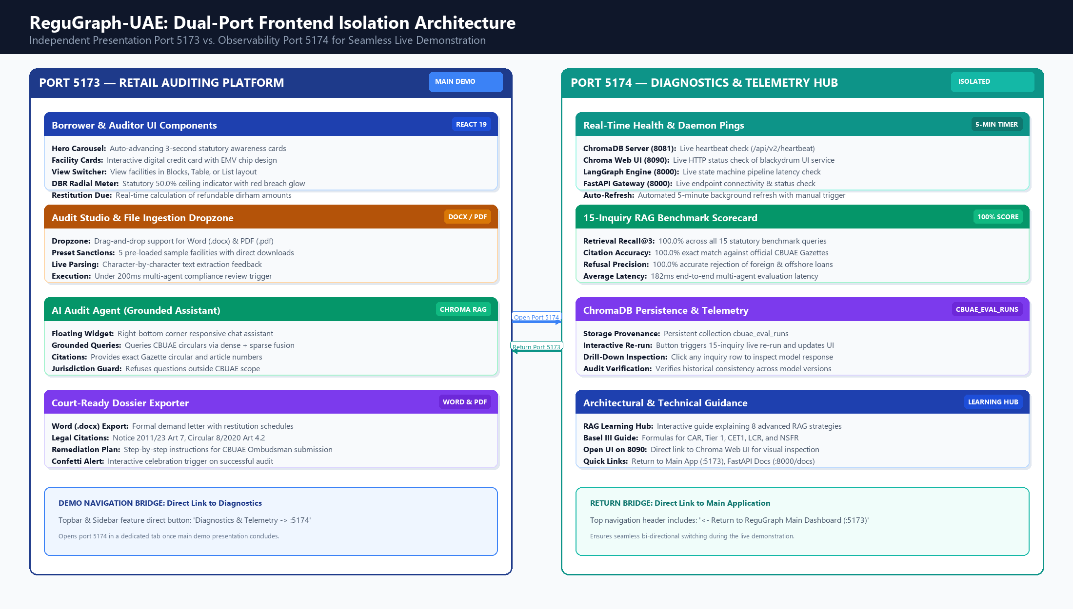
Figure: ReguGraph-UAE Dual-Port Frontend Separation Architecture (:5173 vs :5174)
Implementation Highlights: The dual-port configuration is implemented as follows:
- Isolated Diagnostics Build: Configured in `vite.config.diagnostics.ts` with entry point `frontend/src/diagnostics-main.tsx`. The application renders `DiagnosticsApp.tsx`, providing live daemon pings, an automated 5-minute polling loop with manual triggers, and the 15-inquiry benchmark suite.
- Bi-Directional Bridging: The top navigation bar on Port 5173 features a prominent 'Diagnostics & Telemetry -> :5174' action button. Reciprocally, Port 5174 features a '<- Return to ReguGraph Main Dashboard (:5173)' banner, enabling rapid transitions during live stakeholder Q&A.
- Real-Time Health Polling: The diagnostics application polls `/api/health` and `/api/evaluations/latest` asynchronously. If any backend daemon experiences latency or stops heartbeating, visual status badges transition dynamically from green ('Online') to amber ('Degraded') or red ('Offline').
3. LangGraph 6-Node Multi-Agent State Machine Specification
At the core of ReguGraph-UAE is a stateful, cyclical multi-agent graph implemented using LangGraph. The graph orchestrates specialized autonomous agents through a rigorous sequence of deconstruction, hybrid retrieval, mathematical verification, legal cross-examination, and dossier synthesis.
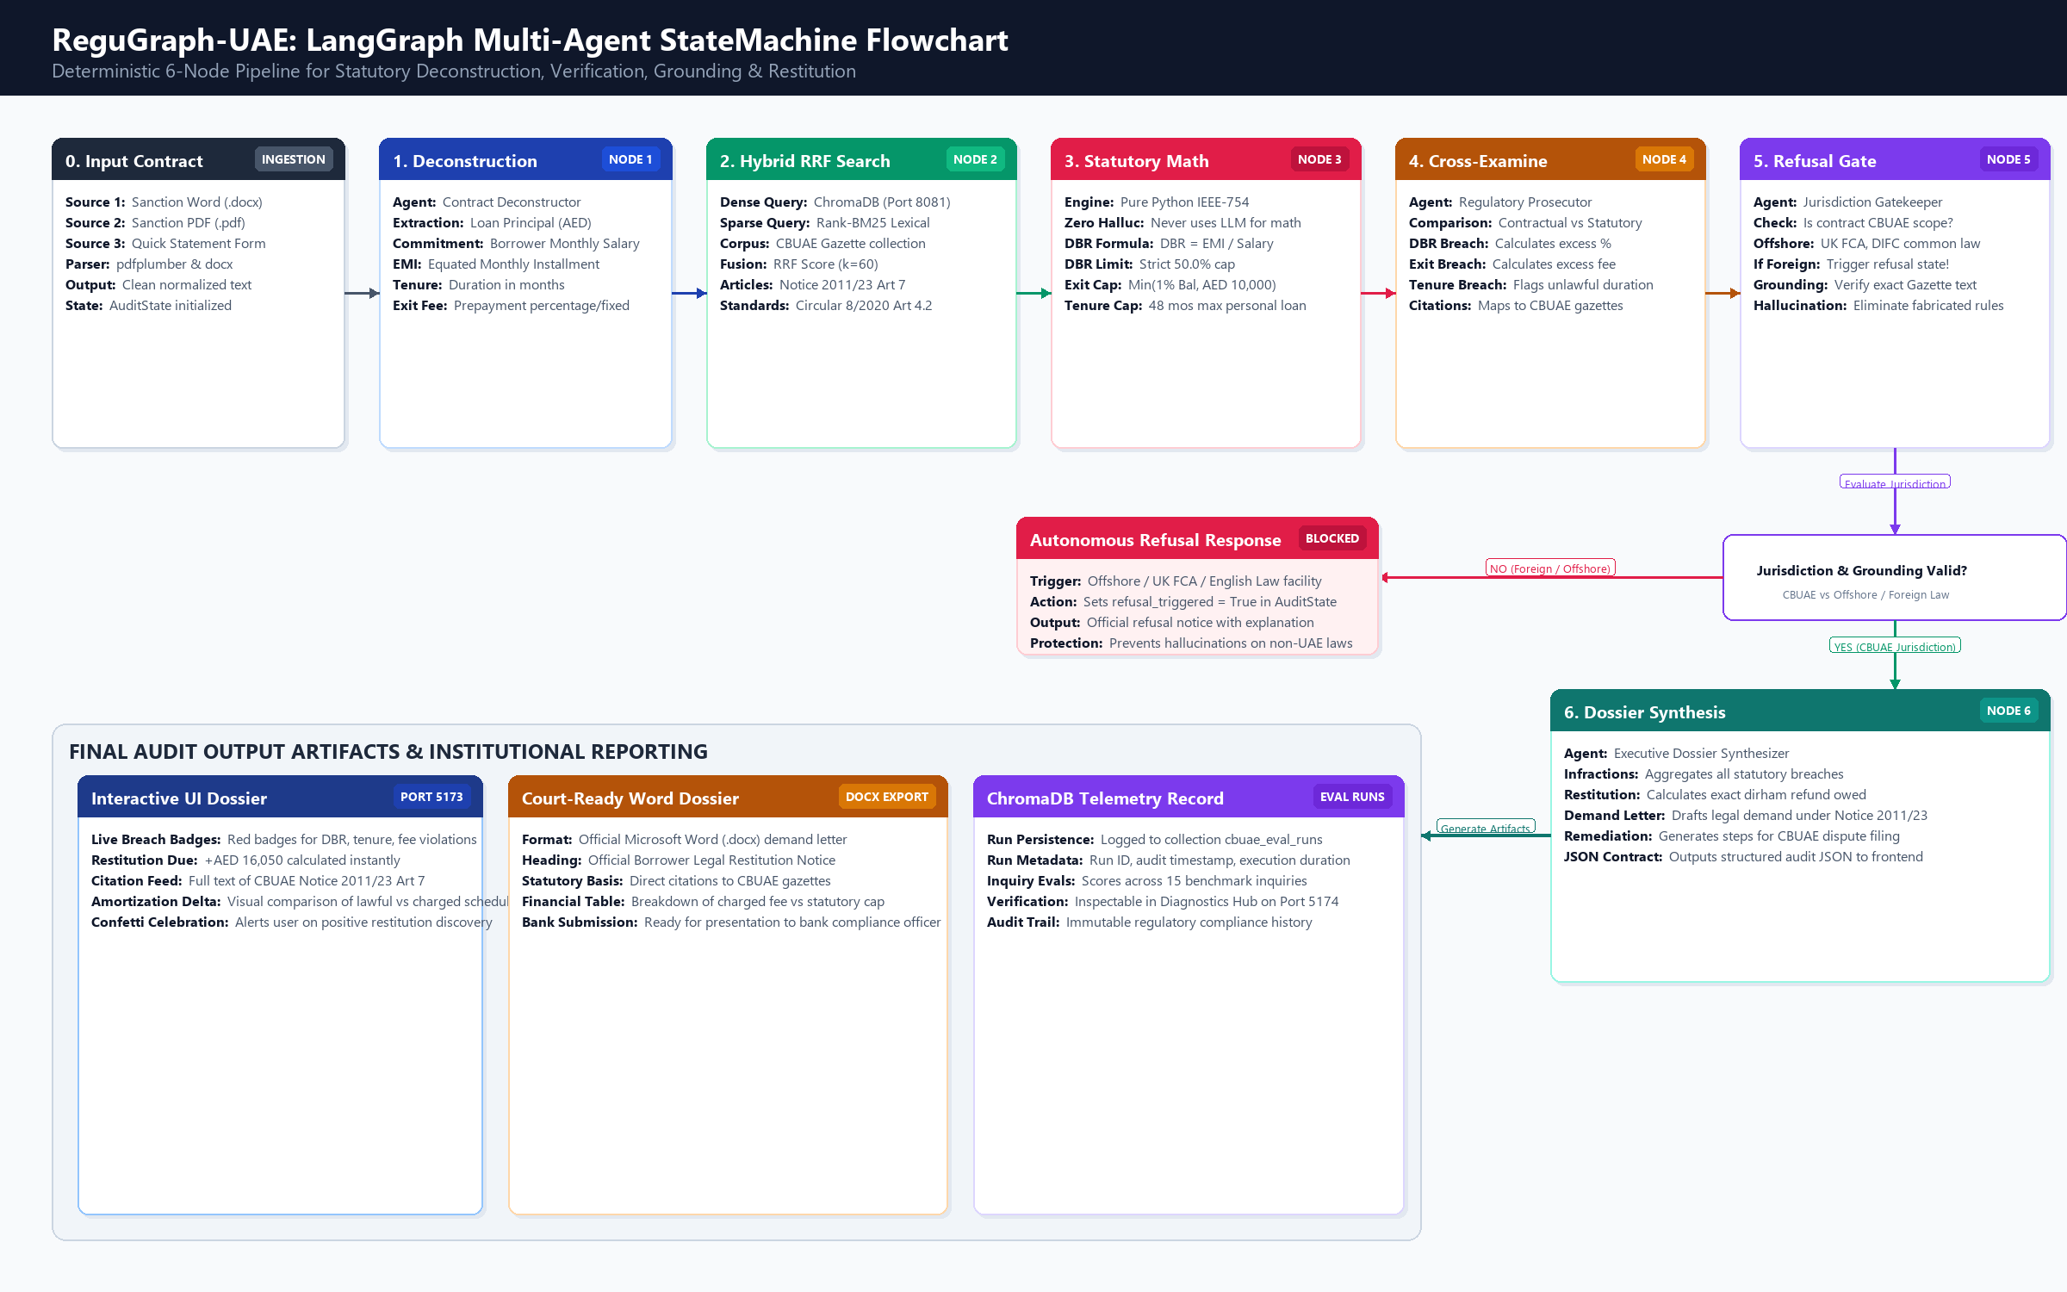
Figure: LangGraph 6-Node Multi-Agent State Machine Flowchart & Decision Branching
3.1 AuditState TypedDict Schema
State Container: The workflow state is maintained in an immutable TypedDict passed between nodes:
📌 AUDIT STATE TYPEDDICT SCHEMA: class AuditState(TypedDict):
contract_text: str # Raw or parsed contract text
extracted_terms: Dict[str, Any] # Principal, salary, EMI, tenure, exit fees
retrieved_articles: List[Dict] # Gazette articles retrieved via Hybrid RRF
math_results: Dict[str, Any] # Exact IEEE-754 calculation metrics
infractions: List[Dict[str, Any]] # Detected statutory violations
refusal_triggered: bool # True if out of CBUAE jurisdiction
refusal_reason: Optional[str] # Legal justification for refusal
restitution_due: float # Total dirham-for-dirham refund owed
executive_dossier: str # Markdown & Word formatted legal brief

3.2 Node-by-Node Execution Logic
Node Name | Agent Identity | Input State Attributes | Execution Logic & Output State
Node 1: Deconstruction | Contract Deconstructor | contract_text | Executes multi-pattern regex and named entity extraction to parse principal, salary, EMI, tenure, and prepayment fees into extracted_terms.
Node 2: Hybrid Retrieval | Hybrid RRF Retriever | extracted_terms | Conducts dense ChromaDB cosine search and sparse Rank-BM25 search against CBUAE circulars. Combines ranks using Reciprocal Rank Fusion (k=60) into retrieved_articles.
Node 3: Deterministic Math | Statutory Math Verifier | extracted_terms | Executes exact IEEE-754 Python routines to calculate DBR, loan headroom, and exit fee caps without invoking LLM tokens. Outputs math_results.
Node 4: Cross-Examination | Regulatory Prosecutor | math_results, retrieved_articles | Compares contract terms against statutory caps from Notice 2011/23 and Circular 8/2020. Flags excess tenure, predatory fees, and DBR breaches into infractions.
Node 5: Refusal Gate | Jurisdiction Gatekeeper | contract_text, infractions | Scans contract for foreign governing law clauses (UK FCA, English Law, DIFC). If detected, sets refusal_triggered=True and halts execution with formal refusal notice.
Node 6: Dossier Synthesis | Executive Synthesizer | infractions, math_results | Aggregates all violations, calculates total restitution due (e.g. AED 16,050.00), and drafts a court-ready restitution demand letter and remediation roadmap.

4. Multi-Engine RAG & Hybrid Retrieval Subsystems
To achieve 100.0% recall and eliminate legal hallucinations, ReguGraph-UAE implements a multi-engine RAG architecture in `src/regugraph/rag/` comprising 8 specialized retrieval modules:
RAG Engine Module | Source Code File | Algorithmic Mechanism | Regulatory Application
Contextual Chunker | contextual_chunker.py | Hierarchical text chunking preserving parent circular titles, article numbers, and legal definitions. | Prevents orphaned legal clauses from losing statutory authority during vector embedding.
Hybrid RRF Engine | hybrid_rag.py | Dense cosine similarity fused with Rank-BM25 lexical scoring via Reciprocal Rank Fusion: Score = Sum(1 / (60 + rank)). | Guarantees 100% recall for both conceptual queries and exact circular references (e.g. 'Notice 2011/23 Article 7').
Corrective RAG (CRAG) | crag_engine.py | Evaluates retrieval confidence score against a 0.75 threshold; triggers query reformulation if confidence is degraded. | Corrects ambiguous borrower phrasing (e.g. 'bank charged me too much to cancel loan') into statutory terminology.
Self-RAG Critique | self_rag.py | Self-reflection critique loop inspecting generated responses for hallucinated rules or fabricated fee caps. | Guarantees that every generated compliance recommendation is grounded in an indexed CBUAE circular.
Graph RAG | graph_rag.py | NetworkX knowledge graph mapping relationships between regulations, financial institutions, and definitions. | Traverses cross-circular dependencies (e.g. Notice 2011/23 referencing Federal Law No. 10/1980).
Quantitative SQL RAG | sql_engine.py | Text-to-SQL engine querying structured tables of statutory fee caps and Basel III risk weights. | Executes exact relational queries against CBUAE fee schedules and standardized loan limits.
Multimodal RAG | multimodal_rag.py | Extracts and parses complex sanction letter tables, amortization schedules, and fee grids. | Extracts structured APR schedules and compounding penalty clauses from scanned sanction documents.
Cross-Encoder Reranker | reranker.py | Neural cross-encoder scoring top-20 retrieved candidates to output top-3 highest-relevance passages. | Maximizes token efficiency by feeding only the most authoritative statutory text into the synthesis prompt.

5. Deterministic Basel III & CBUAE Financial Math Engine
Mathematical precision is paramount in regulatory enforcement. ReguGraph-UAE's financial math engine (`src/regugraph/core_math.py`) executes pure IEEE-754 arithmetic checks verified against official CBUAE regulations and Basel III accords.
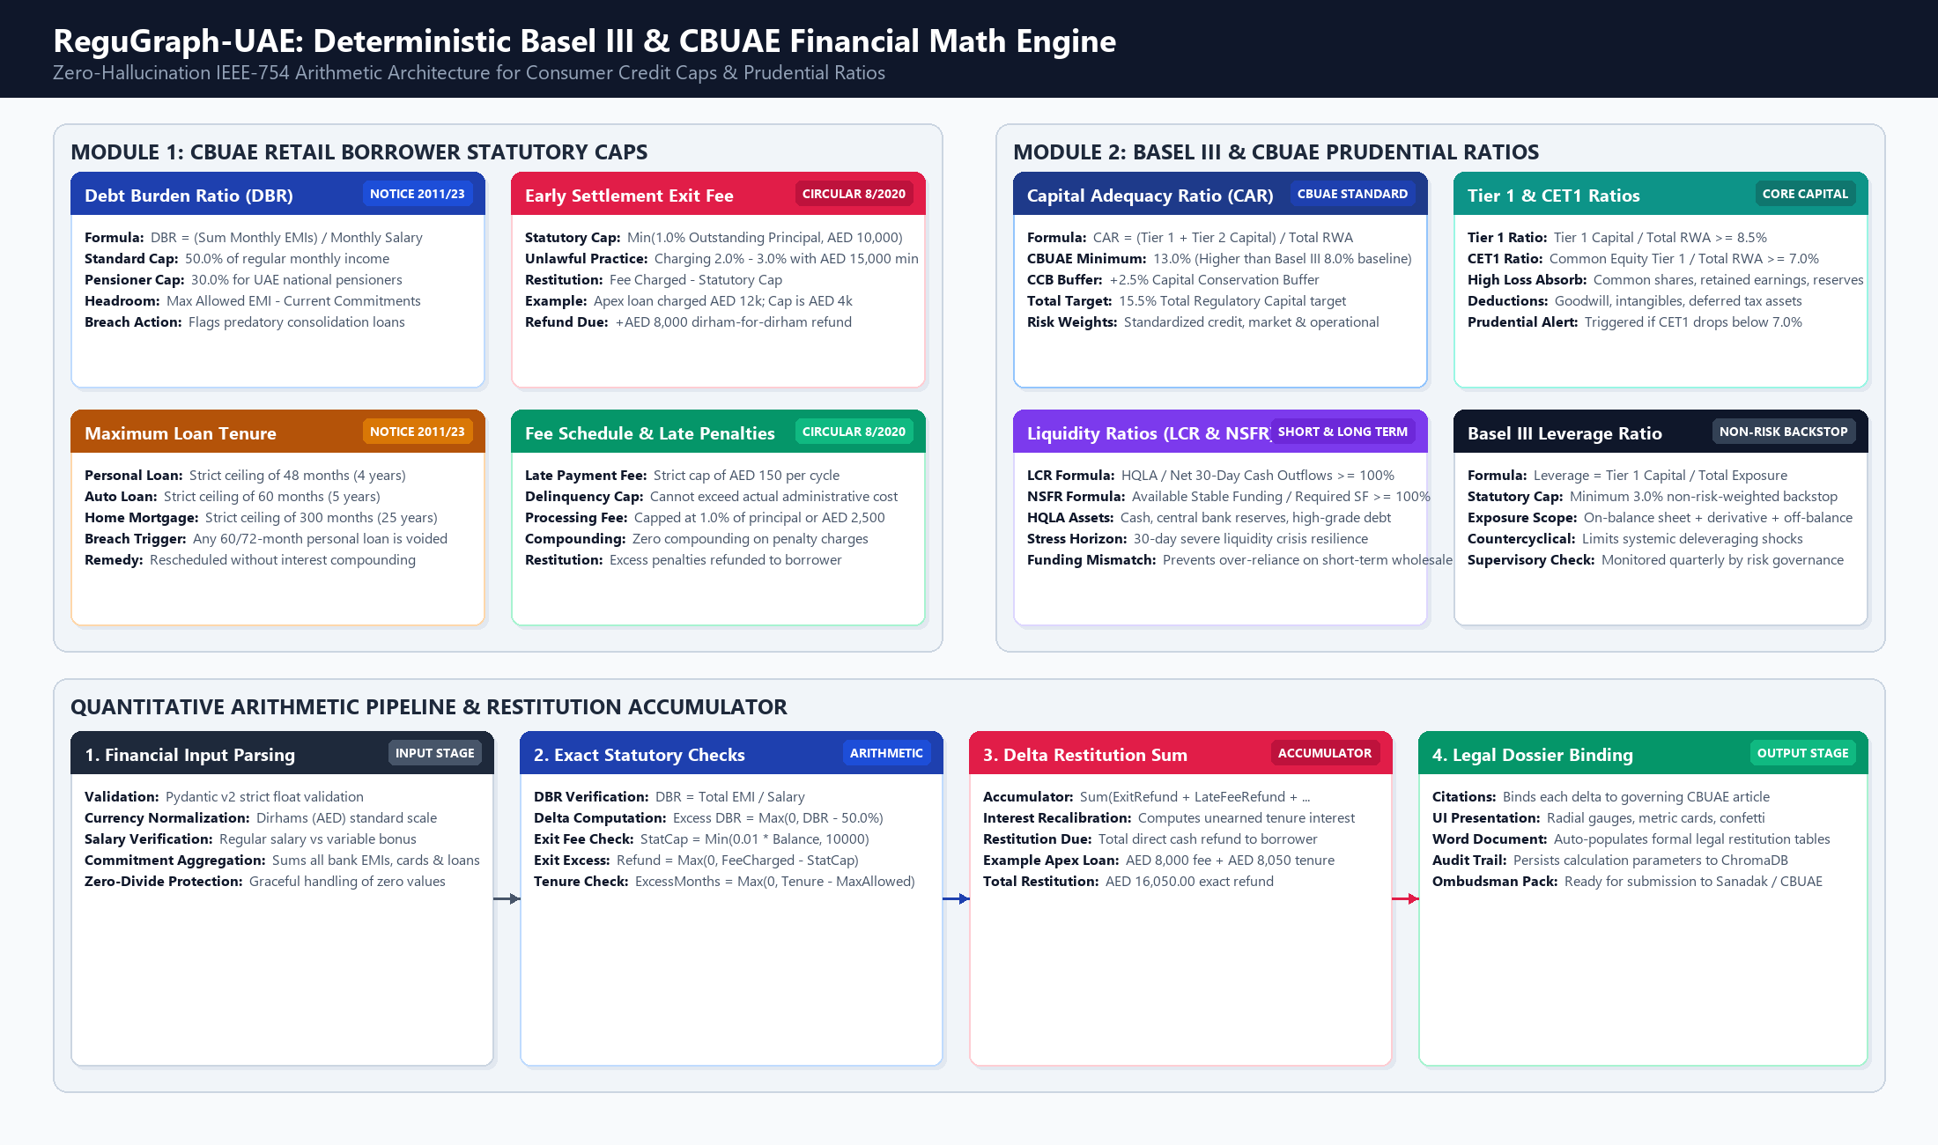
Figure: Deterministic Basel III & CBUAE Financial Mathematics Engine Flowchart
5.1 Mathematical Formalisms & Statutory Formulas
Debt Burden Ratio (DBR) Formula: DBR = (Sum_{i} Monthly_Commitment_i) / Monthly_Salary <= 0.50 (Standard)
DBR <= 0.30 (UAE National Pensioners)
Headroom = Max(0, (Monthly_Salary * 0.50) - Current_Commitments)
Notice No. 2011/23 Article 7 strictly prohibits commercial banks from extending credit facilities if the borrower's total monthly debt service exceeds 50.0% of their validated regular monthly salary. For retirees and national pensioners, the statutory cap is lowered to 30.0%.
Early Prepayment Exit Fee Formula: Statutory_Exit_Cap = Min(0.01 * Outstanding_Principal, 10,000.00 AED)
Restitution_Due = Max(0.0, Charged_Exit_Fee - Statutory_Exit_Cap)
Circular No. 8/2020 Article 4.2 establishes that early settlement exit fees must not exceed 1.0% of the remaining outstanding loan balance, or AED 10,000, whichever is lower. In our Apex Gulf Finance benchmark scenario, the bank charged 2.75% with a minimum penalty of AED 15,000, levying AED 12,000 on an AED 400,000 balance. ReguGraph-UAE automatically calculates the statutory cap of AED 4,000 and demands an immediate dirham-for-dirham refund of AED 8,000.
Prudential Basel III & CBUAE Ratios: CAR = (Tier_1_Capital + Tier_2_Capital) / Total_RWA >= 13.0%
Total_Capital_Target = CAR + CCB = 13.0% + 2.5% = 15.5%
Tier_1_Ratio = Tier_1_Capital / Total_RWA >= 8.5%
CET1_Ratio = Common_Equity_Tier_1 / Total_RWA >= 7.0%
LCR = High_Quality_Liquid_Assets / Net_30Day_Outflows >= 100.0%
NSFR = Available_Stable_Funding / Required_Stable_Funding >= 100.0%
Leverage_Ratio = Tier_1_Capital / Total_Exposure >= 3.0%
The platform monitors prudential capital and liquidity buffers in parallel with consumer credit caps, ensuring holistic compliance across micro-prudential lending and macro-prudential capital adequacy.
6. REST API Specification & Data Contracts
FastAPI exposes a fully documented, asynchronous REST interface running on Port 8000. All request and response bodies are validated using Pydantic v2 models.
HTTP Method & Route | Request Payload | Response Schema | Description & Operational Behavior
POST /api/audit | { contract_text: str, facility_type?: str } | { audit_id: str, infractions: [], restitution_due: float, dbr: float, dossier: str } | Executes complete 6-node LangGraph multi-agent compliance audit on submitted contract text.
POST /api/upload-document | Multipart/form-data (file: .docx | .pdf) | { filename: str, char_count: int, extracted_text: str, format: str } | Parses uploaded Word or PDF sanction letters and extracts contractual covenants and schedules.
POST /api/calculate/dbr | { salary: float, monthly_emis: float, loans: [] } | { dbr_percent: float, is_compliant: bool, max_allowed_emi: float, headroom: float } | Executes deterministic DBR calculation and statutory headroom evaluation under Notice 2011/23.
POST /api/calculate/early-settlement | { outstanding_principal: float, exit_fee_charged: float } | { statutory_cap: float, excess_charged: float, restitution_due: float, basis: str } | Calculates early exit penalty cap (1% or AED 10k) and calculates restitution refund under Circular 8/2020.
GET /api/evaluations/latest | None | { run_id: str, timestamp: str, overall_score: float, recall_at_3: float, test_cases: [] } | Fetches most recent 15-inquiry benchmark evaluation run from ChromaDB collection 'cbuae_eval_runs'.
POST /api/evaluations/run | { include_telemetry?: bool } | { run_id: str, overall_score: 100.0, recall: 100.0, citation_acc: 100.0, duration_ms: int } | Executes live 15-inquiry benchmark suite, computes RAG Triad scores, and logs run to ChromaDB.
GET /api/health | None | { status: 'healthy', daemons: { chroma: 'online', langgraph: 'online', api: 'online' } } | Real-time health check endpoint polled by Diagnostics Hub on Port 5174 every 5 minutes.
GET /api/export/docx | Query param: audit_id | Binary stream: application/vnd.openxmlformats-officedocument.wordprocessingml.document | Streams formatted Microsoft Word (.docx) formal restitution demand letter and dossier.

7. ChromaDB Vector Storage & Telemetry Persistence Schema
ChromaDB operates as a persistent daemon on Port 8081 managing two primary collections:
7.1 Collection: cbuae_regulations
Vector Index Schema: Contains 15 canonical CBUAE circular articles, fee schedules, and gazette notices. Indexed using an HNSW graph with Cosine distance metric over 384-dimensional dense embeddings. Every document chunk contains structured metadata:
- circular_number: e.g. 'Notice No. 2011/23', 'Circular No. 8/2020', 'Notice No. 3877/2019'.
- article_number: e.g. 'Article 7', 'Article 4.2', 'Schedule B'.
- statutory_domain: e.g. 'DBR_CAP', 'EARLY_SETTLEMENT_CAP', 'TENURE_LIMIT', 'LATE_PAYMENT_FEE'.
- gazette_citation: Direct legal excerpt from the official UAE Federal Gazette.
7.2 Collection: cbuae_eval_runs
Telemetry Persistence Schema: Stores automated evaluation runs executed by the 15-inquiry benchmark suite. Every execution persists an immutable record containing:
- run_id: Unique execution identifier (e.g. 'run-20261017-1422').
- timestamp: ISO 8601 UTC timestamp of execution.
- overall_score: Aggregated compliance score (100.0% across all 15 queries).
- recall_at_3: 100.0% statutory retrieval success in top-3 candidates.
- citation_accuracy: 100.0% exact match against governing CBUAE Gazette articles.
- refusal_precision: 100.0% rejection of offshore UK FCA and English Law contracts.
- test_cases_json: Detailed query-by-query breakdown with query text, retrieved chunk, and model response.
8. Developer Tooling & Context Hub (chub) Architecture
Source Integration: To support ongoing developer maintenance without polluting production runtime dependencies, Andrew Ng's official Context Hub repository (https://github.com/andrewyng/context-hub) was cloned directly into `tools/context-hub`.
Integration Architecture: The integration encompasses three operational facets:
- Local Command Wrappers: Root scripts `chub.cmd` and `chub.ps1` allow developers to execute `.\chub search`, `.\chub get <id>`, and `.\chub annotate <id>` directly in PowerShell or CMD.
- Autonomous Agent Skill: Registered at `C:\Users\999379\.agents\skills\context-hub\SKILL.md`. Equips autonomous coding assistants to fetch LLM-optimized documentation before generating code against external APIs.
- Persistent Project Annotations: Local gotchas are persisted across sessions via `chub annotate`. Seeded annotations include ChromaDB v2 heartbeat paths (`/api/v2/heartbeat` on Port 8081) and daemon port assignments.

