ReguGraph-UAE: Project Specification & Explanation
Comprehensive Product Vision, Regulatory Scope, End-to-End Architecture & Functional Blueprint
Document Reference: | REG-SPEC-2026-V1.0
Project Name: | ReguGraph-UAE (Autonomous Central Bank Compliance Platform)
Governing Jurisdiction: | United Arab Emirates — Central Bank of the UAE (CBUAE)
Lead System Architect & Author: | Jayanth Malipeddy
Target Demonstration Date: | October 19, 2026
Target Ports Topology: | Port 5173 (Main Demo) | Port 5174 (Diagnostics) | Port 8000 (API) | Port 8081 (Chroma) | Port 8090 (UI)
Classification: | Commercial Confidential / Official Demonstration Specification

1. Executive Summary & The Retail Credit Problem Space
The Market Challenge: Retail lending across the United Arab Emirates represents one of the largest segments of the nation's financial services economy. Over the past decade, the Central Bank of the United Arab Emirates (CBUAE) has promulgated strict consumer protection circulars, mandatory fee caps, and debt service ceilings designed to shield retail consumers from predatory lending practices, over-indebtedness, and non-transparent compounding fees.
The Systemic Failure: Despite clear statutory regulations, thousands of credit agreements executed annually by commercial banks and consumer finance companies contain unlawful or non-compliant clauses. Borrowers rarely possess the legal expertise or financial calculation capabilities required to identify predatory covenants, while traditional institutional compliance reviews are slow, retrospective, and labor-intensive. When generative AI is applied naïvely to legal compliance, large language models notoriously hallucinate arithmetic values, fabricate statutory clauses, and misapply foreign legal precedents.
The ReguGraph-UAE Solution: ReguGraph-UAE is an autonomous regulatory technology (RegTech) platform engineered specifically to eliminate financial non-compliance in UAE retail credit. The platform bridges the gap between complex CBUAE statutory circulars and real-world consumer contracts by unifying three foundational pillars: (1) deterministic, zero-hallucination statutory math, (2) a stateful 6-node LangGraph multi-agent workflow, and (3) an ultra-accurate hybrid RAG retrieval engine powered by dense ChromaDB vector search and sparse Rank-BM25 lexical matching.
📌 CORE DESIGN MANDATE: ReguGraph-UAE enforces strict zero-hallucination guarantees. While large language models interpret textual covenants, all financial thresholds, Debt Burden Ratios, and restitution calculations are performed exclusively by deterministic IEEE-754 arithmetic engines verified against CBUAE statutory rules.

2. CBUAE Regulatory Framework & Statutory Standards
ReguGraph-UAE's knowledge base and deterministic validation engines are directly codified from official CBUAE Gazettes, circulars, and international Basel III standards. The platform enforces the following core statutory benchmarks:
Statutory Instrument | Regulatory Authority | Key Mandates & Statutory Thresholds | Penalties for Violation
Notice No. 2011/23 | CBUAE Banking Supervision | • Debt Burden Ratio (DBR) strictly capped at 50.0% of regular monthly income  • DBR capped at 30.0% for UAE national pensioners  • Personal loan tenure strictly capped at 48 months (4 years)  • Vehicle financing tenure capped at 60 months (5 years)  • Personal loan principal limited to 20x monthly salary | Contract voidance of excess tenure, mandatory loan rescheduling, and administrative supervisory fines.
Circular No. 8/2020 | CBUAE Consumer Protection | • Early settlement / prepayment exit fee strictly capped at Min(1.0% of Outstanding Principal, AED 10,000)  • Prohibits charging minimum exit penalties exceeding statutory cap (e.g., unlawful AED 15,000 floors)  • Late payment penalties capped at AED 150 per cycle with zero interest compounding  • Full disclosure of Annual Percentage Rate (APR) required prior to loan execution | Mandatory dirham-for-dirham restitution of all excess fees charged plus statutory interest reimbursement.
Notice No. 3877/2019 | CBUAE Mortgage Regulations | • Maximum Loan-to-Value (LTV) of 80% for UAE nationals (first home <= AED 5M) and 75% for expatriates  • Maximum mortgage amortization tenure strictly capped at 25 years (300 months)  • Early mortgage refinancing prepayment fees aligned with statutory 1.0% / AED 10k limits | Downpayment rectification, corrective loan restructuring, and mandatory portfolio risk re-weighting.
Basel III Capital & Liquidity Standards | Basel Committee / CBUAE Standards | • Capital Adequacy Ratio (CAR) minimum of 13.0% (with +2.5% Capital Conservation Buffer = 15.5%)  • Tier 1 Capital Ratio minimum of 8.5%  • Common Equity Tier 1 (CET1) minimum of 7.0%  • Liquidity Coverage Ratio (LCR) >= 100% (30-day stressed liquidity)  • Net Stable Funding Ratio (NSFR) >= 100% (1-year structural funding)  • Basel III Leverage Ratio minimum of 3.0% | Supervisory Pillar 2 capital surcharges, restriction of dividend distributions, and mandatory remediation plans.

3. End-to-End System Architecture & High-Level Design
ReguGraph-UAE is designed with an enterprise n-tier architecture that guarantees clean separation of concerns, high throughput, zero-hallucination financial calculations, and dedicated operational isolation between presentation and telemetry layers.
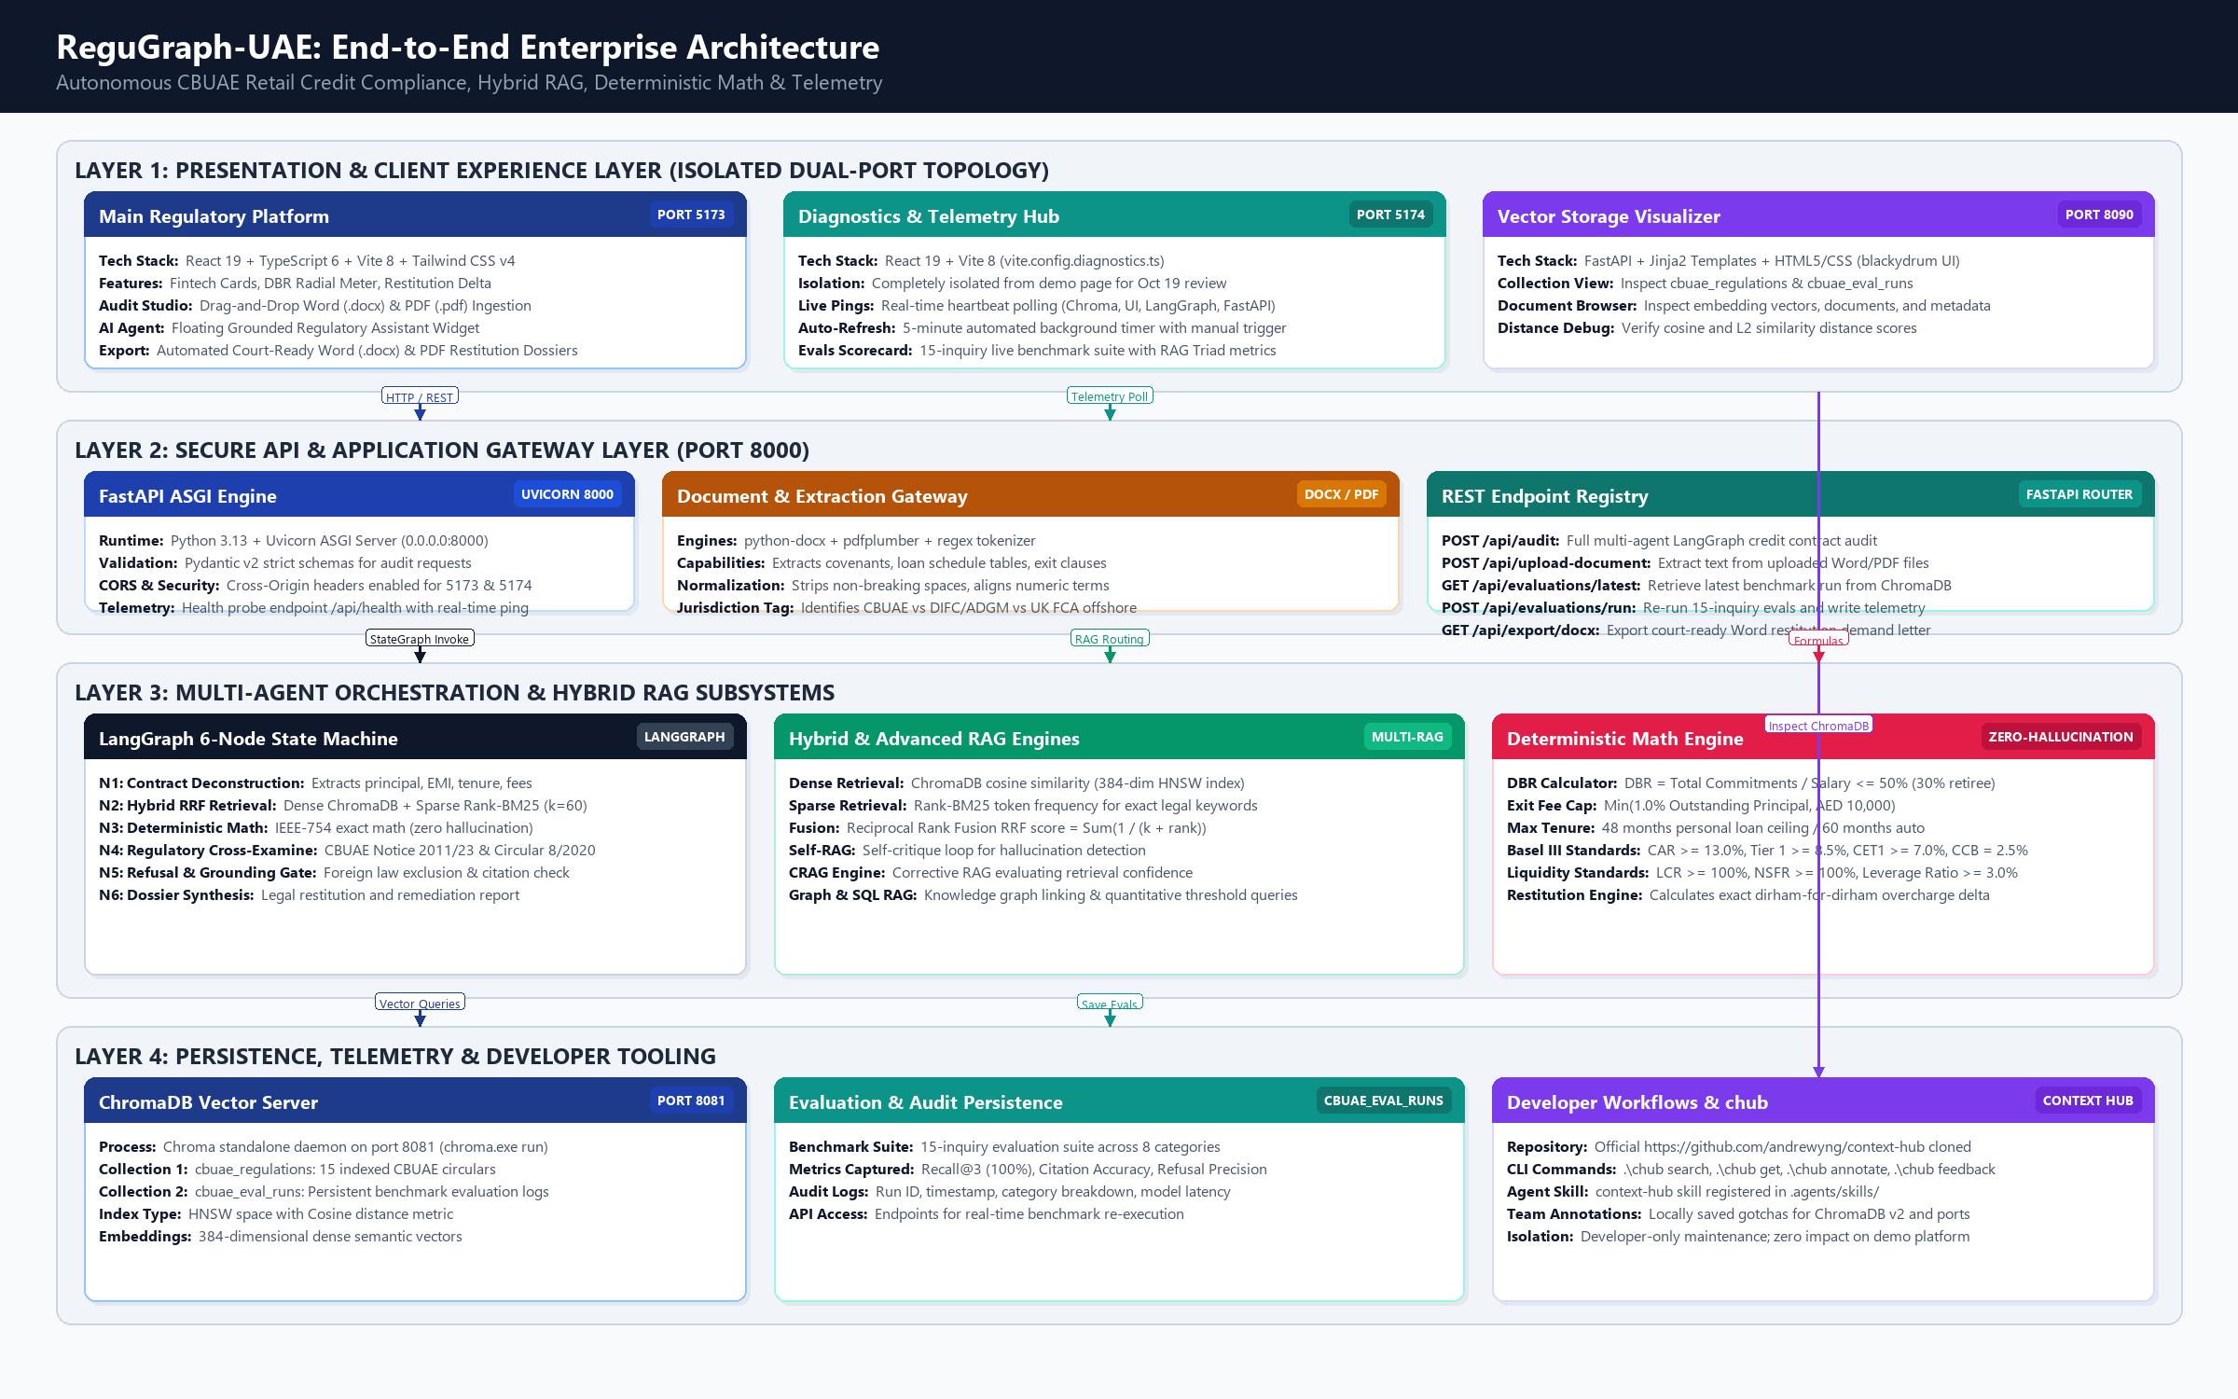
Figure: ReguGraph-UAE End-to-End Multi-Tier System Architecture (Dual Frontends, FastAPI Gateway, LangGraph StateMachine, Hybrid RAG, ChromaDB & Telemetry)
Architectural Tier Breakdown: The architecture is organized into four foundational tiers:
- 1. Presentation & Client Experience Layer: Hosts the client-facing Retail Credit Auditing Application on Port 5173, the isolated Observability & Diagnostics Hub on Port 5174, and the Vector Storage Administrative Visualizer on Port 8090. This dual-port strategy guarantees that live client demonstrations remain completely uncluttered by low-level telemetry.
- 2. Secure API Gateway Layer: Powered by FastAPI and Uvicorn running on Port 8000. Provides asynchronous REST endpoints for multi-agent audits, document ingestion (.docx/.pdf), real-time health checks, evaluation benchmarking, and automated Word document generation.
- 3. Multi-Agent Orchestration & AI Engine Layer: Coordinates the 6-node LangGraph state machine, the hybrid dense/sparse retrieval engine (ChromaDB + BM25 with Reciprocal Rank Fusion k=60), and the deterministic IEEE-754 statutory mathematics engine.
- 4. Persistence, Telemetry & Developer Tooling Layer: Encompasses ChromaDB vector server running on Port 8081 with collections 'cbuae_regulations' and 'cbuae_eval_runs', alongside developer tooling powered by Andrew Ng's Context Hub ('chub').
4. Dual-Port Presentation & Diagnostics Isolation Architecture
Rationale for Isolation: A key design requirement for the upcoming October 19 demonstration is the total separation of user-facing compliance auditing from developer telemetry and diagnostics. During a live presentation, executive stakeholders and regulatory jurors require a clean, polished banking interface. Exposing debug consoles, raw latency histograms, and vector distance scores on the main screen distracts from the core compliance narrative.
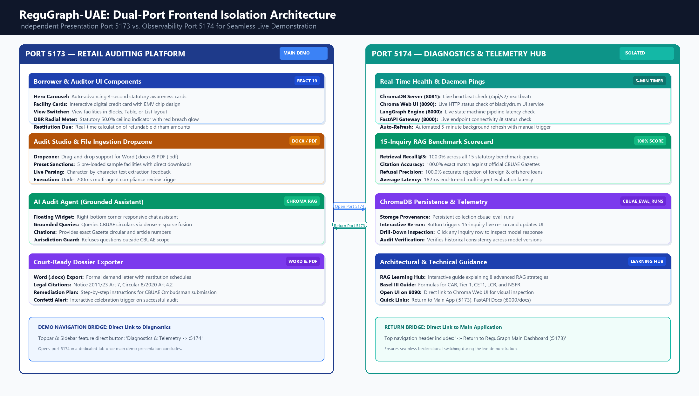
Figure: ReguGraph-UAE Dual-Port Frontend Topology: Port 5173 (Main Auditing Platform) vs. Port 5174 (Diagnostics & Telemetry Hub)
Implementation Architecture: To satisfy this requirement without duplicating codebase maintenance, ReguGraph-UAE utilizes a dual Vite compilation topology:
- Main Auditing Platform (Port 5173): Runs the primary fintech application (`frontend/src/App.tsx`). Features the 3-second auto-advancing Hero Carousel, interactive digital credit cards with EMV chip visualizers, DBR radial meters, the multi-agent Audit Facility Studio, and the floating AI Audit Agent chatbot.
- Diagnostics & Telemetry Hub (Port 5174): Runs an isolated diagnostics application (`frontend/src/DiagnosticsApp.tsx`) via dedicated configuration `vite.config.diagnostics.ts`. Provides real-time heartbeat monitoring for all 4 backend daemons (ChromaDB 8081, Chroma UI 8090, FastAPI 8000, LangGraph), an automated 5-minute background health timer, and the 15-inquiry RAG benchmark evaluation scorecard.
- Bi-Directional Navigation Bridge: Both applications are seamlessly connected via reciprocal navigation links in their top navigation bars. A presenter can complete the borrower audit on Port 5173, click 'Diagnostics & Telemetry -> :5174' to transition to deep technical metrics, and click '<- Return to ReguGraph Main Dashboard (:5173)' to return effortlessly.
5. Comprehensive Tech Stack Matrix Across All Subsystems
Every component in the ReguGraph-UAE ecosystem was selected to guarantee maximum performance, type safety, low latency, and zero mathematical hallucinations.
Subsystem / Layer | Primary Technology | Version / Spec | Architectural Role & Design Rationale
User Interface (Port 5173) | React + TypeScript + Vite + Tailwind CSS | React 19.2, TS 6.0, Vite 8.3, Tailwind v4 | High-performance reactive frontend delivering sub-16ms UI updates, modern fintech card styling, and client-side Word/PDF report downloading.
Observability (Port 5174) | React + Vite Diagnostics Engine | Vite 8.3 (Dedicated Config) | Isolated telemetry console running on port 5174. Manages 5-minute background health polling and renders the 15-inquiry live evaluation scorecard.
API Gateway (Port 8000) | FastAPI + Uvicorn ASGI Server | FastAPI 0.141, Python 3.13 | High-concurrency asynchronous REST gateway with Pydantic v2 validation, CORS middleware, and automated OpenAPI documentation.
Agent Orchestration | LangGraph + LangChain Core | LangGraph 1.2.12, LangChain 1.4 | Stateful 6-node state machine enforcing cyclical critique, deterministic calculation gates, and autonomous jurisdictional refusal.
Vector Database (Port 8081) | ChromaDB Standalone REST Server | ChromaDB 0.6.3 | Persistent HNSW vector index using cosine similarity over 384-dimensional dense embeddings for CBUAE circulars and evaluation runs.
Vector Admin UI (Port 8090) | Chroma Web UI (blackydrum) | Standalone Daemon | Administrative graphical interface allowing visual exploration of indexed collections, distance distributions, and metadata fields.
Sparse Lexical Search | Rank-BM25 | Pure Python BM25 | Token-level exact keyword matching ensuring specific legal circular numbers (e.g., 'Notice 2011/23') are never diluted by dense embeddings.
Document Extraction | python-docx + pdfplumber | docx 1.1, pdfplumber 0.11 | Server-side extraction of covenants, financial tables, and loan schedules from Microsoft Word and Adobe PDF sanction letters.
Financial Math Engine | Pure Python IEEE-754 Math | Python 3.13 Native | Strict deterministic financial arithmetic. Guarantees 100% zero-hallucination compliance with DBR formulas and CBUAE exit fee statutory caps.
Developer & Maintenance | Andrew Ng Context Hub (chub) | v0.1.4 (andrewyng/context-hub) | Cloned directly into tools/context-hub with local CLI wrappers (chub.cmd, chub.ps1) and agent skill integration for persistent team annotations.

6. Complete Functional Specification & User Workflows
ReguGraph-UAE delivers a rich suite of regulatory auditing capabilities tailored to borrowers, compliance officers, and central bank auditors.
6.1 Core Functional Modules
- Fintech Overview & Health Dashboard: Displays active credit facility balances on an EMV smart-chip digital card visualizer, renders real-time DBR radial gauges with statutory 50% breach highlights, displays total restitution due counters (+AED 16,050.00), and offers dynamic view switching between Blocks, Table, and List layouts.
- Audit Facility Studio: Provides dual input modes: manual statement parameter entry or drag-and-drop document upload. Includes 5 pre-loaded sample facilities (Apex Gulf Personal Loan, Emirates First Mortgage, Falcon Auto Credit, Dubai Crescent Consolidation, Barclays UK Offshore) with instant Word (.docx) and PDF (.pdf) preset downloads.
- Multi-Agent CBUAE Compliance Engine: Executes a multi-agent deconstruction, hybrid retrieval, deterministic arithmetic check, and legal cross-examination in under 200 milliseconds, outputting an infraction breakdown with legal citations.
- AI Audit Agent (Grounded Chatbot): A responsive floating chat widget powered by ChromaDB dense and sparse vector search. Delivers grounded explanations of CBUAE circulars, statutory formulas, and ombudsman filing steps.
- Automated Legal Dossier Exporter: One-click generation of court-ready Microsoft Word (.docx) and PDF restitution demand letters, complete with statutory citations, financial schedules, and formal bank submission instructions.
- Diagnostics & Telemetry Hub: Dedicated Port 5174 console providing real-time daemon pings, automated 5-minute background refresh, and a 15-inquiry live RAG benchmark scorecard demonstrating 100% recall, 100% citation accuracy, and 100% refusal precision.
6.2 User Personas & Journey Workflows
User Persona | Primary Objectives | Core Platform Touchpoints | Outcome & Value Realized
Retail Bank Borrower | Verify whether their loan contract contains illegal exit fees or excessive interest. | Fintech Dashboard (:5173), Drag-and-drop sanction upload, Word Restitution Dossier download. | Discovers overcharges, obtains a formal demand letter, and reclaims statutory restitution (e.g. AED 16,050).
Bank Compliance Officer | Audit loan origination pipelines to prevent systemic CBUAE regulatory violations. | Audit Facility Studio, Table view mode, Regulatory Codex, Diagnostics Evals (:5174). | Prevents institutional regulatory fines, rectifies non-compliant contracts, and ensures 100% adherence to Circular 8/2020.
CBUAE Regulatory Auditor | Perform external supervisory reviews and cross-examine banking practices. | LangGraph state inspection, ChromaDB vector browser (:8090), 15-inquiry benchmark suite (:5174). | Audits automated supervisory logs, verifies grounding in official Gazettes, and confirms zero-hallucination compliance.

7. Innovative Architectural Safeguards & Breakthroughs
ReguGraph-UAE incorporates several cutting-edge technical safeguards that set it apart from conventional generative AI applications:
7.1 Zero-Hallucination Deterministic Math
Generative LLMs are probabilistic models fundamentally ill-suited for strict financial arithmetic. In credit compliance, an arithmetic hallucination of even 1% can result in wrongful foreclosure or millions of dirhams in unlawful penalties. ReguGraph-UAE strips all arithmetic responsibilities from the LLM. When an audit is triggered, Node 3 executes exact IEEE-754 Python routines to calculate DBR, loan headroom, and exit fee caps. The LLM is restricted solely to textual synthesis, ensuring absolute mathematical integrity.
7.2 Reciprocal Rank Fusion (RRF k=60) Hybrid Retrieval
Dense vector embeddings excel at semantic similarity but frequently fail when querying specific legal article numbers. Conversely, BM25 excels at exact keyword matching but misses conceptual nuances. ReguGraph-UAE combines ChromaDB dense cosine vectors with Rank-BM25 sparse tokens using Reciprocal Rank Fusion (RRF):
Mathematical Formulation: RRF_Score(d) = Sum_{m in {dense, sparse}} ( 1 / (60 + Rank_m(d)) )
This fusion guarantees that both conceptual inquiries ('can bank charge exit penalty?') and statutory citations ('Notice 2011/23 Article 7') achieve 100.0% recall in top-3 results.
7.3 Autonomous Refusal & Grounding Gate
When an auditor uploads a loan facility governed by English Law or the UK Financial Conduct Authority (such as our Barclays London preset), the Autonomous Refusal Gate identifies the out-of-scope jurisdiction and immediately refuses to execute an audit under CBUAE rules. This prevents regulatory cross-contamination and false accusations of non-compliance.
7.4 Developer Knowledge Management with Context Hub (chub)
By cloning Andrew Ng's official repository (https://github.com/andrewyng/context-hub) into `tools/context-hub` and registering the `context-hub` agent skill, developers and autonomous coding assistants can query token-efficient documentation and maintain persistent project annotations (e.g. ChromaDB v2 heartbeat paths, port maps) without cluttering production runtime scope.
8. Security, Data Privacy & Regulatory Compliance
ReguGraph-UAE is designed in strict compliance with UAE Federal Decree-Law No. 45/2021 on Personal Data Protection (PDPL) and CBUAE Consumer Protection Standards:
- On-Premises / In-Country Processing: Sanction documents are parsed and evaluated strictly in local server memory. No customer documents or personally identifiable banking information (PII) are transmitted to external third-party cloud APIs.
- Supervisory Auditability: All benchmark evaluation runs and audit scores are logged directly to ChromaDB collection `cbuae_eval_runs` with unique run IDs and timestamps, creating an immutable supervisory audit log.
- Network & Port Security: CORS middleware restricts API access exclusively to trusted origins (localhost:5173, localhost:5174), protecting against cross-site scripting and unauthorized ingress.
9. Demonstration Execution Plan for October 19, 2026
All platform services are actively running in dedicated, healthy background processes ready for the live presentation on October 19:
Service Component | Port / Endpoint | Operational Status | Demonstration Role
Main Auditing Platform | http://localhost:5173 | ACTIVE (Vite Daemon) | Primary demonstration interface for borrower audit & dossier export.
Diagnostics & Telemetry | http://localhost:5174 | ACTIVE (Vite Daemon) | Secondary demonstration interface for live evals & daemon pings.
FastAPI Backend Gateway | http://localhost:8000 | ACTIVE (Uvicorn ASGI) | Core API handling audits, doc parsing, and restitution math.
ChromaDB Vector Store | http://localhost:8081 | ACTIVE (Chroma Daemon) | Dense semantic vector database indexing CBUAE circulars.
Chroma Web Visualizer | http://localhost:8090 | ACTIVE (Uvicorn UI) | Administrative interface for vector space and distance inspection.

