CARBONLENS
Low-Level Design (LLD)
Implementation Blueprint from HLD v2.1

Primary implementation rule: Build one thin vertical slice first: sign-in → evidence → deterministic carbon/score → Gemini explanation → Trusted Green Event → reward ledger → dashboard. Add the remaining reward pillars only after the shared contracts work.

Web + Android • Flutter • Firebase • Cloud Run • BigQuery • Vertex AI • Vision/Document AI
Document Version 1.0 • 9 October 2026 • Target: Google JAPAC submission on 18 October 2026

Document Control
Item | Value
Document | CarbonLens Low-Level Design (LLD)
Version | 1.0
Parent design | CarbonLens Google JAPAC Technical Execution Plan + Integrated HLD v2.1
Purpose | Translate HLD components into implementable modules, contracts, schemas, algorithms, states, APIs and deployment steps.
Primary client | Flutter web + Android
Backend | Single modular Cloud Run API for prototype; split later by domain if needed.
Managed services constraint | Google/Firebase/Android managed services; GitHub only for required public source repository.
Build direction | Core-first / inside-out / thin vertical slice
Submission date | 18 October 2026

How to use this LLD
1. Read Section 1 and complete the “First 6 commits” in order. Do not start from UI polish.
2. Create the canonical DTOs and database paths in Sections 6-10 before implementing Gemini or reward rules.
3. Implement the P0 product vertical slice completely before adding Green-Move, Grow-Green and Recycle-Red.
4. Use the acceptance checks at the end of every subsystem as your definition of done.
5. Freeze contracts after the Oct 11 E2E gate unless a blocking defect requires change.

Table of Contents
1. Start Here — Where to Begin
2. LLD Scope and HLD Traceability
3. Implementation Dependency Model
4. Repository and Code Organization
5. Runtime Environments and Configuration
6. Flutter Client LLD
7. Cloud Run API LLD
8. API Contracts and Error Model
9. Firestore Operational Data Model
10. BigQuery Analytical/Reference Data Model
11. Cloud Storage Evidence Model
12. Carbon Engine LLD
13. Sustainability Score LLD
14. Trusted Green Event and Verification Engine
15. Reward Policy and Ledger LLD
16. Four Reward Pillars — Detailed Logic
17. Gemini / AI Orchestrator LLD
18. Vision and Document AI Processing
19. Pub/Sub and Asynchronous Processing
20. Security, IAM and Privacy Controls
21. Logging, Monitoring and SRE
22. Cloud Build / Deployment LLD
23. Test Design and Quality Gates
24. Day-by-Day Coding Sequence
25. Definition of Ready / Definition of Done
Appendix A. Canonical JSON Contracts
Appendix B. Google Service References

1. Start Here — Where to Begin
Answer to “where do I start?” Start at the common contracts and backend boundary, not at the four feature screens. Your first technical success criterion is one real product scan that travels end-to-end through Google services and writes one auditable reward event.

Figure 1. Recommended LLD implementation order

1.1 First 6 commits
Commit | Scope | Must contain | Exit condition
01-bootstrap | Repository + GCP/Firebase skeleton | Flutter app shell, backend folder, cloudbuild files, README, /health | Firebase Hosting placeholder and Cloud Run /health are public/reachable.
02-auth-contracts | Identity + canonical DTOs | Firebase Auth, App Check debug setup, API request/response models, error envelope | Authenticated /v1/me returns server-derived uid.
03-data-core | Firestore + BigQuery references | Collections, factor tables, seed data, repository classes | One factor lookup by category works and records factor version.
04-carbon-score | Deterministic engines | CarbonResult, SustainabilityScore, unit tests | Same input returns same output; no Gemini involved.
05-scan-ai | Evidence + Gemini | Storage upload, Vision/OCR, product resolver, Gemini explanation | Real/sample image becomes structured result + validated explanation.
06-trust-reward | Trusted event + ledger | Verification decision, policy evaluator, transaction-safe ledger, wallet projection | One event can be rewarded once only; replay returns same result.

1.2 What NOT to start with
- Do not begin with Green Store, leaderboard, Earth Pulse or voice AI.
- Do not create four independent reward implementations. All four pillars must converge on one `green_event` contract.
- Do not let Gemini calculate carbon, Green Points or verification status.
- Do not hard-code `$20/tree` into the engine. It is an optional sponsor policy, not a Google payment or scientific carbon value.
- Do not make a separate microservice per domain for the prototype; one modular Cloud Run service is faster and easier to debug.

1.3 First local development milestone
flutter run -d chrome # UI shell
# backend local run
python -m app.main # exposes GET /health and GET /version
# desired first integration
Flutter -> Firebase Auth -> Cloud Run /v1/me -> Firestore -> JSON response

2. LLD Scope and HLD Traceability

2.1 HLD-to-LLD mapping
HLD component | LLD module | Primary persistence | Primary Google integration
Flutter client | apps/carbonlens_flutter | secure local preferences + server state | Firebase Auth, App Check, Health Connect, Maps
API/BFF | api/http + middleware | none directly | Cloud Run, Firebase Admin
Scan module | domains/scan | Firestore scan record + Storage object | Vision API / Document AI
Carbon Engine | domains/carbon | BigQuery factor reference | BigQuery
Trusted Event Engine | domains/trust | Firestore green_events + BigQuery fact | App Check/device/evidence signals
Reward Policy Engine | domains/rewards/policy | Firestore policy snapshot / BigQuery policy history | Firestore transaction
Reward Ledger | domains/rewards/ledger | Firestore immutable ledger + wallet projection | Firestore
AI Orchestrator | domains/ai | Firestore recommendation history | Gemini on Vertex AI
Grow-Green verification | domains/grow_green | Firestore project/check-ins + Storage | Maps, Earth Engine, Gemini/Vision
Recycle-Red verification | domains/recycle_red | Firestore claims + BigQuery recycler registry | Document AI / Vision

2.2 Prototype boundary
- P0: auth/consent, product scan, deterministic carbon + score, Gemini explanation, Trusted Green Event, reward ledger, dashboard, public deployment.
- P1: receipt path, basic Green-Move, Grow-Green plot/check-ins, Recycle-Red document verification, reports.
- P2/Phase 2: Earth Pulse, community leaderboard, voice, Wallet, real sponsor payouts, advanced fraud ML.

3. Implementation Dependency Model

3.1 Dependency rules
- UI may depend on API contracts, but never on database implementation.
- Domain services may use repositories/adapters; repositories must not call Gemini.
- Gemini consumes normalized trusted context only; it never owns source-of-truth fields.
- Reward evaluation consumes a persisted Trusted Green Event and a versioned reward policy.
- Wallet balance is a projection of ledger entries; ledger history is authoritative.
- BigQuery is reference/analytics truth; Firestore is low-latency operational truth.
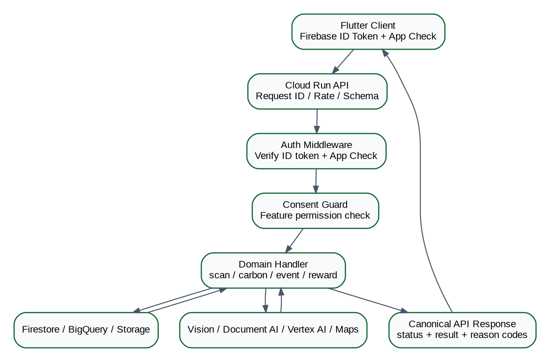
Figure 2. Request handling sequence inside the prototype

3.2 Synchronous vs asynchronous
Operation | Mode | Reason
Login / consent | Synchronous | User needs immediate authorization result.
Carbon estimate | Synchronous | Needed to render scan result.
Gemini explanation | Synchronous with timeout/fallback | User benefit is immediate; deterministic result remains if AI fails.
Reward evaluation | Synchronous for product MVP | Demo simplicity and exact result.
Analytics fan-out | Asynchronous | Should not delay user response.
Grow-Green later checkpoints | Scheduled/event-driven | Long-lived workflow.
Report aggregation | Asynchronous or scheduled | Not on critical request path.

4. Repository and Code Organization
carbonlens/
├── apps/
│ └── carbonlens_flutter/
│ ├── lib/app/ # routes, theme, bootstrap
│ ├── lib/core/ # API, auth, errors, storage helpers
│ ├── lib/features/auth/
│ ├── lib/features/dashboard/
│ ├── lib/features/scan/
│ ├── lib/features/green_move/
│ ├── lib/features/grow_green/
│ ├── lib/features/recycle_red/
│ └── lib/features/rewards/
├── services/
│ └── carbonlens_api/
│ ├── app/main.py
│ ├── app/http/ # routes + middleware
│ ├── app/core/ # config, logging, errors, ids
│ ├── app/domains/scan/
│ ├── app/domains/carbon/
│ ├── app/domains/ai/
│ ├── app/domains/trust/
│ ├── app/domains/rewards/
│ ├── app/domains/green_move/
│ ├── app/domains/grow_green/
│ ├── app/domains/recycle_red/
│ └── tests/
├── data/
│ ├── emission_factors/
│ ├── product_catalog/
│ ├── reward_policies/
│ └── verified_recyclers/
├── bigquery/ddl/
├── firebase/rules/
├── cloudbuild/
├── docs/
└── testdata/

4.1 Domain package contract
Layer | Responsibility | Example
route | HTTP parsing and status mapping | POST /v1/green-events
service | business orchestration | GreenEventService.create_event()
model | domain DTO/state | GreenEvent, VerificationDecision
repository | Firestore/BigQuery persistence | GreenEventRepository
adapter | external Google API | VisionAdapter, GeminiAdapter
policy | pure deterministic rules | RewardPolicyEvaluator
tests | unit + integration | test_duplicate_event_is_idempotent

5. Runtime Environments and Configuration
Config | Local | Prototype/Prod | Rule
GCP_PROJECT_ID | env var | Cloud Run env | Never hard-code.
FIREBASE_PROJECT_ID | env var | Cloud Run env | Must equal accepted token audience/project.
BIGQUERY_DATASET_REFERENCE | carbonlens_reference | carbonlens_reference | Version tables inside dataset.
SCAN_BUCKET | dev bucket | private evidence bucket | No public ACL.
GEMINI_MODEL | configured value | configured value | Model is replaceable without contract changes.
DOCUMENT_AI_PROCESSOR | optional | processor resource id | Secret/config, not client-side.
REWARD_POLICY_VERSION | demo-v1 | active policy pointer | Persist effective version on every reward.
LOG_LEVEL | DEBUG | INFO | No sensitive payload logging.

Secret rule: API keys, processor IDs that should not be exposed, and service credentials belong in Secret Manager or workload identity. Do not commit service-account JSON to GitHub.

6. Flutter Client LLD

6.1 Route map
Route | Screen | Auth? | Primary API
/ | Splash/Bootstrap | No | token/app-check initialization
/login | Login | No | Firebase Auth
/consent | Consent Center | Yes | PUT /v1/consents
/home | Green Dashboard | Yes | GET /v1/dashboard
/scan | Product/Receipt Scan | Yes | POST /v1/scans
/scan/:id | Scan Result | Yes | GET /v1/scans/{id}, /v1/ai/explain
/move | Green-Move | Yes | POST /v1/green-move
/grow | Grow-Green projects | Yes | POST/GET grow-green endpoints
/recycle | Recycle-Red | Yes | POST /v1/recycle-red/claims
/wallet | Rewards | Yes | GET /v1/wallet
/reports | Green Journey | Yes | GET /v1/reports/monthly

6.2 Client state
- `AuthState`: signedOut | signedIn | tokenRefreshing.
- `ConsentState`: feature-level consent booleans + accepted version.
- `ScanState`: idle | uploading | processing | complete | failed.
- `RewardState`: pending | provisional | vested | rejected | revoked.
- `DashboardState`: server snapshot only; do not recompute points client-side.

6.3 API client request headers
Authorization: Bearer <Firebase-ID-token>
X-Firebase-AppCheck: <App-Check-token>
X-Request-Id: <uuid>
Idempotency-Key: <uuid> # required for mutation/reward paths
Content-Type: application/json

6.4 Client privacy rules
- Ask camera/location/Health Connect permission only immediately before a feature needs it.
- Do not cache raw receipts or geo-tagged tree photos longer than required for upload/retry.
- Location shown on public/community views must be coarsened unless the user explicitly opts into precise sharing.
- The client never accepts a Green Points amount from a user-editable field.

7. Cloud Run API LLD

7.1 Prototype deployment unit
Choice: One Cloud Run service named `carbonlens-api` containing modular domains. This minimizes deployment/debug complexity before Oct 18. Each domain exposes an internal interface so it can later become its own service.

7.2 Request middleware order
1. Generate/propagate `request_id`.
2. Apply request size/content-type checks.
3. Verify Firebase ID token and derive `uid`.
4. Verify Firebase App Check token on protected endpoints.
5. Resolve consent requirements for the requested feature.
6. Validate input schema and idempotency key.
7. Execute domain service.
8. Map domain errors to stable HTTP error envelope.
9. Write structured access log with latency and status; exclude raw sensitive evidence.

7.3 Internal interfaces
class CarbonEngine:
estimate_product(product_ref, quantity, region, factor_version=None) -> CarbonResult
class VerificationEngine:
evaluate(event: GreenEventDraft) -> VerificationDecision
class RewardPolicyEngine:
evaluate(event, verification, policy_version) -> RewardDecision
class RewardLedger:
post_once(uid, event_id, decision) -> LedgerResult
class AIOrchestrator:
explain(trusted_context) -> AIExplanation

7.4 Error envelope
{
"error": {
"code": "CONSENT_REQUIRED",
"message": "Location consent is required for Grow-Green check-in.",
"request_id": "req_...",
"retryable": false,
"details": {"consent":"location"}
}
}

8. API Contracts and Error Model

8.1 Core endpoints
Method + path | Input | Output | Idempotent?
GET /health | none | status/build | Yes
GET /version | none | version/git SHA | Yes
GET /v1/me | auth | profile/roles | Yes
PUT /v1/consents | ConsentUpdate | ConsentRecord | Yes by version
POST /v1/scans | ScanCreate | ScanResult/accepted | Yes via key
POST /v1/carbon/estimate | CarbonEstimateRequest | CarbonResult | Yes
POST /v1/ai/explain | TrustedContextRef | AIExplanation | Yes by context hash
POST /v1/green-events | GreenEventDraft | GreenEvent | Yes via event fingerprint
POST /v1/rewards/evaluate | event_id | RewardDecision | Yes
GET /v1/wallet | auth | WalletProjection | Yes
GET /v1/dashboard | period | DashboardSnapshot | Yes

8.2 Pillar endpoints
Endpoint | Purpose | Key validation
POST /v1/green-move | Create commute substitution event | baseline exists; distance/time plausible; Health Connect consent
POST /v1/grow-green/projects | Register planting plot | location consent; point/polygon; privacy mode
POST /v1/grow-green/{id}/checkins | Periodic evidence | fresh timestamp; near plot; media hash unique
POST /v1/grow-green/{id}/confirmations | Visitor confirmation | authenticated confirmer; not owner; anti-collusion rules
POST /v1/recycle-red/claims | Create recycling claim | document + recycler + item; document fingerprint unique
GET /v1/reward-events/{id} | Audit view | owner/admin authorization

8.3 HTTP status policy
Status | Use
200 | Successful read/evaluation.
201 | New resource created.
202 | Accepted for asynchronous processing.
400 | Malformed/invalid field.
401 | Missing/invalid Firebase authentication.
403 | App Check/consent/authorization failure.
404 | Resource not found for authenticated owner.
409 | Idempotency conflict / duplicate evidence.
422 | Semantically valid JSON but ineligible business input.
429 | Rate/cap exceeded.
500 | Unexpected server error; return request_id only.
503 | Dependency unavailable; deterministic fallback when possible.

9. Firestore Operational Data Model
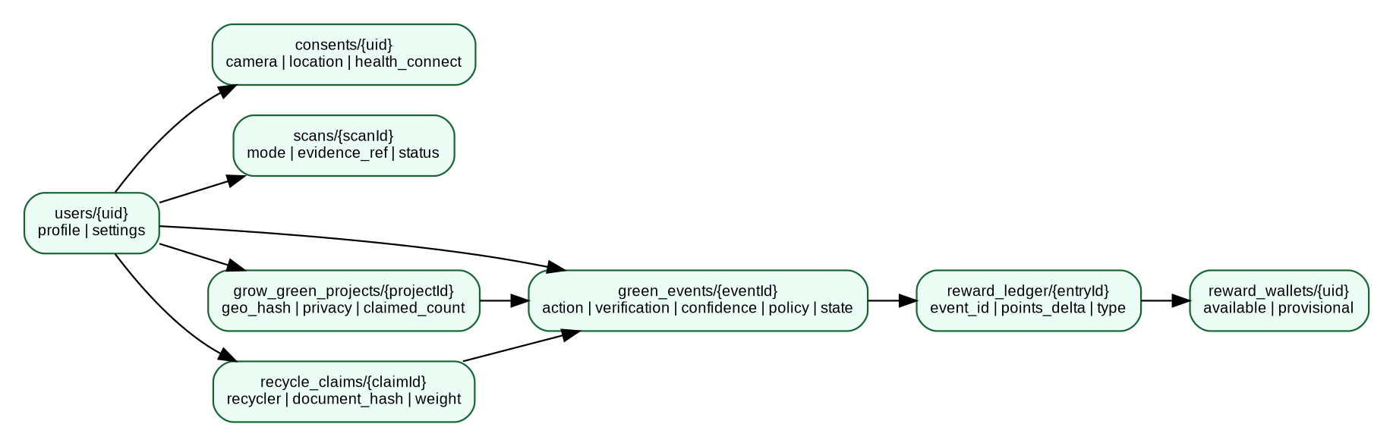
Figure 3. Core operational data relationships

9.1 Collections and key fields
Collection/path | Key fields | Write owner
users/{uid} | display_name, region, created_at, status | backend / controlled profile update
consents/{uid} | policy_version, camera, location, health_connect, personalization, updated_at | backend from user intent
scans/{scanId} | uid, mode, storage_ref, evidence_hash, status, normalized_result, created_at | scan service
green_events/{eventId} | uid, action_type, evidence_refs, impact, verification, confidence, fraud_flags, policy_version, reward_state | trust/reward service
reward_ledger/{entryId} | uid, event_id, points_delta, entry_type, policy_version, created_at, reason_codes | reward service only
reward_wallets/{uid} | available_points, provisional_points, lifetime_earned, updated_at | transactional projection only
reward_policies/{version} | effective_from, segment_rules, caps, sponsor_rules, active | admin/config pipeline
grow_green_projects/{id} | uid, geo_hash, encrypted_location_ref, privacy_mode, claimed_count, species, planting_date, state | grow-green service
grow_green_projects/{id}/checkins/{cid} | captured_at, location_distance_m, media_hash, verification, signals | grow-green service
recycle_claims/{id} | uid, recycler_id, document_hash, item_category, weight_kg, extracted_fields, state | recycle service
verified_recyclers/{id} | name, location, verification_source, allowed_categories, active | curated admin data
recommendations/{id} | uid, context_hash, model, response, created_at | AI orchestrator

9.2 Firestore transaction rule for rewards
transaction:
if reward_ledger where event_id == E exists:
return existing result # replay-safe
verify green_event(E).uid == authenticated uid
require green_event(E).reward_state eligible
create immutable ledger entry
increment wallet available/provisional projection
update event reward_state + ledger_entry_id
commit

9.3 Recommended indexes
- `green_events`: uid + created_at DESC; uid + action_type + created_at DESC; reward_state + updated_at.
- `scans`: uid + created_at DESC; evidence_hash.
- `reward_ledger`: uid + created_at DESC; event_id unique by application rule.
- `grow_green_projects`: uid + state + updated_at.
- `recycle_claims`: uid + created_at DESC; document_hash for duplicate detection.

10. BigQuery Analytical / Reference Data Model

10.1 Reference tables
-- carbonlens_reference.emission_factors
factor_id STRING, category STRING, activity_unit STRING,
kg_co2e_per_unit FLOAT64, region STRING, lifecycle_boundary STRING,
source_name STRING, source_url STRING, factor_set_version STRING,
effective_from DATE, effective_to DATE, confidence_grade STRING
-- carbonlens_reference.product_sustainability
product_ref STRING, category STRING, material STRING, packaging_score INT64,
reusability_score INT64, recyclability_score INT64, durability_score INT64,
carbon_intensity_score INT64, metadata_confidence STRING, source STRING, version STRING
-- carbonlens_reference.verified_recyclers
recycler_id STRING, name STRING, country STRING, region STRING,
accepted_categories ARRAY<STRING>, verification_source STRING, active BOOL

10.2 Analytical facts
-- carbonlens_analytics.green_event_facts
event_id STRING, uid_pseudo STRING, action_type STRING, event_ts TIMESTAMP,
impact_type STRING, impact_value FLOAT64, impact_unit STRING,
verification_level STRING, confidence FLOAT64, reward_state STRING,
points_issued INT64, policy_version STRING, fraud_score FLOAT64
PARTITION BY DATE(event_ts)
CLUSTER BY action_type, verification_level
-- daily_summaries
summary_date DATE, uid_pseudo STRING, estimated_co2e FLOAT64,
avoided_co2e FLOAT64, green_points_earned INT64,
product_events INT64, move_events INT64, grow_events INT64, recycle_events INT64
Privacy rule: Analytics should use a pseudonymous user key. Precise planting coordinates, raw receipt text, phone/email, and raw images should not be copied into BigQuery event facts.

11. Cloud Storage Evidence Model
gs://carbonlens-evidence-<env>/
users/<uid>/
scans/<scan_id>/original.jpg
receipts/<receipt_id>/original.jpg
grow-green/<project_id>/<checkin_id>/photo.jpg
recycle-red/<claim_id>/certificate.jpg
gs://carbonlens-demo-assets-<env>/
products/... # curated public/demo assets only

11.1 Object metadata
Metadata | Purpose
uid | ownership check; do not trust for authorization alone
event_id / scan_id | correlation
sha256 | duplicate evidence fingerprint
captured_at | freshness/plausibility
content_type | processor routing
retention_class | raw-short / evidence-long / demo-public

- Generate signed upload URLs or upload via authenticated backend policy; bucket remains private.
- Lifecycle-delete unnecessary raw product/receipt images after structured facts and hashes are retained.
- Grow-Green evidence may need longer retention for persistence verification; define explicit retention and deletion policy.

12. Carbon Engine LLD

12.1 Input / output
CarbonEstimateRequest
- subject_type: PRODUCT | TRANSPORT
- category / mode
- quantity + unit
- region
- baseline(optional)
- factor_version(optional)
CarbonResult
- estimated_kg_co2e
- avoided_kg_co2e(optional)
- method
- lifecycle_boundary
- factor_id
- factor_set_version
- confidence_grade
- calculation_trace[]

12.2 Product algorithm
1. Normalize product category and quantity.
2. Resolve active factor by category + region + effective date; fallback to global/category average if policy permits.
3. Convert quantity to factor unit.
4. Calculate `estimated_CO2e = normalized_quantity × kg_CO2e_per_unit`.
5. Attach lifecycle boundary, factor provenance and confidence.
6. Never call Gemini from this function.

12.3 Transport algorithm
baseline = distance_km * baseline_factor_kg_per_km
actual = distance_km * actual_factor_kg_per_km
avoided = max(0, baseline - actual)
if substitution_not_proven:
avoided = null
reward_basis = "activity_only_or_none"

12.4 Failure policy
Condition | Result
No matching factor | Return `FACTOR_NOT_FOUND`; do not fabricate.
Unit incompatible | Return `UNIT_CONVERSION_ERROR`.
Factor expired and no active fallback | Return `FACTOR_VERSION_UNAVAILABLE`.
Low confidence category | Return estimate with lower confidence only if allowed; expose method.

13. Sustainability Score LLD

13.1 Scoring dimensions
score = round(
carbon_intensity * 0.40 +
reusability * 0.20 +
packaging * 0.15 +
recyclability * 0.15 +
durability * 0.10
)
# all component scores normalized to 0..100 where higher = better
- Keep weights in versioned configuration (`score_policy_version`) so future scientific review does not rewrite history.
- If a dimension is missing, use a documented missing-data rule; do not silently assume 100 or 0.
- Expose both final score and component scores in API responses.
- Sustainability Score is not a carbon footprint and should never be labeled “Carbon Score”.

13.2 Product replacement delta
improvement_delta = max(0, sustainable_product.score - baseline_product.score)
impact_factor = min(1.0, improvement_delta / 50.0) # demo policy example only
# reward policy owns this mapping; score engine only returns the delta.

14. Trusted Green Event and Verification Engine
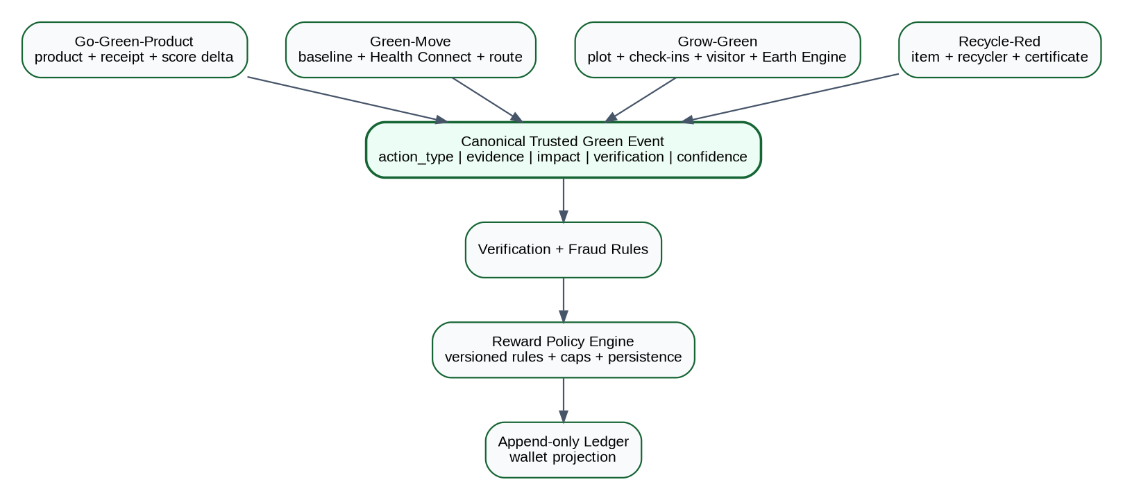
Figure 4. Four input domains converge on one Trusted Green Event contract

14.1 Canonical event schema
GreenEvent {
event_id, uid, action_type, occurred_at, source,
evidence_refs[], evidence_fingerprint,
impact: {type, value, unit, method},
verification: {level, score, checks[], reason_codes[]},
confidence, fraud_flags[], policy_version,
reward_state, created_at, updated_at
}

14.2 Verification levels
Level | Minimum meaning | Reward rule
V0 | Self-declared / insufficient evidence | No high-value reward; awareness only.
V1 | One trusted signal | Capped/reduced or provisional.
V2 | Multiple consistent signals | Normal eligibility subject to policy/caps.
V3 | Strong transaction/document/community/independent verification | Highest eligible confidence; still subject to fraud/caps.

14.3 Generic verification pseudo-logic
checks = run_required_checks(action_type, evidence)
fraud = evaluate_fraud_signals(evidence, history)
level = classify_verification(checks, fraud)
confidence = weighted_confidence(checks)
if fraud.blocking: state = REJECTED
elif level == V0: state = REJECTED_OR_AWARENESS_ONLY
elif action_type == GROW_GREEN: state = PROVISIONAL
else: state = ELIGIBLE_FOR_REWARD

15. Reward Policy and Ledger LLD
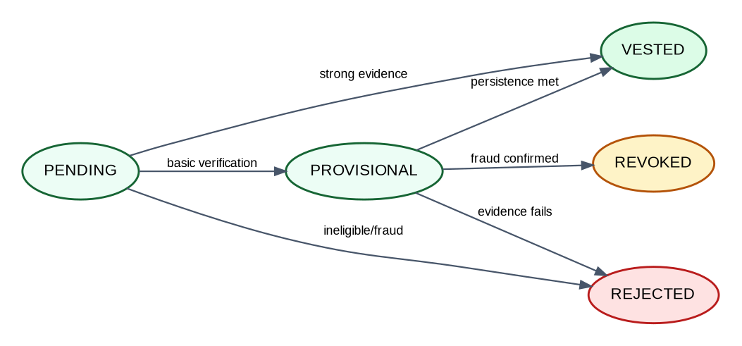
Figure 5. Reward lifecycle state machine

15.1 Policy formula
points = round(
base_action_points
* impact_factor
* verification_factor
* confidence_factor
* persistence_factor
* anti_abuse_adjustment
)
points = min(points, per_event_cap, remaining_daily_cap, remaining_monthly_cap)

15.2 Policy record example
{
"version":"demo-v1",
"segment":"GROW_GREEN",
"base_action_points":100,
"verification_factors":{"V1":0.25,"V2":0.75,"V3":1.0},
"persistence":{"DAY_0":0.10,"DAY_30":0.15,"DAY_90":0.20,"DAY_180":0.25,"DAY_365":0.30},
"caps":{"per_event":5000,"daily":5000},
"sponsor": {"enabled":false,"max_currency_equivalent_per_tree":20}
}

15.3 Ledger invariants
- Every reward ledger entry references exactly one `event_id` and `policy_version`.
- Ledger is append-only; reversals are compensating negative entries.
- A unique event-to-reward guard prevents double credit.
- Wallet balance must be recomputable from ledger.
- Only backend service identity may create ledger entries.
- Gemini, Flutter and analytics pipelines never write rewards.

16. Four Reward Pillars — Detailed Logic

16.1 Go-Green-Product
Step | Implementation
1. Capture | Product image/barcode + optional receipt.
2. Normalize | Vision/OCR → product/category resolver.
3. Baseline | Resolve conventional product/category baseline.
4. Compare | Calculate Sustainability Score delta and optional carbon difference.
5. Verify | Receipt/product evidence, same-category check, duplicate image/receipt hash.
6. Event | Create `GO_GREEN_PRODUCT` green_event.
7. Reward | Policy uses improvement delta, verification and confidence; immediate V2/V3 reward.

eligibility = (new.category == baseline.category) and (score_delta >= min_delta)
if receipt_duplicate or image_reuse: reject
if evidence_level >= V2 and eligibility: evaluate_reward()

16.2 Green-Move
Step | Implementation
Baseline | User registers regular commute: origin area, destination area, normal motorized mode, typical distance.
Evidence | Health Connect activity/session + start/end time + distance; optional Maps route/location.
Plausibility | Speed bounds, overlapping trips, duplicate session IDs, unrealistic distance, time window.
Substitution | Trip must match a registered commute pattern or explicit replacement declaration.
Impact | Avoided CO2e = baseline transport - actual transport.
Reward | V2+ only for carbon-linked reward; per-trip/day caps.

Important: A recreational walk is healthy but is not automatically avoided transport emissions. The LLD requires a credible baseline/counterfactual before carbon-linked points are issued.

16.3 Grow-Green
Checkpoint | Required implementation | State / reward
Day 0 | Create project; point/polygon; claimed count; species if known; fresh geo/time photo; image hash | PENDING → PROVISIONAL; small initial tranche
Day 30 | Owner check-in near registered plot; fresh photo | Remain PROVISIONAL
Day 90 | Fresh owner evidence + optional visitor confirmation | Additional tranche if consistent
Day 180 | Fresh evidence + optional plot-level vegetation signal | Partially vested
Day 365 | Fresh evidence + visitor/independent signal when available | VESTED; final tranche / survival badge

16.3.1 Grow-Green checks
- Distance from check-in location to registered plot <= policy threshold.
- Media SHA-256 and perceptual similarity checks block reused images.
- Timestamp must be fresh and monotonically follow previous checkpoint.
- Owner cannot confirm own project as visitor.
- Visitor confirmation weight decreases for repeated reciprocal confirmations.
- Earth Engine Sentinel-2/vegetation data is optional plot-level corroboration; it does not prove each individual sapling.
- Sponsor monetary-equivalent policy remains separate from GP and must never be described as a Google Maps payment.

16.4 Recycle-Red
Step | Implementation
1. Item intake | Photo + category + optional weight; avoid unnecessary serial numbers.
2. Document | Upload recycler receipt/certificate.
3. Extract | Document AI expense/invoice/OCR extracts recycler, date, document number, amount/weight where present.
4. Registry | Match normalized recycler against curated `verified_recyclers`.
5. Fraud | Fingerprint document; compare across users; validate date/location/category plausibility.
6. Impact | Verified diverted item category/weight; optional sourced carbon/resource benefit separately.
7. Reward | V2/V3 reward with category/weight caps.

17. Gemini / AI Orchestrator LLD

17.1 AI responsibilities
Allowed | Not allowed
Explain CarbonResult and SustainabilityScore | Invent emission factors or carbon values
Recommend greener alternatives from supplied candidates | Issue Green Points or change wallet
Summarize why verification passed/failed using reason codes | Override deterministic fraud/verification decision
Compare known product metadata | Create unsupported claims about manufacturer/environmental impact

17.2 Prompt context contract
SYSTEM RULES
- Use only FACTS supplied below for numeric sustainability/carbon claims.
- Do not create or modify carbon values, verification levels or reward points.
- If evidence is insufficient, state uncertainty.
- Return JSON matching the response schema.
TRUSTED FACTS
product = {...}
carbon_result = {...}
sustainability_score = {...}
verification = {...}
candidate_alternatives = [...]

17.3 AI response schema
{
"summary":"...",
"why_score":"...",
"recommended_action":"...",
"alternative_product_ref":"...|null",
"confidence_note":"...",
"safety_caveat":"...|null"
}
- Validate JSON before returning to Flutter.
- Use a short timeout and deterministic fallback text so the demo still works if Gemini is unavailable.
- Store model identifier, prompt template version and context hash for reproducibility.

18. Vision and Document AI Processing

18.1 Product scan pipeline
1. Client requests upload slot / creates scan id.
2. Image uploaded to private Cloud Storage path.
3. Backend computes content hash and checks duplicates.
4. Vision extracts labels/text/barcode-like evidence as available.
5. Resolver maps evidence to curated product/category; confidence is recorded.
6. Carbon and score engines run only after normalization.
7. Raw image follows retention policy.

18.2 Receipt / certificate pipeline
1. Classify document purpose: purchase receipt vs recycler certificate/receipt.
2. Send document to configured Document AI processor (Expense/Invoice/OCR depending sample format).
3. Normalize supplier/recycler name, date, document number, total/weight/line items when available.
4. Create normalized fingerprint from stable fields + document hash.
5. Run duplicate and registry checks.
6. Store extracted structured facts and processor/version metadata.
Current Google capability note: Document AI provides pretrained Expense and Invoice parsers plus Enterprise Document OCR. Choose the processor that best matches the sample evidence and keep a fallback OCR path.

19. Pub/Sub and Asynchronous Processing

19.1 Event envelope
{
"event_type":"green_event.verified",
"event_version":"1.0",
"event_id":"evt_...",
"occurred_at":"2026-10-15T10:00:00Z",
"trace_id":"...",
"subject_ref":"green_events/evt_...",
"data": {"action_type":"GO_GREEN_PRODUCT","verification_level":"V2"}
}

19.2 Topic handling rules
- Consumers are idempotent by `event_id`.
- Do not publish raw images, precise location or complete receipt text in Pub/Sub payloads; publish references.
- Use dead-letter/retry policy for non-user-facing analytics tasks.
- Reward issuance remains synchronous/transactional in the prototype; do not rely on at-least-once Pub/Sub delivery for exactly-once points.

20. Security, IAM and Privacy Controls

20.1 Authentication / App Check
- Firebase ID token is verified server-side; `uid` comes from decoded token, never request body.
- Protected custom backend calls include App Check token; backend verifies it with Firebase Admin.
- Consent guard checks feature-specific permission before processing location/health/personalized data.

20.2 Service accounts
Identity | Minimum responsibilities
carbonlens-api-runtime | Firestore access, BigQuery read/append as required, Storage evidence access, Vertex AI invoke, Vision/Document AI invoke, Pub/Sub publish, Secret Manager access.
carbonlens-build | Build/push to Artifact Registry and deploy approved Cloud Run/Firebase artifacts.
analytics-consumer (optional) | BigQuery append/read summaries; no reward ledger write.

20.3 Sensitive data controls
Data | Control
Email/profile | Firebase Auth; minimum replication into app DB.
Precise Grow-Green location | Restricted operational record; public view is coarsened/hidden based on privacy mode.
Health Connect data | Read minimum activity/distance/session fields required; no unrelated health data.
Receipt/certificate | Private object, structured extraction, short raw retention when possible.
Reward ledger | Immutable/audited; user can read own entries only.
Analytics | Pseudonymous uid; no raw image/location.

21. Logging, Monitoring and SRE

21.1 Structured log fields
severity, timestamp, service, revision, request_id, trace_id, uid_hash,
route, status_code, latency_ms, domain, event_id, action_type,
verification_level, policy_version, dependency, error_code
- Never log Firebase tokens, App Check tokens, raw receipt OCR text, full geo coordinates or raw Gemini prompts containing personal data.
- Use request/trace id across scan → carbon → AI → event → reward.
- Log reward reason codes and policy version for auditability.

21.2 Minimum dashboard
Metric | Alert / demo target
Cloud Run request 5xx rate | Alert if >5% for 5 minutes; target <1% during demo.
p95 API latency | Track by route; investigate >2s excluding AI/document processing.
Gemini failure/timeout rate | Fallback must keep deterministic result visible.
Vision/Document AI failures | Track per processor.
Reward duplicate conflicts | Expected near zero; spikes indicate replay/bug.
Rejected/revoked events | Track by reason code.
Cloud Run instances | Observe scale-to-zero/warm behavior.

22. Cloud Build / Deployment LLD

22.1 Backend build
GitHub main
-> Cloud Build trigger
1. run unit tests
2. build container
3. push Artifact Registry
4. deploy Cloud Run revision
5. smoke GET /health and /version
6. route 100% traffic if smoke succeeds

22.2 Frontend build
GitHub main
-> Cloud Build
1. flutter test
2. flutter build web --release
3. deploy Firebase Hosting
4. optional Android APK/AAB build
5. Firebase App Distribution for testers

22.3 Release metadata
- Expose `/version` with semantic version, git SHA, build timestamp and active reward policy version.
- Tag Oct 18 submission release in GitHub.
- Keep rollback-able Cloud Run revision and previous Firebase Hosting release available.

23. Test Design and Quality Gates

23.1 Unit tests
Module | Required tests
Carbon Engine | factor lookup, unit conversion, versioning, missing factor, avoided-emissions floor at zero
Score Engine | weights, missing dimension rule, 0/100 bounds, deterministic results
Verification | V0-V3 mapping, duplicate evidence, plausibility, collusion signal
Reward Policy | all factors, caps, versioning, zero/negative handling, persistence tranches
Ledger | same event twice does not double-credit; reversal creates compensating entry
AI validation | invalid/non-JSON response falls back; no numeric authority from model

23.2 Integration tests
- Firebase token → Cloud Run → Firestore owned record.
- Storage image → Vision → resolver → CarbonResult.
- Receipt/certificate → Document AI → fingerprint → registry match.
- Green event → verification → reward → wallet.
- Grow-Green checkpoint transition and privacy enforcement.
- Health Connect fixture → Green-Move plausibility + substitution.

23.3 E2E demo test
1. Fresh browser: sign in.
2. Accept camera/personalization consent.
3. Scan/select bottle image.
4. See product/category confidence.
5. See CarbonResult + Sustainability Score separately.
6. See Gemini recommendation.
7. Submit sustainable replacement evidence.
8. Receive one reward entry; replay same evidence does not double-credit.
9. Dashboard refresh shows updated points and event history.

24. Day-by-Day Coding Sequence
Date | LLD coding priority | End-of-day proof
Oct 9 | Backend skeleton, middleware, /health, /version, /v1/me, Firestore repositories | Authenticated Flutter call reaches Cloud Run and persists user/consent.
Oct 10 | Gemini adapter + structured prompt/response contract using seeded CarbonResult | AI explanation works without owning carbon values.
Oct 11 | Seeded product E2E: scan DTO → factor → score → Gemini → event → reward → dashboard | 2-minute working vertical slice.
Oct 12 | Storage + Vision/OCR + product resolver; replace seeded evidence | Real/sample image drives same contract.
Oct 13 | BigQuery factor/catalog/reference DDL + seed datasets + provenance | Backend reads versioned factor data.
Oct 14 | Finalize Carbon/Score algorithms and tests | Deterministic test vectors pass.
Oct 15 | Trusted event + policy + ledger; Product fully live; thin other pillars | All action types create auditable events.
Oct 16 | Security rules, App Check enforcement, UI polish, observability, public release | Stable public URL and Android test build.
Oct 17 | No feature expansion: docs, video, screenshots, README, rehearsal | Submission pack complete.
Oct 18 | Smoke/rollback only; submit tagged release | Every public artifact opens and demo path works.

Critical schedule rule: If you are behind, cut P2 wrappers first. Never cut the deterministic Carbon Engine, Trusted Green Event, reward ledger, or one complete real Google-service vertical slice.

25. Definition of Ready / Definition of Done

25.1 Feature Definition of Ready
- User story and action type are known.
- Required consent/evidence is identified.
- Canonical request and response fields are defined.
- Data owner (Firestore vs BigQuery vs Storage) is defined.
- Verification level and reward eligibility rules are defined.
- Failure/fallback behavior is known.

25.2 Feature Definition of Done
- Unit tests pass.
- Authenticated and App Check-protected where applicable.
- No client-authoritative carbon/points fields.
- Structured logs include request/event correlation.
- Sensitive inputs are not logged.
- Duplicate/replay behavior is tested.
- UI shows confidence and reason where appropriate.
- Cloud Run/Firebase deployed artifact passes smoke test.
- README/API notes updated.

25.3 Submission Definition of Done
- Public Firebase Hosting URL works from signed-out fresh browser.
- Cloud Run APIs serve deployed build and `/version` identifies release.
- At least one product flow uses real Vision/Cloud Storage/BigQuery/Vertex AI.
- Reward ledger proves exact-once behavior.
- Four-pillar architecture is visible; Product is fully live and at least two additional pillars are demonstrated with bounded real evidence.
- No claim that Google pays $20/tree or that Maps/satellite imagery proves individual tree survival.
- Public GitHub contains source, architecture, setup, limitations and data-source notes.
- Demo video and PPT/PDF match the deployed build.

Appendix A. Canonical JSON Contracts

A.1 Green Event draft
{
"action_type":"GO_GREEN_PRODUCT",
"occurred_at":"2026-10-15T08:30:00Z",
"evidence_refs":["scans/scan_123","receipts/rec_123"],
"subject":{"category":"toothbrush","baseline_ref":"plastic_toothbrush","actual_ref":"wooden_toothbrush"},
"client_context":{"app_version":"1.0.0"}
}

A.2 Reward decision
{
"event_id":"evt_123",
"eligible":true,
"state":"VESTED",
"points":86,
"policy_version":"demo-v1",
"factors":{
"base":100, "impact":1.0, "verification":0.9,
"confidence":0.95, "persistence":1.0, "anti_abuse":1.0
},
"caps_applied":[],
"reason_codes":["CATEGORY_REPLACEMENT_VERIFIED","RECEIPT_UNIQUE"]
}

A.3 Grow-Green check-in
{
"captured_at":"2026-11-08T06:20:00Z",
"storage_object":"gs://.../photo.jpg",
"location":{"lat":null,"lng":null,"client_distance_to_plot_m":18},
"checkpoint":"DAY_30"
}
# precise coordinates may be sent securely but are not returned in public/community views

Appendix B. Google Service References
Firebase Authentication — Verify ID tokens: https://firebase.google.com/docs/auth/admin/verify-id-tokens
Firebase App Check — Verify tokens from a custom backend: https://firebase.google.com/docs/app-check/custom-resource-backend
Cloud Run — Deploy container images: https://cloud.google.com/run/docs/deploying
Cloud Run — Autoscaling: https://cloud.google.com/run/docs/about-instance-autoscaling
Document AI — Processor list: https://cloud.google.com/document-ai/docs/processors-list
Health Connect — Developer center: https://developer.android.com/health-and-fitness/health-connect
Earth Engine — Sentinel-2 catalog: https://developers.google.com/earth-engine/datasets/catalog/sentinel-2
Vertex AI — Generative AI documentation: https://cloud.google.com/vertex-ai/generative-ai/docs
Cloud Vision — Documentation: https://cloud.google.com/vision/docs
BigQuery — Documentation: https://cloud.google.com/bigquery/docs
Firestore — Documentation: https://firebase.google.com/docs/firestore
Cloud Build — Documentation: https://cloud.google.com/build/docs

LLD Final Guidance
Build philosophy: Do not code CarbonLens as four apps. Code one evidence-to-trust-to-reward platform with four adapters. The shared contracts (`CarbonResult`, `GreenEvent`, `VerificationDecision`, `RewardDecision`, `LedgerEntry`) are the most important code you will write before Oct 18.

