Date: 17-3-19
Daily report on WIT & WIL
Name of the faculty : Dr.P.Padmavathi Name of the subject : Engineering Chemistry
Class/ Section : I B.Tech II sem CSE – C
1 | Grid Reference No : | 6.3
2 | Scenario Reference: |   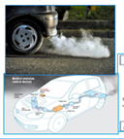
3 | Topic Covered: | e-waste from cars management
4 | Brief Write – up (500 words): Here Describe how the topic(Mentioned in point: 3) is mapped with the scenario (mentioned in point : 2)  Scenario Mapping  Electronic waste or e-waste describes discarded electrical or electronic devices. Used electronics which are destined for reuse, resale, salvage, recycling, or disposal are also considered e-waste.  Examples of electronic waste include, but not limited to: TVs, computer monitors, printers, scanners, keyboards, mice, cables, circuit boards, lamps, clocks, flashlight, calculators, phones, answering machines, digital/video cameras, radios, VCRs, DVD players, MP3 and CD players  It includes computers, consumer electronics, fridges etc which have been disposed of by their original users. ... Common items of electrical and electronic waste are: Large household appliances (refrigerators/freezers, washing machines, dishwashers) Small household appliances (toasters, coffee makers, irons, hairdryers)  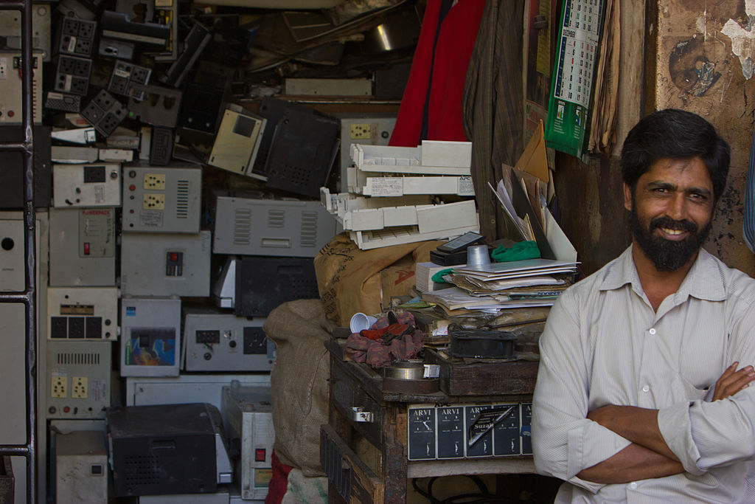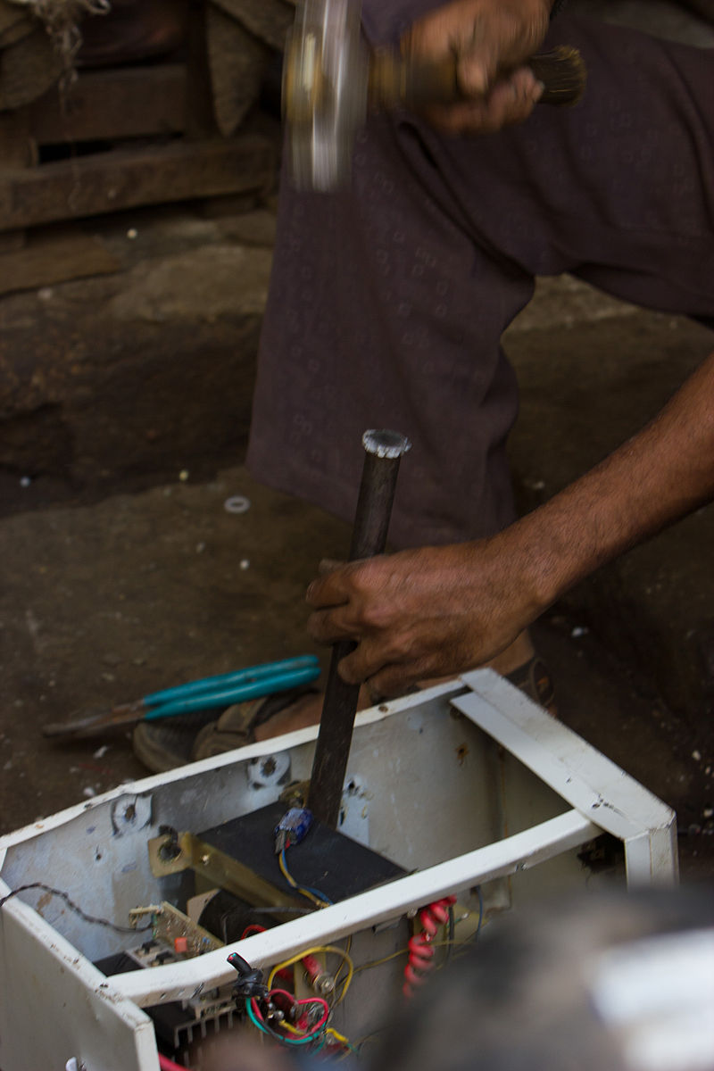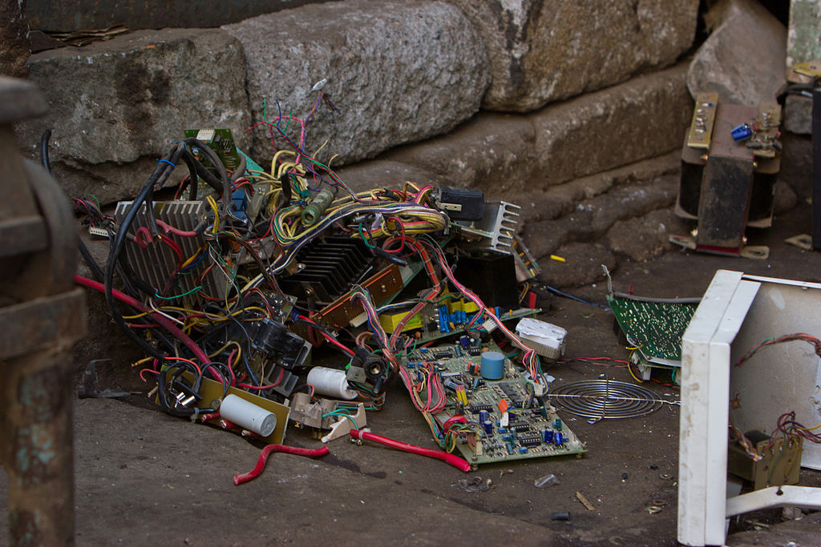  Collection center and dissembling the electronic equipment  Our waste electronics are polluting drinking water and harming ecosystems around the world. It’s time to fix the problem.  All electronic waste is made up of deadly chemicals such as lead, cadmium, beryllium, mercury and brominated flame retardants. Disposing of gadgets and devices improperly increases the chances of these dangerous chemicals contaminating the soil, polluting the air and leaching into water bodies.  When e-waste is deposited in a landfill, it tends to leach when water passes through it picking up trace elements. After which the contaminated landfill water reaches natural groundwater with increased toxic levels, this can be harmful if it enters any drinking water bodies.  5 Ways to Safely Dispose Of Your Electronic Waste  - Give Back to Your Electronic Companies and Drop Off Points.  - Visit Civic Institutions. ...  - Donating Your Outdated Technology. ...  - Sell Off Your Outdated Technology. ...  - Give Your Electronic Waste to a Certified E-Waste Recycler. The positive aspect of e-waste recycling is that you have quite a few recycling options. ...
5 | - Relevant additional illustration if any : Other examples  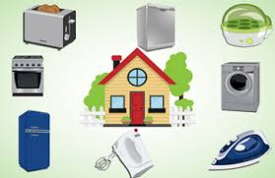  e- Waste generated from house must be given to a collection center from which it will be sent to an incinerator.  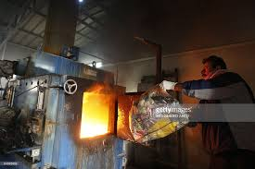
6 | Video links / web links if any: | https://www.youtube.com/watch?v=zmZnEd0Lzuc  e- waste disposable methods
7 | Signature of Repository Administrator:

