Date: 18-4-19
Daily report on WIT & WIL
Name of the faculty : Dr.P.Padmavathi Name of the subject : Engineering Chemistry
Class/ Section : I B.Tech II sem CSE – C
1 | Grid Reference No : | 6.5
2 | Scenario Reference: | 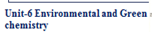  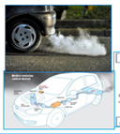
3 | Topic Covered: | Green chemistry principles in automotive industry
4 | Brief Write – up (500 words): Here Describe how the topic(Mentioned in point: 3) is mapped with the scenario (mentioned in point : 2)  Scenario Mapping  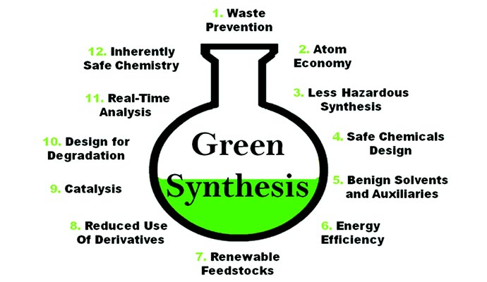  Green chemistry tries, when possible, to utilize benign, renewable feedstocks as raw materials. From the point view of green chemistry, combustion of fuels obtained from renewable feedstocks is more preferable than combustion of fossil fuels from depleting finite sources. For example, many vehicles around the world are fueled with diesel oil, and the production of biodiesel oil is a promising possibility. As the name indicates, biodiesel oil is produced from cultivated plants oil, e.g. from soya beans. It is synthesized from fats embedded in plant oils by removing the glycerine molecule. The advantages of using biodiesel oil are obvious. It’s fuel from renewable resources and contrary to normal diesel oil. Reaction for biodiesel oil production The great threats to the environment are organic solvents applied in many syntheses. They are released into the environment by a volatilization process, especially in the case of volatile organic compounds (VOCs) and as a result of leakage. The emission of such compounds is significant because in many syntheses their amounts exceeds the amount of reagents. The new solutions for practical synthesis aim at complete elimination of solvents or to substitute the compounds belonging to VOCs by cheap technological media, harmless for humans and the environment. The use of supercritical fluids9,10 (SCFs) in chemical processes is becoming more and more prevalent. Carbon dioxide as a supercritical fluid is most frequently used as medium for reactions. It is inflammable, easily available (from natural sources) and cheap. The discovery of supercritical carbon dioxide opened a way to new processes in textile and metal industries and for dry cleaning of clothes.Micell Technologies Company offers technology for removal of stains using liquid carbon dioxide instead of the perchloroethylene (PERC) more commonly applied.  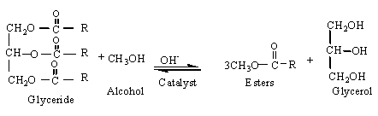
5 | - Relevant additional illustration if any : Other examples  Green chemistry in medicinal field    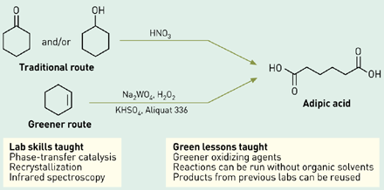
6 | Video links / web links if any:
7 | Signature of Repository Administrator:

