Date: 20-4-19
Daily report on WIT & WIL
Name of the faculty :Dr.K.Madhavi Name of the subject : Engineering Chemistry
Class/ Section : I B.Tech II sem CSE – A
1 | Grid Reference No : | 6.4
2 | Scenario Reference: |   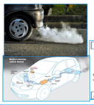
3 | Topic Covered: | Self healing materials in car
4 | Brief Write – up (500 words): Here Describe how the topic(Mentioned in point: 3) is mapped with the scenario (mentioned in point : 2)  Scenario Mapping  self-healing materials that could repair internal damage all by themselves.  Nothing lasts forever, although some natural materials (such as stone) certainly do their best. Materials that we use everyday generally stop working for three different reasons:  - Aging: Most materials gradually decay, sometimes over a very long period of time  - Wear: Most materials wear out gradually through constant use (friction is one of the biggest culprits; materials that are repeatedly moved back and forth will break through fatigue).  - Defects: Some materials break suddenly and very unexpectedly when applied forces (stresses and strains) make internal fractures (usually tiny cracks or other defects inside) spread rapidly.  The first self-healing materials were polymers (plastics made from long, repeating molecules) with a kind of embedded internal adhesive, reported in 2001 by Scott White, Nancy Sottos, and colleagues from the University of Illinois at Urbana-Champaign. Since then, a variety of other self-healing materials have been developed. Self-healing materials come in four main kinds: materials with embedded "healing agents," like those developed by Professor White; materials with a kind of internal "vascular" circulation analogous to blood; shape-memory materials; and reversible polymers.  Self-healing materials can use embedded capsules in a variety of different ways. The simplest approach is for the capsules to release an adhesive that simply fills the crack and binds the material together. In a slightly different approach, the main body of the material is a solid polymer, while the capsules contain a liquid monomer (one of the basic, endlessly repeated units that makes up the polymer). When the material fails and the capsules break, the monomer mixes with the polymer, more polymerization occurs, and the damage is healed effectively by creating more of the original material to replace the damaged area. Typically, a powdered chemical catalyst has to be embedded as well so the polymerization will happen at a relatively low, everyday temperature and pressure.  Scientists have recently developed a polyurethane coating that heals its own scratches when exposed to sunlight.  The chitosan is chemically incorporated into traditional polymer materials, such as the ones used in the outer coatings to protect the paint on cars. When a scratch occurs on the outer coating, the chemical structure is damaged and the chitosan responds to the UV component of sunlight. Chemical chains are then formed with other materials in the coating, eventually filling the scratch. This process can take less than an hour and may eventually lead the “scratch free car” or other products in the future.  In December 2005 we reported the world’s first clear paint that repairs scratches on painted car surfaces, Nissan “Scratch Guard” . "Scratch Guard" contained a newly developed high elastic resin that helps prevent scratches from affecting the inner layers of a car’s painted surface. Repair took anything from one day to a week and Nissan has been offering this self-healing paint as an option on its X-Trail SUV since 2005. This product appears similar to the Chitosan containing compound, but achieves its results in a slightly different manner.  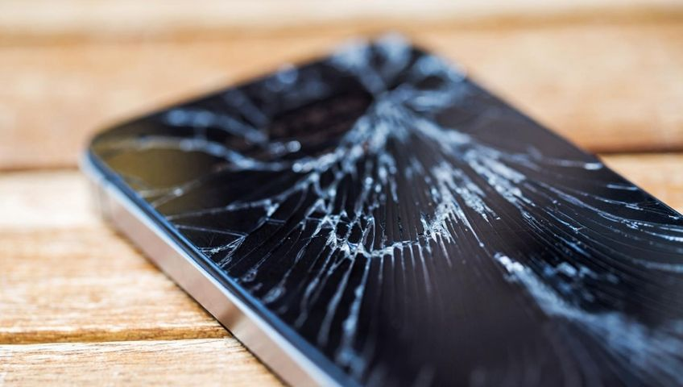  Scratch less glass with self healing material  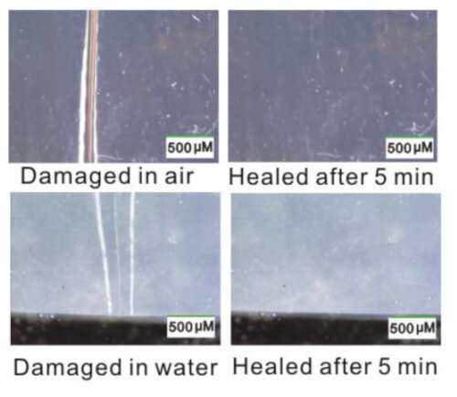  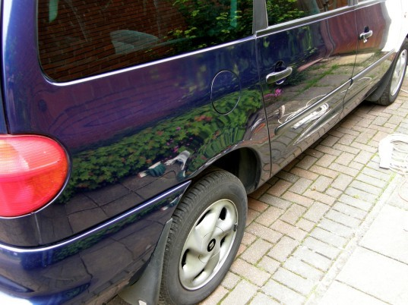  Self healing paints in car
5 | - Relevant additional illustration if any : Other examples  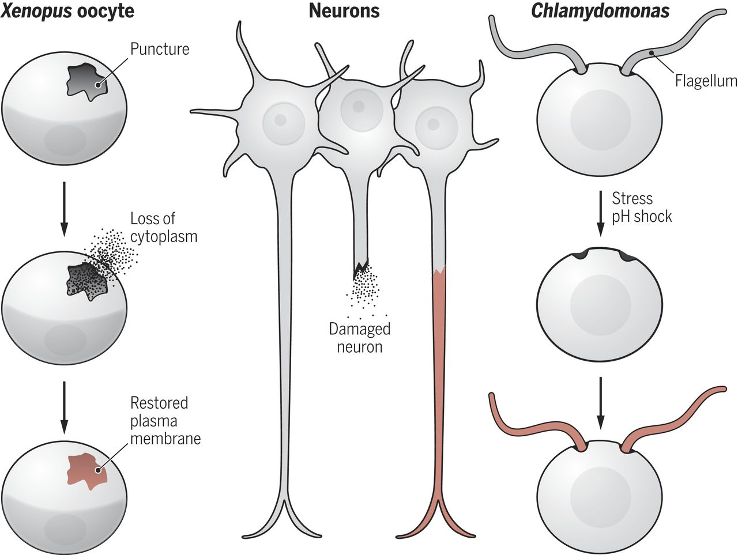
6 | Video links / web links if any: | https://www.youtube.com/watch?v=jc5GKBaiqBA  self healing car – no dent  https://www.youtube.com/watch?v=h-fka0wfY8w
7 | Signature of Repository Administrator:

